**Name: Kshitija Shamrao Jadhav**

**PRN: 2019BTECS00053**

**BATCH: B6**

**Data Encryption Standard (DES):**

**Data encryption standard (DES)** has been found vulnerable to very powerful attacks and therefore, the popularity of DES has been found slightly on the decline. DES is a block cipher and encrypts data in blocks of size of **64 bits** each, which means 64 bits of plain text go as the input to DES, which produces 64 bits of ciphertext. The same algorithm and key are used for encryption and decryption, with minor differences. The key length is **56 bits**. The basic idea is shown in the figure:

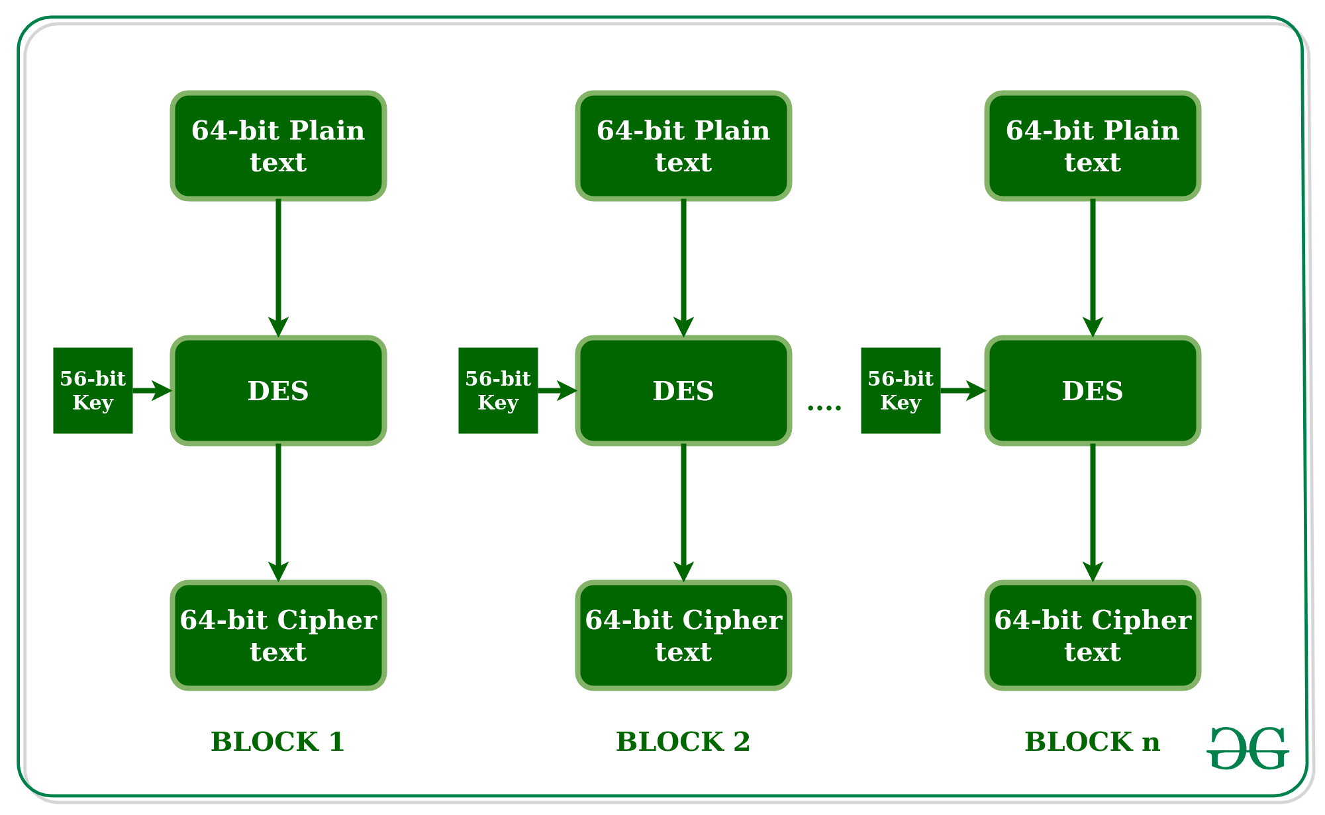

#include <bits/stdc++.h>

using namespace std;

string hex2bin(string s)

{

    // hexadecimal to binary conversion

    unordered_map<char, string> mp;

    mp['0'] = "0000";

    mp['1'] = "0001";

    mp['2'] = "0010";

    mp['3'] = "0011";

    mp['4'] = "0100";

    mp['5'] = "0101";

    mp['6'] = "0110";

    mp['7'] = "0111";

    mp['8'] = "1000";

    mp['9'] = "1001";

    mp['A'] = "1010";

    mp['B'] = "1011";

    mp['C'] = "1100";

    mp['D'] = "1101";

    mp['E'] = "1110";

    mp['F'] = "1111";

    string bin = "";

    for (int i = 0; i < s.size(); i++) {

        bin += mp[s[i]];

    }

    return bin;

}

string bin2hex(string s)

{

    // binary to hexadecimal conversion

    unordered_map<string, string> mp;

    mp["0000"] = "0";

    mp["0001"] = "1";

    mp["0010"] = "2";

    mp["0011"] = "3";

    mp["0100"] = "4";

    mp["0101"] = "5";

    mp["0110"] = "6";

    mp["0111"] = "7";

    mp["1000"] = "8";

    mp["1001"] = "9";

    mp["1010"] = "A";

    mp["1011"] = "B";

    mp["1100"] = "C";

    mp["1101"] = "D";

    mp["1110"] = "E";

    mp["1111"] = "F";

    string hex = "";

    for (int i = 0; i < s.length(); i += 4) {

        string ch = "";

        ch += s[i];

        ch += s[i + 1];

        ch += s[i + 2];

        ch += s[i + 3];

        hex += mp[ch];

    }

    return hex;

}

string permute(string k, int* arr, int n)

{

    string per = "";

    for (int i = 0; i < n; i++) {

        per += k[arr[i] - 1];

    }

    return per;

}

string shift_left(string k, int shifts)

{

    string s = "";

    for (int i = 0; i < shifts; i++) {

        for (int j = 1; j < 28; j++) {

            s += k[j];

        }

        s += k[0];

        k = s;

        s = "";

    }

    return k;

}

string xor_(string a, string b)

{

    string ans = "";

    for (int i = 0; i < a.size(); i++) {

        if (a[i] == b[i]) {

            ans += "0";

        }

        else {

            ans += "1";

        }

    }

    return ans;

}

string encrypt(string pt, vector<string> rkb, vector<string> rk)

{

    // Hexadecimal to binary

    pt = hex2bin(pt);

    // Initial Permutation Table

    int initial_perm[64] = { 58, 50, 42, 34, 26, 18, 10, 2,

                             60, 52, 44, 36, 28, 20, 12, 4,

                             62, 54, 46, 38, 30, 22, 14, 6,

                             64, 56, 48, 40, 32, 24, 16, 8,

                             57, 49, 41, 33, 25, 17, 9, 1,

                             59, 51, 43, 35, 27, 19, 11, 3,

                             61, 53, 45, 37, 29, 21, 13, 5,

                             63, 55, 47, 39, 31, 23, 15, 7 };

    // Initial Permutation

    pt = permute(pt, initial_perm, 64);

    cout << "After initial permutation: " << bin2hex(pt) << endl;

    // Splitting

    string left = pt.substr(0, 32);

    string right = pt.substr(32, 32);

    cout << "After splitting: L0=" << bin2hex(left)

         << " R0=" << bin2hex(right) << endl;

    // Expansion D-box Table

    int exp_d[48] = { 32, 1, 2, 3, 4, 5, 4, 5,

                      6, 7, 8, 9, 8, 9, 10, 11,

                      12, 13, 12, 13, 14, 15, 16, 17,

                      16, 17, 18, 19, 20, 21, 20, 21,

                      22, 23, 24, 25, 24, 25, 26, 27,

                      28, 29, 28, 29, 30, 31, 32, 1 };

    // S-box Table

    int s[8][4][16] = { { 14, 4, 13, 1, 2, 15, 11, 8, 3, 10, 6, 12, 5, 9, 0, 7,

                          0, 15, 7, 4, 14, 2, 13, 1, 10, 6, 12, 11, 9, 5, 3, 8,

                          4, 1, 14, 8, 13, 6, 2, 11, 15, 12, 9, 7, 3, 10, 5, 0,

                          15, 12, 8, 2, 4, 9, 1, 7, 5, 11, 3, 14, 10, 0, 6, 13 },

                        { 15, 1, 8, 14, 6, 11, 3, 4, 9, 7, 2, 13, 12, 0, 5, 10,

                          3, 13, 4, 7, 15, 2, 8, 14, 12, 0, 1, 10, 6, 9, 11, 5,

                          0, 14, 7, 11, 10, 4, 13, 1, 5, 8, 12, 6, 9, 3, 2, 15,

                          13, 8, 10, 1, 3, 15, 4, 2, 11, 6, 7, 12, 0, 5, 14, 9 },

                        { 10, 0, 9, 14, 6, 3, 15, 5, 1, 13, 12, 7, 11, 4, 2, 8,

                          13, 7, 0, 9, 3, 4, 6, 10, 2, 8, 5, 14, 12, 11, 15, 1,

                          13, 6, 4, 9, 8, 15, 3, 0, 11, 1, 2, 12, 5, 10, 14, 7,

                          1, 10, 13, 0, 6, 9, 8, 7, 4, 15, 14, 3, 11, 5, 2, 12 },

                        { 7, 13, 14, 3, 0, 6, 9, 10, 1, 2, 8, 5, 11, 12, 4, 15,

                          13, 8, 11, 5, 6, 15, 0, 3, 4, 7, 2, 12, 1, 10, 14, 9,

                          10, 6, 9, 0, 12, 11, 7, 13, 15, 1, 3, 14, 5, 2, 8, 4,

                          3, 15, 0, 6, 10, 1, 13, 8, 9, 4, 5, 11, 12, 7, 2, 14 },

                        { 2, 12, 4, 1, 7, 10, 11, 6, 8, 5, 3, 15, 13, 0, 14, 9,

                          14, 11, 2, 12, 4, 7, 13, 1, 5, 0, 15, 10, 3, 9, 8, 6,

                          4, 2, 1, 11, 10, 13, 7, 8, 15, 9, 12, 5, 6, 3, 0, 14,

                          11, 8, 12, 7, 1, 14, 2, 13, 6, 15, 0, 9, 10, 4, 5, 3 },

                        { 12, 1, 10, 15, 9, 2, 6, 8, 0, 13, 3, 4, 14, 7, 5, 11,

                          10, 15, 4, 2, 7, 12, 9, 5, 6, 1, 13, 14, 0, 11, 3, 8,

                          9, 14, 15, 5, 2, 8, 12, 3, 7, 0, 4, 10, 1, 13, 11, 6,

                          4, 3, 2, 12, 9, 5, 15, 10, 11, 14, 1, 7, 6, 0, 8, 13 },

                        { 4, 11, 2, 14, 15, 0, 8, 13, 3, 12, 9, 7, 5, 10, 6, 1,

                          13, 0, 11, 7, 4, 9, 1, 10, 14, 3, 5, 12, 2, 15, 8, 6,

                          1, 4, 11, 13, 12, 3, 7, 14, 10, 15, 6, 8, 0, 5, 9, 2,

                          6, 11, 13, 8, 1, 4, 10, 7, 9, 5, 0, 15, 14, 2, 3, 12 },

                        { 13, 2, 8, 4, 6, 15, 11, 1, 10, 9, 3, 14, 5, 0, 12, 7,

                          1, 15, 13, 8, 10, 3, 7, 4, 12, 5, 6, 11, 0, 14, 9, 2,

                          7, 11, 4, 1, 9, 12, 14, 2, 0, 6, 10, 13, 15, 3, 5, 8,

                          2, 1, 14, 7, 4, 10, 8, 13, 15, 12, 9, 0, 3, 5, 6, 11 } };

    // Straight Permutation Table

    int per[32] = { 16, 7, 20, 21,

                    29, 12, 28, 17,

                    1, 15, 23, 26,

                    5, 18, 31, 10,

                    2, 8, 24, 14,

                    32, 27, 3, 9,

                    19, 13, 30, 6,

                    22, 11, 4, 25 };

    cout << endl;

    for (int i = 0; i < 16; i++) {

        // Expansion D-box

        string right_expanded = permute(right, exp_d, 48);

        // XOR RoundKey[i] and right_expanded

        string x = xor_(rkb[i], right_expanded);

        // S-boxes

        string op = "";

        for (int i = 0; i < 8; i++) {

            int row = 2 * int(x[i * 6] - '0') + int(x[i * 6 + 5] - '0');

            int col = 8 * int(x[i * 6 + 1] - '0') + 4 * int(x[i * 6 + 2] - '0') + 2 * int(x[i * 6 + 3] - '0') + int(x[i * 6 + 4] - '0');

            int val = s[i][row][col];

            op += char(val / 8 + '0');

            val = val % 8;

            op += char(val / 4 + '0');

            val = val % 4;

            op += char(val / 2 + '0');

            val = val % 2;

            op += char(val + '0');

        }

        // Straight D-box

        op = permute(op, per, 32);

        // XOR left and op

        x = xor_(op, left);

        left = x;

        // Swapper

        if (i != 15) {

            swap(left, right);

        }

        cout << "Round " << i + 1 << " " << bin2hex(left) << " "

             << bin2hex(right) << " " << rk[i] << endl;

    }

    // Combination

    string combine = left + right;

    // Final Permutation Table

    int final_perm[64] = { 40, 8, 48, 16, 56, 24, 64, 32,

                           39, 7, 47, 15, 55, 23, 63, 31,

                           38, 6, 46, 14, 54, 22, 62, 30,

                           37, 5, 45, 13, 53, 21, 61, 29,

                           36, 4, 44, 12, 52, 20, 60, 28,

                           35, 3, 43, 11, 51, 19, 59, 27,

                           34, 2, 42, 10, 50, 18, 58, 26,

                           33, 1, 41, 9, 49, 17, 57, 25 };

    // Final Permutation

    string cipher = bin2hex(permute(combine, final_perm, 64));

    return cipher;

}

int main()

{

    // pt is plain text

    string pt, key;

    cout<<"Enter plain text(in hexadecimal): ";

    cin>>pt;

    cout<<"Enter key(in hexadecimal): ";

    cin>>key;

    // Key Generation

    // Hex to binary

    key = hex2bin(key);

    // Parity bit drop table

    int keyp[56] = { 57, 49, 41, 33, 25, 17, 9,

                     1, 58, 50, 42, 34, 26, 18,

                     10, 2, 59, 51, 43, 35, 27,

                     19, 11, 3, 60, 52, 44, 36,

                     63, 55, 47, 39, 31, 23, 15,

                     7, 62, 54, 46, 38, 30, 22,

                     14, 6, 61, 53, 45, 37, 29,

                     21, 13, 5, 28, 20, 12, 4 };

    // getting 56 bit key from 64 bit using the parity bits

    key = permute(key, keyp, 56); // key without parity

    // Number of bit shifts

    int shift_table[16] = { 1, 1, 2, 2,

                            2, 2, 2, 2,

                            1, 2, 2, 2,

                            2, 2, 2, 1 };

    // Key- Compression Table

    int key_comp[48] = { 14, 17, 11, 24, 1, 5,

                         3, 28, 15, 6, 21, 10,

                         23, 19, 12, 4, 26, 8,

                         16, 7, 27, 20, 13, 2,

                         41, 52, 31, 37, 47, 55,

                         30, 40, 51, 45, 33, 48,

                         44, 49, 39, 56, 34, 53,

                         46, 42, 50, 36, 29, 32 };

    // Splitting

    string left = key.substr(0, 28);

    string right = key.substr(28, 28);

    vector<string> rkb; // rkb for RoundKeys in binary

    vector<string> rk; // rk for RoundKeys in hexadecimal

    for (int i = 0; i < 16; i++) {

        // Shifting

        left = shift_left(left, shift_table[i]);

        right = shift_left(right, shift_table[i]);

        // Combining

        string combine = left + right;

        // Key Compression

        string RoundKey = permute(combine, key_comp, 48);

        rkb.push_back(RoundKey);

        rk.push_back(bin2hex(RoundKey));

    }

    cout << "\nEncryption:\n\n";

    string cipher = encrypt(pt, rkb, rk);

    cout << "\nCipher Text: " << cipher << endl;

    cout << "\nDecryption\n\n";

    reverse(rkb.begin(), rkb.end());

    reverse(rk.begin(), rk.end());

    string text = encrypt(cipher, rkb, rk);

    cout << "\nPlain Text: " << text << endl;

}

//key shift 12916 compression  d box 1bit shift  left for others by 2bits 28  divided

**Output:**

