附录A
表A1 量子更新旋转角方向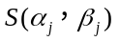查询表
Table A1 Query table of quantum update rotation direction
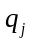 | 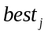 | 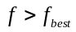
 |  |  | 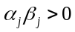 | 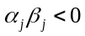 | 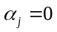 | 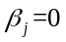
0 | 0 | FALSE | 0 | 0 | 0 | 0
0 | 0 | TRUE | 0 | 0 | 0 | 0
0 | 1 | FALSE | +1 | +1 | 0 | ±1
0 | 1 | TURE | -1 | -1 | ±1 | 0
1 | 0 | FALSE | -1 | +1 | ±1 | 0
1 | 0 | TURE | +1 | -1 | 0 | ±1
1 | 1 | FALSE | 0 | 0 | 0 | 0
1 | 1 | TURE | 0 | 0 | 0 | 0
注：，分别表示当前染色体与当前最优染色体在二进制表达形式下的第列。

附录B
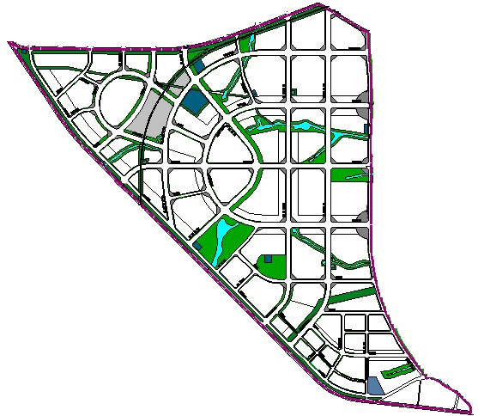
图B1 某规划区道路分布地理图
Fig. B1 Road map of a certain planning area

表B1 道路分布图中各路网节点信息表
Table B1 Information of network nodes in the road map
路网节点序号 |  | 节点横坐标(km) |  |  | 节点纵坐标(km) |  | 出租车数量 | 出租车需求数
1 |  |  | 0.00 | 13.50 |  | 15 |  | 30
2 |  |  | 2.55 | 13.50 |  | 20 |  | 30
3 |  |  | 5.55 | 13.7 |  | 20 |  | 30
4 |  |  | 7.50 | 14.00 |  | 28 |  | 30
5 |  |  | 10.50 | 14.50 |  | 20 |  | 40
6 |  |  | 12.00 | 15.00 |  | 18 |  | 30
7 |  |  | 13.20 | 13.50 |  | 19 |  |  | 30
8 |  |  | 12.00 | 13.50 |  | 26 |  |  | 40
9 |  |  | 10.50 | 13.50 |  | 23 |  |  | 30
10 |  |  | 7.70 | 12.50 |  | 35 |  |  | 30
11 |  |  | 6.50 | 11.00 |  | 30 |  |  | 30
12 |  |  | 4.70 | 12.00 |  | 30 |  |  | 40
13 |  |  | 3.20 | 12.00 |  | 29 |  |  | 45
14 |  |  | 2.00 | 12.50 |  | 31 |  |  | 50
15 |  |  | 1.50 | 11.20 |  | 21 |  |  | 40
16 |  |  | 2.50 | 9.50 |  | 22 |  |  | 50
17 |  |  | 4.00 | 10.20 |  | 20 |  |  | 40
18 |  |  | 5.70 | 10.00 |  | 29 |  |  | 40
19 |  |  | 7.25 | 9.75 |  | 26 |  |  | 40
20 |  |  | 8.00 | 10.75 |  | 36 |  |  | 45
21 |  |  | 9.00 | 11.25 |  | 35 |  |  | 46
22 |  |  | 10.50 | 11.25 |  | 28 |  |  | 30
23 |  |  | 12.00 | 11.25 |  | 26 |  |  | 45
24 |  |  | 13.20 | 11.25 |  | 20 |  |  | 30
25 |  |  | 13.20 | 9.00 |  | 10 |  |  | 30
26 |  |  | 12.00 | 9.00 |  | 20 |  |  | 40
27 |  |  | 10.50 | 9.00 |  | 14 |  |  | 30
28 |  |  | 9.30 | 9.00 |  | 12 |  |  | 40
29 |  |  | 7.50 | 9.00 |  | 20 |  |  | 30
30 |  |  | 5.50 | 9.00 |  | 30 |  |  | 30
31 |  |  | 4.10 | 8.50 |  | 18 |  |  | 40
32 |  |  | 5.40 | 6.50 |  | 34 |  |  | 30
33 |  |  | 6.50 | 6.00 |  | 41 |  |  | 40
34 |  |  | 8.10 | 7.250 |  | 30 |  |  | 30
35 |  |  | 9.10 | 6.70 |  | 34 |  |  | 50
36 |  |  | 10.50 | 6.70 |  | 31 |  |  | 40
37 |  |  | 12.00 | 6.70 |  | 30 |  |  | 30
38 |  |  | 13.20 | 6.70 |  | 34 |  |  | 40
39 |  |  | 13.20 | 4.80 |  | 38 |  |  | 30
40 |  |  | 12.00 | 4.80 |  | 26 |  |  | 30
41 | 10.40 |  |  | 4.80 |  | 21 |  |  | 30
42 | 8.50 |  |  | 5.70 |  | 31 |  |  | 40
43 | 7.70 |  |  | 5.00 |  | 30 |  |  | 50
44 | 9.50 |  |  | 3.00 |  | 24 |  |  | 40
45 | 10.50 |  |  | 2.00 |  | 26 |  |  | 30
46 | 10.50 |  |  | 3.00 |  | 21 |  |  | 40
47 | 12.75 |  |  | 2.00 |  | 26 |  |  | 30
48 | 13.75 |  |  | 0.50 |  | 20 |  |  | 30
49 | 14.90 |  |  | 0 |  | 20 |  |  | 30

附录C 配电网结构及参数
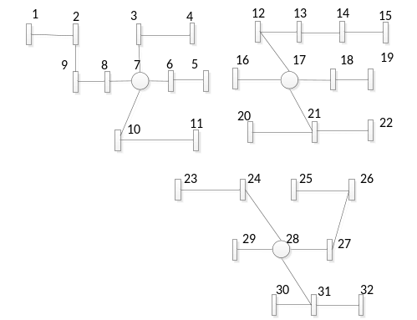
图C1 规划区域内配电网结构图
Fig. C1 Distribution network structure in planning area

表C1 配电网各节点坐标及负荷

Table C1 Node coordinates and load of each distribution network node

电网节点序号 | 节点横坐标(km) | 节点纵坐标(km) |  | 负荷（MW）
1 | 1.00 | 12.50 | 0.75
2 | 2.55 | 12.50 | 0.90
3 | 4.55 | 12.73 | 1.15
4 | 6.50 | 12.00 | 1.05
5 | 7.50 | 10.00 | 1.10
6 | 6.00 | 10.00 | 1.20
7 | 5.00 | 10.00 | 0.00
8 | 3.20 | 10.00 | 1.35
9 | 2.52 | 10.00 | 0.85
10 | 4.70 | 8.50 | 1.15
11 | 6.50 | 8.50 | 0.65
12 | 9.00 | 12.50 | 1.40
13 | 10.20 | 12.50 | 0.70
14 | 12.00 | 12.50 | 1.25
15 | 13.50 | 12.20 | 1.15
16 | 8.50 | 10.50 | 2.40
17 | 9.50 | 10.20 | 1.15
18 | 11.70 | 10.00 | 1.35
19 | 12.95 | 9.75 | 1.60
20 | 9.00 | 9.00 | 2.20
21 | 10.50 | 9.25 | 1.50
22 | 12.95 | 9.25 | 0.60
23 | 6.00 | 6.25 | 1.50
24 | 8.20 | 6.25 | 0.40
25 | 10.20 | 6.00 | 0.50
26 | 12.00 | 6.00 | 0.85
27 | 10.50 | 4.00 | 0.95
28 | 9.30 | 4.00 | 0.00
29 | 7.50 | 4.00 | 1.35
30 | 8.70 | 2.00 | 0.65
31 | 10.10 | 2.00 | 2.10
32 | 12.40 | 2.00 | 2.20

附录D
表D1 算例参数值设定表
Table D1 Parameter values used in planning model

参数 |  | 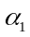 | 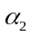 | 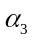 |  | 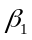 | 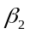 |  | /元 | w
取值 | 1 | 1 | 0.5 | 0.5 | 1 | 1 | 0.5 | 0.9 | 20000 | 0.01
参数 | /元 |  | /年 | /元 | 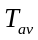/时 | 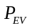 | 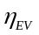 | 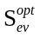 | 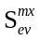
取值 | 100000 | 0.1 | 30 | 1 | 5 | 100 | 0.9 | 0.5 | 0.3 | 0.04
参数 | 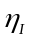 | 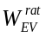/kWh | 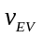/（km/h） |  | 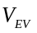/V | 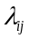 | /元 | 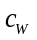/元 |  | /min
取值 | 1.27 | 60 | 30 | 0.1 | 384 | 1.32 | 1.6 | 20 | 0.02 | 10

附录E
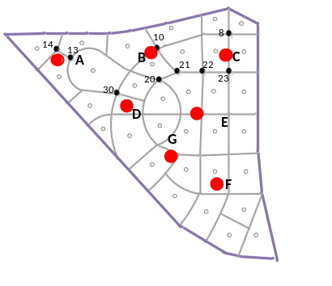
图E1 充电站数量为7时站址分布
Fig. E1 Results of charging stations location when building 7 stations

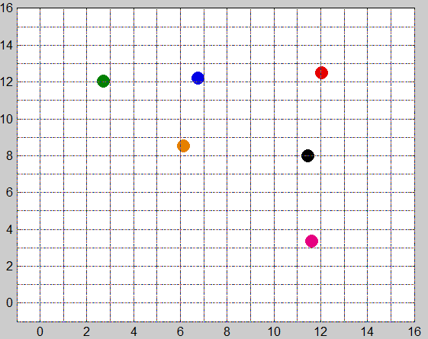
图E2 充电站数为6时MATLAB原始图
Fig. E2 Original MATLAB graph when building 6 stations

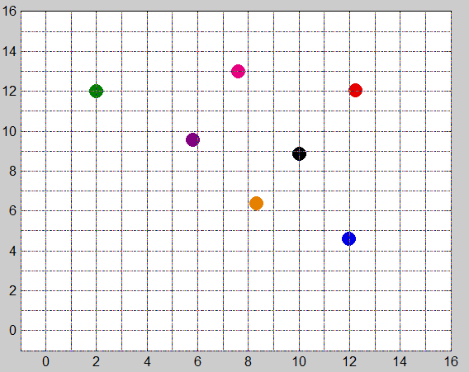
图E3 充电站数为7时MATLAB原始图
Fig. E3 Original MATLAB graph when building 7 stations

