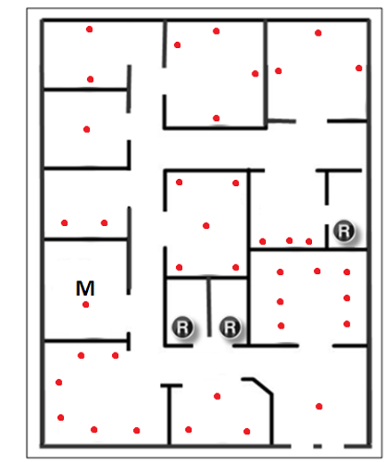
Database

Switch
Printer
PC
Router
GVT
Database
Modem
PC
PC
PC
PC
PC
PC
Smartphone

Smartphone

Created by Unlicensed Version
Created by Unlicensed Version
Created by Unlicensed Version
Created by Unlicensed Version
Created by Unlicensed Version
Created by Unlicensed Version
Created by Unlicensed Version
Created by Unlicensed Version
Created by Unlicensed Version

