A - Plug |  |  |  |  | B - Plug
 | Name | Function | Color |  |  | Name | Function | Color
1 | DPO 2 | Fan relay control | grn |  | 1 | REF | CAS 1 | Wht/blu
2 | AVI 4 | PPS 1 | Grn/wht |  | 2 | SYNC | CAS 2 | wht
3 | IGN 1 | 1 Leading | Brwn |  | 3 | AVI 7 | Air Temp | Red/yel
4 | IGN 2 | 2 Leading | Blu |  | 4 | AVI 8 | Coolant Temp | Red/wht
5 | IGN 3 | 3 Leading | grn |  | 5 | REF- | CAS 1 | Wht/orng
6 | IGN 4 | 1 Trailing | red |  | 6 | SYNC- | CAS 2 | Wht/grn
7 | IGN 5 | 2 Trailing | yel |  | 7 | SPI 4 | Clutch SW | Blu/yel
8 | IGN 6 | 3 Trailing | orng |  | 8 | SPI 1 | Flex | Brn/wht
9 | 5v+ | Aux sen 5v | Yel/blu |  | 9 | SPI 2
10 | GND | BAT/CHASSIS | Blk |  | 10 | SPI 3 | VSS | Blu/wht
11 | GND | BAT/CHASSIS | blk |  | 11 | 12v | Ecu/Inj Power | Yel/blk
12 | 8v |  |  |  | 12 | AVI 6 | Oil Pressure | Yel/red
13 | 12v ign | Not used |  |  | 13 | AVI 1 | Oil Temp | Yel/Red
14 | AVI 10 | OMP Position | Grn/Yel |  | 14 | SG | Sensor Ground | Grn/yel
15 | AVI 9 | Fuel Pressure | Grn/Blu |  | 15 | SG | TB Ground | Big Blu
16 | AVI 2 | TPS 1 | Tan/wht |  | 16 | SG | Pedal Ground | Brn/wht
17 | AVI 3 | TPS 2 | Blu/wht |  | 17 | IGN 7 | IAC | Blk/red
18 | DPO1 | Tacho | Blu |  | 18 | IGN 8
19 | INJ 1 | INJ 1 (pri F) | Brwn |  | 19 | DPO 4
20 | INJ 2 | INJ 2 (pri R) | Red |  | 20 | AVI 5 | PPS 2 | Orng/wht
21 | INJ 3 | INJ 3 (sec F) | Blu |  | 21 | KNOCK 1 | KNOCK | wht
22 | INJ 4 | INJ 4 (sec R) | Yel |  | 22 | KNOCK 2
23 | DPO 3 | Boost Solenoid | Orng/blk |  | 23 | CAN HI | CAN to aim | Wht/blu
24 | DPO 5 | Fuel Pump Cont. | Grn/blu |  | 24 | CAN LO | CAN to aim | Wht
25 | DPO 6 | Not used |  |  | 25 | DBW 1 | Motor 1 | Purple
26 | 12v | Ecu/Inj Power | Yel/blk |  | 26 | DBW 2 | Motor 2 | Org/Blk
27 | INJ 5 | INJ 5 (3 pri) | Grn
28 | INJ 6 | INJ 6 (3 sec) | Orng
29 | INJ 7 | FP PWM | purple
30 | INJ 8
31 | Stepper 1 | OMP B1 | Grn/blk
32 | Stepper 2 | OMP B2 | Blk/red
33 | Stepper 3 | OMP A1 | Blk/yel
34 | Stepper 4 | OMP A2 | Blu/blk
Haltec h 2500 Elite 20b

Throttle Body
Pin | Function | Haltech Pin | Name | Wire
A | Motor 2 | B26 | DBW 2 | Orng/Blk
B | Motor 1 | B25 | DBW 1 | Purple
C | TB Grnd | B15 | Sig Grnd | Big Blu
D | TPS 1 | A16 | AVI 2 | Tan/Wht
E | +5v | A9 | 5v | Yel/blu|Pink
F | TPS 2 | A17 | AVI 3 | Blu/wht
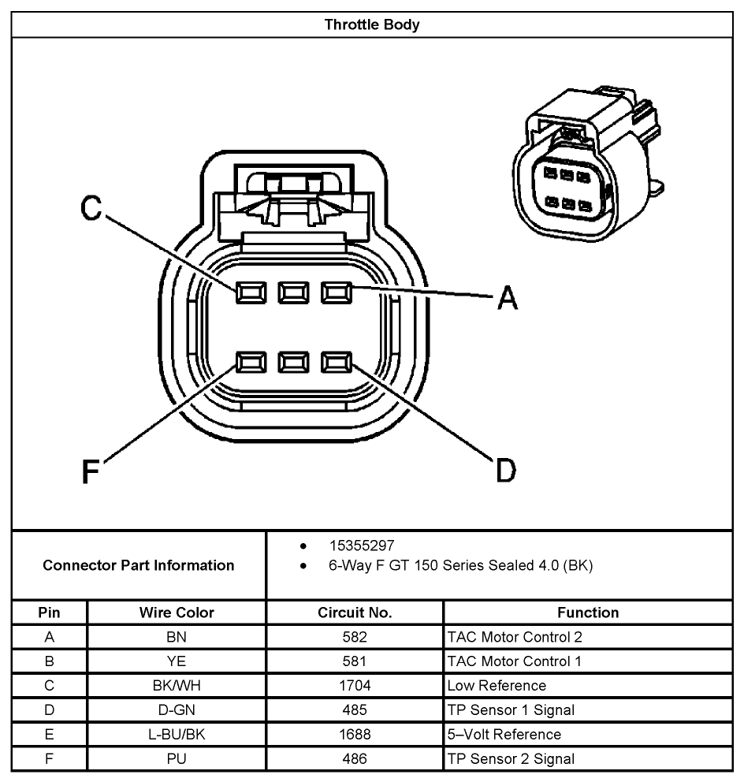

Accelerator Pedal
Pin | Function | Haltech Pin | Name | Wire
A | Ground | B16 | Sig Grnd | Brn/Wht
B | PPS 2 | B20 | AVI 5 | Orng/Wht
C | +5v | A9 | +5v | Yel/blu|Pink
D | Ground | B16 | Sig Grnd | Brn/Wht
E | PPS1 | A2 | AVI 4 | Grn/wht
F | +5v | A9 | +5v | Yel/blu|Pink
