1. Run “GitHub Desktop.lnk”
2. Key Summary and Press “Commit to master “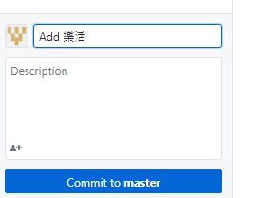
3. Press “Fetch Origin “ upload to web

