

DEPARTMENT OF

COMPUTER SCIENCE

*Te Tari Rorohiko*

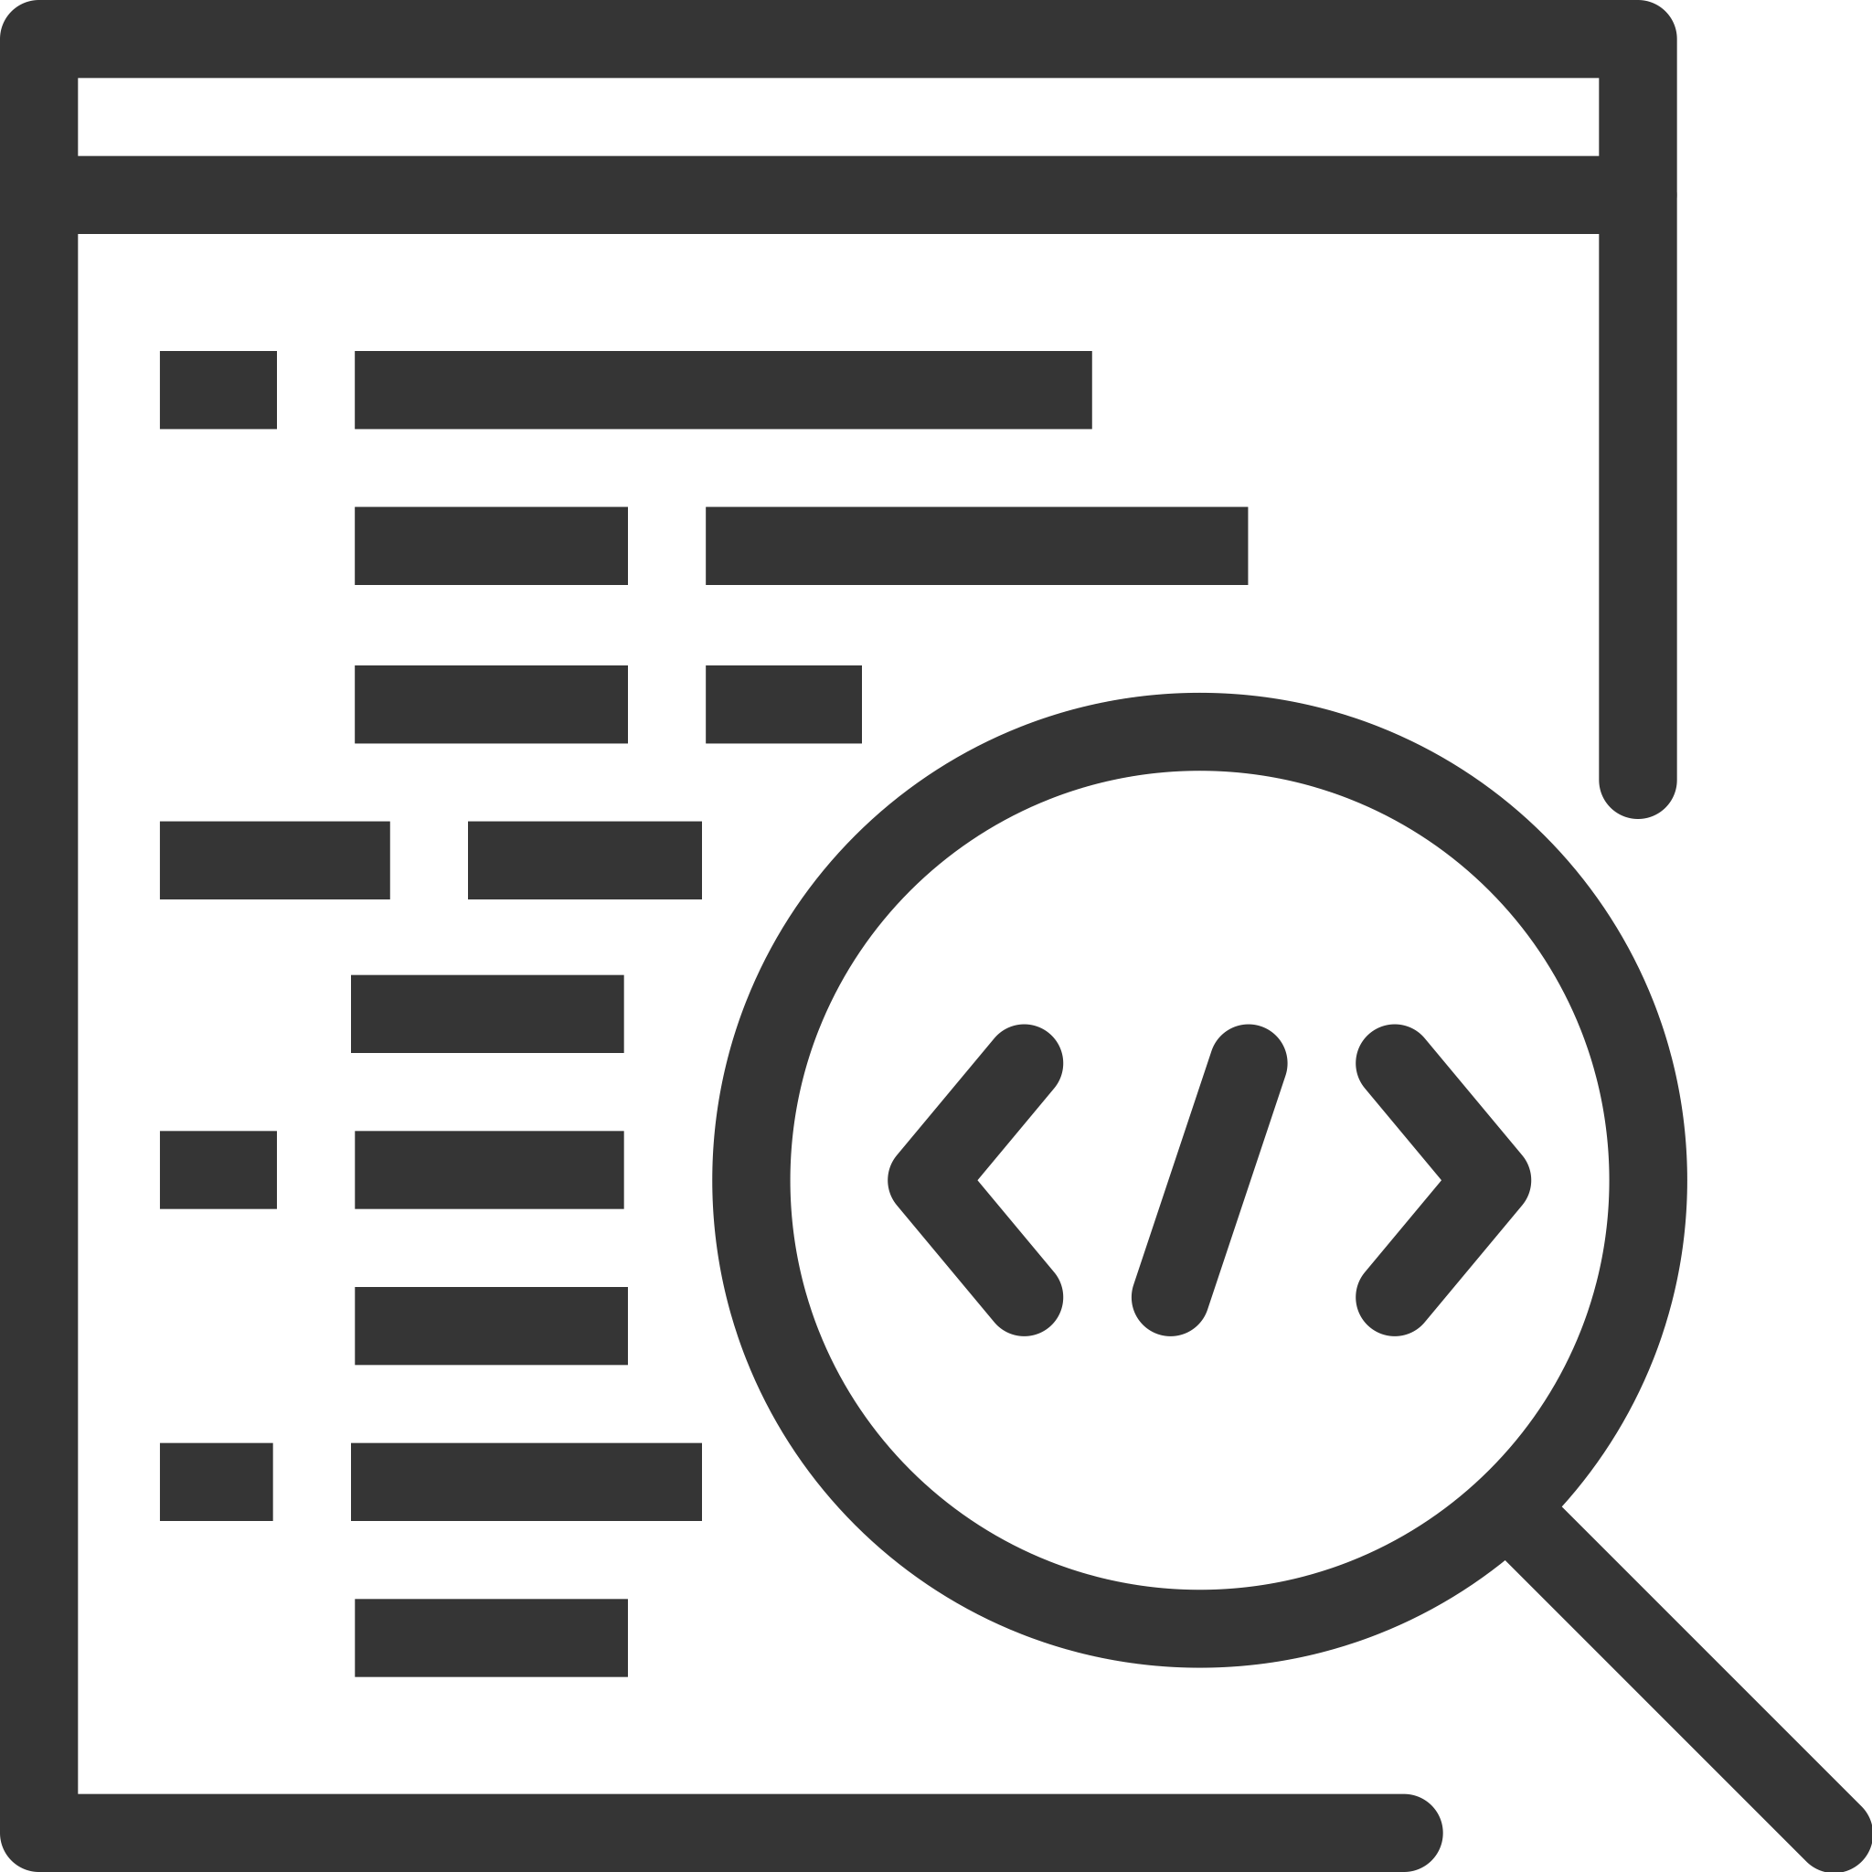

**2025**

Contributors

J. Turner

J. Kasmara

© 2024 University of Waikato. All rights reserved. No part of this book may be reproduced or distributed in any form or by any means, or stored in a database or retrieval system, without prior consent of the Department of Computer Science, University of Waikato.

The course material may be used only for the University’s educational purposes. It includes extracts of copyright works copied under copyright licences. You may not copy or distribute any part of this material to any other person, and may print from it only for your own use. You may not make a further copy for any other purpose. Failure to comply with the terms of this warning may expose you to legal action for copyright infringement and/or disciplinary action by the University.

**MEET BOT MARLEY** 4

Artificial Intelligence, AI 4

Societal Impact AI 5

Bot Marley the Robot Music 5

Set Up and Configuration 8

Making Bot Marley Move 9

Today’s Exercise 15

Summary 16

Useful Resources 17

# **MEET BOT MARLEY**

Welcome to the newest addition to the CSNeT programme, Artificial Intelligence Series. In today’s session, we introduce you to music with science.



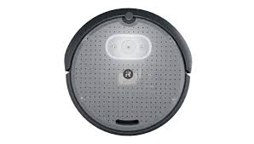

*Figure 1: Our Roomba robot vacuum, Bot Marley*

## Artificial Intelligence, AI

AI, which stands for artificial intelligence, is widely used and topical. However, it is often overhyped and used more for marketing lingo. The actual true definition of AI is defined and industry accepted by AI Forum NZ as follows:

*“advanced digital technologies that enable machines to reproduce or surpass abilities that would require intelligence if humans were to perform them. This includes technologies that enable machines to learn and adapt, to sense and interact, to reason and plan, to optimise procedures and parameters, to operate autonomously, to be creative and to extract knowledge from large amounts of data”*

Moreover, AI in robotics, has a working definition as an umbrella term for computers, software or other computer-controlled devices imitating intelligent human behaviour.

## Societal Impact AI

Who says AI in robotics can’t be entertaining? Just look at this rooster hitching a ride on a robot vacuum—proof that even our feathered friends are getting in on the tech revolution! But robots aren’t just about laughs or play; they’re changing lives in some incredible ways.

Socially therapeutic robots, for example, are making a real difference. They can boost well-being for the elderly, those with physical limitations, or really anyone willing to interact with them. These robots handle tasks such as housekeeping, help lower blood pressure, and even ease anxiety and loneliness. Nowadays, robots are everywhere—whether it’s your robot vacuum doubling as a chicken taxi, sleep apnea devices, or smart home gadgets like fridges with internal cameras so you can peek at your groceries while shopping. And let’s not forget self-driving cars, like Teslas, that are becoming a normal part of family life.

Behind all this innovation is artificial intelligence, where engineering, computer science, and creativity come together to make our lives easier, safer, and, honestly, way more fun.

## Bot Marley the Robot Music

For the first 3 sessions of CSNeT Artificial Intelligence Series, you will get the opportunity to program Bot Marley, our robot music (see Figure 1). However, before we begin the exercises, let’s take a closer look at the robot.

Create 3 Robot is made by the robotics company, iRobot, which sells hobby robots with the purpose of creating the possibility of changing or adapting the robot’s functions through experimentation with the basic elements of robotics, path planning and sense of music. Additionally, they make the iRobot Coding App called Root (see Figure 2). Both types of robots have open-source software which means the platform can be easily (and freely) developed by anyone.

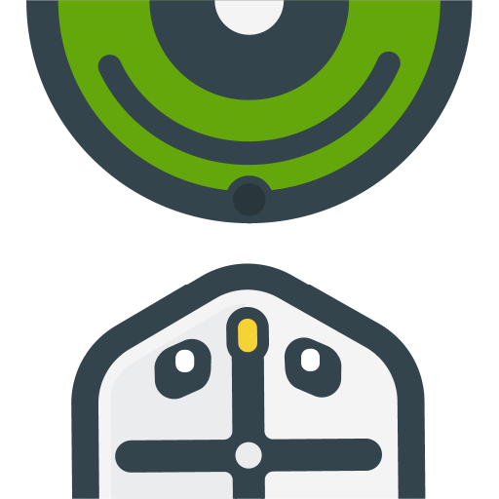

*Figure 2:* *iRobot Coding App, Root, https://code.irobot.com/#/*

The iRobot Bot Marley features a Roomba-style frame constructed from plastic (see Figure 3). There is a set of metallic charging contacts (see Figure 4) located on the underside at the top centre of the frame, which connect to the Home Base® Charging station to recharge its battery. A docking sensor helps the robot locate and align itself with its charging dock or home base. This sensor enables the robot to autonomously return to its dock when it needs to recharge (see docking_autonomous.py). These components enable the robot to move independently; without them, the robot would not be able to navigate on its own. This is similar to how infrared (IR) signals were used with the Petoi Norbert robot dog to facilitate autonomous movement.

In the iRobot Create 3, the docking sensor works by:

* Detecting IR signals emitted by the dock.
* Measuring the relative position and strength of the IR signal to help guide the robot toward the charging station.
* Assisting with precise alignment to ensure successful docking and recharging.

The other components of Bot Marley include the cable passthrough, seven IR obstacle sensors, programmable buttons (e.g., Button 1 in Figure 3, which is factory-programmed to set the robot in Standby mode), multi-zone bumper, cliff sensors, cargo bay, handle, optical odometry, wheels and caster. It runs **Python Web Playground v1.2.3**, a coding environment designed for running Python code within a browser-based interface. It serves as a web-based IDE (Integrated Development Environment) for experimenting with Python scripts, testing code blocks, and learning Python without requiring local installation. <https://edu.irobot.com/learning-library/create-3-web-playground-for-python>

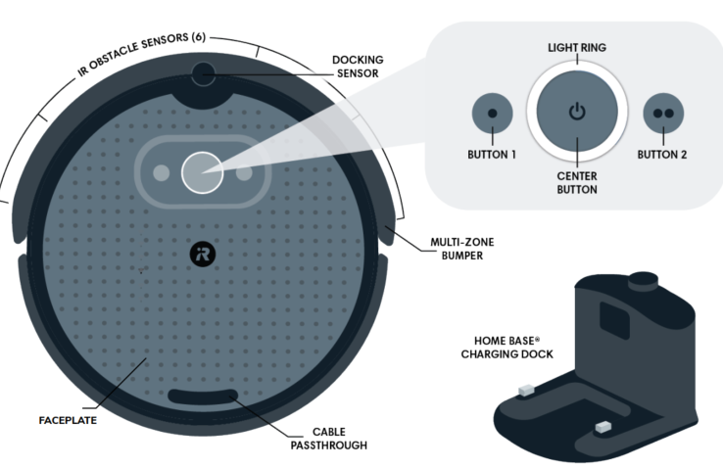

*Figure 3: Labelled Top-Diagram of Bot Marley*

iRobot includes two hardware components on the bottom part of Bot Marley: a caster wheel and two drive wheels (see Figure 4). These components help balance the robot's weight and provide stability for its movement. The caster wheel can freely rotate 360 degrees, enabling smooth turning and movement when the robot changes direction. The drive wheels are positioned on either side of the robot’s body, and this symmetrical placement is essential for achieving balanced and stable movement. On the other hand, the two independently controlled drive wheels move accurately along programmed paths. They are the most critical components responsible for propelling and manoeuvring the robot.

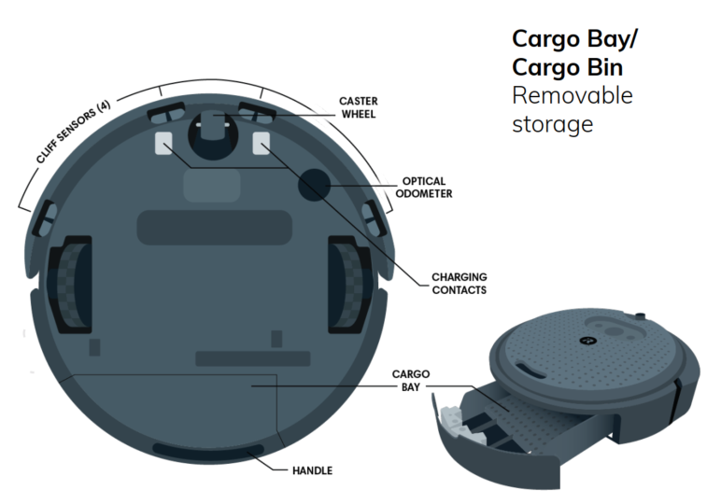

*Figure 4: Labelled Bottom-Diagram of Bot Marley*

Bot Marley is equipped with various sensors, including optical odometry, cliff sensors, IR obstacle sensors, and multi-zone bumper sensors, all connected to digital pins on the circuit board. These sensors allow the robot to detect obstacles, avoid falls, and track its movement with precision. In later sessions, you will be using some of these to make Bot Marley perform dance moves and sing off but in this session we cover the basic movements.

## Making Bot Marley Move

There are many preprogrammed actions provided by iRobot that are used straight out of the box. Using a computer, Bot Marley can be programmed with ~~iRobot Coding App (watch this space-COMING SOON; see Figure 7 and 8),~~ Python Web Playground, or ROS 2 to use the built-in actions or to create custom actions and sequences.

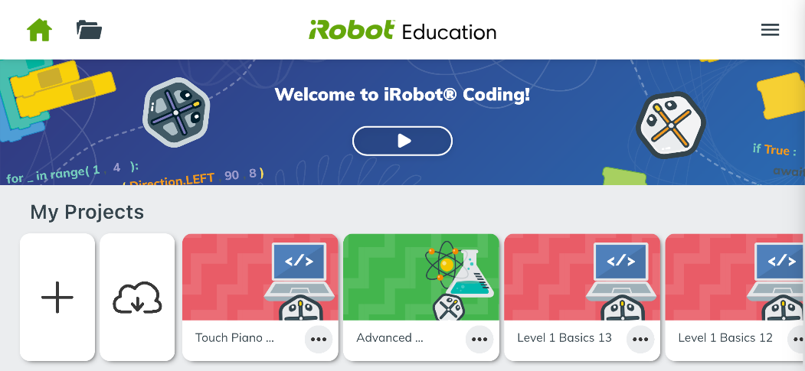

*Figure 7: iRobot Mobile App*

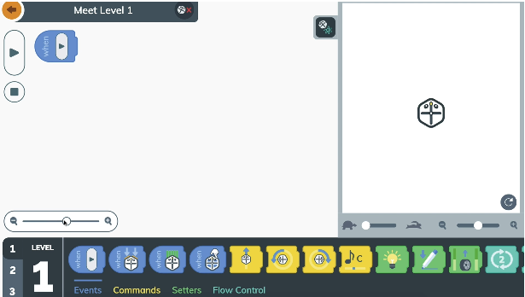

*Figure 8: iRobot Coding Blocks Interface*

To program Bot Marley, we are going to use Python via **Python Web Playground v1.2.3, https://python.irobot.com/**. Once opened, you should be presented with the screen shown in Figure 9.

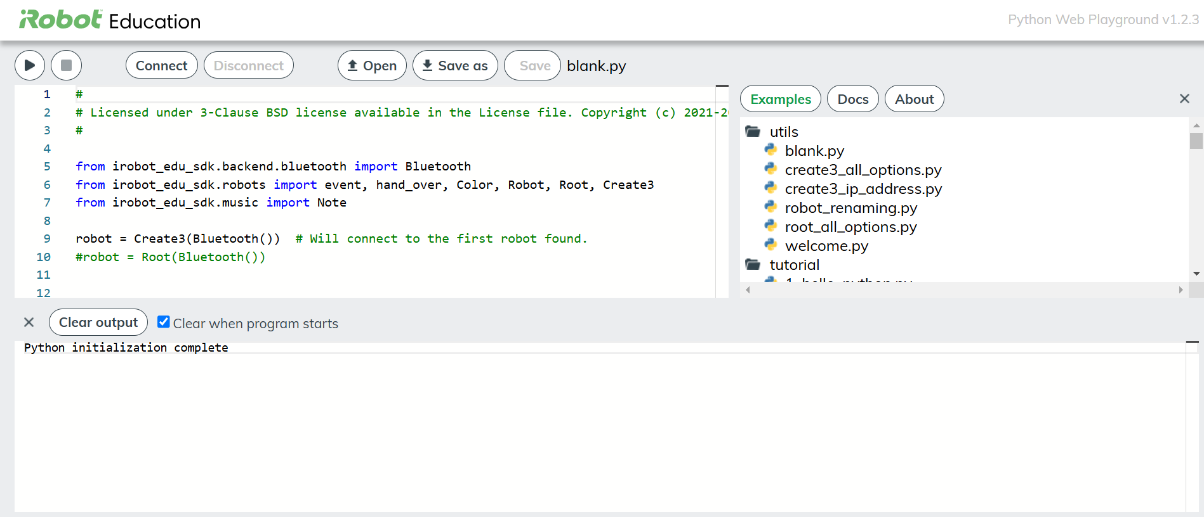

*Figure 9: Python Web Playground v1.2.3 Interface*

Create a new file called botmarley.py and save it your folder (see Figure 12). This is where we will write our code for today’s session. Feel free to ask staff for assistance if you get stuck.

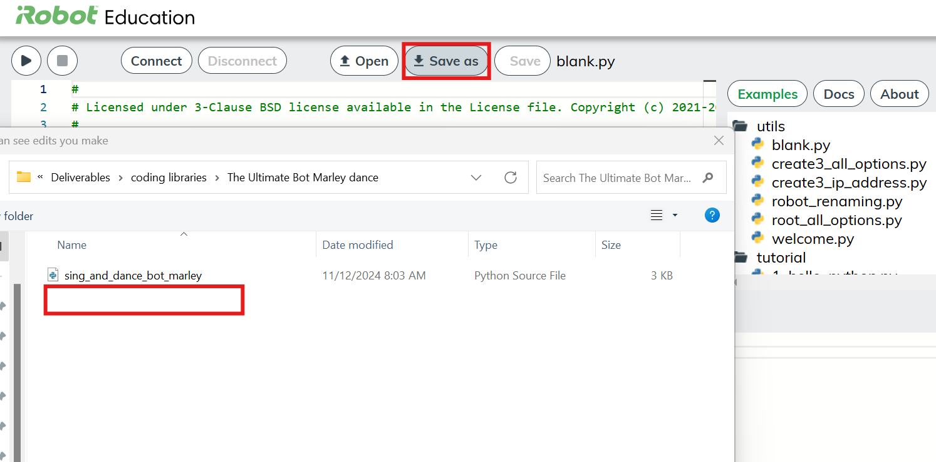

*Figure 12: Creating a Python File in Web Playground*

Now we can start writing code to make Bot Marley move and play around with more advanced moves.

Firstly, we must include this code:

**01** from irobot_edu_sdk.backend.bluetooth import Bluetooth

**02**

**03** from irobot_edu_sdk.robots import event, Robot, Create3

**04**

**05** robot = Create3(Bluetooth())

Line 1 and 3 tells the program to use the **irobot_edu_sdk** library; without it, none of the commands specific to the robot would be recognised (i.e., Bot Marley cannot be programmed without importing this library). Once the specific library is recognised, Line 1 requests the **Bluetooth** module to be imported from the **irobot_edu_sdk.backend.bluetooth** package. This allows the program to establish a Bluetooth connection with the robot.

Line 3 instructs the program to import the following items from the **irobot_edu_sdk.robots** module:

* **event:** used for event-driven programming to respond to specific actions.
* **Robot:** a general base class interacting with robots.
* **Create3:** a specific class for interacting with the **iRobot Create 3** robot.

Line 5 initialises an instance of the **Create 3** class and assigns it to the variable *robot*. The **Bluetooth()** call creates a Bluetooth connection object, which is passed as an argument to **Create 3** to enable communication between the Python program and the iRobot Create 3 robot.

In summary, what the three lines of code do:

* Imports the necessary modules to enable Bluetooth communication and control the **iRobot Create 3 robot**.
* Creates a connection to the robot using Bluetooth and stores this connection in the variable *robot*.
* This sets up the foundational connection to the robot, allowing you to send commands, receive feedback, and interact with it programmatically.

Secondly, we must know trigger an event:

**07** @event(robot.when_play)

**08** async def play(robot):

**09** print('play!')

**10**

**11** robot.play()

Line 7 and 8 tells the program to run commands (inserted in line 10) according to the event triggered, e.g., when play button is pressed. Line 8 uses **async** which is a shorthand for asynchronous functions. Asynchronous functions enable non-blocking execution, a programming model where a program can execute instructions independently, allowing multiple events or instructions to run without waiting for one to finish before moving on to the next. For example, in line 10, we can insert both blocks of command for **when_bumper(robot)** and **when_touched(robot)** to Bot Marley.

Line 9 prints the message **“play!”** to the console.

Line 11 manually triggers the **when_play** event for the robot. **When_play** event is triggered, the play() functions runs.

Line 10 is where you can write your code, such as commands to move forward, turn, or respond to sensors.

Let’s begin with instructing Bot Marley to walk forward for 16 centimetres (see the code in Figure 13).

*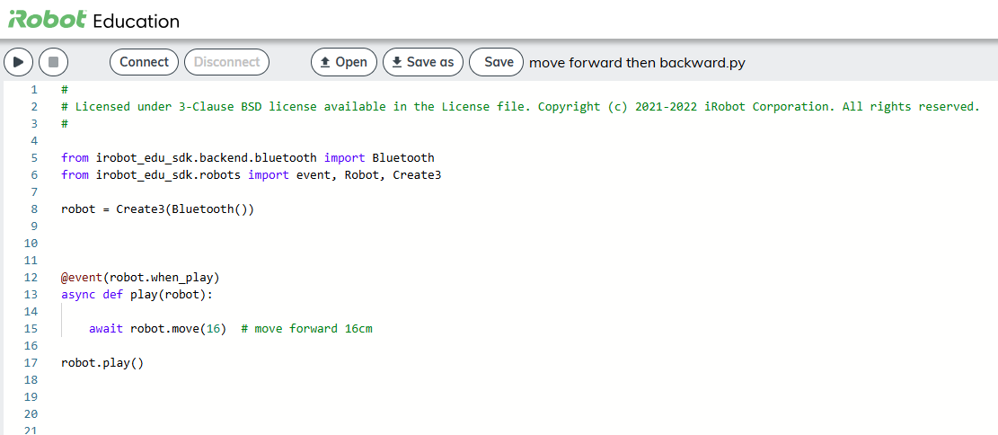 Figure 13: Python Code for Walking Forward For 16 Centimetres*

Click on the ‘Run’ button to run the program. If the program quits without Bot Marley moving, the reason might be due to an incorrect skill string (e.g. ‘robot.move(+)’ – walk forward) or Bluetooth lost connection. Feel free to ask staff for assistance if you get stuck.

What is the number passed to the await robot.wait(0.5) function for? What does it do?

The number is referred to as a delay by Bot Marley; however, it's more like a duration (i.e., how long the robot waits before moving on to the next line of code), measured in seconds. For example, a 0.5 second delay means the robot waits for 0.5 seconds before executing its next move.

Now that you know the command for walking forward, how do you get Bot Marley to walk to the left, right or backwards?

Hopefully walking left and right was easy (i.e. robot.turn_left(90), robot.turn right(90))but walking backwards may not have been as easy because it requires a different plane of command of robot.move(-16).

Now that you know some of the basic movements, try out each of these actions referring to **Command Reference** and see what they do:

* await robot.move(32)
* await robot.move(-32)
* await robot.turn_left(180)
* await robot.turn right(180)
* await robot.turn left (45)
* await robot.turn right(45)
* await robot.move(48)
* await robot.move(-48)
* await robot.navigate_to(16,16)
* async def when_play(robot):
* async def when_bumper(robot):
* await robot.set_lights_rgb(0, 0, 255)
* await robot.set_lights_rgb(255, 0, 0)
* await robot.set_lights_rgb(0, 255, 0)
* await robot.set_wheel_speeds(10, -10)
* await robot.wait(0.2)
* await robot.arc(Robot.DIR_LEFT, 90, 4)
* await robot.arc(Robot.DIR_RIGHT, 90, 4)

## Bot Marley Persona

Andrei, a 15-year-old high school student attending Tauranga Boys’ College, spends long hours sitting at his desk, waiting for a call from his grandma in the UK. The time difference and uncertainty of when she’ll call create a lonely and boring atmosphere for him. To fill the void, Andrei interacts with his companion bot, Marley, who provides both entertainment and instant gratification.

One evening, Andrei asked Marley to sing him an early “Happy Birthday” song before midnight. Feeling energised and ready to have some fun, he invited Marley to perform “Three Little Birds” with some style, dancing the night away.

That night, Andrei learned something intriguing about artificial intelligence—the autonomy behind his robot. He began to question how AI memory might shape Marley’s “brain.” Noting how Marley remembered his birthday as December 13th, Andrei realised Marley would likely offer to sing “Happy Birthday” again next year.



*Figure 14: Andrei sitting at his desk, waiting for a call from grandma*

## Performance Night Exercise

We think Andrei has an amazing companion bot, Marley, but we believe Marley could benefit from some performance enhancements – this is where you come in! For the first 3 sessions, you will be Marley’s programmer, where you will prepare Marley in sessions 1 and 2 for a Big Performance Night happening in session 3. During this event, Marley must demonstrate great creativity, adaptability, and wit to impress Andrei and his family.

In Session 3, you have been tasked with enhancing Marley’s ability to personalise interactions and perform songs with style to keep Andrei entertained. Your task is to create a program that:

1. Allows Marley to sing a custom song (like “Three Little Birds”) upon request.
2. Learns Andrei's birthday (December 13th) and remembers it for the future to deliver a “Happy Birthday” surprise.
3. Adds an option for Marley to “dance” or display a celebratory animation to make performances fun and engaging.

Remember to save your code in a safe place as you will need it for the Big Performance Night in session 3. Stay tuned for Session 2, where we will learn about AI memory to make Marley’s interactions feel dynamic and responsive!

**Routine:**

Bot Marley would like to impress Andrei with few more dance moves.

Here is the routine broken down into exercises:

**Today’s Exercises:**

1. Begin with getting Bot Marley to move forward 30cm, move backward 30cm and then move forward 30cm one more time.
2. Select the 3 tricks Bot Marley will perform (they must be unique to showcase shake about motion).
3. Make Bot Marley turn around full circle.
4. Once Bot Marley complete a full circle, finish off with final dance move any of your choice.

**Advanced Exercises:**

See if you can replace your code with the loops for code efficiency. For example:

thistuple = ("robot.move(16)", " await robot.turn_left(45)", " await robot.turn_right(45)")

for x in thistuple:

print(x)

Once you think you are ready, ask a staff member to watch his performance!

## Summary

In this session, we introduced you to our robot music, Bot Marley, and instructed him to perform basic movements such as forward, backward and rotational movements. We used the Bluetooth connection to communicate with Bot Marley and the Python programming language to instruct what actions he was to perform. In the simulated environments, we introduced Root, a web-based IDE (Integrated Development Environment) for experimenting with Python scripts via Block programming which range from Level 1 to 3 catering users new to Python programming to intermediary level programming. Next week, we will move onto designing dance choreography alongside note frequencies to see how Bot Marley creates societal impact touching on one of the benefits of artificial intelligence.

## Useful Resources

* What is artificial intelligence? (K12 – 8): <https://youtu.be/G6de8L7cVvM?si=QLDaLNkHCo85-ET7>
* Artificial intelligence: A Brief History: <https://youtu.be/yaL5ZMvRRqE>
* The Complete History and Future of Artificial Intelligence or Ethics: <https://www.techtarget.com/searchenterpriseai/tip/The-history-of-artificial-intelligence-Complete-AI-timeline?utm_source=chatgpt.com>, <https://verloop.io/blog/the-timeline-of-artificial-intelligence-from-the-1940s/?utm_source=chatgpt.com>, <https://en.wikipedia.org/wiki/Timeline_of_artificial_intelligence?utm_source=chatgpt.com#2020s>
* W3 Schools Python tutorials: <https://www.w3schools.com/python/default.asp>
* Artificial Intelligence ethics: <https://newzealandcurriculum.tahurangi.education.govt.nz/introduction-to-artificial-intelligence/5637235331.p>
* Python Web Playground v1.2.3: <https://python.irobot.com/>
* Create 3 Getting Started <https://edu.irobot.com/learning-library/create-3-getting-started>