Brainstorming

Feel free to add whatever information you want, this is just an area for creating and collecting ideas. We’ll evaluate them at a later

## Visualization

* Scatterplot matrix:

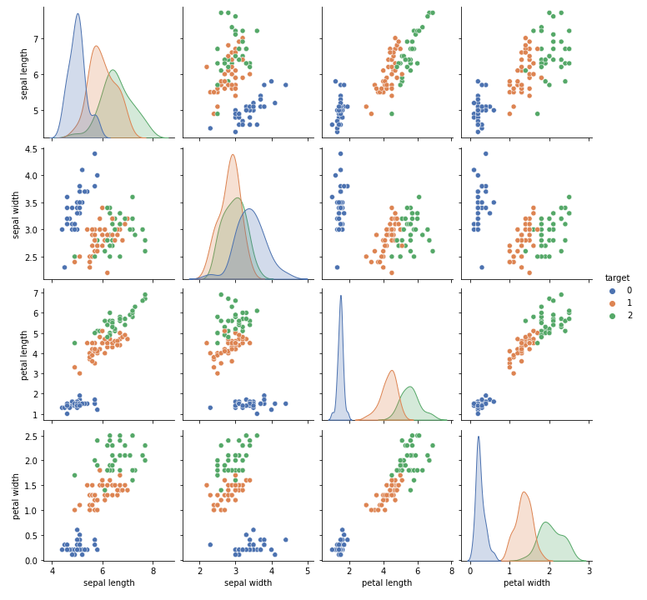

## Features

* Add slider in dependence of the year
* Add dropdown menu to select a specific country

## Things to keep in mind

* Some attributes might correlate heavily, but this is only visible if we adjust the data for time.

For example: GDP rises if more girls are educated. But this only happens if we wait until those new students enter the work force. So keeping that in mind, we could make some interesting observations.

## Descriptive Statistics for individual attribute

* Mean, Median
* Variance

## Correlations between attributes

* Pearson correlation coefficient