Investing in Health Systems: Insights into How Health Financing Shape Workforce Density and UHC Outcomes
Background
Evidence from the World Health Organization (WHO) demonstrates that a minimum density of 44.5 doctors, nurses, and midwives per 10,000 population is essential to deliver essential health services and sustain progress toward Universal Health Coverage (UHC) (World Health Organization, 2025). Countries that reach or surpass this threshold consistently record service coverage indices above 70%, reflecting improved access, quality, and equity in care (Ahmat, Asamani, & Illou, 2022).
Results
Minimum Average Skill Mix to achieve 70% UHC per 10000 population
To determine the minimum average proportion of health workers (doctors, nurses, midwives, dentists, and pharmacists) per 10,000 population required to meet the 70% UHC, a descriptive analysis of data from 47 WHO African regional countries spanning from 2000 to 2024 was conducted. It was discovered that on average, we need 11.09 doctors, 2.19 dentists, 28.53 nurses or midwives, and 2.81 pharmacists per 10,000 population to achieve 70% universal health coverage.
Relationship between UHC and Cadre Specific HWF Densities
A further descriptive analysis of the relationship between UHC and specific cadres' health workforce densities was performed to determine whether there is a relationship between universal health coverage and specific cadre health workforce densities. We found that health workforce densities are positively correlated with UHC levels, such that universal health coverage rates non-linearly increase with an increase in health workforce densities, regardless of cadre.
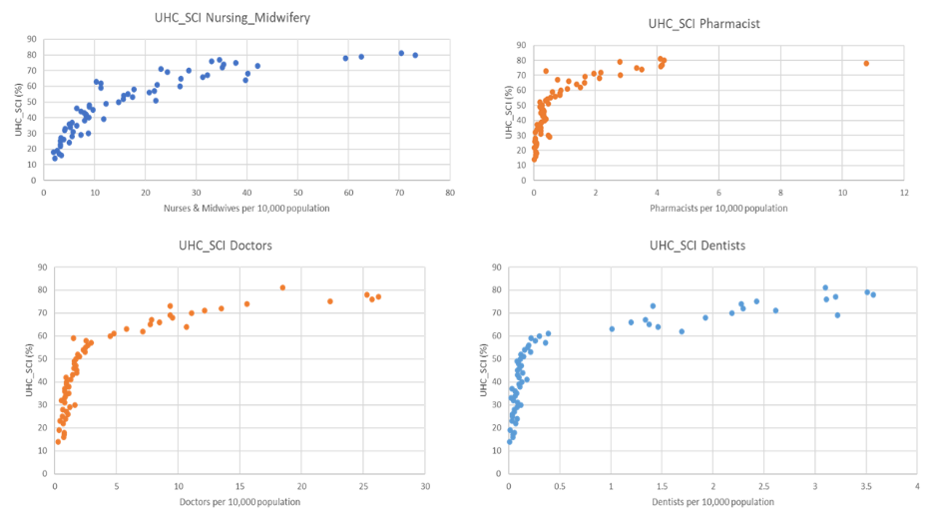
Effect of Government Health Financing on Health Workforce Densities
A panel data analysis was performed to assess whether health financing has a significant effect on health workforce density, with fixed- and random-effects models fitted to the data. The Hausman test results ($χ^{2}=16.859, pvalue<0.001$) confirmed that the fixed effect model is preferred over the inconsistent random effects model. The fitted fixed effect model was given by:
${HWF}_{it}=α_{i}+{β*GGHED}_{it}+e_{it}$ (1)
The Domestic General Government Health Expenditure (GGHED) per capita (in current USD) was found to be positively correlated with health workforce (HWF) density, such that each unit increase in the government health expenditure per capita (in current USD) corresponds to a 0.07 unit increase in HWF density per 10,000 population within countries over time. The fitted model's overall R-squared was found to be 0.10595, implying that only 11% of the variation in workforce density is explained by the government expenditure per capita. This implies that although increasing government health-related spending per person consistently boosts workforce density, financing alone is insufficient. Hence, there is also a need to explore other factors such as training capacity, retention, migration e.t.c that may influence health workforce density.
Sensitivity of Workforce Density to Government-Specific Health Financing Changes
Elasticity measures were performed to check how sensitive workforce density is to government-specific health financing changes, where a fixed effects panel regression model with log-transformed variables, given by :
$log⁡({HWF)}_{it}=α_{i}+{β*log⁡(GGHED)}_{it}+e_{it}$ (2)
Results show that a 1% increase in government health expenditure (GGHED) per capita is significantly associated with a 0.40% increase (elasticity) in workforce density within countries over time. Since the elasticity value was less than 1%, it confirms that workforce density responds to financing but not proportionally (inelastic), hence doubling the amount the government spends per person wouldn’t necessarily double the workforce density. Due to the non-linear relationship between the health workforce density and health financing, a threshold regression model with segmented relationships, expressed in equation (3), was also fitted to the data to ascertain whether there is any significant threshold ($ε)$ after some level of financing, which may result in a significant rise in workforce density.
${HWF}_{it}=\left\{\begin{aligned}∝+β_{1}{GGHED}_{it} if {GGHED}_{it}<ε \\ ∝+β_{2}{GGHED}_{it} if {GGHED}_{it}≥ε \end{aligned}\right.$ (3)
The result of the model found the threshold level where the slope of the relationship between government health expenditure and health workforce density changes to be $\$74.31$per person, implying that the relationship between GGHED and HWF is different before and after this level. It was discovered that before the breakpoint of $74.31 per capita, each additional dollar of GGHED per capita is associated with an increase of about 0.40 health workers per 10,000 population. However, this term adjusts after the breakpoint such that a unit increase in GGHED per capita leads to an increase of about 0.06 health workers per 10,000 population.
Lagged Effect of Government-Specific Health Financing on Workforce Density
A lagged fixed-effect model was fitted to the data to help us capture any delayed effects government health expenditure may have on health workforce density. The results show that government spending has a small (0.0412), almost significant (pvalue=0.0709) impact on health workforce density within one year. However, the strongest positive effect (0.1114) appears after 4 years, suggesting that health financing translates into workforce growth through other constraints such as training, retention, and so on. Implying that government health expenditure per capita influences health workforce density both in the short term (maybe through hiring) and medium term (maybe through training and deployment). In addition to this, an R-squared value of 0.342 was recorded, implying that 34% of the variation in workforce density within countries is explained by lagged government spending.

Application of Modern Portfolio Theory in HRH
The Core Idea is to treat HRH workforce like a portfolio to optimize the skillset in the cadres.
The equivalent of Human Resources for Health
- Asset- Health Worker Cadres
- Returns- Health Outcomes- DALYs
- Risk- Attrition, Shortages
- Portfolio- Workforce Composition
- Diversification- Skill-mix distribution across cadres
- Efficient frontier- Optimal workforce mix under budget constraints
Case Study is Rwanda
The optimal weights are given by:
Nurses Midwives Dentists Pharmacists Doctors
0.6234 0.1577 0.0200 0.0362 0.1627
Rwanda health spending is highly aid sensitive.
The model is implicitly telling Rwanda:
Under constrained HRH spending (100 bn RWF), the DALY-efficient workforce mix is heavily nurse-led with strong midwife/doctor complement.
Cadre | Cost | DALY productivity | DALY/$
Nurses | low | Moderate-high | high
Midwives | Low-mid | very high maternal | very high
Doctors | high | high | moderate
Dentists | mid | low pop DALY | low
Pharmacists | low | moderate | moderate
Rwanda is fiscally constrained, aid-sensitive, wage-dominated, nurse-centric optimal

Coverage and Gap analysis

Requirements Model: Defining the Needed Workforce
The workforce requirement was estimated using two complementary approaches:
- a Benchmark (normative density) model, and
- a Need-linked (burden-adjusted) model.
Let $t$ index year, $c$ index cadre, and $P_{t}$ denote the total population in year $t$.

1. Benchmark requirement model
For each cadre $c$, a target workforce density per 10,000 population, $B_{c}$, is specified.
The required headcount for cadre $c$ in year $t$ is:
$$R_{c,t}^{\text{bench}}=\frac{B_{c}}{10,000},P_{t}$$
where:
- $R_{c,t}^{\text{bench}}$ = required stock under benchmark model
- $B_{c}$ = benchmark density (per 10,000 population)
- $P_{t}$ = population in year $t$
This model assumes workforce need grows proportionally with population.

2. Need-linked requirement model
The need-linked model adjusts total required workforce density based on disease burden and health system performance indicators. This model assumes the total required HRH density varies with an index of health need (burden and outcomes), and is then allocated across cadres using fixed shares. The model is undertaken in steps as follows;

Step 1: Standardization of need indicators
Let:
- $D_{t}$ = DALYs
- $M_{t}$ = Maternal Mortality Ratio (MMR)
- $N_{t}$ = NCD Mortality Rate
- $U_{t}$ = UHC Service Coverage Index
Each indicator is standardized using a z-score:
$$z\left(X_{t}\right)=\frac{X_{t}-μ_{X}}{σ_{X}}$$
A composite need index is constructed as:
$$NI_{t}=w_{D}z\left(D_{t}\right)+w_{M}z\left(M_{t}\right)+w_{N}z\left(N_{t}\right)+w_{U}z\left(U_{t}\right)$$
where $w_{U}<0$ since higher UHC coverage reduces need.

Step 2: Total required density
Let $B_{\text{base}}$ denote the base total HRH density (per 10,000 population), and $λ$ the sensitivity parameter.
$$B_{t}^{\text{need}}=max\left(0,B_{\text{base}}+λNI_{t}\right)$$

Step 3: Convert density to total required stock
$$R_{\text{total},t}^{\text{need}}=\frac{B_{t}^{\text{need}}}{10,000},P_{t}$$

Step 4: Allocation across cadres
Let $s_{c}$ denote the share allocated to cadre $c$, such that:
c​sc=1
The cadre-specific need-linked requirement becomes:
$$R_{c,t}^{\text{need}}=s_{c},R_{\text{total},t}^{*\text{need}}$$

3. Coverage and gap metrics
For each cadre and year, supply $S_{c,t}$ is compared to requirement $R_{c,t}^{k}$, where $k∈\{\text{bench},\text{need}\}$.
Coverage ratio:
$${\text{Coverage}}_{c,t}^{k}=\frac{S_{c,t}}{R_{c,t}^{k}}$$
Workforce gap:
$${\text{Gap}}_{c,t}^{k}=S_{c,t}-R_{c,t}^{k}$$
A coverage ratio above 1 indicates surplus relative to requirement, while values below 1 indicate shortages.

Key model quantities
The projected workforce supply for cadre $c$ in year $t$ is given by the equation:
$$S_{c,t}=S_{c,t-1}\left(1+g_{c}\right)$$
where $g_{c}$ is the estimated growth rate for cadre $c$.

While the required workforce for cadre $c$ in year $t$, under requirement type $k$ is given as:
$$R_{c,t}^{k}$$
where:
- For the Benchmark model,
$$R_{c,t}^{\text{bench}}=\frac{B_{c}}{10,000},P_{t}$$
- For the Need-linked model,
$$R_{c,t}^{\text{need}}=s_{c}⋅\left(\frac{B_{\text{base}}+λNI_{t}}{10,000},P_{t}\right)$$
Here,
- $P_{t}$ = population in year $t$
- $B_{c}$ = benchmark density per 10,000
- $B_{\text{base}}$ = base total HRH density
- $λ$ = sensitivity to health need
- $NI_{t}$ = composite need index
- $s_{c}$ = cadre share (with c​sc=1)
This model is a national Human Resources for Health (HRH) projection and gap analysis tool developed for the five countries: Burkina Faso, Democratic republic of Congo (DRC), Guinea Bissau, Mozambique and South Africa. It estimates future health workforce supply, compares it against alternative workforce requirement benchmarks, and quantifies staffing gaps up to 2035 under different policy scenarios. The following maps are the coverage ratios for the five countries. In addition, we present charts for workforce gap analysis.
Summary results
For the coverage ratio, the charts indicate that across Guinea-Bissau, Mozambique, South Africa, the DRC, and Burkina Faso, workforce coverage generally improves over time - especially under scale-up scenarios - but remains uneven across cadres, with persistent shortages among dentists and pharmacists in most countries, relative adequacy in South Africa, and substantial gaps under need-linked requirements compared to benchmark targets.

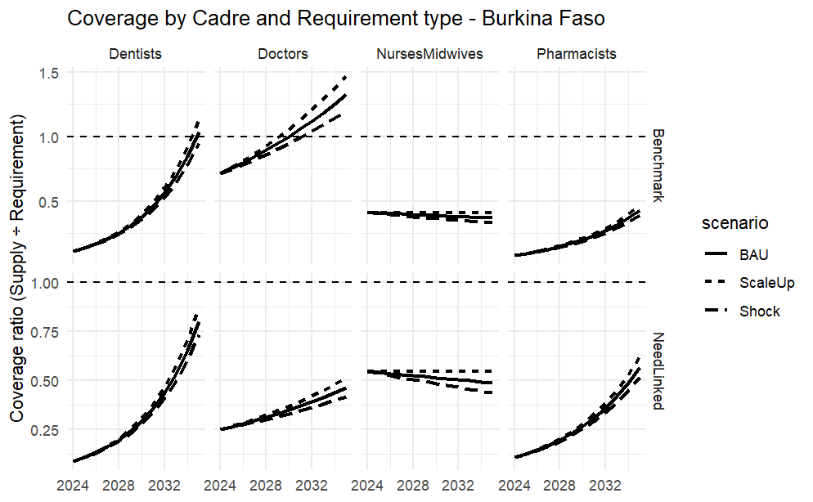

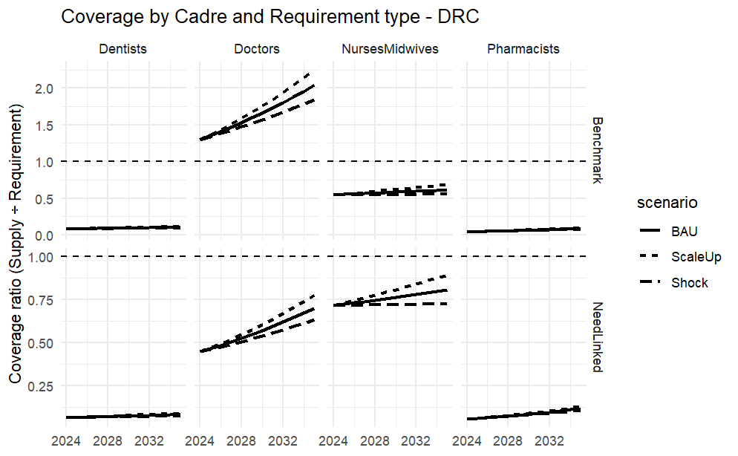
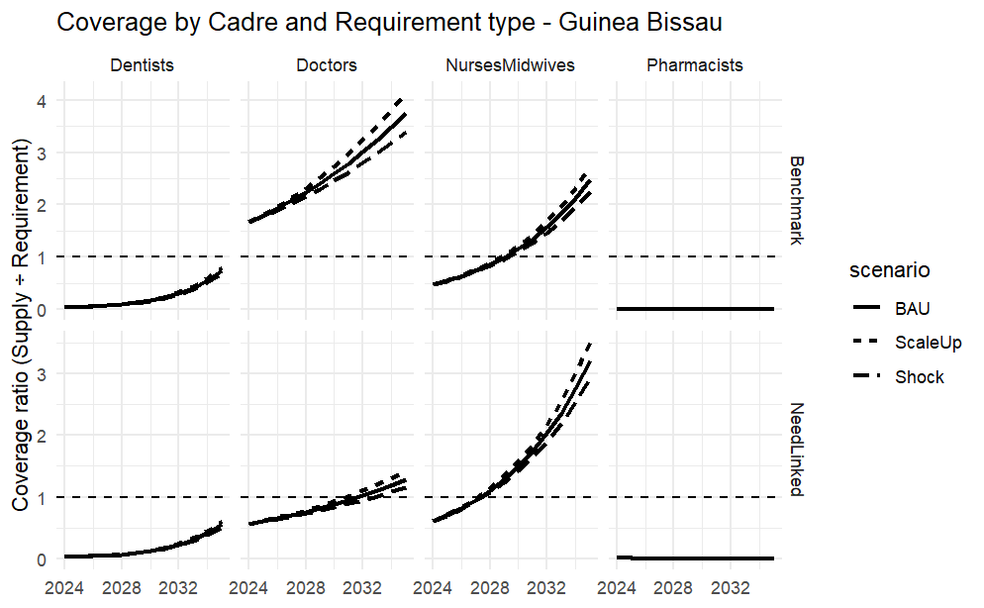
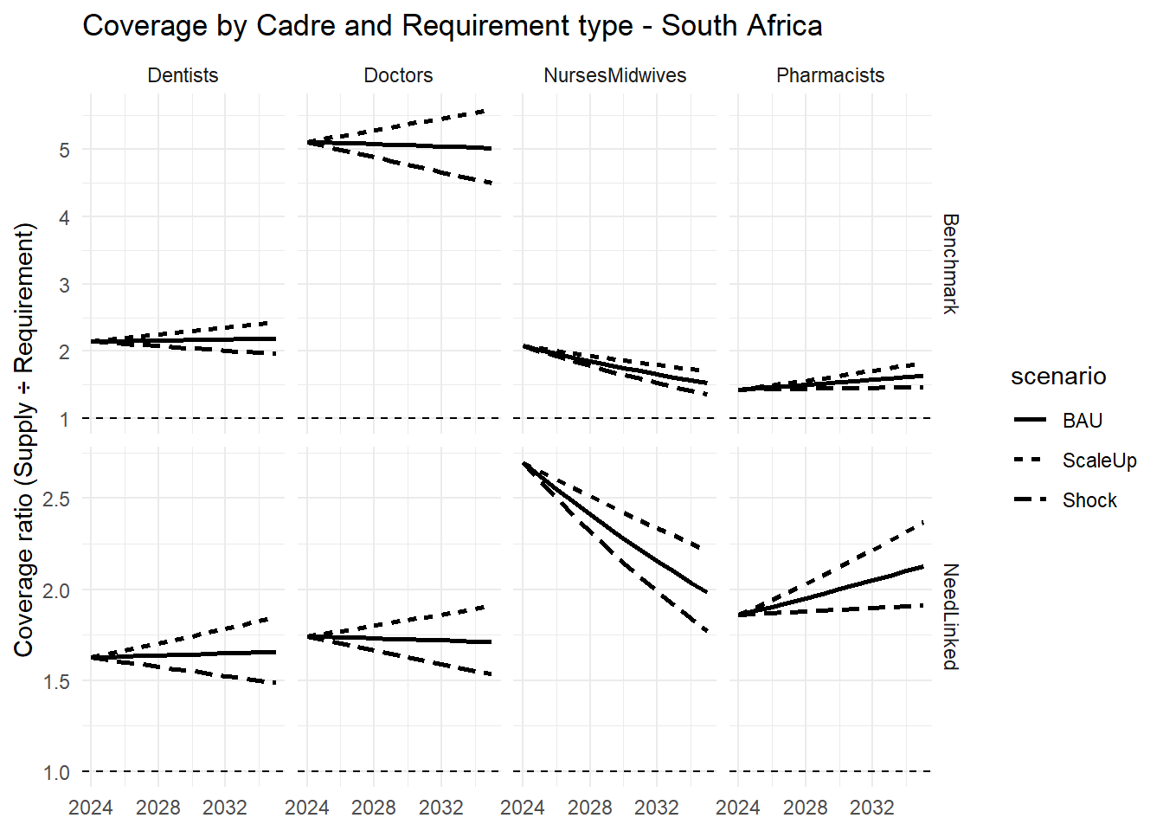

Gap analysis results are presented for only one country, that is Burkina Faso, but can also be obtained in the same manner. The charts indicate that under the benchmark requirement, doctors move into surplus and dentists nearly close their gap, while nurses/midwives and pharmacists remain in large deficits; under the need-linked requirement, however, all cadres remain below adequacy, especially the nurses/midwives; showing that workforce shortages are much more pronounced when adjusted for population health need, with ScaleUp improving gaps and Shock worsening them.
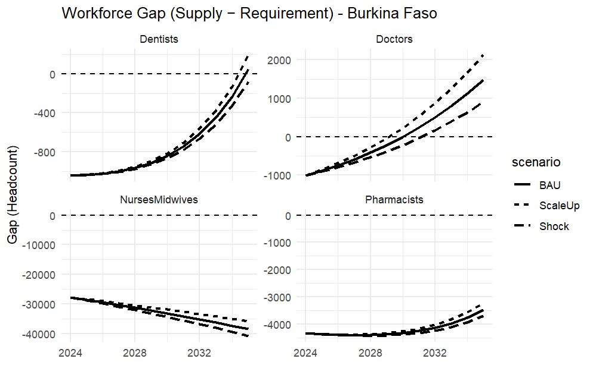
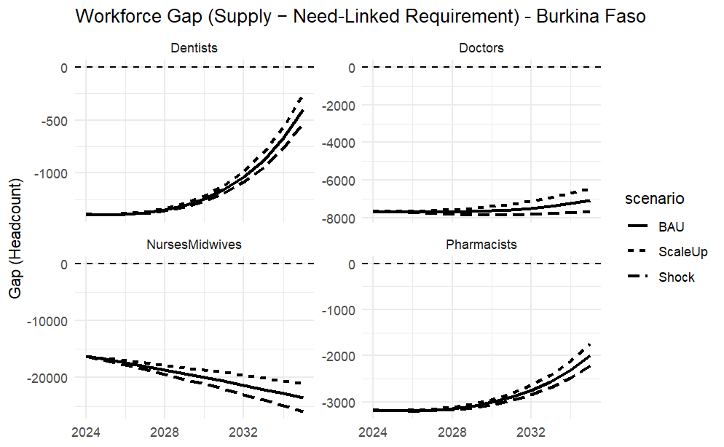

Fixed Effects Models (Panel Regression)
A llongitudinal panel analysis using annual country-level data for 47 countries observed over an unbalanced period spanning up to 18 years. The analysis combined demographic, macroeconomic, health financing, health workforce, and health outcome indicators to examine the relationship between human resources for health (HRH) and key health system outcomes. The data was sourced from credible international sources including WHO and world bank.
Two primary outcomes were examined the life eexpectancy at birth (LE) measured in years and used as a summary indicator of population health and Universal Health Coverage Service Coverage Index (UHC_SCI) . The main explanatory variable of interest was measures of health workforce availability, expressed as densities per population:
Workforce density was constructed as the number of physicians, pharmacists, dentists, and nursing/midwifery personnel per 10,000 population. To account for broader demographic, health system and economic context, the models also included. The ratio of Government health expenditure per capita (GGHED per capita) to Gross domestic product per capita (GDP per capita) and population density.
The main objective was to estimate the association between health workforce density and UHC service coverage and life expectancy; assess nonlinear and threshold effects in the workforce–outcome relationship; and identify workforce density levels associated with diminishing marginal returns.
First, we estimate the longitudinal association between health workforce density and health system performance, measured by life eexpectancy at birth (LE) and the Universal Health Coverage Service Coverage Index (UHC_SCI), using country-level panel data.
We then test for the presence of a structural breakpoint (kink) in the workforce–outcome relationship, allowing for differential marginal effects below and above an empirically determined workforce density threshold.
Finally, we identify the workforce density level at which marginal returns to workforce expansion decline, indicating a transition from a workforce-constrained regime to a moderate-return regime.

Statistical Approach
Panel regression models were estimated using both fixed-effects and random-effects specifications. Hausman tests were used to guide model selection. We then added a kink (piecewise linear) model that allows the marginal effect of an explanatory variable to change at an unknown threshold. The baseline Panel model is given by:
$$Y_{it}=∝_{i}+τ_{t}+βW_{it}+X_{it}+ϵ_{it}$$
Where
$Y_{it}$= outcome variable (e.g., LE or UHC_SCI)
$W_{it}$ = workforce density
$X_{it}$= vector of control variables
$∝_{i}$= country-specific fixed effect
​ $τ_{i}$= time (year) fixed effect
$ϵ_{it}$- Error term
To allow for a structural change in marginal effects at an unknown threshold $k$, we define
$${(W_{it}-k)}_{+}=max⁡(0,W_{it }-k)$$
The kink model will be
$$Y_{it}=∝_{i}+τ_{t}+β_{1}W_{it}+β{(W}_{it}-k)+X_{it}+ϵ_{it}$$
The threshold is estimated as
$$\hat{k}=arg \min_{k}{\sum_{i,t }{{{\hat{ϵ}}_{it}^{2}}_{}}}$$
Results
Universal Health Coverage
We compared the fitted fixed effects and random effects model. From the Hausman test ($χ^{2}=11.5, df=25, p-value<0.001)$,we rejected the null hypothesis and conclude that the random effects model was inconsistent because the individual-specific errors are correlated with the regressors. We therefore report the fixed effects model.
In fixed-effects panel models adjusting for year effects, population density and government health expenditure ,workforce density was positively associated with UHC service coverage. A one-unit increase in workforce density (per 10,000 population) was associated with a 0.11-point increase in UHC-SCI (β = 0.110, p = 0.004). The coefficients for factor(Year) show a clear upward trend. Starting around 2006, the time effects become highly significant and increase in magnitude (from 10.8 in 2006 to 22.9 in 2023). This indicates a strong global or systemic improvement in UHC scores over time that isn't explained by your three main independent variables.
From the piece wise regression, the estimated kink term capturing a change in marginal returns above the candidate threshold was not statistically significant (β = 0.043, p = 0.72), indicating no evidence of a discrete breakpoint in the workforce–UHC relationship.
A grid-search procedure was used to identify the workforce density threshold minimizing the residual sum of squares in fixed-effects models. The optimal breakpoint was identified at approximately 9 health workers per 10,000 population for UHC( figure 1). This threshold represents the transition from ‘extreme health workforce crisis’ to ‘basic functional capacity’. It is the point where basic primary care geared towards UHC begins to stabilize.However, the slope-change parameter was not statistically significant, suggesting that while marginal returns may diminish beyond this level, there is no evidence of a discrete structural break.
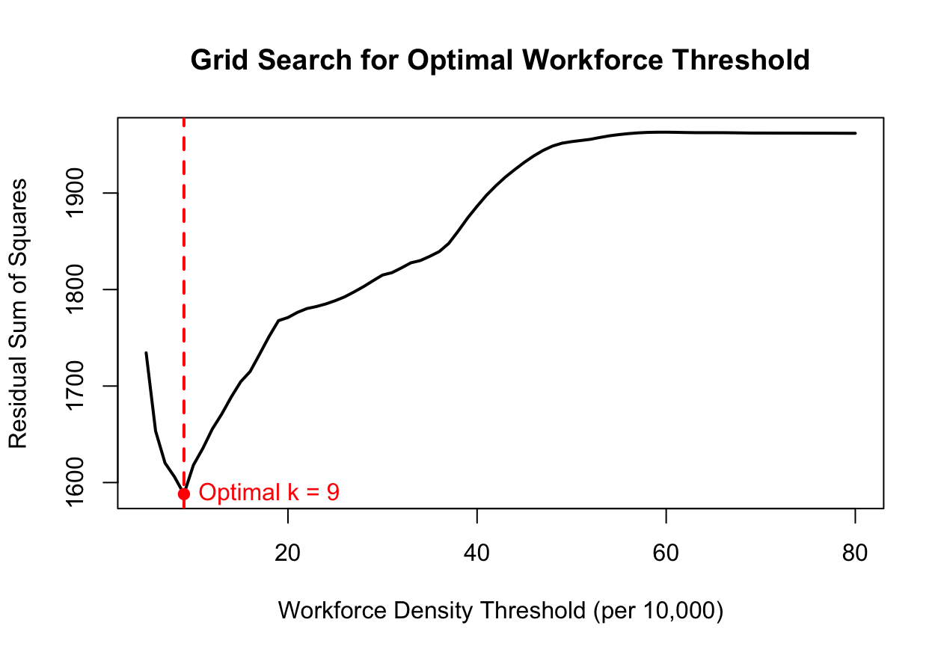
Figure 1: Workforce density threshold.
Life expectancy outcome
There was no statistically significant difference between the fixed effects and random effects coefficients (Hausman test ($χ^{2}=0.0669, df=23, p-value=0.9999$ )).
In random-effects panel models adjusting for population density, government health expenditure, and year effects, workforce density was not significantly associated with life expectancy (β = 0.016, p = 0.41). The estimated slope change above the optimal breakpoint (38 workers per 10,000 population) was negative but statistically insignificant (β = –0.079, p = 0.16), providing no evidence of a structural threshold in the workforce–longevity relationship. The life expectancy at birth (LE) threshold of 38.0 is closer to the broader WHO global benchmarks and represents the population health impact.
Comparison
Health workforce density is a critical driver for the UHC Service Coverage Index (UHC_SCI) but does not significantly impact life expectancy. Hiring more health workforce directly improves service delivery (vaccinations, prenatal care, hospital access), which raises the UHC score. On the other hand, life expectancy is influenced by broader factors not necessarily the health work force.
While a density of 9 health workers per 10,000 serves as the critical breakpoint for expanding service coverage (UHC), a significantly higher density of 38 per 10,000 is required to achieve structural improvements in life expectancy. This suggests that service coverage is a necessary but insufficient precursor to longevity, requiring nearly four times increase in workforce density to translate into extended life expectancy.

Mixed Effects Models within an Artificial Neural Network (ANN) framework
- Objectives
- To develop a Mixed Effects Models within an Artificial Neural Network (ANN) Model.
- To apply the developed model to quantify the relationship between UHC and GDP.
- Procedure
Step 1. Initial Fixed Effects Model
Train an artificial neural network to get initial predictions, ignoring the grouping structure.
Step 2. Estimate Residuals
Calculate the residuals from the initial ANN model.
Step 3. Model Random Effects
Fit a standard (parametric) mixed-effects model to the residuals using a random-effects structure. This estimates the variance attributable to each group.
Step 4. Adjust Target Variable
Update the original target variable by removing the estimated random effects.
Step 5: Re-train ANN
Re-train the neural network using the adjusted target variable.
Step 6. Iterate
Repeat steps 2 to 5 until the model converges on stable estimates for both the fixed (ANN) and random effects.
(c ) Results

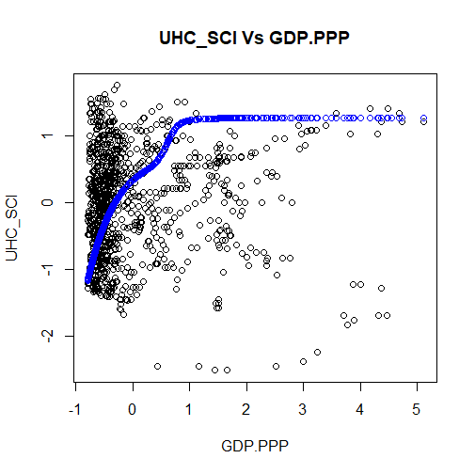
Mean Squared Error = 0.5102201
(d) Interpretation
- The suggested model is able to quantify the expected positive relationship between GDP.PPP and UHC_SCI but the quantification is poor with fewer data points.
- While higher GDP enables better care, UHC is not solely dependent on wealth. A full model will be developed based on the available data.

