Outline

Cover Page

Summary / abstract

Previous research

Protein information

Peptides

MS2 data

Image Noise Reduction

Smaller label set for gray scale images

Noise is not as noticeable in images (color variations)

In our data, variations in intensities of peaks can change the output

Statistical MS-Reduce

Our Model

Data: Protein sequences broken into peptide sequences

Peptide sequences fed through MaSS simulator to output

Noise MS2 and No-Noise MS2

Input: array of intensities with each m/z value as index

Dense connected neural network

Mass Spectrum Noise Reduction with Neural Networks

Group 8

Jonah Kubath

Matt Peter

Abstract

Increasing the rate at which we can identify proteins via their peptide sequences is one of the many computational problems present in the world today. Over the past few decades, protein mass spectrometry has become the primary way of identifying proteins. However, due to the complexity and quantity of proteins, as well as the large amount of “noise” that comes with gathering data, identifying one with an extremely high degree of certainty quickly becomes a daunting task. To solve this problem, large amounts of research have been put into finding ways to decrease the amount of time it takes to identify proteins, while still maintaining a decent level of accuracy. For our project, we decided to specifically focus on finding ways to reduce that large amount of “noise” that is part of the input data using neural networks. Our reasoning behind choosing this path was mostly due to the current success of neural networks in terms of noise reduction in images and audio. Unfortunately, due to the scale and complexity of proteins and the limited time and resources we had, our results did not provide any supporting evidence that neural networks are indeed a viable path to protein identification.

In the field of proteomics, “the study of all proteins in a biological system”, mass spectrometry is a technique that is used “to detect, identify and quantitate molecules based on their mass-to-charge (m/z) ratio” [1]. In order to do this, a protein must first be broken down into a set of peptides using enzymes. After this is done, the first stage of mass spectrometry (MS1) takes place, where peptides are further broken down into ions using an ion source and are separated by m/z ratio. In the second stage of mass spectrometry (MS2), ions of a particular m/z ratio are selected and fragmented, creating fragment ions which are then separated and detected [2]. This collection of fragment ions can then be quantified in MS2 data as “spectra”, a collection of “peaks” that shows the ions’ corresponding intensities at various m/z ratios.

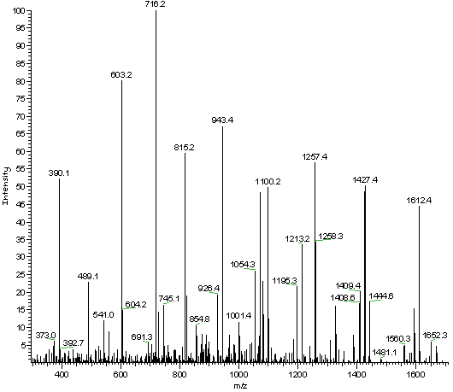

MS2 Data

This MS2 data is then analyzed in order to determine what the original peptides and proteins were. Unfortunately, only a small percentage of the peaks in a spectrum are useful in determining its peptide, as lot of the peaks are either noise or simply not helpful for the given spectrum [3]. This means that a large portion of the time spent analyzing the spectra does not actually improve the end result. In an effort to reduce the amount of time needed to accurately identify a peptide, research has been directed towards finding a way to eliminate this noise without severely reducing the accuracy of the results. One of the algorithms that has been developed to accomplish this is MS-REDUCE.

MS-REDUCE consists of a three-stage pipeline through which the MS2 data is passed. The three stages of the pipeline are (i) Spectral Classification, (ii) Peak Quantization, and (iii) Weighted Random Sampling.

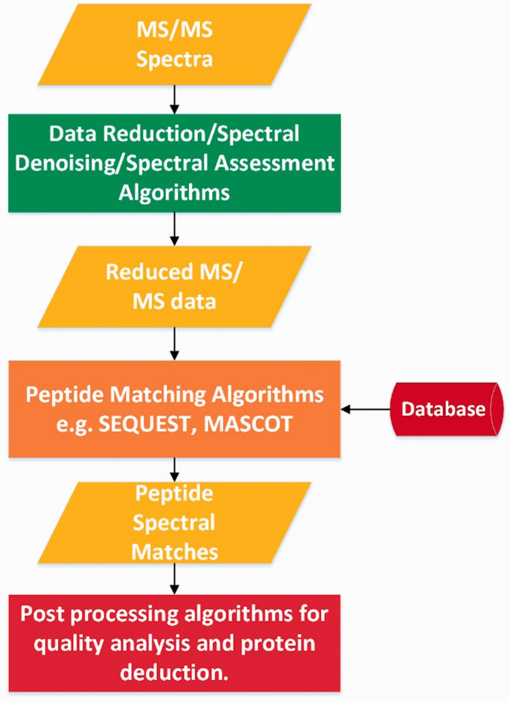

Pipeline for MS-REDUCE algorithm

In the Spectral Classification stage, spectra are placed into one of four classes based on the difference between the average of their highest ten peaks and the average of their lowest ten peaks, also known as their intensity spread. The boundaries of each of the four classes are determined by the average intensity spread over all the spectra in the dataset, with the first class having the smallest intensity spreads and the fourth class having the largest intensity spreads. After all the spectra have been classified, their peaks are grouped in the Peak Quantization stage. In this stage, all the peaks in a given spectrum are placed into one of *n* levels, where *n* is determined based on which class the spectra was placed in in the Spectral Classification stage (Ex. Class 1 = 5 Levels; Class 2 = 7 Levels; Class 3 = 9 Levels; Class 4 = 11 Levels). The boundaries of each of the *n* levels is determined by the average intensity of the highest ten peaks in the given spectra, with the lowest level having the lowest intensity peaks and the highest level having the highest intensity peaks. Finally, in the Weight Random Sampling stage, *p* peaks are selected from a given spectrum, where *p* is determined based on the reduction factor. For example, if the reduction factor is 70% and there are 30 peaks in the given spectrum, 9 of those peaks will be selected in the Weight Random Sampling stage. As far as figuring out which peaks to select, peaks are selected starting from the highest quantization level and continuing with lower quantization levels until the number of peaks needed have been selected. If a given level has less than the remaining number of peaks needed, all the peaks from that level are selected and the amount is subtracted from the remaining needed. If a given level has the exact number of remaining peaks needed, all the peaks from the level are selected and the sampling process is complete. If a given level has more than the remaining number of peaks needed, the amount needed are randomly selected from the all peaks on that layer and the sampling process is complete [3]. The result of this three-stage pipeline is a set of spectra that are reduced to a partially randomized sample of the original spectra with the lowest peaks removed.

[Introduce Image Noise Reduction]

[Explain our process]

Previous research

Protein information

Peptides

MS2 data

Image Noise Reduction

Smaller label set for gray scale images

Noise is not as noticeable in images (color variations)

In our data, variations in intensities of peaks can change the output

Statistical MS-Reduce

[1] <https://www.thermofisher.com/us/en/home/life-science/protein-biology/protein-biology-learning-center/protein-biology-resource-library/pierce-protein-methods/overview-mass-spectrometry.html>

[2] <https://en.wikipedia.org/wiki/Tandem_mass_spectrometry>

[3] <https://academic.oup.com/bioinformatics/article/32/10/1518/1743195>