Test Strategy
For this project I used a combination of automated JUnit testing and manual GUI testing. Automated testing was used to test the main model logic separately from the graphical user interface. This included testing player scores, login, register validation, dice game results and exception handling.
Manual GUI testing was also used because the application is a Java Swing prototype. This helped check that the user could log in, register, choose a game, view score history and logout using the interface.
The testing included valid and invalid data. Any failed tests would be investigated, fixed in the code and retested.

Automated Testing
Test No | Action | Expected | Actual | Result  (pass/fail)
001 | Checks if a score can be added to a player | Score is added and highest score returns correct value | 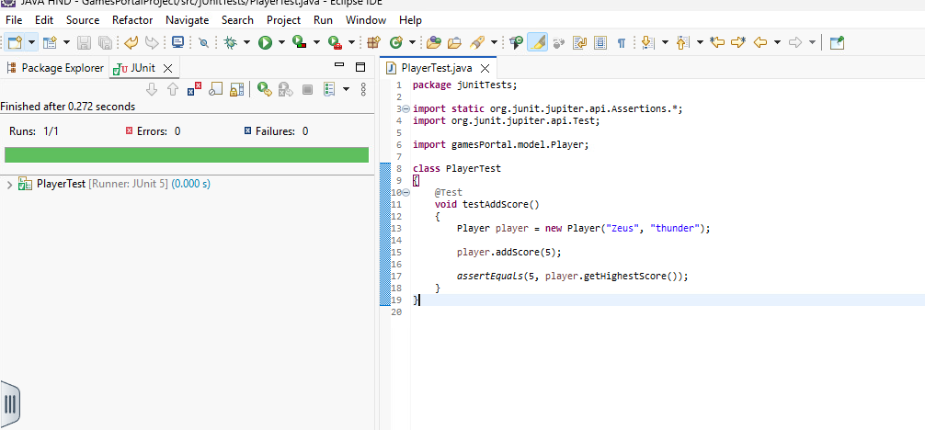 | pass
002 | testHighestScore() | Checks if the highest score is found from multiple scores | 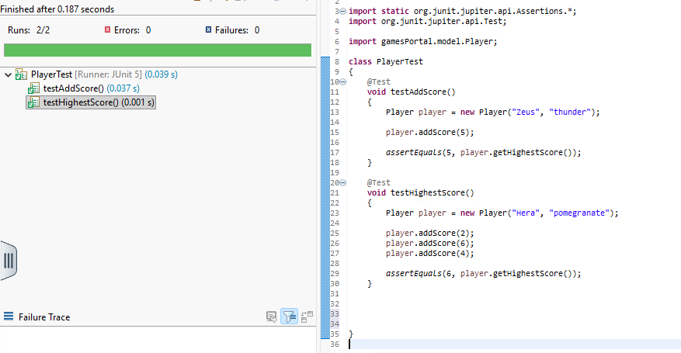 | pass

003 | testScoreHistoryNotEmpty() | Checks if score history contains scores after adding them | 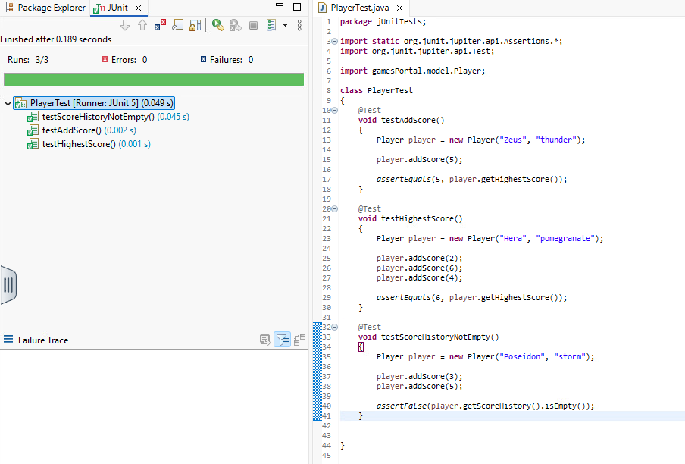 | pass
004 | testValidLogin() | Checks login with correct username and password | 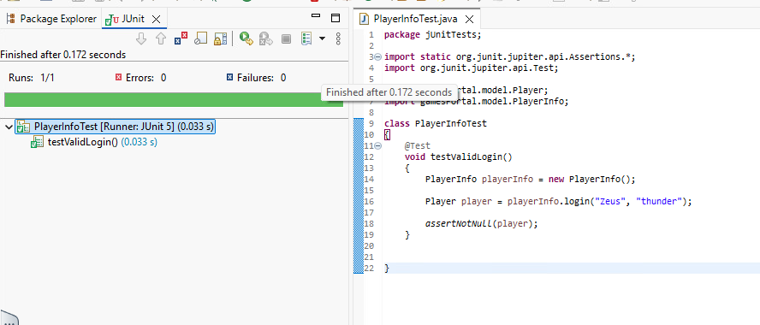 | pass
005 | testInvalidLogin() | Checks login with incorrect password | 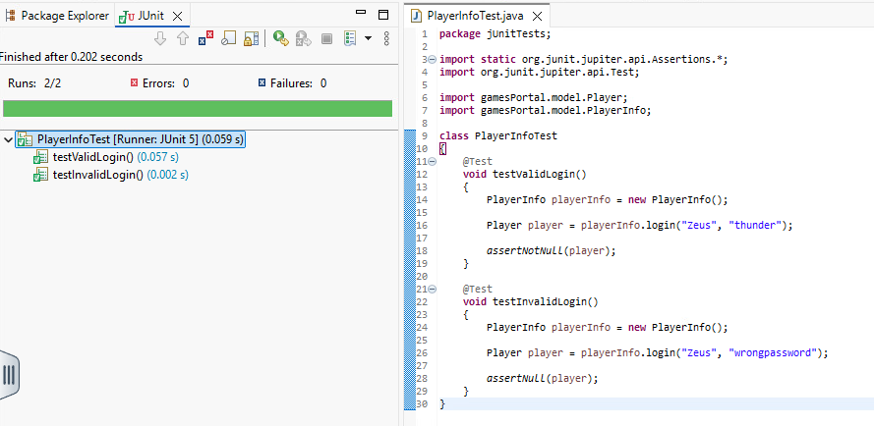 | pass
006 | Run testDuplicateUsername() using an existing username: Zeus. | The system should reject the duplicate username. | 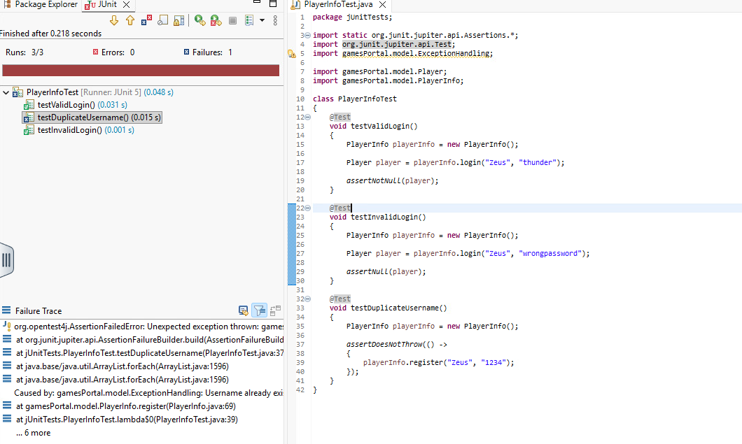 | fail
007 | testThrowSixReturnsText() | Checks if ThrowSix game returns a result string after playing. | 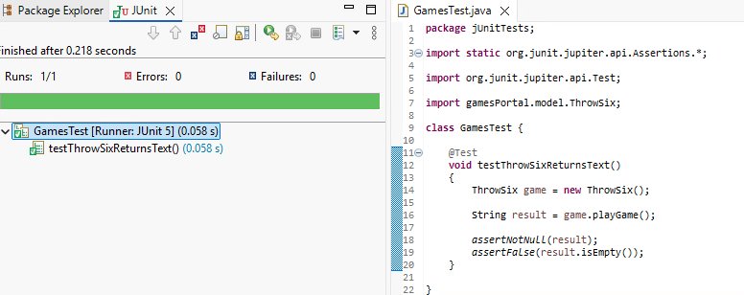 | pass
008 | testDoubleDiceGameReturnsText() | Checks if DoubleDiceGame returns a result string after playing | 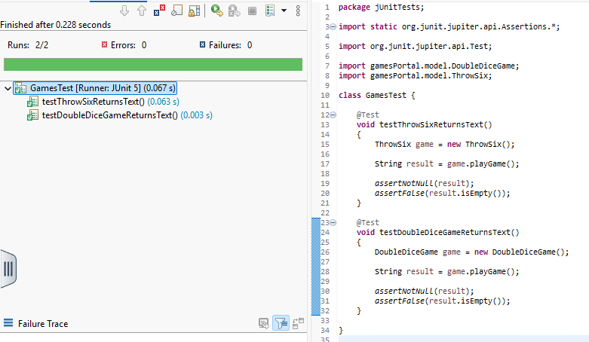 | pass
009 | testTwoPlayerGameReturnsText() | Checks if TwoPlayerGame returns a result string afterplaying. | 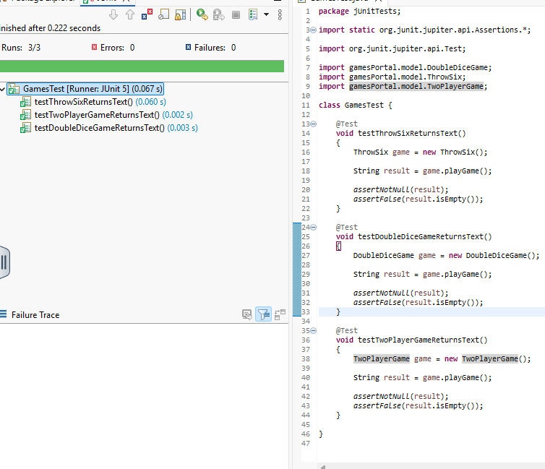 | pass
010 | All test classes run together | Runs 9/9 | 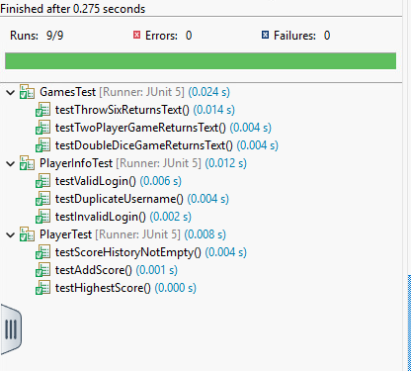 | pass

Manual Testing
Test No | Action | Expected | Actual | Result  (pass/fail)
011 | Launch the application from RunApplication. | LoginView opens correctly. | 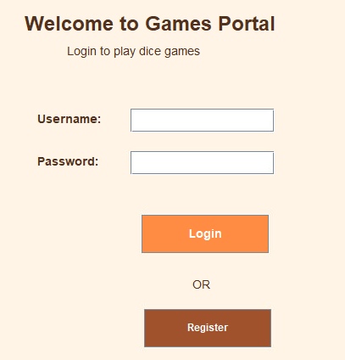 | pass
012 | testHighestScore() | Checks if the highest score is found from multiple scores |  | pass
013 | Enter invalid login details. | Error message displayed and login denied. | 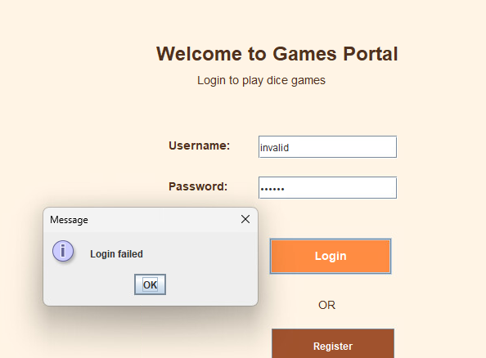 | pass
014 | Register a new player with valid details. | New player is registered and can log in. | 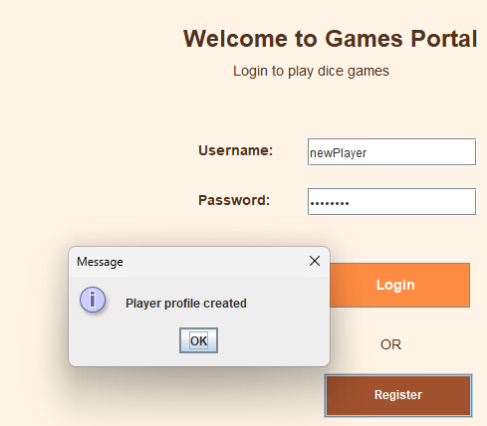 | pass
015 | Click Throw Six button. | Game result popup is displayed. | 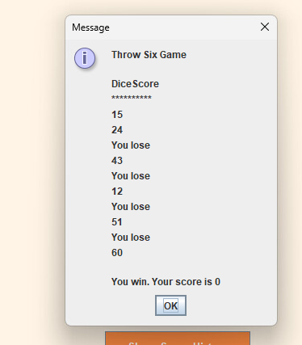 | pass
016 | Click Double Dice button. | Game result popup is displayed. | 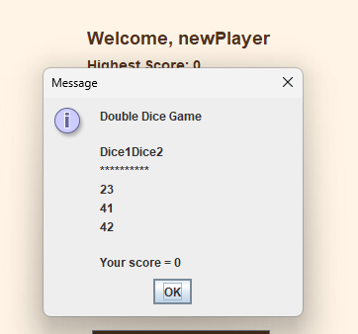 | pass
017 | Click Two Player Game button. | Game result popup is displayed. | 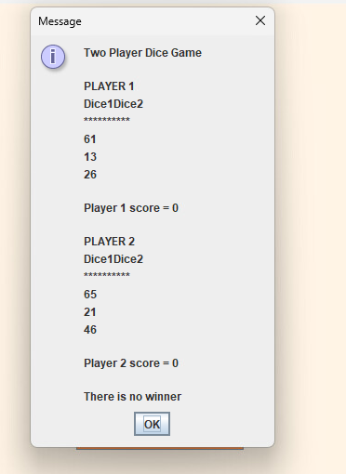 | pass
018 | Click Show Score History. | Score history popup is displayed. | 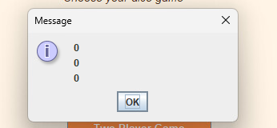 | pass
019 | Click Logout. | User returns to LoginView. |  | pass
020 | Register with empty username/password. | Validation message should appear | 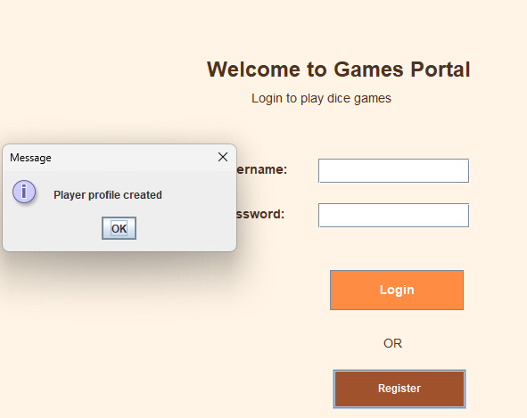 | fail

Test Remediation

- Re-test date: 27/05/2026
During automated testing, the testDuplicateUsername() test initially failed. The test incorrectly expected the register method to allow a duplicate username without throwing an exception. However, the PlayerInfo.register() method was designed to reject duplicate usernames using the custom ExceptionHandling exception. To correct the test, assertDoesNotThrow() was replaced with assertThrows(), which correctly checks that the expected exception is thrown when attempting to register an existing username.
Test No | Action | Expected | Actual | Result
006 | Run testDuplicateUsername() again after changing the test to use assertThrows(). | The test should pass because duplicate username correctly throws ExceptionHandling. | 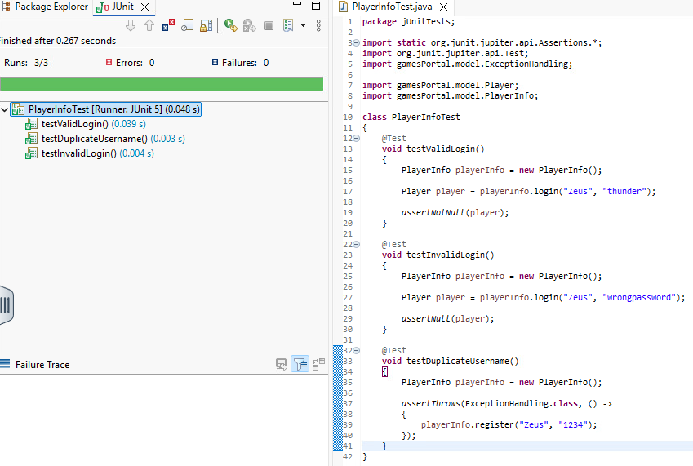 | pass

- Re-test Date: 27/05/2026
During manual testing, it was found that the register process did not correctly handle empty username and password fields.
To fix this issue, validation was added inside the register() method. The method now checks if the fields are empty and throws the custom ExceptionHandling exception with the message "Fields cannot be empty".
After adding this validation, the application correctly prevents invalid registration attempts and displays an error message to the user.
Test No | Action | Expected | Actual | Result
020 | Leave username and password fields empty and click Register again after validation fix. | Validation message displayed and registration denied. | 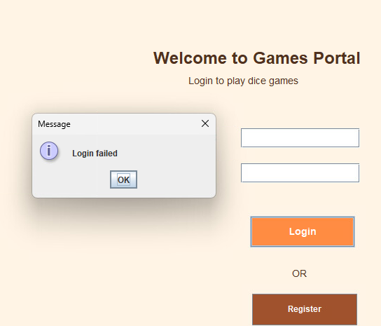 | pass

