**Naga Jyothi Kunaparaju**

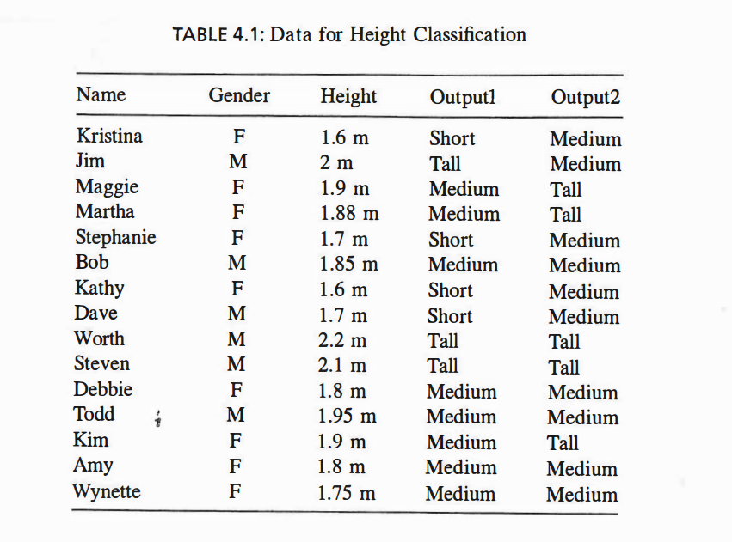

**7.** Use KNN to classify (Jim, M, 2.0) with K = 5 using the height data and assuming

that Output2 is correct.

A rule of thumb is that K < SQRT (number of training items)

For K = 5

Nearest neighbors:

1. (Steven, M, 2.1) -> tall
2. (Todd, M, 1.95) -> medium
3. (Maggie, F, 1.9) -> tall
4. (Kim, F, 1.9) -> tall
5. (Martha, F, 1.88) -> tall

**Therefore we classify (Jim, M, 20) is tall.**

**9.** Redo Example 4.5 using Output2 data.

|  |  |  |  |  |  |  |  |
| --- | --- | --- | --- | --- | --- | --- | --- |
|  |  | **Short** | **Medium** | **Tall** | **Short** | **Medium** | **Tall** |
| **Gender** | M | 0 | 4 | 2 | 0 | 4/10 | 2/5 |
|  | F | 0 | 6 | 3 | 0 | 6/10 | 3/5 |
| **Height** | 0-1.6 | 0 | 0 | 0 | 0 | 0 | 0 |
|  | 1.6-1.7 | 0 | 2 | 0 | 0 | 2/10 | 0 |
|  | 1.7-1.8 | 0 | 3 | 0 | 0 | 3/10 | 0 |
|  | 1.8-1.9 | 0 | 3 | 1 | 0 | 3/10 | 1/5 |
|  | 1.9-2 | 0 | 1 | 2 | 0 | 1/10 | 2/5 |
|  | 2-inf | 0 | 1 | 2 | 0 | 1/10 | 2/5 |

P(short) = 0/15 = 0

P (medium) = 10/15 = 2/3 =0.667

P (tall) = 5/15 = 1/3 = 0.333

P(short|M) = 0

P(medium|M) = 4/10

P(tall|M) = 2/5

P(short| 2.0) = 0

P(medium|2.0) =1/10

P(tall|2.0) = 2/5

P(short|(M,2.0)) = 0 * 0 = 0

P(medium|(M,2.0)) = P (medium|M ) *(medium|2.0) = 4/10 * 1/10 = .04

P(tall|(M,2.0)) = P(tall|M) = 2/5* P(tall|2.0) =2/5 * 2/5 = 4 /25 = 0.16

P (Short or Medium or Tall | (M,2.0)

= P(short|(M,2.0))* P(short)

+ P(medium|(M,2.0))* P(medium|M)

+ P(tall|(M,2.0)) * P(tall|M)

= 0 + (0.667* 0.04 )+ (0.16 * 0.333)

= 0.079967

From Bayes theorem

P (t | short)

= P(short|(M,2.0)) * P(short) / P (Short or Medium or Tall | (M,2.0)

=0

P(t|medium)

= P(medium|(M,2.0)) * P (medium) / P (Short or Medium or Tall | (M,2.0)

= 0.04 * 0.667 / 0.079967

= 0.3336

P(t|tall)

= P(tall|(M,2.0)) * P(tall) / P (Short or Medium or Tall | (M,2.0)

=0.16 * 0.333 / 0.079967

= 0.05328/0.079967

=0.66627

Since the maximum probability of the tuple t is for tall (the probability being 0.66627), we classify the tuple **(Jim, M, 20)** as tall.