McLaughlin, William A51

Wehbe, Semaan A 52

Trackman, Rebecca A52

Burns, John Henry A52

Kunnumpurath, Julie A53

Game Manual

Registration/Login Instructions:

When you run the start function, this login screen will appear:

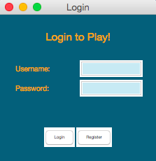

If you have never logged in before, click the register button, and this screen will appear. Follow the instructions and fill out the information, then click the register button.

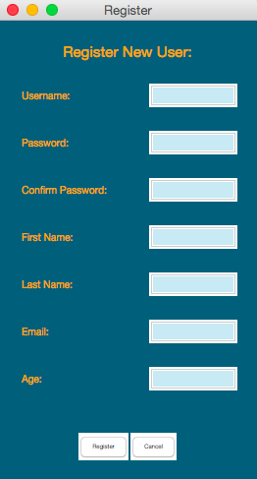

After you register, you can log in with your username and password on the login screen. After you log in, the Python Game Suite will appear. Choose which game you would like to play.

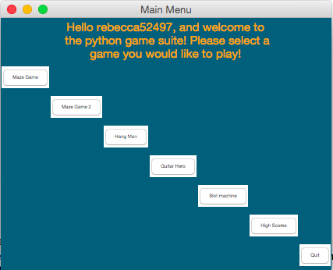

Maze Runner Instructions:

When you click maze game in the python game suite, the game will bring you to this screen and immediately begin. Use the left and right arrow keys to move the orange ball and avoid hitting the black bricks that fall down the screen.

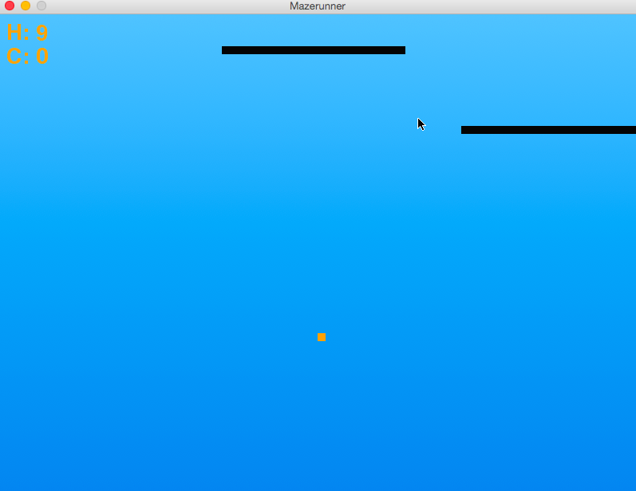

As the game progresses, you must continue avoiding to hit the black bricks in order to continue playing.

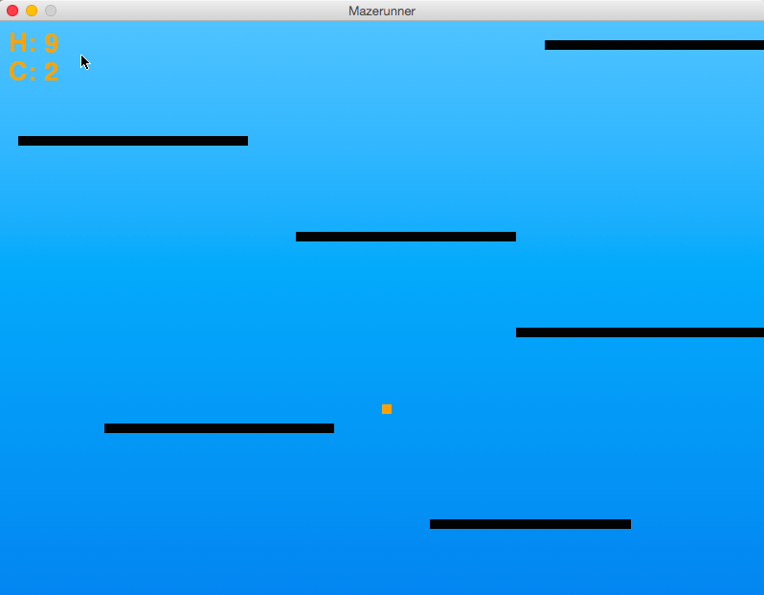

If you see this yellow star appear in the bottom left hand screen, then you need to press the ‘p’ key and the black bricks will turn white. While the blocks are white, the orange ball can go through the bricks without dying.

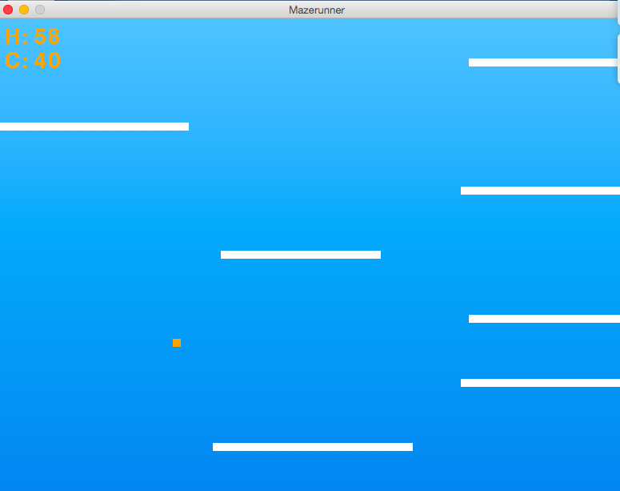

As soon as the bricks turn black again, you must go back to avoiding them in order to stay alive.

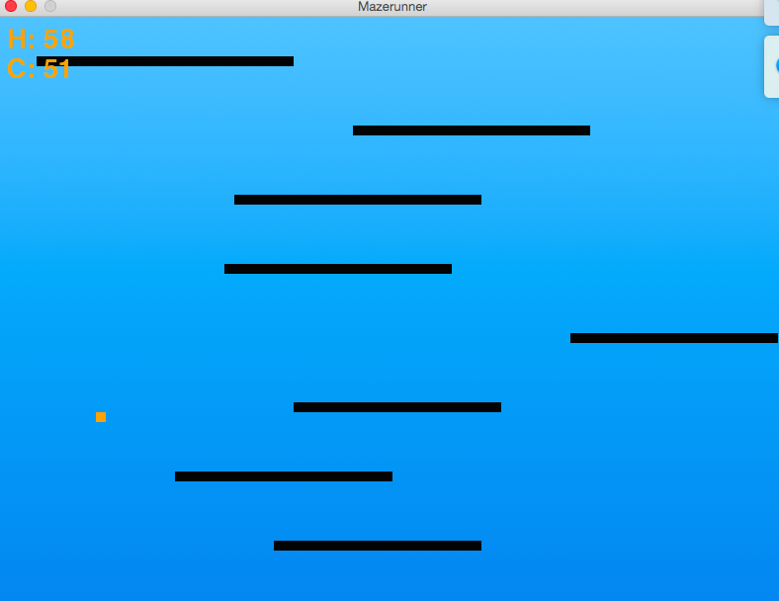

In the top left hand corner, the orange H is your high score for the game and the orange C is your current score. There is one point added to your current score every time you pass a black brick without hitting it. In this example, my current score is 1 and my high score is 9.

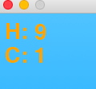

If you get a new high score in a specific, this message will show up on the top of the screen to show you that you have just achieved a new high score.

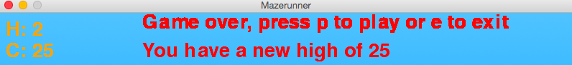

When you lose the game, the top of the screen will show the prompt below, and you can type “p” if you want to continue, or “e” if you want to exit the game.



Maze Game 2 Instructions:

When you click maze game 2 in the python game suite, the game will bring you to this screen and you will immediately begin. Use the left and right arrow keys to stay in the orange maze without hitting either side.

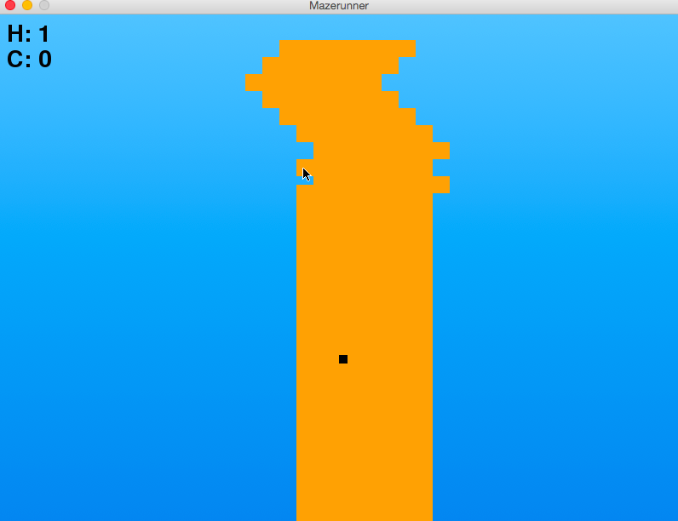

As the game progresses, you must continue to stay within the orange maze in order to continue playing.

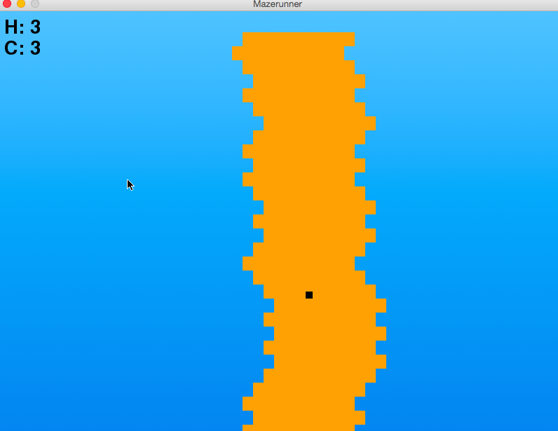

In the top left hand corner, the black H tells you your high score, and the black C tells you your current score. There is one point added to your current score for every 30 barriers that you pass without hitting either side of the maze.

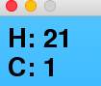

If you get a new high score in a specific, this message will show up on the top of the screen to show you that you have just achieved a new high score.

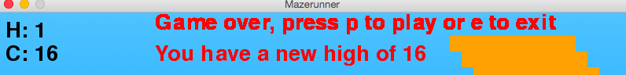

When you lose the game, the top of the screen will show the prompt below, and you can type “p” if you want to continue, or “e” if you want to exit the game.



Slot Machine Instructions:

When you click slot machines in the python game suite, the game will bring you to the screen show below (on the left) and the game will begin. If you have no points from previous games, you will not be able to play the game and this screen below will be shown (on the right).

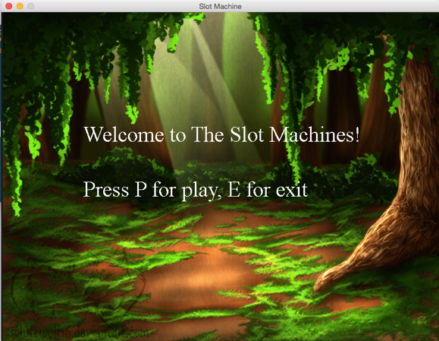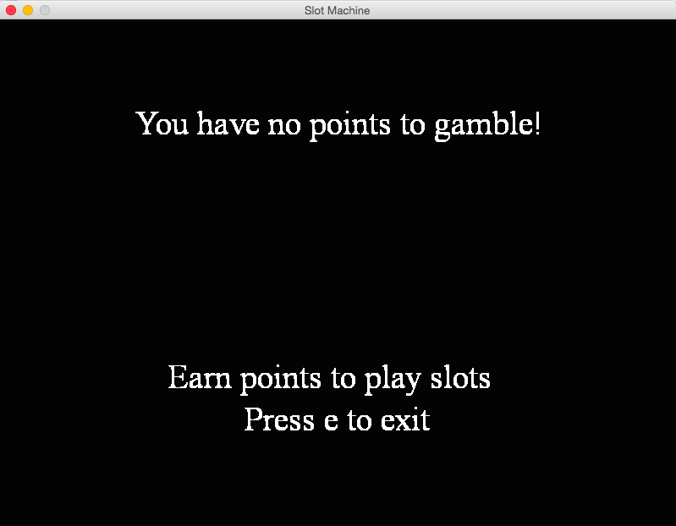

You are starting with the total number of points you have in the python game suite (including points from all other games) and it costs 5 points to play each game. To spin the first wheel, press ‘J’, to spin the second wheel, press ‘K’, and to spin the third wheel, press ‘L’.

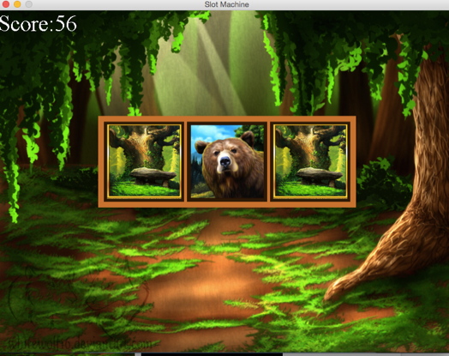

If two of the three numbers are the same, you will get ten points. If all three of the numbers are the same, you will get 50 points.

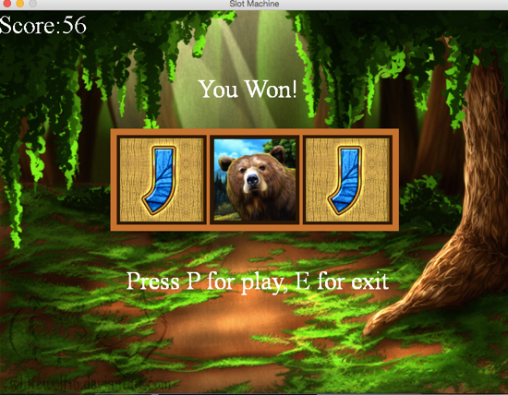

In the top left hand corner, the white C tells you your current score

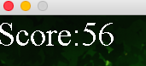

After you spin three times, whether you win or lose, you can either play again or exit the game, as long as you have points.

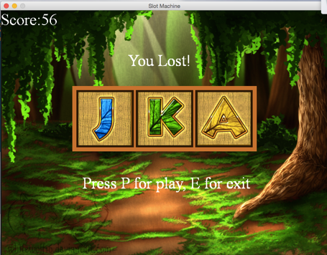

If you run out of points, you automatically lose the game and have to exit



Guitar Hero Instructions:

For this game, the objective is to fill the meter on the left side of the screen.



To do this you must “hit” each note at the appropriate time, with missing as few as possible. The notes will randomly appear and you must hit the appropriate button for each note.



At the bottom of the screen you will see the stationary button, which serve as a reference to when a key should be pressed. The keys are as follows:



Blue circle – ‘j’

Green button – ‘k’

Orange button – ‘l’

Red button – ‘;’

When each key is pressed, the hollow button will light up, alerting you that you have pressed the button. Press the key when a ‘note’ reaches the circle. Pressing too early or too late will reduce the gauge and cause you to lose a point. Missing a note entirely will also result in a lost point and gauge. Timing is important!



Each time you hit a note, the gauge will fill up a small amount and you will receive a point. In the top left hand corner, the white H shows your high score and the white C shows your current score.



The game continues until the meter is filled. Once you fill the meter, you win!

Hangman Instructions:

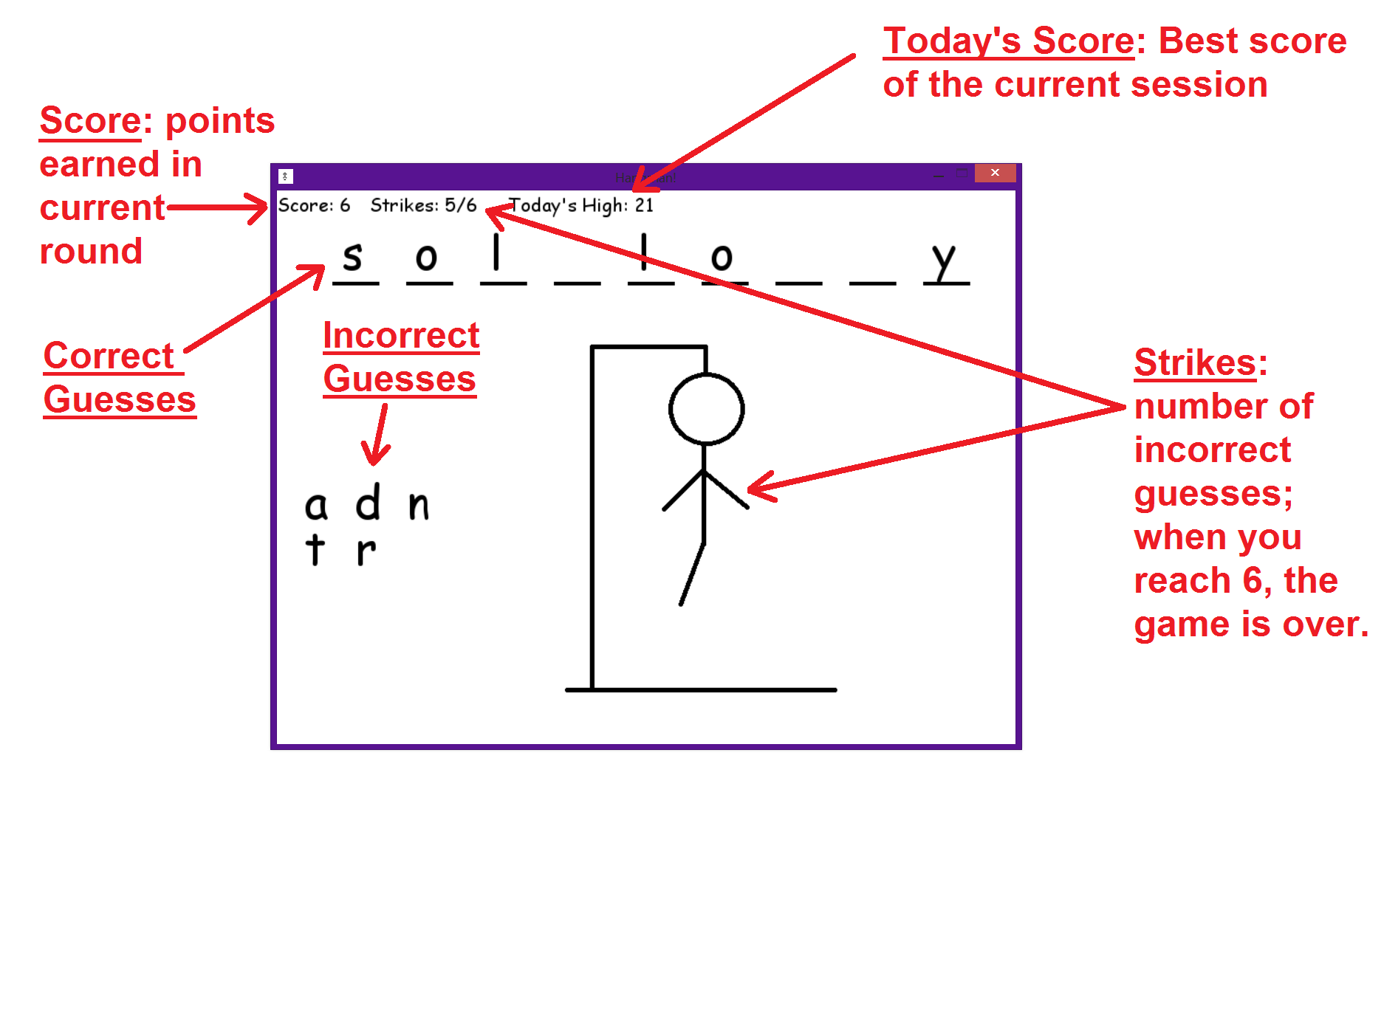

To play, simply type the letter you’d like to guess. If your guess is correct, all instances of that letter will be revealed in the puzzle. If not, the letter will be displayed on the left side of the screen and you will get a strike. When the puzzle is filled in completely, you win! If you reach 6 strikes before you complete the puzzle, then you lose!

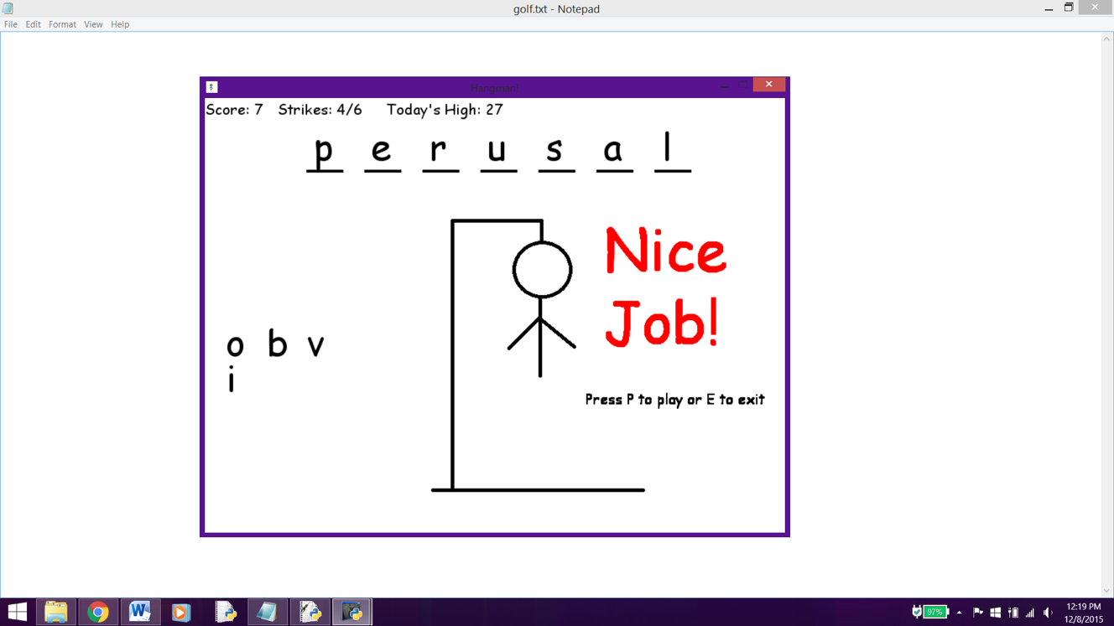

If you guess all the letters in the puzzle before you reach six strikes, you win! Pressing ‘P’ will give you a chance to add onto your score with another puzzle. Pressing ‘E’ will exit the game; your high score, as well as all the points you’ve accumulated, will be saved.

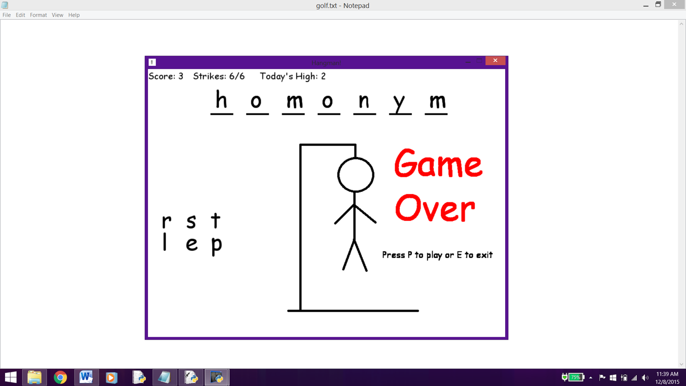

Once you reach six strikes, you lose. The remainder of the puzzle will be displayed. If you choose to play again, your score will be reset to zero. When you exit the game, your high score and all the points you’ve accumulated will be saved.