Csip-OA Instrument: Embedded Electronics Design and Firmware
Background:
PMEL’s Csip-OA ocean carbon instrument, currently under development, allows researchers to autonomously monitor the movement of CO₂ into the world’s ocean, measure ocean acidification, and constrain the amount of CO₂ being absorbed and stored in the ocean globally. The instrument measures the concentration of CO2 gas in the atmosphere at the ocean’s surface and dissolved in the ocean, as well as the total Dissolved Inorganic Carbon (DIC) in the ocean. By measuring these two carbon parameters, scientists can fully define the ocean carbon chemistry at the point of measurement. The Csip-OA instrumentation is the next generation replacement for two operational instruments developed at PMEL, and currently deployed worldwide, the MAPCO₂® and ASVCO₂®. These instruments are deployed for 400+ days on buoys and robotic surface vehicles from the Arctic to the Tropics where they autonomously collect climate quality measurements (accuracy < 2ppm CO₂) and calibrate themselves. PMEL has a benchtop prototype Csip-OA instrument that uses Commercial-Off-The-Shelf (COTS) industrial controllers and lab view code. This highly configurable benchtop prototype is being used to refine the design and instrument methodology in preparation for developing the low power, autonomous, embedded instrument, which will be the focus of this effort. The Benchtop version’s code and information can be found on the EDD_DIC/ dev_testact Github Repository.
Scope of Work:
Port the benchtop CSIP-OA prototype instrument over to a low power embedded system.
- Csip-OA CCA(s) Design: Embedded ultra-low-power electronics Circuit Card Assembly(s) (CCA) design package for the Csip-OA instrument. The design goal will aim to achieve autonomous operation in an ocean environment subjected to vibration and shock and temperatures between 0 deg. C and 60 deg. C for a minimum of 400 days without failure.
- Csip-OA Firmware Package: Embedded command and control firmware for the Csip-OA. Must perform a measurement cycle on demand. A measurement cycle will consist of a set sub-states that calibrate the instrument, perform seawater and air pCO2 and DIC sampling, take measurements, perform basic onboard statistics on a measurement time series, and package both the raw sub state measurements and the statics into files that are saved onboard and to a higher-level control system upon request.

Overview:
The Csip-OA sensor will operate very similarly to the ASVCO2 Gen2 Instrument, for details see the ASVCO2 Gen2 Github repository. The sensor will be powered and controlled by an external data logging and telemetry system. When given a take sample command, the Csip-OA will walk through a series of instrument states, much like the ASVCO2 sensor:
- Zero calibrate itself
- Span calibrate itself
- Strip the DIC loop of all CO2
- Take the DIC water sample
- Equilibrate the DIC water sample while injecting acid into the sample
- Purge the DIC water sample
- Add the pCO2 water sample
- Equilibrate the pCO2 water sample
- Take an Air measurement
- Package the data into (try to match existing ASVCO2 data formats as much as possible to ease the amount of data pipeline rework required):
  - Summary data for near-real-time comms.
  - Raw data for post processing
- To get the DIC measurement value, instrument data will be processed on shore using a Matlab or Python Program. We should experiment with doing this calculation onboard the instrument, but I believe this will not be possible.

There will be 3 main variants of the Csip-OA sensor. Each variant should share the electronics hardware and firmware, but will differ slightly in the structure of instrument states, the type of gas sensor that is integrated, the number of valves required, and the number of reference gases that are attached (0-4). Here is an overview of the different configurations (listed in order of development):

Buoy/USV:
- 8 air valves
- 1 calibration gas
- Licor LI-830 gas sensor
- ASVCO2 equilibrator

Subsurface:
- 4 air valves
- No calibration gases
- Senseair Admont K96 gas sensor

Ship/Shore:
- 10 air valves
- 3-4 calibration gases
- Licor LI-7815 gas sensor
- ASVCO2 equilibrator
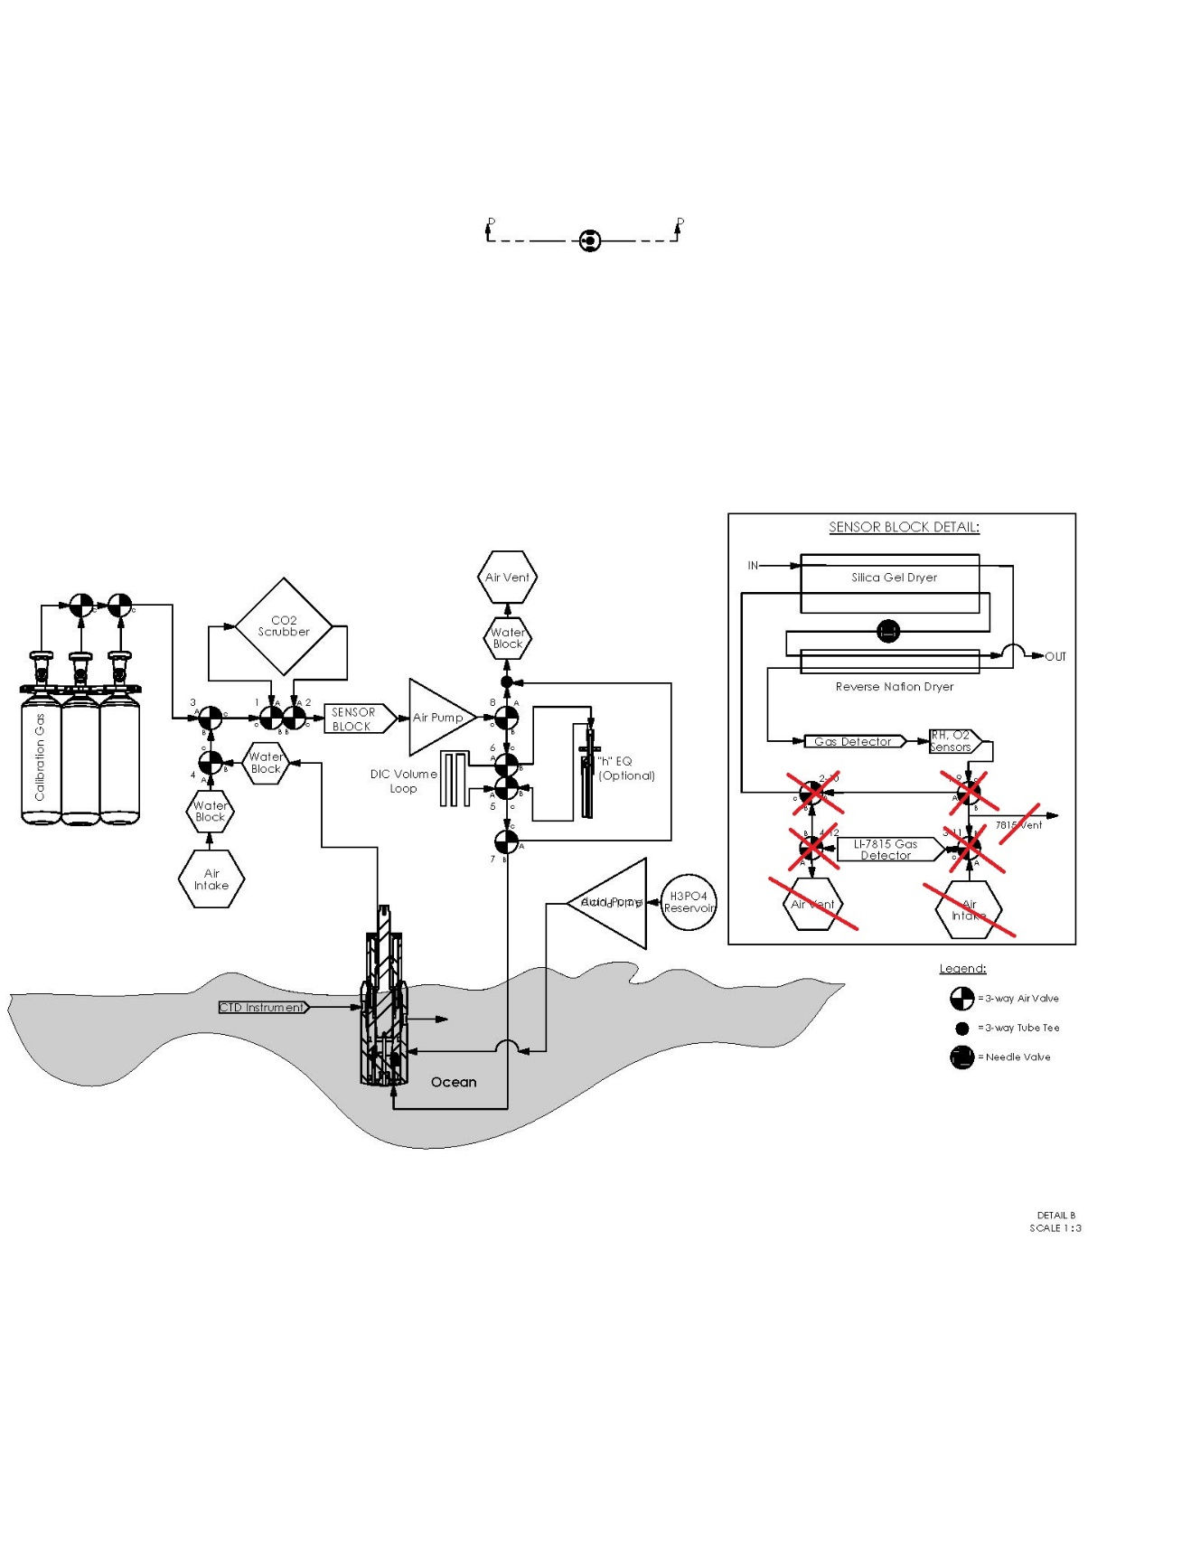

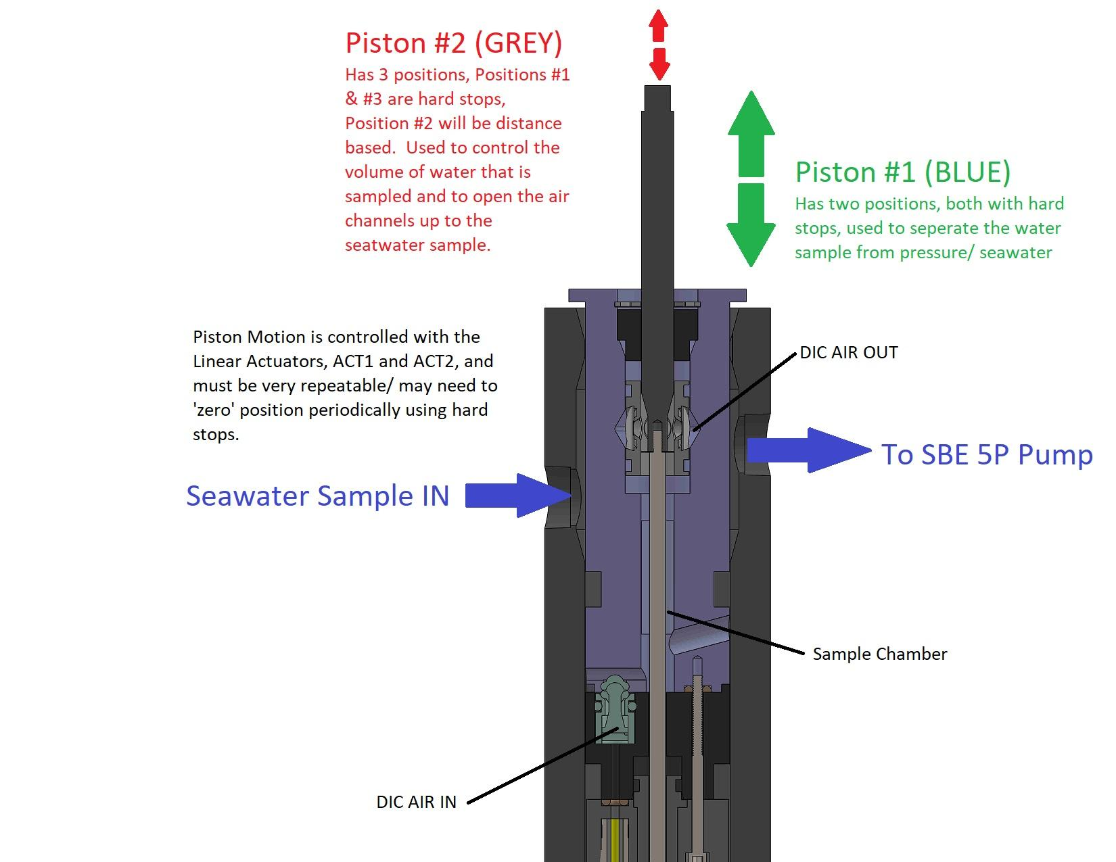

Components:
- Air Valves: 12VDC, 2-wire, 3/2 latching solenoid valves. Burkert 6724-S01,2FFPK-FB46-012/DC-AT-55-12* CF16
- Air Pump: 6VDC. KNF NMP09KPDC-B 6V
- Acid Pump: 2.6 – 3.0 VDC @ 0.1A stepper motor w/ ¼ micro stepping. Takasago RP-TX
- Water Pump: 12VDC. SBE5P
- Linear Actuators (x2): Actuonix P16-50-256-12-P

We will need precise position control for the linear actuator, as well as some current sensing control so we can both accurately position the valve. We are using the RC servo control boards you can buy for these actuators for the benchtop system. You give the RC board a %PWM signal and the board commands the actuator to the appropriate position.
- AT/RH Sensor: Sensirion SHT35
- O2 Sensor: SST Sensing LuminOx LOX-O2-F
- Gas Detector:
- LI-830
  - Input voltage: 12-30 VDC
  - After warmup (without pump): 0.33A @ 12 VDC (4.0 W) average
  - After warmup (with pump): 0.42A @ 12 VDC (5.0 W) average
  - During warmup: 1.2 A @ 12 VDC (14 W) maximum
- LI-7815
  - Pins 1 and 5 (24 VDC Input): Minimum 6 A at 24 V
  - Pins 3 and 4 (10.5 to 33 VDC Input): Minimum 14 A at 10.5 VDC; 6 A at 24 VDC
  - Wall-power
- Senseair ADMONT K96
  - 6-8.5V @ 300mA

