**Topics: Descriptive Statistics and Probability**

1. Look at the data given below. Plot the data, find the outliers and find out $μ, σ, σ^{2}$

|  |  |
| --- | --- |
| **Name of company** | **Measure X** |
| Allied Signal | 24.23% |
| Bankers Trust | 25.53% |
| General Mills | 25.41% |
| ITT Industries | 24.14% |
| J.P.Morgan & Co. | 29.62% |
| Lehman Brothers | 28.25% |
| Marriott | 25.81% |
| MCI | 24.39% |
| Merrill Lynch | 40.26% |
| Microsoft | 32.95% |
| Morgan Stanley | 91.36% |
| Sun Microsystems | 25.99% |
| Travelers | 39.42% |
| US Airways | 26.71% |
| Warner-Lambert | 35.00% |

ANS:

1. Mean $μ$ = 33.271333
2. Variance $σ^{2}$ = 287.146612
3. Std $σ$ = 16.945401
4. Outlier = Morgan Stanley 91.36%

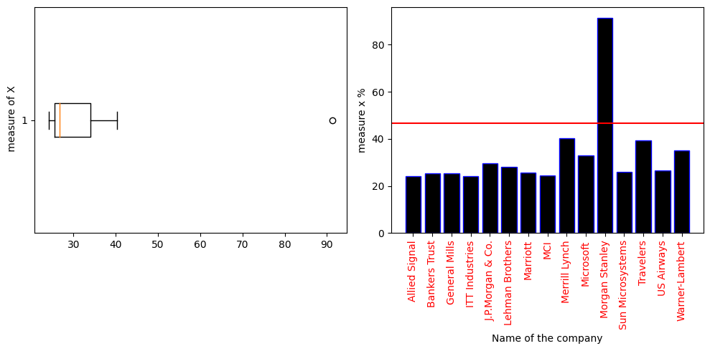



Answer the following three questions based on the box-plot above.

1. What is inter-quartile range of this dataset? (Please approximate the numbers) In one line, explain what this value implies.

ANS: IQR= 12-5(app)

The variable has 1 outlier and median of the data point is 7.5(app)

1. What can we say about the skewness of this dataset?

ANS: Positively skewed

1. If it was found that the data point with the value 25 is actually 2.5, how would the new box-plot be affected?

ANS: Median will closer to lower end & IQR will reduced



Answer the following three questions based on the histogram above.

1. Where would the mode of this dataset lie?

ANS: The mode represents the value or bin with the highest frequency. It is the data point or range of values that appears most frequently in the dataset(4-8)app

1. Comment on the skewness of the dataset.

ANS: Positively skewed

1. Suppose that the above histogram and the box-plot in question 2 are plotted for the same dataset. Explain how these graphs complement each other in providing information about any dataset.

ANS: The both box plot and histogram are right skewed and has outliers. The median is easily visualized in box plot and where as mode is visualized by histogram.

1. AT&T was running commercials in 1990 aimed at luring back customers who had switched to one of the other long-distance phone service providers. One such commercial shows a businessman trying to reach Phoenix and mistakenly getting Fiji, where a half-naked native on a beach responds incomprehensibly in Polynesian. When asked about this advertisement, AT&T admitted that the portrayed incident did not actually take place but added that this was an enactment of something that “could happen.” Suppose that one in 200 long-distance telephone calls is misdirected. What is the probability that at least one in five attempted telephone calls reaches the wrong number? (Assume independence of attempts.)

ANS: A = 1/200 = Probability of a single call being misdirected

B = 1-A = 199/200 = Probability of a single call not being misdirected

N= 5 = No of attempts

P(B) = 199/200 (for single time call)

P(B)^N = (199/200) ^5

P(telephone calls reaches the wrong number) = 0.0247 ~ 2.48%

1. Returns on a certain business venture, to the nearest $1,000, are known to follow the following probability distribution

|  |  |
| --- | --- |
| x | P(x) |
| -2,000 | 0.1 |
| -1,000 | 0.1 |
| 0 | 0.2 |
| 1000 | 0.2 |
| 2000 | 0.3 |
| 3000 | 0.1 |

1. What is the most likely monetary outcome of the business venture?

ANS: 2000

1. Is the venture likely to be successful? Explain

ANS:

Yes, venture is making profit like p(x>0)+p(x>1000)+p(x>2000)+p(x>3000)=0.2+0.2+0.3+0.1 = 0.8 which is most likely 80% chances that the venture making profit.

1. What is the long-term average earning of business ventures of this kind? Explain

Long-term avg: (−2000*0.1)+(−1000*0.1)+(0*0.2)+(1000*0.2)+(2000*0.3)+(3000⋅0.1)

=-200-100+0+200+600+300 =800$ Avg

1. What is the good measure of the risk involved in a venture of this kind? Compute this measure

ANS:

E(x) = (-2000*0.1-1000*0.1+0*0.1+1000*0.2+2000*0.3+3000*0.1)

= -200-100+0+200+600+300 =800

E(x)^2 = (-2000^2*0.1)+(- 1000^2*0.1)+0^2*0.1+(1000^2*0.2)+(2000^2*0.3+3000^2*0.1)

E(x)^2=2800000

Variance = E(x)^2 – E(x)^2

= 2800000 - 800^2

= 2160000.

*The good measure of the risk involved in a venture of this kind depends on the Variability in the distribution. Higher Variance means more chances of risk