The A-Team

UMBC Textbook Marketplace

Tuc Nguyen - Amra Mo - Jun Kwon - Hao Wu

Amir Beshir - Sophia Shin

IS 436 - Structured Systems Analysis and Design

Deliverable I - System Request (D1)

February 21, 2019

**Team Name:** The A-Team

**Project contact person:** Tuc Nguyen

tuc.november@umbc.edu

|  |  |  |
| --- | --- | --- |
| **Name** | **Contact** | **Role & Bio** |
| Tuc Nguyen | tuc.november@umbc.edu | Project Manager  I have been a supervisor for many years at my jobs. I often have to work along with other teams and report to upper management. I have experience in Java, SQL, and C++. |
| Amra Mo | LY49775@umbc.edu | Programmer  I have experience as a network administrator. My primary duties include performing disaster recovery and other operations in regards to network infrastructure. I have training in Java, SQL, and networking. |
| Jun Kwon | kwon8@umbc.edu | Programmer   I’ve been a systems administrator for almost a year and a half now, with training in computer networking, cybersecurity, DBMS structure, HTML, Java, and SQL. |
| Hao Wu | haowu1@umbc.edu | System Analyst  I have experience with data and database development. My primary duties as a system analyst are to introduce necessary system improvements, design systems to implement changes, and motivate others to use our systems. |
| Amir Beshir | abesh1@umbc.edu | Business Analyst  Previously created a business plan in other courses which involved market analysis, strategy and implementation, management, and financial analysis. I also have a background in Java, SQL, and HTML. |
| Sophia Shin | sshin4@umbc.edu | System Analyst  I have experience in creating, planning, analyzing, implementing, and programming web applications. I also have knowledge of using HTML, CSS, PHP, Database, JavaScript. |

**System Request**

**Project Name:** UMBC Textbook Marketplace

**Business Need:** Our mission is to create an application for UMBC that would serve as a marketplace for students to sell or purchase their textbooks amongst each other as a listing. Each listing would have the student’s contact information, condition of the book, subject and class the book belongs in, catalog #, book title, author, offer price they are willing to sell/buy it for. We want to provide a safe service where UMBC-only students and alumni can reach out to one another on campus to get rid of their textbooks easier, as well as make money without going through the trouble of selling / purchasing their books by having them shipped off online.

**Functionality:** Listing creation and management

* Ability to create a **buying** listing or a **selling** listing
* Fields such as contact information, book information, and pricing.
* Editing and deleting

Student profile creation

* Login
* Contact information
* Picture

Listing browser

* Ability to filter by categories such as buying or selling, price, author, and title.
* Search function, with advanced search, able to search whether a listing is buying or selling, price ranges, catalog numbers, titles, authors, and editions.

Agreement functionality

* When either seller or buyer is interested, the interested party can send their contact information to a listing’s creator. The creator can then decide to message the interested party or not.

**Expected Value:** This app will help students reduce costs when it comes to purchasing books. The application will be able to self sustain itself for many years to come and will only need very minor updates and debugging. We expect to have a profit ranging between $50,000 to $100,000 in the initial startup from sponsorships and advertisements that will be incorporated to make this app free for the users.

**Special Issues or Constraints:**

* Feedback from beta testers to improve the product.
* Address security issues because student’s UMBC information is linked to their account with the app.
* The system must be operational prior in advance of the academic term starting.

**Feasibility Analysis**

**Technical feasibility:** Familiarity with Application

We are familiar with the technology that may be required to create and implement this project, since similar services such as Bookholders, Facebook Market Place, and the UMBC bookstore exists.

Lack of familiarity with technology

However, with our limited skill sets and knowledge, we may not be able to build and fully launch a fully functional product with all the functions that we may want into a mobile application.

Project size

Due to our limited knowledge of how to actually make the product, it can be as hard and as big as our skills may allow. If we want to make a simple but functional product, it may take 2-3 months given our current standing.

Compatibility with existing systems

The product will be able to be used on most web browsers and mobile.

**Economic feasibility:**

Development Costs: Operational Costs:

Development team salaries Software upgrades

Software licensing fees Hardware repair and upgrades

Data conversion costs Operational team salaries

Development training

Tangible Benefits: Intangible Benefits:

Increased sales Increased market share Reductions in inventory Higher-quality products

Reductions in customer complaints Improved customer service

Increased brand recognition

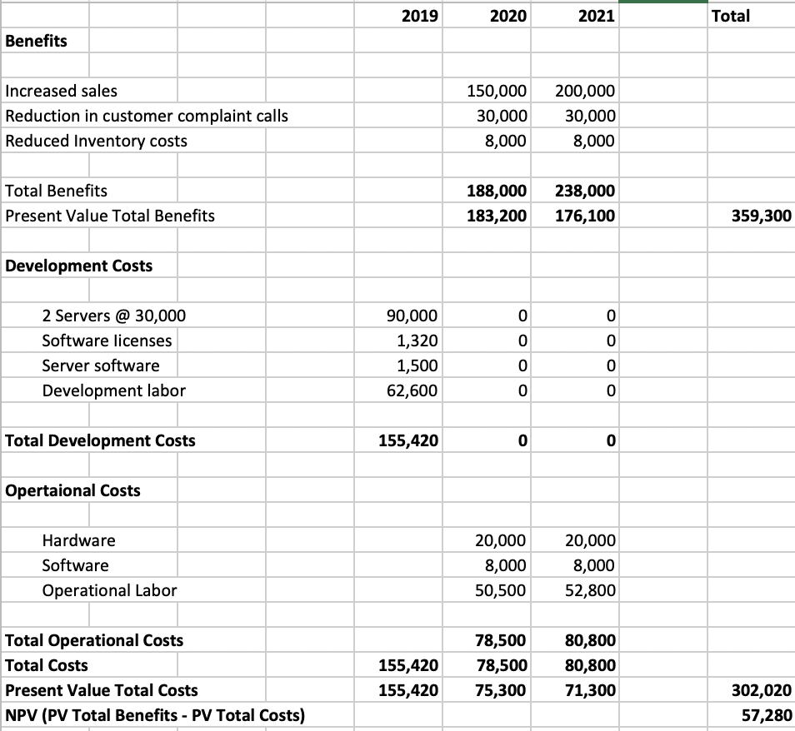

**Organizational feasibility:** Organization members

The structure of our organization is very diverse. This limits the number of stakeholders. As of now, the only stakeholders are the current founders, Tuc, Amra, Jun, Hao, Amir, and Sophia. We all have a base foundation of coding but we individually have experience in particular aspects. Tuc has experience as a supervisor, Amra has experience as a network administrator, Jun has experience as a systems administrator, Sophia has experience with web applications, Hao has experience as a systems analyst, and Amir has experience as a business analyst.

Possible partnerships/competition

Possible competition: Other textbook marketplaces like Abebook.com, Textbooks.com, Amazon, etc.

Possible partnerships: UMBC bookstore, UMBC SGA

**KanbanFlow:**

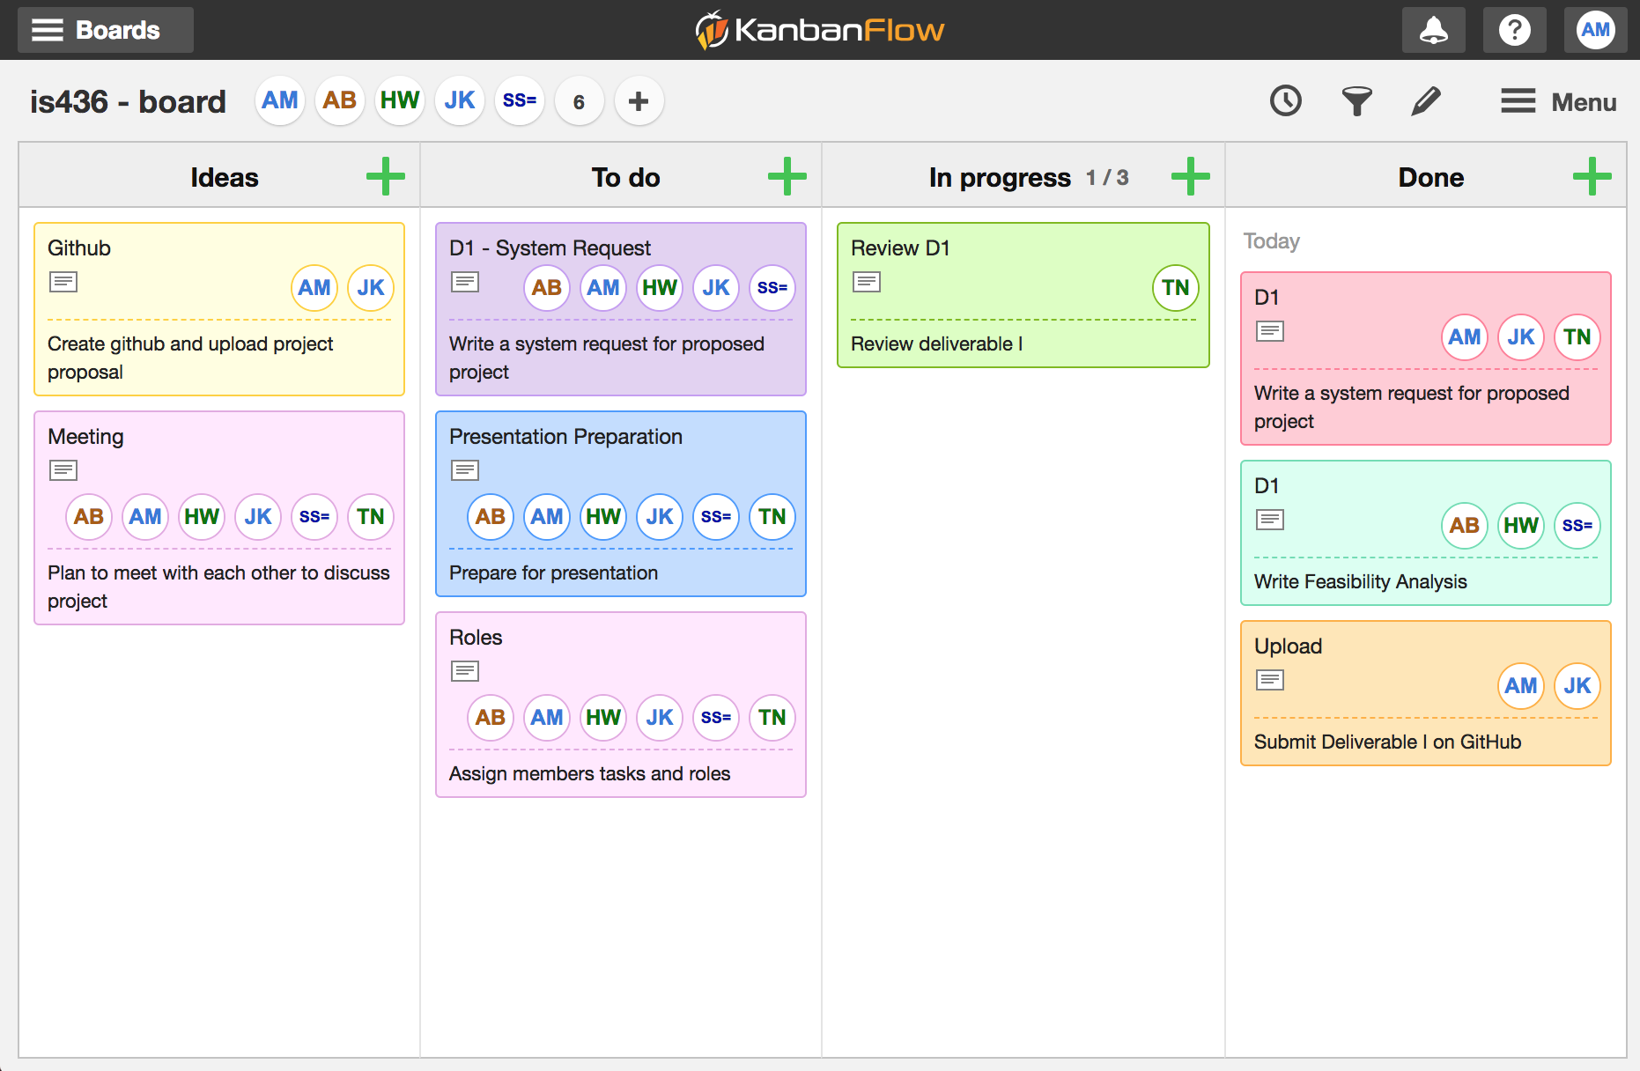

**Team Availability Chart:**

