1. ImportError: No module named MySQLdb

ImportError: No module named MySQLdb

该错误是源于我们没有安装Python连接MySQL所需的MySQLdb库而引起。

# 2. [Python version 2.7 required, which was not found in the registry](http://www.cnblogs.com/min0208/archive/2012/05/24/2515584.html)

新建一个register.py 文件，把一下代码贴进去，保存（G盘）

[复制代码](javascript:void(0);)

#

# script to register Python 2.0 or later for use with win32all

# and other extensions that require Python registry settings

#

# written by Joakim Loew for Secret Labs AB / PythonWare

#

# source:

# http://www.pythonware.com/products/works/articles/regpy20.htm

#

# modified by Valentine Gogichashvili as described in http://www.mail-archive.com/distutils-sig@python.org/msg10512.html

import sys

from _winreg import *

# tweak as necessary

version = sys.version[:3]

installpath = sys.prefix

regpath = "SOFTWARE\\Python\\Pythoncore\\%s\\" % (version)

installkey = "InstallPath"

pythonkey = "PythonPath"

pythonpath = "%s;%s\\Lib\\;%s\\DLLs\\" % (

installpath, installpath, installpath

)

def RegisterPy():

try:

reg = OpenKey(HKEY_CURRENT_USER, regpath)

except EnvironmentError as e:

try:

reg = CreateKey(HKEY_CURRENT_USER, regpath)

SetValue(reg, installkey, REG_SZ, installpath)

SetValue(reg, pythonkey, REG_SZ, pythonpath)

CloseKey(reg)

except:

print "*** Unable to register!"

return

print "--- Python", version, "is now registered!"

return

if (QueryValue(reg, installkey) == installpath and

QueryValue(reg, pythonkey) == pythonpath):

CloseKey(reg)

print "=== Python", version, "is already registered!"

return

CloseKey(reg)

print "*** Unable to register!"

print "*** You probably have another Python installation!"

if __name__ == "__main__":

RegisterPy()

[复制代码](javascript:void(0);)

输入以下命令（register.py 存放在 G盘底下）

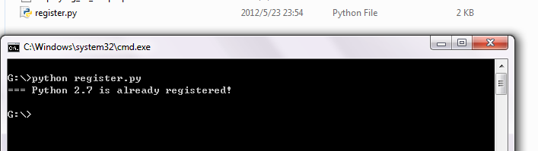

显示“python 2.7 is already registered”

再安装setuptools的时候，就能自动识别出来python2.7了。

win7是 64的原因，在安装python（32位）时，如果选择只为当前用户，以上问题是不会出现的，如果选择所有用户，那就用上面的方法解决吧。

# 3.

[ImportError DLL load failed: %1 不是有效的 Win32 应用程序](http://blog.csdn.net/seven_zhao/article/details/16945043)

win7 64位，安装mysqldb 后提示：ImportError DLL load failed: %1 不是有效的 Win32 应用程序，是由于安装的32位的 [**MySQL**](http://lib.csdn.net/base/mysql)-[**Python**](http://lib.csdn.net/base/python)-1.2.3.win32-py2.exe,，只要改成64位版本的就可以了。

如果没有找到，可以使用如下链接下载：

32位：http://download.csdn[**.NET**](http://lib.csdn.net/base/dotnet)/detail/seven_zhao/6607621

64位：http://download.csdn[**.Net**](http://lib.csdn.net/base/dotnet)/detail/seven_zhao/6607625

也可以在如下地址下载：

http://www.codegood.com/downloads

# 4.

Flask官网：http://flask.pocoo.org中文http://dormousehole.readthedocs.io/en/latest/

Flask安装：pip install flask

# 5.

官网

http://flask-script.readthedocs.io/en/latest/

安装

pip install Flask-Script

# 6.

@app.route(**'/image/<int:image_id>/'**)  
**def** image(image_id):  
 image = Image.query.get(image_id)  
 **if** image == **None** :  
 **return** redirect(**'/'**)  
 **return** render_template(**'pageDetail.html'**,image=image)

**Int与强转类型的对象之间不能加空格**

# 7.

Flask-Login（代码演示）

官方网站：http://flask-login.readthedocs.io/en/latest/

1. 初始化：login_manager = LoginManager(app)

2. 回调函数（通过session里的id获取用户信息）

@login_manager.user_loader

def load_user(user_id):

return User.query.get(user_id)

3. User用户接口

is_authenticated

is_active

is_anonymous

get_id()

核心函数和属性

login_user(user)

logout_user()

login_required

current_user

# 8. [“UnicodeDecodeError: 'ascii' codec can't decode byte”](http://stackoverflow.com/questions/21129020/how-to-fix-unicodedecodeerror-ascii-codec-cant-decode-byte)

*# encoding=utf8***import** sys  
reload(sys)  
sys.setdefaultencoding(**'utf8'**)

# 9. AttributeError: 'unicode' object has no attribute 'startsWith'

**Startswith写错了，注意大小写**