The Florida Housing Project

By Kyle Morris

DSC 630 Predictive Analytics

Spring 2020

Milestone 3

# Abstract

Given the attributes of a home, that is to say, the number of bedrooms, amenities offered, and location, we should be able to estimate the cost of the home. In this case, we would take the monthly rent to estimate the total cost of a 30 year fixed-rate mortgage. The data came from the Census bureau and classified housing units as either undervalued, overvalued, or a good fit.

# Intro/background of the problem

The Florida Housing Project will be using information collected on housing in Florida in order to predict housing costs. Given these inputs, we should be able to tell whether a house is a good deal or not based on the predicted price. I will be the only one working on this project.

There are many different styles of house available, and while I would like to focus on any single-family domiciles (while ignoring dorms, student housing, etc.) it may eventually fall to us having to focus on a single style of home. I’m hoping that we can keep all types in, however.

### Background

Ultimately, the final sale price of a home is based on what the market will bear. That being said, there are a number of tangible, measurable indicators that can have the effect on the price of a home. While some intangibles do exist, generally similar homes within the same region will sell for a similar price range. Set a price too high, and the house will sit on the market for months.

We do have some value indicators available to us in our data set. Mortgage payments and appraised value for property taxes stand out.

### Problem Statement

Through analysis of publicly available housing records in the state of Florida, the goal is to narrow down fields that have the most effect on market price. Once the 230+ fields of data have been pared down to a more manageable set, the hope is to build a linear model that can predict the price of a home and, given that value, indicate whether a home is priced as expected, priced too low, or priced too high.

### Scope

While data is available for all 50 states, the District of Columbia, and Puerto Rico, the variance between the different regions due to cost of living, availability of housing, etc. can result in wildly different values. In order to minimize this regional variation, we will be focusing only on data from the state of Florida. Data is available over both a five-year span and a single year span, and we will be focusing on a single year, the most recent data available.

Although information is provided that can be used to compare costs between multiple years, we will only be focusing on a single year’s worth of data.

# Methods

Our data will be read in the CSV format using Python. From there, we will transform and clean up the data. This outputted data will then be read into R which is what the rest of the analysis will be conducted in. We will split the data into a training set and a test set, using our model to predict the value for the test set.

As we currently have nearly 100,000 observations in our data set, we shouldn’t need fear not having enough data for analysis. However, certain programs are better suited to larger databases than others, so if we begin to run into problems, we may need to adjust our approach (or cut down our data).

Data Sources

The primary requirement for data for this project will be the housing data. We will be using data provided by the US Census. The ACS Public Use Microdata Sample files are a sample of the actual responses to the American Community Survey and include most population and housing characteristics. This information is freely provided in CSV format by the Census Bureau, and we will be using the 2018 housing data for the state of Florida.

The data was imported into Python and initial cleanup was performed. The dataset was not complete and had a number of columns with NA values. The following columns: ['BDSP', 'HUGCL', 'NPP', 'NR', 'NRC', 'PARTNER', 'PSF', 'R18', 'R60', 'R65', 'SRNT', 'SSMC', 'SVAL'] were identified as having both NAN values and values in which 0 was a valid response. In this case, a value of -1 was selected in order to provide a numerical result for the column while still differentiating the NA case from the 0 case.

The next set of columns, ['FINCP', 'OCPIP', 'SMOCP'], it was determined that the mean was more appropriate as a replacement value. Finally, the rest of the columns did not use 0 as a value and so those were put in.

Once these transformations were complete, the data was outputted back into a CSV file and sent into R. We began to look at our target variables, GRNTP (Gross Rent Payments), RNTP (Rent Payments) and VALP (Property Value). Preliminary analysis of the data showed that both rent payments were mostly normally distributed, but with huge spikes at 0 (~76% of our data points), while Property Value was positively skewed. With options for rent payments to either replace with average or remove those values, we went with removing the values. We still have 30,000 points of data without them, and we can then produce a model that predicts rent payments for renters, and house value for purchasers.

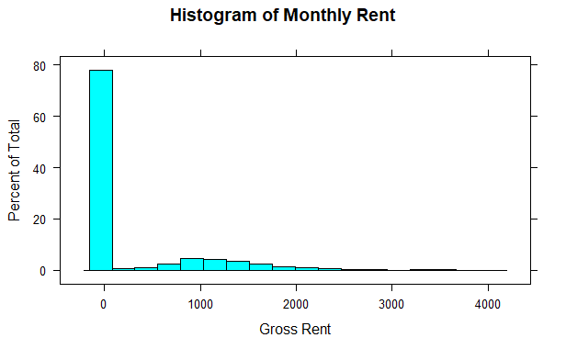

Fig. 1: GRNTP Histogram

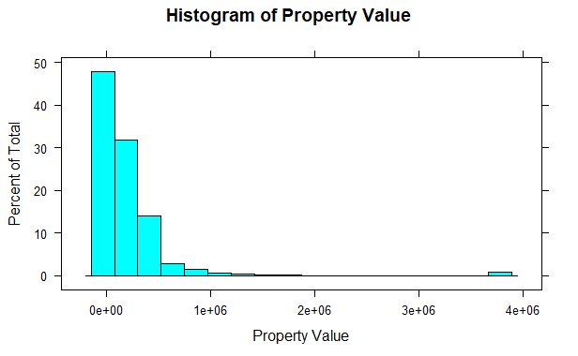

Fig. 2: VALP Histogram

A log transformation should be sufficient for the Property Value to normalize that dataset. From there, we can build the model. Our data was partitioned into 2 sets, a training set and a testing set. For the monthly rent, this was done on our subset (rent > 0) data. For property value, the original dataset was used.

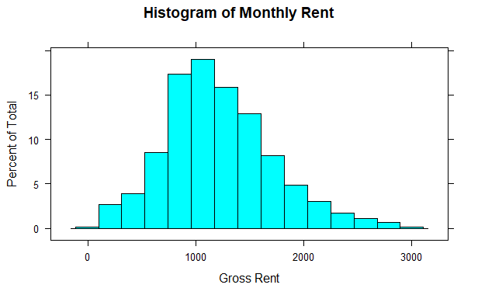

Fig. 3: GRNTP with values > 0

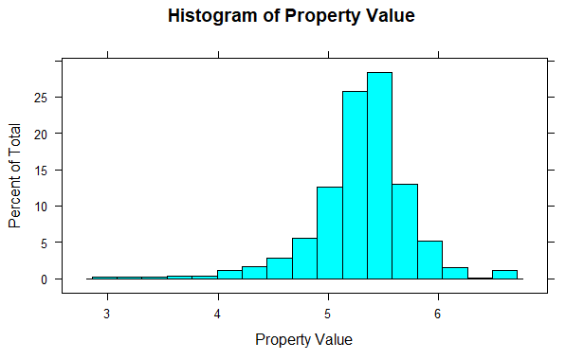

Fig. 4: VALP after log transformation.

After running the first model, it was discovered that the RNTP variable was the most significant factor. As that column does tie to GRNTP, it doesn’t actually tell us anything. The model was run again without this particular section.

# Results

After adjustment, 7 variables were identified that had both importance to determining gross rent: BDSP (number of bedrooms), ELEP (electricity cost per year), YBL (Year built), WATP (Water cost per year), BLD (building type), ACR (acreage of lot) and GASP (Gas price per year). Many of the other factors were reports on the family that lives there instead of the home itself – while knowing multimillionaires live at a home, it doesn’t necessarily translate to a better home. These 7 are more focused on the home itself.

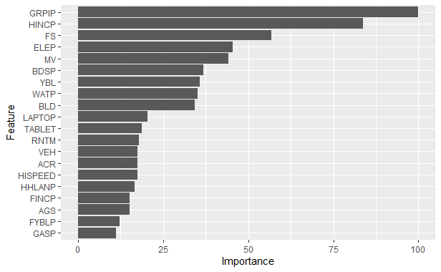

Fig. 5: Feature Importance before selection.

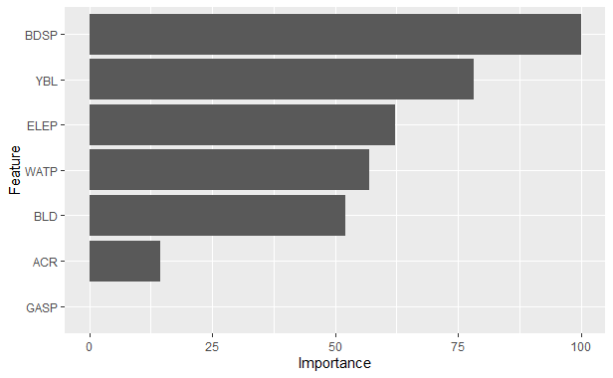

Fig. 6: Feature importance after selection.

For the Property Value, some other factors were considered. SVAL (Specified Owner Unit), BLD (building type), MHP (Mobile Home Costs), BDSP (Number of Bedrooms, YBL (Year built) , CONP (Condo Fee) , ELEP (Electricity Cost per Year), WATP (Water cost per year), and GASP(gas cost per year) were considered. While some of these are the same, they were not as important as in the rent and not necessarily in the same order.

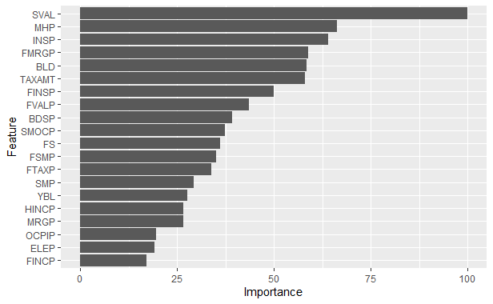

Fig. 7: Feature Importance before selection.

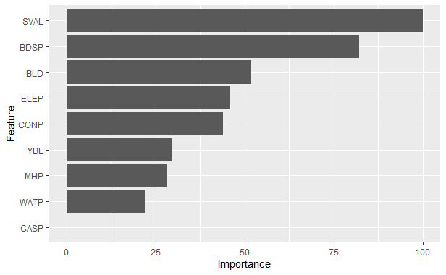

Fig. 8: Feature Importance after selection.

The resulting model was plotted against the test set. The difference between the listed value and the predicted values is as shown:

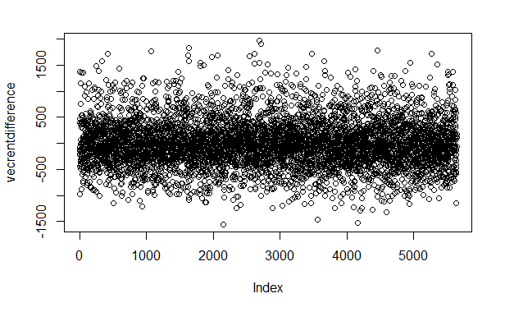

Fig. 9: GRNTP – Predicted Value.

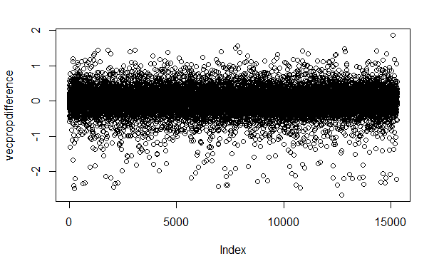

Fig. 10: VALP – Predicted Value

# Discussion/conclusion

As you can see, the vast majority of our predicted values fall within $500 of the actual values. With property values, those values are fairly close as well.

As stated in our introduction, while these values are by no means gospel, it can give you a better idea of which properties are overvalued and which are undervalued.

The results of this project could easily be adapted for use in other states. While this one was Florida focused, we could run the analysis again on another state’s properties. I suspect that the Florida Model would not perform as well on other states and it would be important to tweak things for each population of data given. Hopefully the insight gleaned in running this project would translate well to my house search later this year.

# Acknowledgments

The Census Bureau, for making their data easily accessible. It cannot be overstated how important to this project that having a good codex in place made things so much easier to interpret the data.

# References

US Census Bureau