HBAS集群部署
环境准备
系统系统 centos6.5
三台服务器：172.17.110.156/157/158
安装包： jdk-8u91-linux-x64.tar.gz
zookeeper-3.4.10.tar.gz
hadoop-2.7.6.tar.gz
hbase-2.0.1-bin.tar.gz

集群规划
node1  172.17.110.156 | node2  172.17.110.157 | Node3  172.17.110.158
NameNode | NameNode
DataNode | DataNode | DataNode
Zookeeper | Zookeeper | Zookeeper
ResourceManager | ResourceManager
NodeManager | NodeManager | NodeManager
HMaster | HMasetr
RegionServer | RegionServer | RegionServer

1、JDK安装
tar -zxvf jdk-8u91-linux-x64.tar.gz -C /usr/local/
配置环境变量
[root@admin local]# vim /etc/profile

export JAVA_HOME=/usr/local/jdk1.8.0_91
export JRE_HOME=/usr/local/jdk1.8.0_91/jre
export PATH=$JAVA_HOME/bin:$PATH
[root@admin local]# source /etc/profile
2、安装ZooKeeper
tar -zxvf zookeeper-3.4.10.tar.gz -C /data
配置zoo.cfg
cp /data/zookeeper-3.4.10/conf/zoo_sample.cfg /data/zookeeper-3.4.10/conf/zoo.cfg
vi zoo.cfg
# The number of milliseconds of each tick
tickTime=2000
# The number of ticks that the initial
# synchronization phase can take
initLimit=10
# The number of ticks that can pass between
# sending a request and getting an acknowledgement
syncLimit=5
# the directory where the snapshot is stored.
# do not use /tmp for storage, /tmp here is just
# example sakes.
dataDir=/data/zookeeper
# the port at which the clients will connect
clientPort=2181
server.1=172.17.110.156:2888:3888
server.2=172.17.110.157:2888:3888
server.3=172.17.110.158:2888:3888
# the maximum number of client connections.
# increase this if you need to handle more clients
#maxClientCnxns=60
#
# Be sure to read the maintenance section of the
# administrator guide before turning on autopurge.
#
# http://zookeeper.apache.org/doc/current/zookeeperAdmin.html#sc_maintenance
#
# The number of snapshots to retain in dataDir
#autopurge.snapRetainCount=3
# Purge task interval in hours
# Set to "0" to disable auto purge feature
#autopurge.purgeInterval=1

创建数据目录和myid
mkdir /data/zookeeper
vi /data/zookeeper/myid
myid 文件中只有一个数字，与server id对应
echo 1 >/data/zookeeper/myid

3、防火墙配置
iptables -A INPUT -p tcp -m state --state NEW --dport 2181 -j ACCEPT
iptables -A INPUT -p tcp -m state --state NEW --dport 2888 -j ACCEPT
iptables -A INPUT -p tcp -m state --state NEW --dport 3888 -j ACCEPT
保存防火墙配置规则
service iptables save
重启防火墙
service iptables restart
同步到其它机器
注：myid 文件中只有一个数字，与server id对应
4、启动zookeeper集群
启动
/data/zookeeper-3.4.10/bin/zkServer.sh start
查看状态
/data/zookeeper-3.4.10/bin/zkServer.sh status
停止
/data/zookeeper-3.4.10/bin/zkServer.sh stop
检测集群是否正常启动

5、安装HADOOP
tar -zxvf hadoop-2.7.6.tar.gz -C /data
配置环境变量
[root@admin local]# vim /etc/profile

export HADOOP_HOME=/data/hadoop-2.7.6
export PATH=$JAVA_HOME/bin:$HADOOP_HOME/bin:$PATH
[root@admin local]# source /etc/profile
再使用hadoop命令，发现可以有提示了，则表示配置生效了。

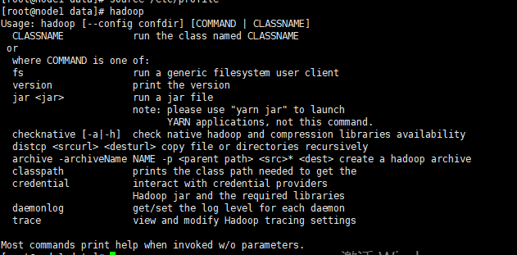

Hadoop的配置
进入hadoop-2.7.6的配置目录：
cd /data/hadoop-2.7.6/etc/hadoop
依次修改core-site.xml、hdfs-site.xml、mapred-site.xml、yarn-site.xml
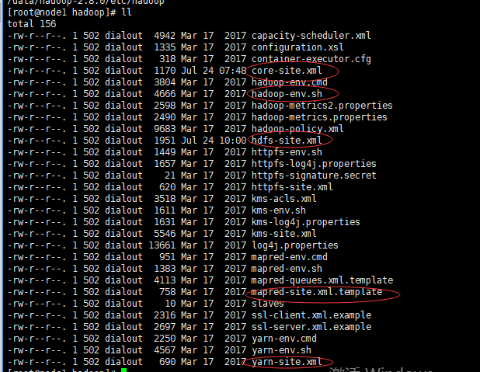
vi hadoop-env.sh
JAVA_HOME=/usr/local/jdk1.8.0_91
vi core-site.xml

<configuration>
<!-- 指定hdfs的nameservice为lw_ns-->
<property>
<name>fs.defaultFS</name>
<value>hdfs://lw_ns</value>
</property>
<!--指定hadoop数据临时存放目录-->
<property>
<name>hadoop.tmp.dir</name>
<value>/data/hadoop-2.7.6/tmp</value>
</property>

<property>
<name>io.file.buffer.size</name>
<value>4096</value>
</property>
<!--指定zookeeper地址-->
<property>
<name>ha.zookeeper.quorum</name>
<value>node1:2181,node2:2181,node3:2181</value>
</property>

</configuration>

vi hdfs-site.xml
<configuration>
<property>
<name>dfs.name.dir</name>
<value>/data/hadoop-2.7.6/name/</value>
</property>
<property>
<name>dfs.data.dir</name>
<value>/data/hadoop-2.7.6/data/</value>
</property>
<!-- 指定副本数，不能超过机器节点数 -->
<property>
<name>dfs.replication</name>
<value>3</value>
</property>

<!-- 为namenode集群定义一个services name -->
<property>
<name>dfs.nameservices</name>
<value>lw_ns</value>
</property>

<!-- nameservice 包含哪些namenode，为各个namenode起名 -->
<property>
<name>dfs.ha.namenodes.lw_ns</name>
<value>node1,node2</value>
</property>

<!-- 名为node1的namenode的rpc地址和端口号，rpc用来和datanode通讯 -->
<property>
<name>dfs.namenode.rpc-address.lw_ns.node1</name>
<value>node1:9000</value>
</property>

<!-- 名为node2的namenode的rpc地址和端口号，rpc用来和datanode通讯 -->
<property>
<name>dfs.namenode.rpc-address.lw_ns.node2</name>
<value>node2:9000</value>
</property>

<!--名为node1的namenode的http地址和端口号，用来和web客户端通讯 -->
<property>
<name>dfs.namenode.http-address.lw_ns.node1</name>
<value>node1:50070</value>
</property>

<!-- 名为node2的namenode的http地址和端口号，用来和web客户端通讯 -->
<property>
<name>dfs.namenode.http-address.lw_ns.node2</name>
<value>node2:50070</value>
</property>

<!-- namenode间用于共享编辑日志的journal节点列表 -->
<property>
<name>dfs.namenode.shared.edits.dir</name>
<value>qjournal://node1:8485;node2:8485;node3:8485/lw_ns</value>
</property>

<!-- 指定该集群出现故障时，是否自动切换到另一台namenode -->
<property>
<name>dfs.ha.automatic-failover.enabled.lw_ns</name>
<value>true</value>
</property>

<!-- journalnode 上用于存放edits日志的目录 -->
<property>
<name>dfs.journalnode.edits.dir</name>
<value>/data/hadoop-2.7.6/tmp/data/dfs/journalnode</value>
</property>

<!-- 客户端连接可用状态的NameNode所用的代理类 -->
<property>
<name>dfs.client.failover.proxy.provider.lw_ns</name>
<value>org.apache.hadoop.hdfs.server.namenode.ha.ConfiguredFailoverProxyProvider</value>
</property>

<!-- 一旦需要NameNode切换，使用ssh方式进行操作 -->
<property>
<name>dfs.ha.fencing.methods</name>
<value>sshfence</value>
</property>

<!-- 如果使用ssh进行故障切换，使用ssh通信时用的密钥存储的位置 -->
<property>
<name>dfs.ha.fencing.ssh.private-key-files</name>
<value>/home/hadoop/.ssh/id_rsa</value>
</property>

<!-- connect-timeout超时时间 -->
<property>
<name>dfs.ha.fencing.ssh.connect-timeout</name>
<value>30000</value>
</property>
</configuration>

vi mapred-site.xml
<!-- 采用yarn作为mapreduce的资源调度框架 -->
<configuration>
<property>
<name>mapreduce.framework.name</name>
<value>yarn</value>
</property>
</configuration>

vi yarn-site.xml
<configuration>

<!-- 启用HA高可用性 -->
<property>
<name>yarn.resourcemanager.ha.enabled</name>
<value>true</value>
</property>

<!-- 指定resourcemanager的名字 -->
<property>
<name>yarn.resourcemanager.cluster-id</name>
<value>yrc</value>
</property>

<!-- 使用了2个resourcemanager,分别指定Resourcemanager的地址 -->
<property>
<name>yarn.resourcemanager.ha.rm-ids</name>
<value>rm1,rm2</value>
</property>

<!-- 指定rm1的地址 -->
<property>
<name>yarn.resourcemanager.hostname.rm1</name>
<value>node1</value>
</property>

<!-- 指定rm2的地址 -->
<property>
<name>yarn.resourcemanager.hostname.rm2</name>
<value>node2</value>
</property>

<!-- 指定当前机器master188作为rm1 -->
<property>
<name>yarn.resourcemanager.ha.id</name>
<value>rm1</value>
</property>

<!-- 指定zookeeper集群机器 -->
<property>
<name>yarn.resourcemanager.zk-address</name>
<value>node1:2181,node2:2181,node3:2181</value>
</property>

<!-- NodeManager上运行的附属服务，默认是mapreduce_shuffle -->
<property>
<name>yarn.nodemanager.aux-services</name>
<value>mapreduce_shuffle</value>
</property>

</configuration>
vi slaves
node1
node2
node3

6、启动Hadoop
1)启动Journalnode
cd /data/hadoop-2.7.6/sbin
./hadoop-daemon.sh start journalnode
每台都启动
- 格式化Name和ZKFC
在node1,node2执行
cd /data/hadoop-2.7.6/bin
./hdfs namenode -format
./hdfs zkfc -formatZK

- 启动HDFS、YARN、ZookeeperFailoverController
在node1上执行
cd /data/hadoop-2.7.6/sbin
./start-dfs.sh
./start-yarn.sh
./hadoop-daemon.sh start zkfc
在node2上，启动ResourceManager，备用主节点的ResourceManager需要手动启动：
cd /data/hadoop-2.7.6/sbin
yarn-daemon.sh start resourcemanager

- 查看Namenode、ResourceManager状态
hdfs haadmin -getServiceState node1
yarn rmadmin -getServiceState rm1
hdfs haadmin -getServiceState node2
yarn rmadmin -getServiceState rm2
也可以通过Web界面来查看，浏览器中输入 ip:50070 查看HDFS，输入 ip:8088/cluster/cluster 查看YARN。
- 安装配置HBase
解压压缩包到/data/hadoop-2.7.6目录下
tar zxvf hbase-2.0.1-bin.tar.gz -C /data/hadoop-2.7.6/
cd /data/hadoop-2.7.6/hbase-2.0.1/conf
配置文档
1）vi hbase-env.sh
JAVA_HOME=/usr/local/jdk1.8.0_91
export HBASE_PID_DIR=/data/hadoop-2.7.6/hbase-2.0.1/pids
//修改HBASE_MANAGES_ZK，禁用HBase自带的Zookeeper，因为我们是使用独立的Zookeeper
export HBASE_MANAGES_ZK=false
2）vi hbase-site.xml
<configuration>
<!-- 设置HRegionServers共享目录，请加上端口号 -->
<property>
<name>hbase.rootdir</name>
<value>hdfs://node1:9000/hbase</value>
</property>

<!-- 指定HMaster主机 -->
<property>
<name>hbase.master</name>
<value>hdfs://node1:60000</value>
</property>

<!-- 启用分布式模式 -->
<property>
<name>hbase.cluster.distributed</name>
<value>true</value>
</property>

<!-- 指定Zookeeper集群位置 -->
<property>
<name>hbase.zookeeper.quorum</name>
<value>node1:2181,node2:2181,node3:2181</value>
</property>

<!-- 指定独立Zookeeper安装路径 -->
<property>
<name>hbase.zookeeper.property.dataDir</name>
<value>/data/zookeeper-3.4.10</value>
</property>

<!-- 指定ZooKeeper集群端口 -->
<property>
<name>hbase.zookeeper.property.clientPort</name>
<value>2181</value>
</property>
</configuration>
3）vi regionservers
node1
node2
node3
- 创建pid文件保存目录
mkdir -p /data/hadoop-2.7.6/hbase-2.0.1/pids
- 拷贝Hbase到其他机器
scp -r hbase-2.0.1 node2:/data/hadoop-2.7.6/
scp -r hbase-2.0.1 node3:/data/hadoop-2.7.6/
- 启动hbase
cd /data/hadoop-2.7.6/hbase-2.0.1/bin/
Node1
./start-hbase.sh
Node2
./hbase-daemon.sh start master
在浏览器中输入 ip:16010
- 集群启动结果
Hadoop + Zookeeper + HBase 高可用集群启动后，进程状态如下：
描述 | node1 | node2 | node3
HDFS主 | NameNode | NameNode
HDFS从 | DataNode | DataNode | DataNode
YARN主 | ResourceManager | ResourceManager
YARN从 | NodeManager | NodeManager | NodeManager
HBase主 | HMaster | HMaster
HBase从 | HRegionServer | HRegionServer | HRegionServer
Zookeeper独立进程 | QuorumPeerMain | QuorumPeerMain | QuorumPeerMain
NameNodes数据同步 | JournalNode | JournalNode | JournalNode
主备故障切换 | DFSZKFailoverController | DFSZKFailoverController

