

From Packets to Plant Impact

Why the next evolution of OT security monitoring isn’t about seeing more - it’s about understanding what matters
Velos Shield Point of View Whitepaper Series • August 2026

EXECUTIVE SUMMARY
The next evolution of OT monitoring is understanding, not just visibility
Operational technology monitoring has spent a decade learning to see: to discover assets, decode protocols and flag suspicious activity. That progress matters, and it isn’t finished. But in my conversations with security leaders, plant managers and engineers, I keep hearing the same underlying frustration - more dashboards, more alerts, and still not enough clarity about what actually happened and why it matters.
This paper lays out how I believe OT monitoring needs to evolve next: from seeing the plant, to preserving trustworthy evidence, to interpreting it in operational context, to grounding AI in that evidence, to remembering what the organization has already learned, and finally, to helping people understand - quickly and with confidence - what changed and what to do about it.

  Visibility, redefined
  Treated as a continuing property of the system, not a one-time sensor feature.
  Events over inventory
  The event becomes the unit of attention; the asset provides context.
  AI grounded in evidence
  Reasoning over a trustworthy, traceable representation - not raw logs.
  Memory that compounds
  Validated knowledge is retained, so the plant stops re-explaining itself.

WHAT’S INSIDE
Six beliefs, one direction
This series is deliberate in its progression. Each part builds on the one before it.

 | PART 01  See the Plant Without Touching the Plant
 | PART 02  Beyond Asset Visibility
 | PART 03  From Protocol Awareness to Operational Awareness
 | PART 04  AI Cannot Understand the Plant from Packets Alone
 | PART 05  The Plant Should Not Have to Forget
 | PART 06  When the Plant Can Explain Itself

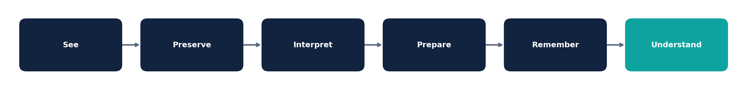
The progression this paper argues for: See → Preserve → Interpret → Prepare → Remember → Understand.

PART 01 - SEE
See the Plant Without Touching the Plant
Why passive visibility must become persistent visibility

“
A monitoring system shouldn’t be judged by whether the sensor is running. It should be judged by whether it keeps preserving evidence you can trust as the plant changes.

Passive is a method, not a guarantee
Industrial environments are difficult places to observe. Devices may be old, protocols may be unusual, traffic may be asymmetric, and changes in segmentation or maintenance can alter what a monitoring point can see.
Passive monitoring is valuable precisely because it can observe without inserting itself into control paths. But passivity alone does not guarantee complete or durable visibility - a sensor can be online while evidence is delayed, dropped, de-contextualized, or simply unavailable to the people who need it.

We treat visibility as a property, not a feature
Our view is that visibility should be understood as a continuing service property rather than an appliance checkbox. The question worth asking isn’t ‘is the sensor healthy?’ It’s ‘can the system keep preserving the evidence needed to understand what happened?’

What persistent visibility means in practice
- Evidence remains attributable to its source.
- Important events stay available even when the plant is under load or changing.
- Monitoring degradation is visible - not hidden behind a green health indicator.
- Recovery from interruptions preserves continuity instead of silently creating a blind spot.
- The operating limits of the monitoring system are understood and measurable.

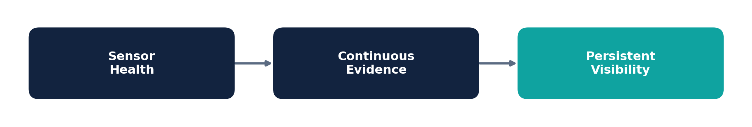
From sensor health to persistent, trustworthy visibility.
OUR POSITION
The future of passive OT monitoring isn’t simply broader coverage. It’s trustworthy, persistent visibility whose limitations are themselves observable.

Why it matters for your team
If the evidence chain can’t be trusted, everything built on top of it becomes less trustworthy - asset understanding, event detection, analytics, AI explanations, and historical analysis. Visibility is the foundation the rest of the stack has to be built on, which is exactly why we don’t treat it as solved just because a sensor is plugged in.

PART 02 - PRESERVE
Beyond Asset Visibility
Why the event should become the unit of attention

“
The event is the unit of attention. The asset is the unit of context. The process is the unit of consequence.

The industry learned to count assets - that was only step one
Asset discovery transformed OT monitoring by making previously obscure environments visible. Knowing which controllers, workstations, servers and engineering stations exist remains foundational, and we still invest heavily in getting it right.
But a plant can have a highly accurate inventory and still leave an analyst asking the most important question: what changed?

Why the event matters more than the list
An event captures a change or observation that can actually be investigated. It connects evidence to an asset, a relationship, a time window, and eventually an operational question. This doesn’t diminish asset inventory - it changes its role. Assets provide the context required to understand events, rather than being the endpoint of the analysis.
Layer | Question
Evidence | What was actually observed?
Event | What changed or occurred?
Asset | Which system or device was involved?
Relationship | How is it connected to other systems?
Process | What operational function does it support?
Context | Was it expected here and now?
Consequence | Why could it matter?

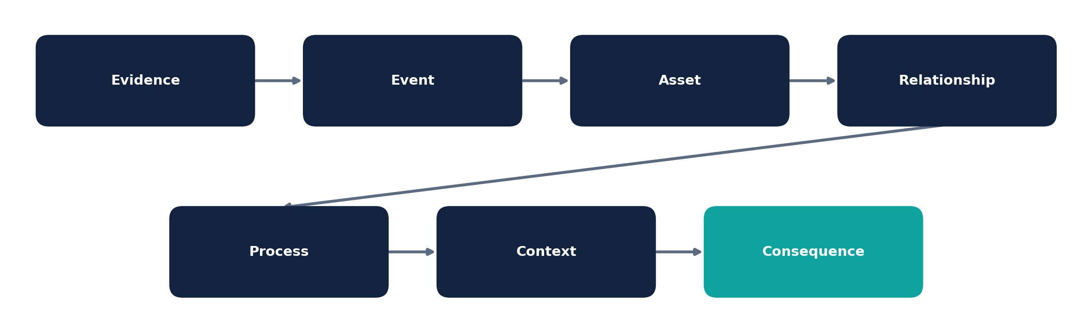
The event-centric chain: from raw evidence to operational consequence.

From alerts to durable events
We believe important events should stay traceable to their underlying evidence and remain capable of later enrichment - without rewriting what was originally observed. That separation lets the system preserve facts while allowing understanding to evolve as more context arrives.

A shift in mindset, not just terminology
An asset-centric view asks: ‘What do we have?’
An event-centric view adds: ‘What changed?’
An operational view finally asks: ‘Why does that change matter here?’ That last question is the one your team actually gets paid to answer - and it’s the one most monitoring tools are worst at supporting.
PART 03 - INTERPRET
From Protocol Awareness to Operational Awareness
Why identifying the command is only the beginning

“
Observed ≠ inferred ≠ impact. Each layer should retain its own evidence and its own uncertainty.

Protocol meaning is not plant meaning
Protocol decoding is essential - it establishes what happened at the technical level. But an industrial command doesn’t carry its full operational meaning inside the packet itself. The same controller write, configuration change, or engineering action can mean very different things depending on who initiated it, when it happened, what the plant was doing, whether it was authorized, and what process depends on the target.

Four levels of understanding
- Packet - What traffic was observed?
- Protocol - What industrial action occurred?
- Operational observation - Was the action expected in this setting?
- Plant-impact hypothesis - What could the operation experience?


Each layer of interpretation should retain its own evidence and uncertainty.

What we think a useful system should actually say
Suppose a controller program download is observed. The network can establish that the download occurred. Identity systems may establish the source. Asset context may establish the controller’s role. Historical information may show that similar activity is common during maintenance.
If today’s maintenance context is missing, the responsible conclusion isn’t automatically ‘attack.’ It’s that a technically significant action occurred and its legitimacy requires validation. This distinction matters in OT specifically because legitimate exceptions are part of normal plant operation - unlike in IT, where the same pattern might reasonably default toward suspicion.
THE OBJECTIVE ISN’T CERTAINTY AT ANY COST
A monitoring system should make uncertainty useful - exposing what’s known, what’s inferred, what’s missing, and what evidence would resolve it. That beats forcing every unusual event into a binary malicious/benign call.

PART 04 - PREPARE
AI Cannot Understand the Plant from Packets Alone
Why trustworthy industrial AI starts with evidence

“
AI shouldn’t become the source of truth for the plant. It should reason over a trustworthy, structured and traceable representation of what the plant already knows.

The AI temptation - and why we resist it
Industrial environments generate enormous volumes of telemetry. It’s tempting to point a language model at raw logs or packet-derived data and ask it to explain what’s happening. We think that approach starts at the wrong layer. Data volume does not equal operational understanding, and I’d be doing you a disservice if I pretended otherwise just because it makes for a cleaner demo.

Build the evidence chain first - then let AI reason over it
Deterministic systems should keep establishing protocol facts. Normalization should create stable representations. Event construction should preserve durable units of attention. Context should connect events to assets, identities, timing and process information. Only then should AI operate as an interpretation and reasoning layer over that representation - not as a replacement for it.
Layer | Our view
Capture | Preserve network evidence without changing the control process.
Protocol | Establish deterministic technical facts.
Normalization | Create stable, machine-readable representations.
Events | Preserve durable units of attention.
Context | Connect evidence to assets, timing, roles and processes.
Memory | Retain validated relationships and history.
AI | Explain, correlate, summarize and generate bounded hypotheses.
Human / workflow | Validate consequential interpretations and actions.

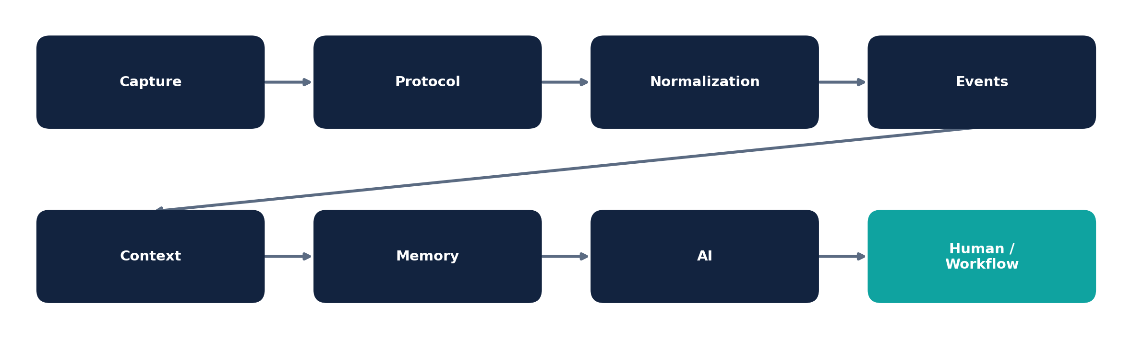
Evidence, context and memory precede AI in our stack - not the other way around.

Trustworthy AI is also a provenance problem
A useful industrial assistant should be able to show where an answer came from. Factual statements should trace to evidence; hypotheses should be clearly labelled; missing context should be visible rather than papered over. The goal isn’t to make the model sound certain - it’s to make its uncertainty understandable and actionable for the person relying on it.
OUR POSITION
The industrial AI opportunity isn’t ‘put an LLM on the logs.’ It’s building an evidence-aware intelligence layer over a trustworthy representation of the plant.

PART 05 - REMEMBER
The Plant Should Not Have to Forget
How operational memory should change OT monitoring

“
Every validated investigation has the potential to make the plant easier to understand the next time the same relationship or pattern appears.

Your plant generates knowledge, not just telemetry
An engineer explains why a vendor workstation connects to a controller. An operator confirms a configuration change is normal during a maintenance window. A security analyst determines a recurring communication path is legitimate. That knowledge usually lives in tickets, spreadsheets, emails, and individual memory - and when the investigation closes, the monitoring system often keeps the event but loses the lesson. The result is a costly loop: the same people keep re-explaining the same relationships.
THE BIG IDEA
The plant should not have to forget what its people have already learned.

What we mean by ‘plant memory’
Plant memory isn’t a giant archive of everything that has ever happened. It’s a curated representation of evidence-backed relationships, normal patterns, exceptions, decisions and historical context. A knowledge graph is one possible implementation - but the graph itself isn’t the important idea. The important idea is that validated knowledge becomes reusable context.
Memory | Example
Relationship | Vendor workstation regularly reaches a controller
Expected pattern | Maintenance activity occurs within an established window
Exception | Temporary access is approved until a defined date
Decision | An observed action was validated as legitimate
Dependency | A controller supports a particular production function
History | A similar event occurred and was previously explained

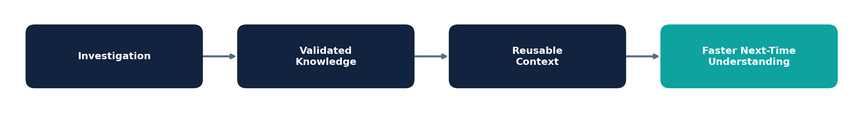
Validated knowledge becomes reusable context - so the next investigation starts further ahead.

Memory has to stay honest
Plants change. Assets get replaced, vendors change, network paths get redesigned, and maintenance practices evolve. We believe operational memory should carry provenance, time, confidence, ownership and validity - a relationship that was true last year shouldn’t silently become today’s truth.
VALIDATED PLANT MEMORY
Remember what was learned, preserve why it was believed, and make it possible to know when that knowledge should no longer be trusted.

PART 06 - UNDERSTAND
When the Plant Can Explain Itself
From monitoring events to operational understanding

“
The goal of the next generation of OT monitoring isn’t more alerts. It’s shrinking the distance between something happening and people understanding what happened, why it matters, and what to validate.

Where the first five ideas are headed
Trustworthy visibility, durable events, operational context, and evidence-and-memory-grounded AI aren’t separate initiatives. They’re building blocks. This final part is the consequence of putting them together.
THE PROGRESSION
PACKET → EVENT → ASSET → RELATIONSHIP → CONTEXT → MEMORY → INTERPRETATION → VALIDATION → OPERATIONAL UNDERSTANDING

From reporting to explaining
At the lowest level, the system reports that a controller write occurred. It identifies the source and destination. Context establishes the controller’s operational role. Memory shows whether similar activity has been observed and previously explained. Current context determines whether today’s activity resembles or differs from that history. The system can then present an evidence-backed explanation, make uncertainty explicit, and identify what should be validated next.

What ‘the plant can explain itself’ actually means
This phrase is intentionally provocative, but it doesn’t mean autonomous control or an all-knowing AI. It means the monitoring environment can assemble evidence, context, history and reasoning into an explanation a human can actually evaluate - quickly, and without having to trust a black box.
A useful explanation should answer | Our expectation
What happened? | State the observed event and its evidence.
What supports it? | Show the relevant evidence and provenance.
Why does it matter here? | Connect the event to assets, relationships and process context.
What remains uncertain? | Explicitly expose missing or ambiguous information.
What should happen next? | Identify a sensible validation or investigation step.

The intelligence loop
- Observe - collect evidence without interfering with the process.
- Preserve - retain important events and their provenance.
- Interpret - distinguish facts from inference.
- Contextualize - connect activity to assets, roles, processes and timing.
- Remember - retain validated knowledge and exceptions.
- Explain - assemble evidence into an understandable narrative.
- Validate - involve the appropriate human or external system.
- Learn - allow validated outcomes to improve future interpretation.

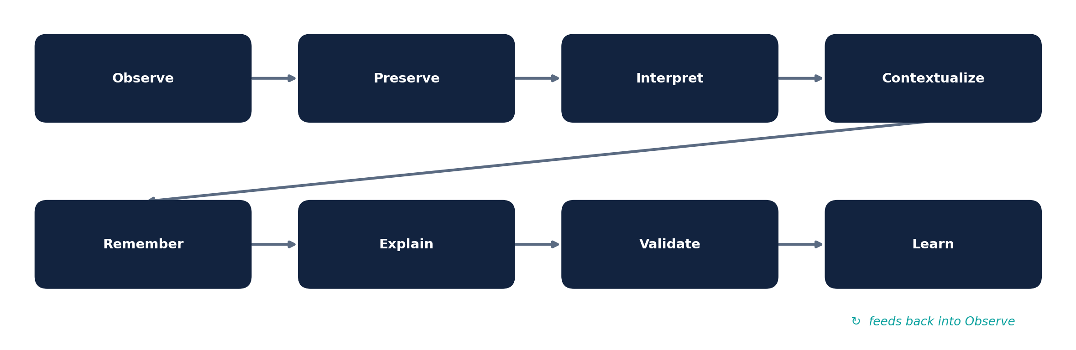
Understanding as a continuous, self-reinforcing cycle - not a one-time report.

Where we see AI fitting - and where it doesn’t
AI becomes a reasoning and explanation layer, not the foundation of truth. Deterministic systems establish facts. Contextual systems establish relationships. Memory preserves validated knowledge. AI helps people navigate complexity - and humans stay in the loop wherever consequences are significant. I don’t think that changes any time soon, and I wouldn’t want it to.
WHITEPAPER IN ONE STATEMENT
Intelligence doesn’t begin with AI. It begins with evidence. It gains value through context. It becomes more useful through memory. And it earns trust through traceability and human validation.

CLOSING
Where we think this industry is headed
OT monitoring is moving from a visibility problem toward an understanding problem. The winners of that transition won’t necessarily be the systems that produce the greatest number of detections. They’ll be the systems that preserve trustworthy evidence, understand it in the context of a specific plant, remember what the organization has learned, and help people act on that understanding. That’s the direction we’re building toward - and the standard I want us to be measured against.
CLOSING THOUGHT
The future of OT monitoring may not be defined by how many packets a system can see or how many alerts it can generate. It may be defined by how well it can preserve evidence, remember what the plant has taught us, and explain what changed in terms that matter to the operation.

A position, not a product claim
This paper describes our perspective on how OT monitoring can evolve. It intentionally doesn’t present every idea here as an already-shipped capability, and it doesn’t claim this is the only valid architecture.
LET’S TALK
How you think about OT Security, we’d like to hear it. Reach out to us in contact@velosshield.com to continue the conversation.

About Velos Shield
Velos Shield builds OT monitoring designed around trustworthy evidence, operational context and persistent memory - so security and engineering teams spend less time re-discovering what they already know, and more time acting on what matters.

