**MBAA811 Thesis Outline**

**Saturday, March 4, 2017**

Table of Contents

1. Executive Summary 3

Introduction 3

Company and Management 3

Market Opportunities 3

Financial Projections 3

1. Business Opportunity 4
2. Market Analysis 5
3. Competitive Analysis 6
4. Marketing Plan 7
5. Operational Plan 8
6. Financial Plan (forecasts, p&l, balance sheet, cash statements) 9
7. Future Opportunities for Growth 10
8. Bibliography 11
9. Appendices 14

Appendix 1 Business Opportunity 15

Appendix 2 Market Analysis 15

Appendix 3 Competitive Analysis 15

Appendix 4 Marketing Plan 15

Appendix 5 Operational Plan 15

Appendix 6 Financial Plan (forecasts, p&l, balance sheet, cash) 15

Appendix 7 Future Opportunities for Growth 15

# Executive Summary

## Introduction

## Company and Management

## Market Opportunities

## Financial Projections

# Business Opportunity

Background

# Market Analysis

Text 3

# Competitive Analysis

Text 4

# Marketing Plan

Targeting customers

Marketing Strategy

Marketing Targets

Customer Feedback

# Operational Plan

# Personnel

Recruitment and training

# Financial Plan (forecasts, p&l, balance sheet, cash statements)

# Financial history

Projections

Detail next 3 years

Cash flow 12 months

# Future Opportunities for Growth

Text 8

# Bibliography

American Medical Writers Association. (2016). *2015 Salary Survey: Highlights for Employee Medical Writers.* Retrieved March 4, 2017, from AMWA Resources: http://www.amwa.org//Files/Employee%20Infographic%20FINAL%206.21.16.pdf

American Medical Writers Association. (2016). *2015 Salary Survey: Highlights for Freeland Medical Writers and Editors.* Retrieved March 4, 2017, from http://www.amwa.org//Files/Freelance%20Infographic%20FINAL%206.21.16.pdf

Antonijevic, Z. (2015). Need for Optimal Design of Pharmaceutical Programs and Portfolios in Modern Medical Product Development. In Z. Antonijevic, *Optimization of Pharmaceutical R&D Programs and Portfolios: Design and Investment Strategy* (pp. 3-16). Cham, Switzerland: Springer.

Antonijevic, Z., Bolognse, J., Burman, C., Chuang-Stein, C., Jennison, C., Kimber, M., . . . Pinheiro, J. (2015). Impact of Phase 2b Strategies on Optimization of Drug Development Programs. In Z. Antonijevic, *Optimization of Pharmaceutical R&D Programs and Portfolios: Design and Investment Strategy* (pp. 83-103). Cham, Switzerland: Springer.

BioBridges. (2014). *Clinical Regulatory Medical Writing Forum: Ensure structured content, ef cient review processes and streamline submissions while remaining compliant with the changing regulatory guidelines.* Retrieved March 4, 2016, from http://www.biobridges.com/sites/default/files/C523_WP_Final.pdf

Chen, C., Beckman, R. A., & Sun, L. Z. (2015). Maximizing Return on Investment in Phase II Proof-of-Concept Trials. In Z. Antonijevic. Cham, Switzerland: Springer.

Dezzani, L. (2017). *Top 20 Pharma Companies based on R&D Investments in 2015-16*. Retrieved March 4, 2017, from IGEAHUB: https://igeahub.com/2017/02/09/top-20-pharma-companies-based-on-rd-investments-in-2015-16/

Getz, K. A., & Kaitin, K. (2014). Why Does the Industry Need a Change? In P. Schueler, & B. Buckley, *Re-Engineering Clinical Trials: Best Practices for Streamlining the Development Process* (pp. 3-15).

Getz, K. A., & Kaitlin, K. (2015). The Impact of Bad Protocols. In S. P, & B. B, *Re-Engineering Clinical Trials: Best Practices for Streamlining the Development Process* (pp. 105-116). Elsevier.

Getz, K. A., Kim, J., Stergiopoulos, S., & Kaitlin, K. (2013). New governance mechanisms to optimize protocol design. *Drug Inform J, 47*.

Getz, K. A., Stergiopoulos, S., Short, M., Surgeon, L., Krauss, R., Pretorius, S., . . . Dunn, D. (2016). The Impact of Protocol Amendments on Clinical Trial Performance and Cost. *Therapeutic Innovation & Regulatory Science, 50*(4), 436-441.

Getz, K. A., Zuckerman, R., Cropp, A., Hindle, A., Krauss, R., & Kaitlin, K. (2011). Measuring the incidence, causes, and repercussions of protocol amendments. *Drug Inform, 45*, 265-275.

Hans, A. (2015). Experiences with Lean and Shop Floor Management in R&D in Other Non-Pharmaceutical Branches. In P. Schüler, & B. Buckley, *Re-Engineering Clinical Trials: Best Practices for Streamlining the Development Process* (pp. 65-76). Elsevier.

Luisi P., R. W. (2015). Re-Engineering Clinical Trials: Best Practices for Streamlining the Development Process. In P. Schüler, & B. Buckley, *Re-Engineering Clinical Trials* (pp. 41-53). Elsevier.

Nixon, R., & Ireland, B. (2015). Using Decision Analysis to Support the Design of Clinical Trials Within a Program. In Z. Antonijevic. Cham, Switzerland: Springer.

Persinger, C. (2015). Challenges of Portfolio Management in Pharmaceutical Development. In Z. Antonijevic, *Optimization of Pharmaceutical R&D Programs and Portfolios* (pp. 71-80). Cham, Switzerland: Springer.

Schüler, P., & Heering, C. (2015). What Makes a Good Protocol Better? In P. Schüler, & B. Buckley, *Re-Engineering Clinical Trials: Best Practices for Streamlining the Development Process.* Elsevier.

Schuhmacher, A., Gassmann, O., & Hinder, M. (2016). Changing R&D models in research-based pharmaceutical companies. *Journal of Translational Medicine, 14*(105), 1-11.

Schulz, K. F., Bobulsky, S. T., David, F. S., Patel, N. R., & Antonijevic, Z. (2015). Drug Development and the Cost of Capital. In Z. Antonijevic, *Optimization of Pharmaceutical R&D Programs and Portfolios: Design and Investment Strategy* (pp. 35-47). Cham, Switzerland: Springer.

Sullivan, L. B. (2015). How Quality Performance Metrics Enable Successful Change. In P. Schüler, & B. B, *Re-Engineering Clinical Trials: Best Practices for Streamlining the Development Process* (pp. 337-347). Elsevier.

Writing Assistance, Inc. (2013). *A Guide to Estimating Medical Writing Projects*. Retrieved March 4, 2016, from http://www.writingassist.com/pdfs/estimatingmedicalwritingguide_v2_1_2013.pdf

# Appendices

## Appendix 1 Business Opportunity

Text 2

## 

## Appendix 2 Market Analysis

Text 3

## 

## Appendix 3 Competitive Analysis

Text 4

## 

## Appendix 4 Marketing Plan

Text 5

## Appendix 5 Operational Plan: Organization

MW Resourcing Strategic Plan Template (available through BioBridges). Need to update & Modfify. http://www.biobridges.com/knowledge-center/articles

<Note: modify table as appropriate to your needs.>

| **Table 1 Medical Writing Human Resource Options** | | |
| --- | --- | --- |
| **Resource Term** | **Typical Working Location** | **Definition** |
| Full-Time Employee (FTE) | Onsite | Individual contributors who work directly for the sponsor company, typically for 40 hours per week (or more when there are pressing deadlines) |
| Part-Time Employee (PTE) | Onsite | Individual contributors who work directly for the sponsor company, typically for less than 40 hours per week |
| Contractor/ Consultanta | Onsite or Offsite | For this article, individual consultants and contractors are referred to simply as consultants; the terms often mean the same thing, except in a financial or legal sense.  Consultants may be self-employed, work with other consultants, or work for a larger organization (described in Table 2). They may charge an hourly or project rate. Consultants may work onsite or remotely, may be solely dedicated to a company (full-time or part-time), or provide occasional support. They also vary in their location and therefore proximity to your office.   * Onsite consultants often work both remotely and in the company office, but could work in your office full-time (thus referred to as “onsite”); they may work onsite 1 day a week or more, as necessary for meetings with team members, or to obtain document approval signatures. They often have access to a company computer and will likely need little support or oversight from you after introductory training on departmental processes. * Offsite consultants work remotely, but depending on their proximity to the company office and availability, may make regular visits to the office, eg, monthly. They may or may not have access to a company computer, which could affect the level of support needed from you; eg, uploading documents to a company’s document management system. * CRO writers are employed by CROs and are either solely dedicated to a client company (referred to in this paper as a Dedicated Writer) or supporting more than 1 such company (referred to in this paper as a General Writer). Whether or not the CRO has the status as a company’s preferred provider could affect the number of available General and Dedicated writers. |

<Note: modify table as appropriate to your needs.>

| **Table 2 Medical Writing Resource Providers** | | |
| --- | --- | --- |
| **Provider Term** | **Typical Work Location** | **Definition** |
| Contract Resource  Organization (CRO) | Offsite | CROs, while originally dedicated to running clinical trials for sponsor companies, now offer functional and flexible resource options such as statistical analysis or medical writing, which is performed by either a dedicated or non-dedicated individual or team for a specific task or ongoing needs. |
| Contingent Resource  Provider (CRP) | Offsite or onsite | A CRP is a term used for a business that employs or contracts seasoned consultants and designs flexible and scalable human resourcing for a sponsor company. A CRP can provide anything from remote consultants working on a single, short-term project to an entire fleet of consultants working over many years. |
| Functional Service  Provider (FSP) | Onsite | The term “functional” in FSP refers to an entire department or function, such as regulatory affairs. Therefore, the FSP will employ resources who work within a company’s business, in house or remotely, but are paid and managed by the FSP. The main difference between a CRP and FSP is that the FSP may directly manage individuals working at the sponsor company (while a CRP provides consultants who are managed by the sponsor). |
| Individual Contractor/ Consultant | Offsite or onsite | This term refers to an individual contractor/consultant who has a contract directly with the sponsor company. |

## Appendix 6 Operational Plan: Resourcing

. <Note: modify table as appropriate to your needs.>

| **Table 3 Medical Writing Typical Document Types** | |
| --- | --- |
| **Document Name** | **Abbreviation** |
| Clinical Study Protocol/Amendment | Protocol |
| Investigator Brochure | IB |
| Model Informed Consent Form | Model ICF |
| Clinical Study Report | CSR |
| Briefing Document | BD |
| Common Technical Document Module | CTD Module |

***Building Block 3: Functional and Corporate Essential Attributes***

This section contains essential background informational that influence our resourcing decision-making: <Note: modify table as appropriate to your needs.>

* Company, business-unit, and individual relevant objectives or goals
* Internal MW functional overview—current resources, departmental strengths and weaknesses
* Internal MW staff—as individual strengths and weaknesses, unique aspects of the team, relevant goals

Table 4 provides an overview of the essential information that will influence our resourcing strategy. <Note: modify table as appropriate to your needs.>

| **Table 4 Relevant Goals and Issues** | | |
| --- | --- | --- |
|  | **Relevant Goals** | **Comments** |
| Overall Business |  |  |
| Department or Division or Business Unit |  |  |
| Functional Area |  |  |

Table 5 is an assessment of the quantity and capabilities of our internal resources within the context of the relevant goals noted above. <Note: modify table as appropriate to your needs.>

| **Table 5 Medical Writing Team Strengths and Considerations** | | |
| --- | --- | --- |
| **Resource** | **Strengths** | **Considerations** |
| Overall MW Team |  |  |
| <Writer 1> |  |  |
| <Writer 1> |  |  |
| <Writer 1> |  |  |
| <Consultant 1> |  |  |
| <Consultant 1> |  |  |
| <CRO writer 1> |  |  |
| <CRO writer 2> |  |  |

***Building Block 4: Weighting Scales***

The content in Tables 3, 4, and 5 are now transformed into weighting scales that can be utilized to evaluate one type of project to another, and one type of human resource to another, for the purposes of assigning the right resource to a project. Note that, in these scales, relative values are placed on different attributes, and the scales have a range of high=10 and low=1. However, it is essential to realize that neither high nor low is better or worse than one another; they are simply different and present a range of attributes.

Table 6 is a chart that provides a range of important attributes to be used for assigning a score to a specific document or document type. <Note: modify table as appropriate to your needs.>

| **Table 6 Document Weighting Scale** | | |
| --- | --- | --- |
| **Scientific Complexity** | **Project Complexity** | **Corporate Importance** |
| Documents that require significant scientific and/or medical interpretation by the writer in dialogue with the medical monitor. | Documents that must align with other documents being prepared simultaneously or sequentially; these are often part of a larger, complex submission. | Documents that are a part of corporate or departmental goals and the outcome will significantly impact the goals and/or the perception of Medical Writing. |
| **Scoring: High=10, Low=1** | | |

Table 7 is a chart that provides a range of important attributes to be used for assigning a score to a resource or resource type. <Note: modify table as appropriate to your needs.>

| **Table 7 Writer Capabilities Weighting Scale** | | | |
| --- | --- | --- | --- |
| **Scientific Data Interpretation Skills** | **Project Management Skills** | **Knowledge of Teams, Processes, Products** | **Ability to Work Independently** |
| Ability to provide significant scientific, medical, and/or data interpretation skills. | Ability to initiate, manage, and complete projects with little to no guidance and in alignment with cross-functional teams and business processes. | Strong relationships and mutual respect with team members; strong knowledge of current business processes and products. | Ability to work without significant management or oversight. Knows when to act independently and when to ask for help. |
| **Scoring: High=10, Low=1** | | | |

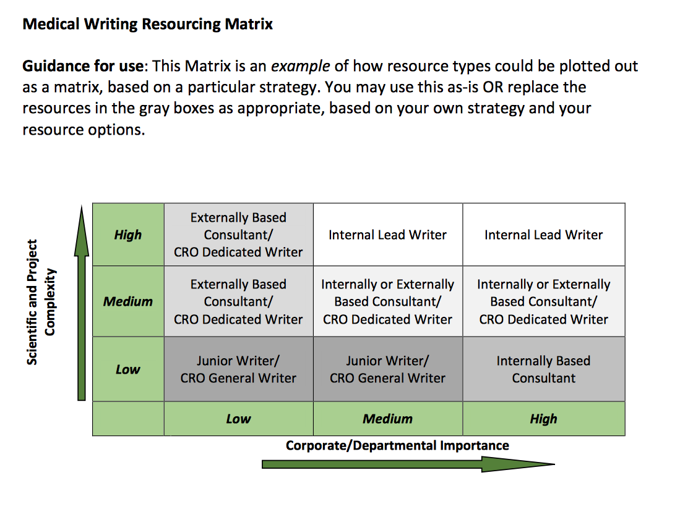

|  |  |  |
| --- | --- | --- |
| **Resource** | **Role** | **Points** |
| Internal FTE Writer | Program-Dedicated Writer | 8-10 points |
| Junior Writer | 5-6 points |
| Consultant | Internally Based Writer | 7-9 points |
| Externally Based Writer | 4-7 points |
| CRO | Dedicated Writer | 5-7 points |
| Other | 0-3 points |

## Appendix 6 Financial Plan (forecasts, p&l, balance sheet, cash)

Text 7

Expenses

Staff

Supplies

Computers

Services – Webex

## 

## Appendix 7 Future Opportunities for Growth

Text 8