**Dungeon 2**: Mistress’ Fashion Sense (Cloth Simulation, **34g of total 100 g**). 1g may be exchanged for a human percentage point in COMP5823M.

The Great Designer Mistress Fingercutter is the fashion designer responsible for the costumes for the birthday celebrations of Lord Spinhead. She is designing a long dress with unheard of patterns that requires extremely careful cutting and sewing. After accidentally chopping off some of her helpers’ fingers, she has finalised the design but still wants to test different fabrics.

You, my loyal geniuses, will provide your assistance. You will build a cloth simulation system to show different fabric behaviours. It should come with a GUI where you can load/write cloth mesh files (OBJ files). It should also be able to detect and resolve simple cloth-object collisions. Mistress Fingercutter has graciously agreed that the first demo can be uncomplicated which only involves a couple of simple scenarios.

For your hard work, the Mistress Fingercutter has graciously agreed to give you rewards for:

1. A GUI to load OBJ files and render them in OpenGL (simple rendering without textures is acceptable). (**5g**)
2. The same GUI to write OBJ files. This should write a single frame into an OBJ file.(**5g**)
3. A mass-spring model to simulate a piece of cloth with arbitrary shapes specified by an OBJ file mesh. The mesh vertices are modelled as point masses and the mesh edges are modelled as springs. Simulate the cloth free falling onto the floor, with cloth-floor collisions handled (not cloth self-collisions). The floor is defined by a plane through the origin with a normal of 0,1,0. (similar to the figure below **7g**)

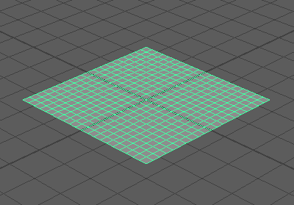

1. Simulation Scenario 1 (SS1): a square piece of cloth floating horizontally in the air, which then free-falls onto a sphere on the ground (similar to the figure below). (**4g**)

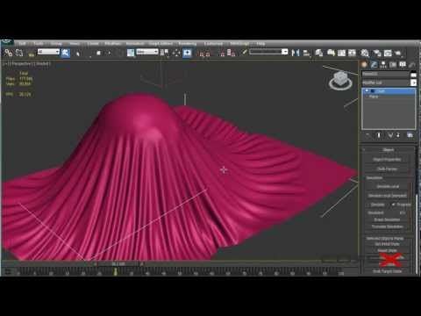

1. Simulation Scenario 2 (SS2): a square piece of cloth floating horizontally in the air first, then free-falling with two adjacent corners fixed in the space. (**4g**)
2. SS1 with the sphere rotating in-place round the Y axis (up-axis) and friction between the sphere and the cloth. (**3g**)
3. SS2 with wind blowing. (**3g**)
4. Texture, lighting, and the ability to export the simulation result to a video. (**3g**)

The total reward is **5g + 5g + 7g + 4g + 4g + 3g + 3g + 3g** = **34g**.

There are several places in town where you can find assistance.

Hint 1: The Mesh Master at the Asylum of Geometry. (You can find the specs of OBJ files at https://en.wikipedia.org/wiki/Wavefront_.obj_file and some sample code in Minerva under Lab Resources)

Hint 2: The Geomonger (a person who sells raw geometries) at the Mesh take-out place. (You can find other mesh software to help you debug and test your system. Meshlab: http://www.meshlab.net/)

Hint 3: It is acceptable to export frames into images first, then use tools such as ffmpeg to make videos.

Hint 4: The collision between the ball and the cloth should not be sticky. It can be implemented by a post-processing step to move any vertex inside the sphere to the closest point on the surface of the sphere.

Hint 5: Wind blowing can be modelled as a steady force in a fixed direction.

Hint 6: At each cloth vertex, the friction force between the sphere and the cloth is always in the opposite direction of their relative motions. The plane the friction force lies in is orthogonal to the surface normal of the sphere at that cloth vertex.

Hint 7: How to fix a corner at a location? In a mass-spring model, this can be easily done by not updating the velocity and position of that corner vertex!

**The whole submission needs to be implemented in Visual Studio C++. It should be your own work except for any third-party libraries. Make sure that you submit a zip file containing the *whole* Visual Studio solution. You are free to use third-party libraries for GUI, rendering, triangulation, video-capture and linear algebra operations, etc. But IT SHOULD BE STANDALONE SO THAT I CAN RUN IT ON MY WINDOWS COMPUTER. If you choose to do it on other platforms e.g. Linux, please also submit the whole project including the makefiles. And you will be asked to give me a live demo for assessment.**