Jeffrey Lanning

Lab 1 - CS5590VC

1. Scrumdo tasks:

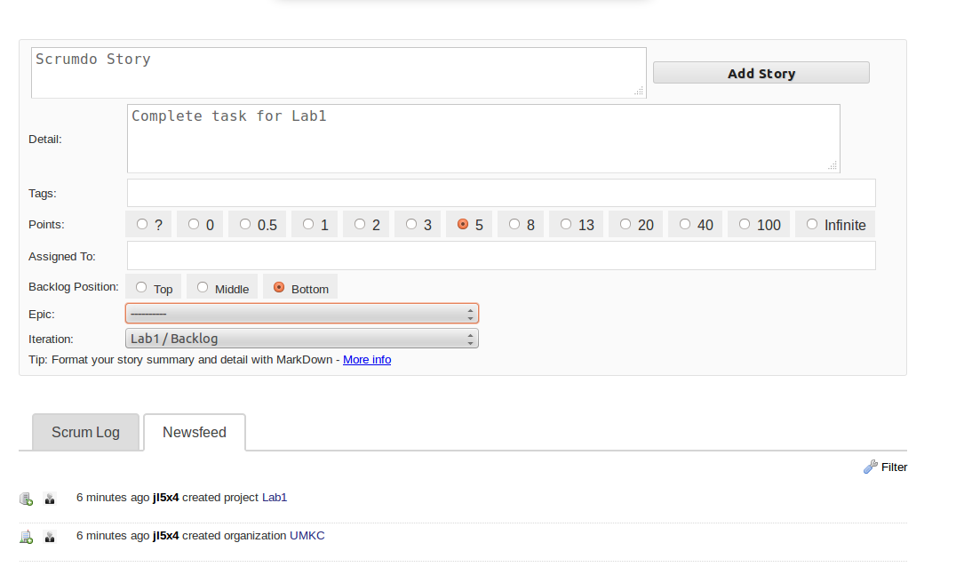

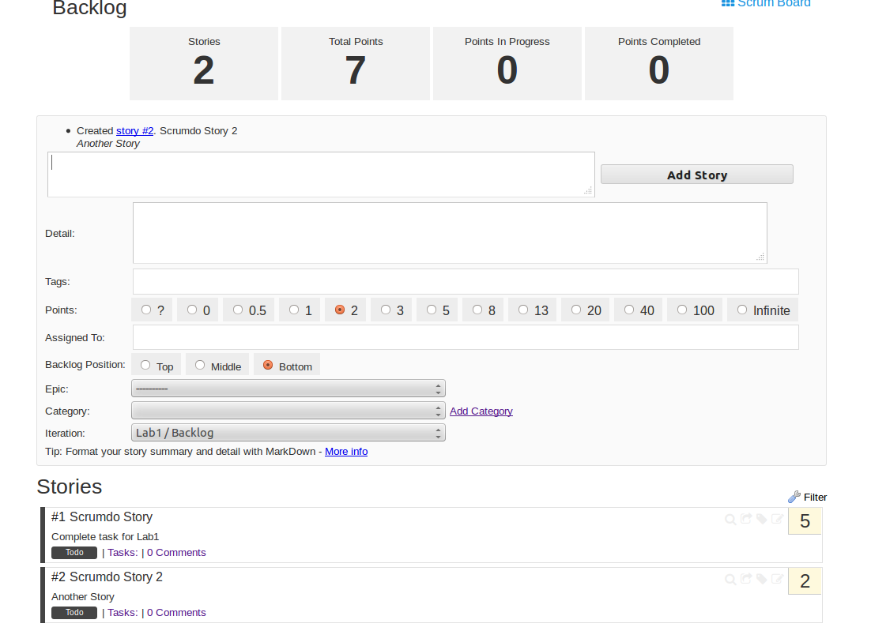

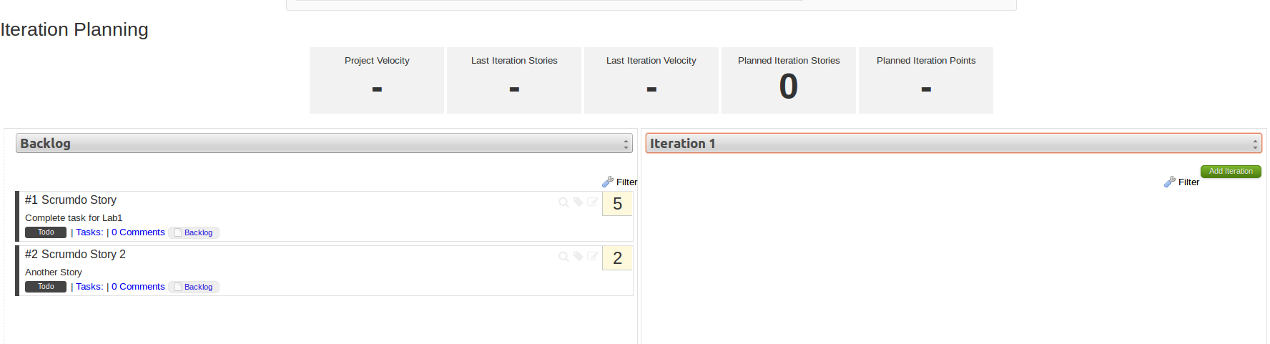

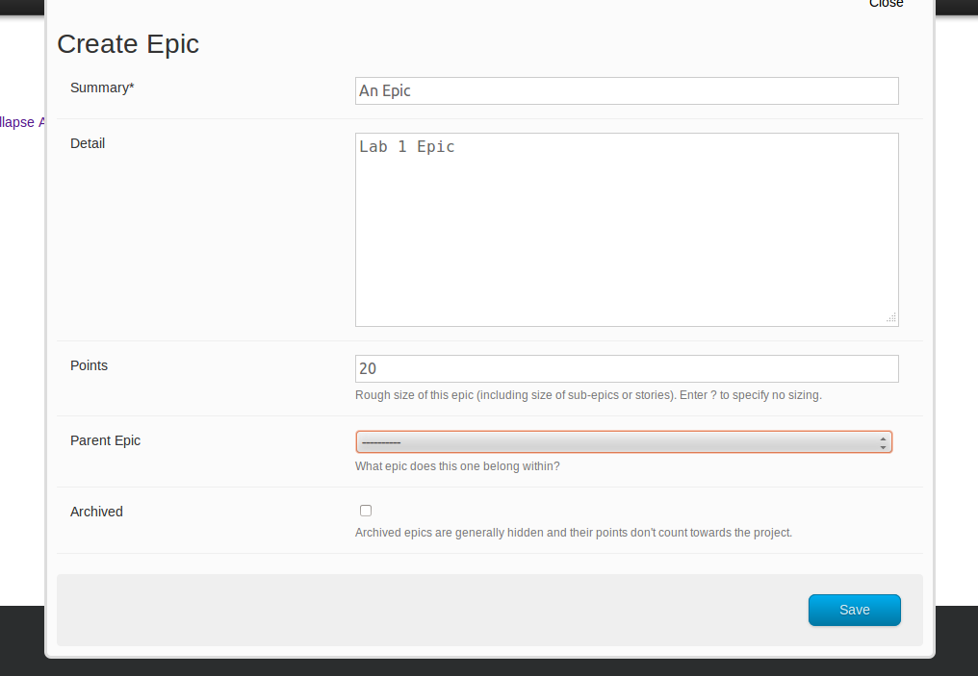

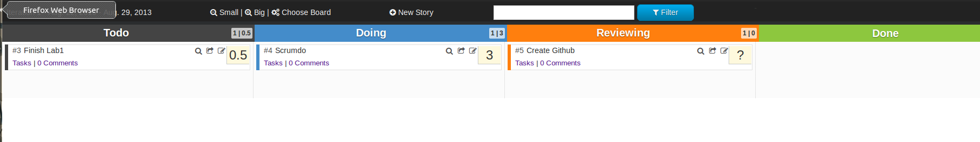

2) GitHub Tasks:

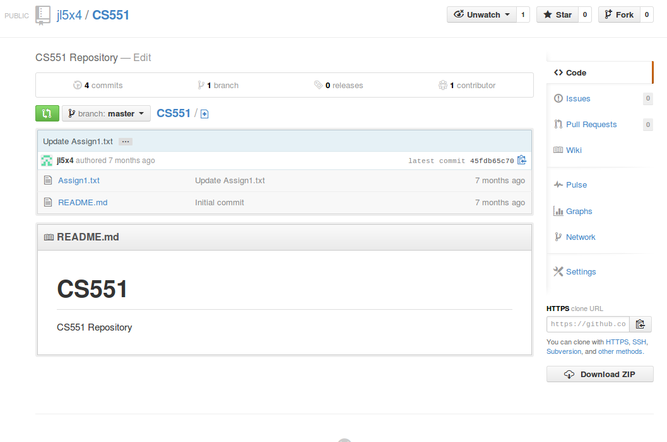

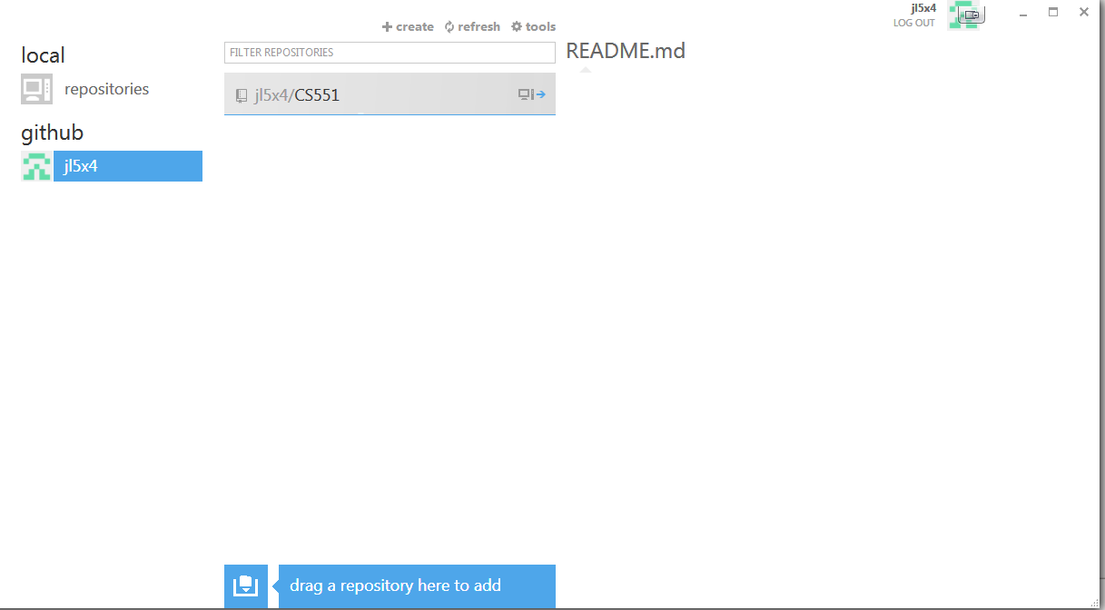

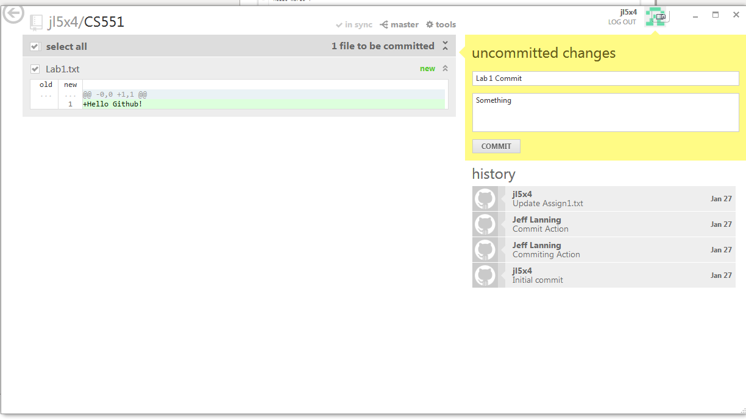

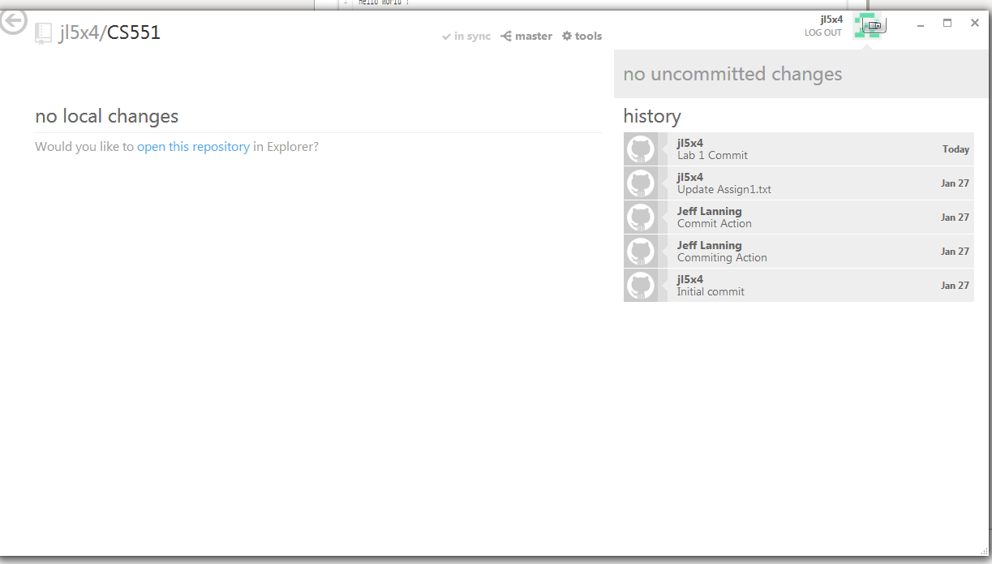

3) a. Class Diagram:

* Using Visio, design a UML class diagram for the home security system. Make sure each class is labeled with any key attributes or operations. Also include some examples of inheritance of attributes and methods to the class diagram and explain about them.

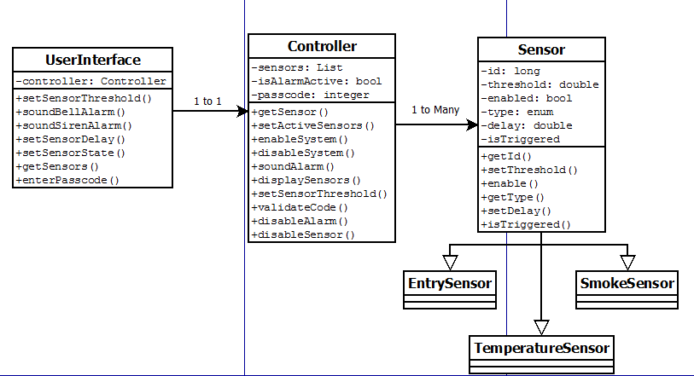

b) Sequence Diagram

* Using Visio, design a UML sequence diagram to show how the program responds to an alarm being triggered.

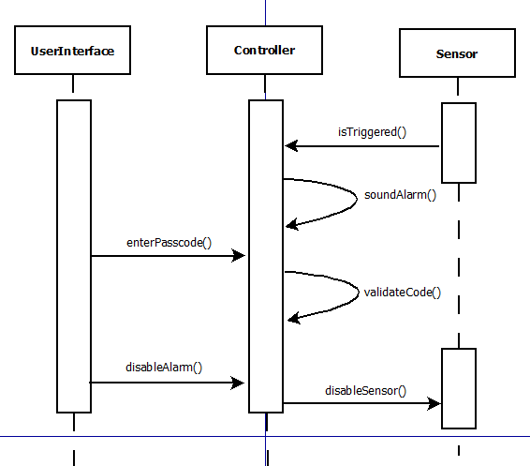

c) Architecture Diagram

* Using Visio, Design a software architecture for this system

