**CS5590 VC – Lab 2 Report – Jeff Lanning**

For Lab 2, I created a mobile application using JQuery Mobile, HTML5, CSS3, and JSFiddle. My application is a tool used for travelling to Yellowstone National Park. It serves two functions:

1. Getting directions from one’s current location (Kansas City) to Yellowstone.
2. Obtaining current weather data including temperature and cloud conditions at Yellowstone.

I used Google Map APIs to obtain directions by utilizing the Directions Service and view the map using the DirectionsRenderer. For the weather application, I used Wunderground weather services for Yellowstone, Wyoming.

Instructions:

User is at the main page, they can click the button for either getting directions to Yellowstone, or getting the weather at Yellowstone. Note at any time the user can click the Home button to go back to the main page.

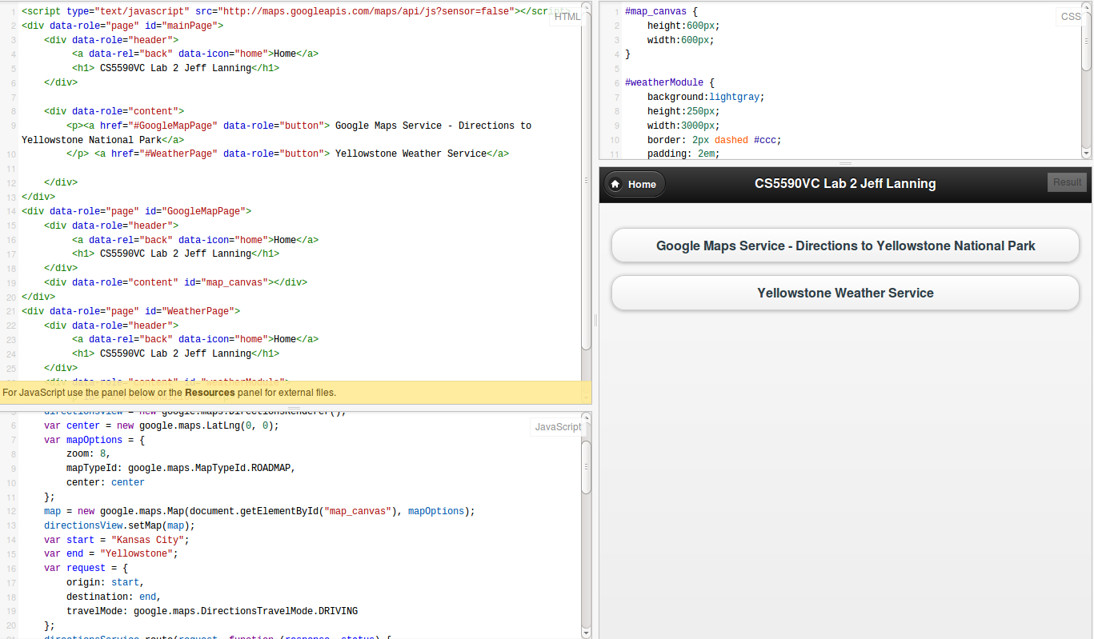

User clicks the Directions button for a Google Map containing directions from their current location to Yellowstone.

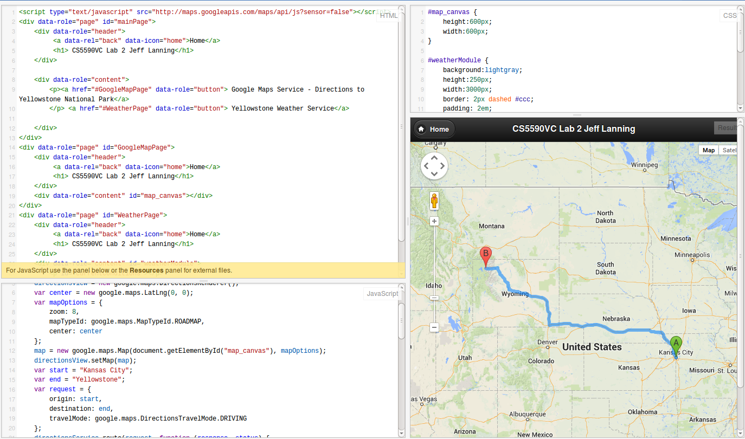

User clicks the Weather button to view current weather conditions at Yellowstone.

