Jeff Lanning

CS5590VC – Lab3

The purpose of this lab was to create a Mashup Web application that utilizes a RESTful service connecting to the Hadoop/Linux cloud instance. My mashup application also utilizes services from Google Search, Twitter, and Google Maps. The user is instructed to insert their name or name of a location. Once the user enters their input, the client calls my RESTful Web Service [0] using AJAX and JSONP message format to retrieve the user’s location from the Web Service and displays it in a text box. It then calls into the Twitter API [1] to allow the user to tweet their results from the RESTful Webservice. The service returns this information and the application calls into the Google Search API [2] and obtains the top web query result. The result is displayed in the text box. Then the application calls into the Google Maps API [3] to map the location (if one exists). Below are screenshots with an example run through.

[0] http://vhost1264.dc1.on.ca.compute.ihost.com:8080/VC_Lab5_Web/jaxrs/mypath/greeting/

[1] <https://dev.twitter.com/docs/api>

[2] <https://developers.google.com/web-search/docs/#API_Overview>

[3] <https://developers.google.com/maps/documentation/javascript/>

The user can enter their name or location. I chose a location: UMKC.

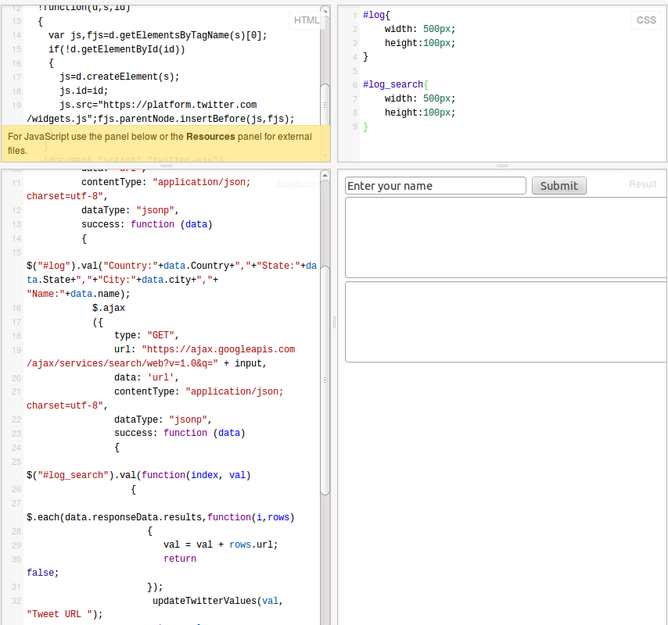

Once the user enters something and presses Submit, the Mashup calls into the RESTful service and retrieves their location and passes this information back to the user in JSONP format. It then uses this information to perform a Google search and retrieves the most relevant result. It automatically creates a Twitter button that pulls in this information for the user to Tweet.

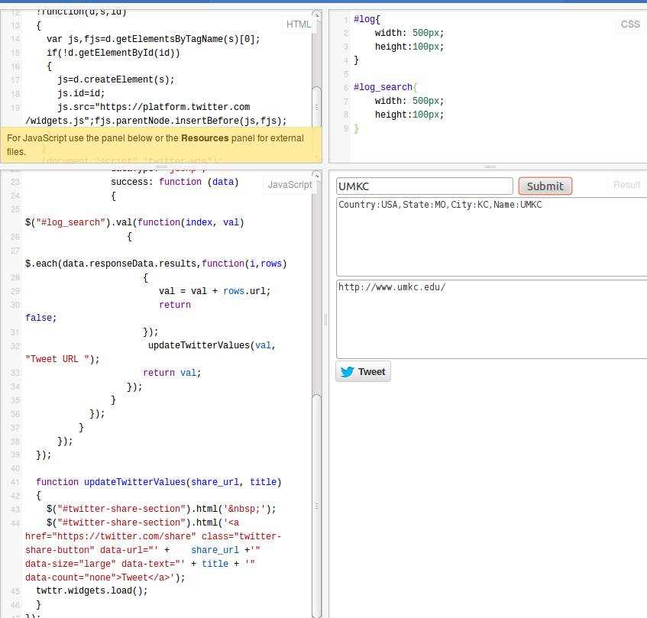

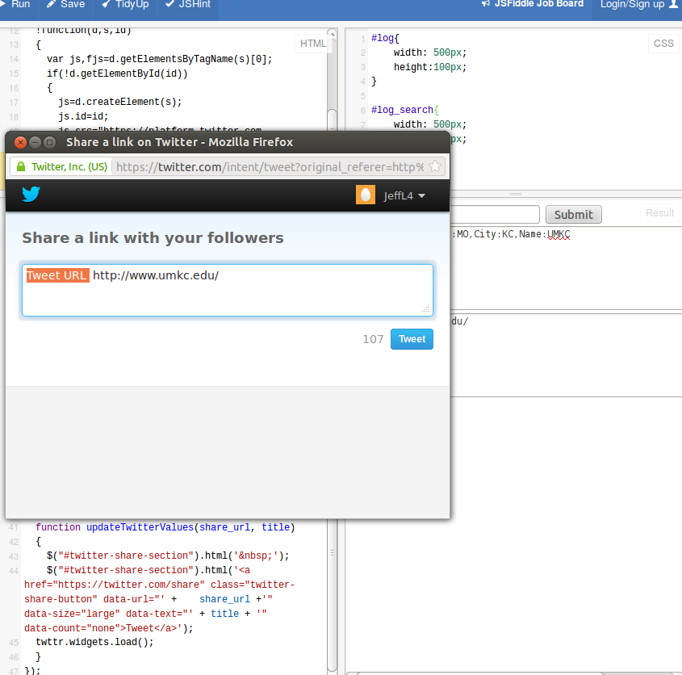

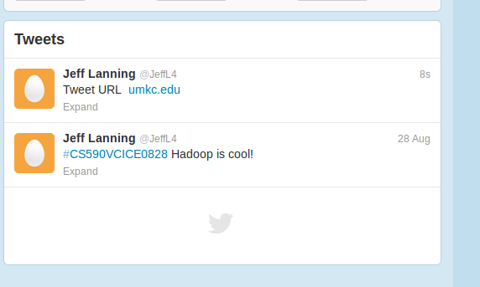

It then automatically maps directions from Kansas City to the user’s specified location.

