Jeffrey Lanning

CS5590VC – Lab4

9/15/2013

1. Hadoop Command Line: Follow the steps of running hadoop WordCounting operation using your own input file.

I created the input file using ‘vi lab4_input.txt’. I wrote text in the input file: ‘Do as I say not as I do’ . I then inputted the input text into Hadoop using the command: ‘hadoop fs –put lab4_input.txt /input2’. Once this was done I ran the hadoop wordcount job: ‘hadoop jar /mnt/biginsights/opt/ibm/biginsights/IHC/hadoop-example.jar wordcount /input2 /output2.

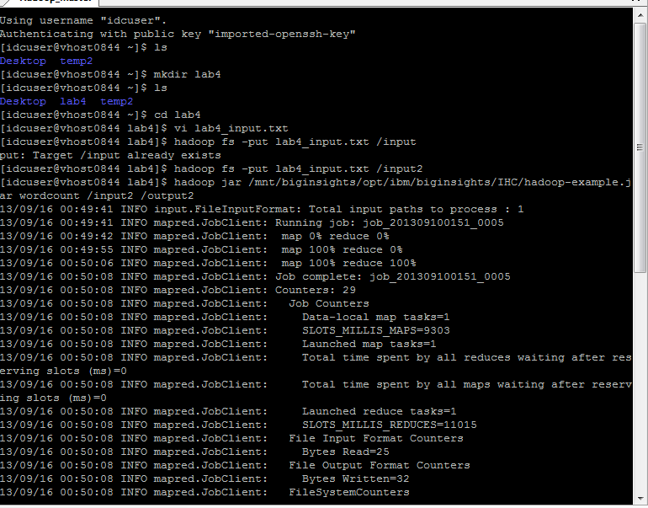

Once the Map/Reduce job was finished, I output the results using ‘hadoop fs –cat /output2/*00.

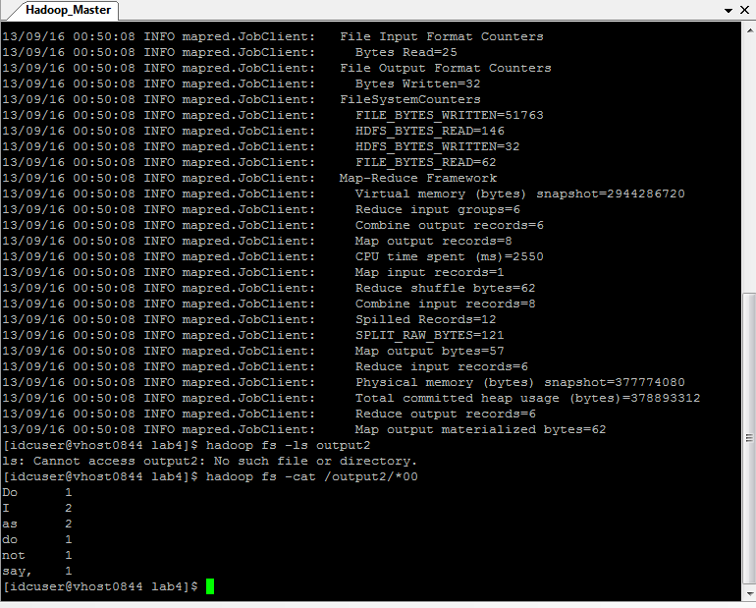

1. Hadoop Java Based Approach: Refer to the additional Tutorial 6 ppt and follow the steps to create the jar file of your own WordCount MapReduce and deploy/run it to your own Hadoop instances. The code and guidelines are now available in Tutorials/Tutorial 6.

Here is the code for the Map/Reduce algorithm for word count. The map function takes in the input key/value pairs, uses StringTokenizer to separate out each line from the value (the document) into words separated by whitespace. It then outputs the map results into a map of word to the value 1.

/**

* **@see** org.apache.hadoop.mapred.Mapper#map(java.lang.Object, java.lang.Object, org.apache.hadoop.mapred.OutputCollector, org.apache.hadoop.mapred.Reporter)

*/

@Override

**public** **void** map(LongWritable key, Text value, OutputCollector<Text, LongWritable> out, Reporter reporter) **throws** IOException

{

String line = value.toString();

StringTokenizer st = **new** StringTokenizer(line);

**while** (st.hasMoreTokens())

{

word.set(st.nextToken());

out.collect(word, *one*);

}

}

The Reduce function inputs the key/values pairs from the map job. It loops through all the values for each key and calculates a new word sum. It then outputs the word/wordsum as a new key/value pair.

**public** **static** **class** Reduce **extends** MapReduceBase **implements** Reducer<Text, LongWritable, Text, LongWritable>

{

**public** **void** reduce(Text key, Iterator<LongWritable> values, OutputCollector<Text, LongWritable> out, Reporter reporter) **throws** IOException

{

**int** wordSum = 0;

**while** (values.hasNext())

{

wordSum += values.next().get();

out.collect(key, **new** LongWritable(wordSum));

}

}

}

I exported the jar and put it on my Hadoop server via FTP. Here is the input text file for the jar.

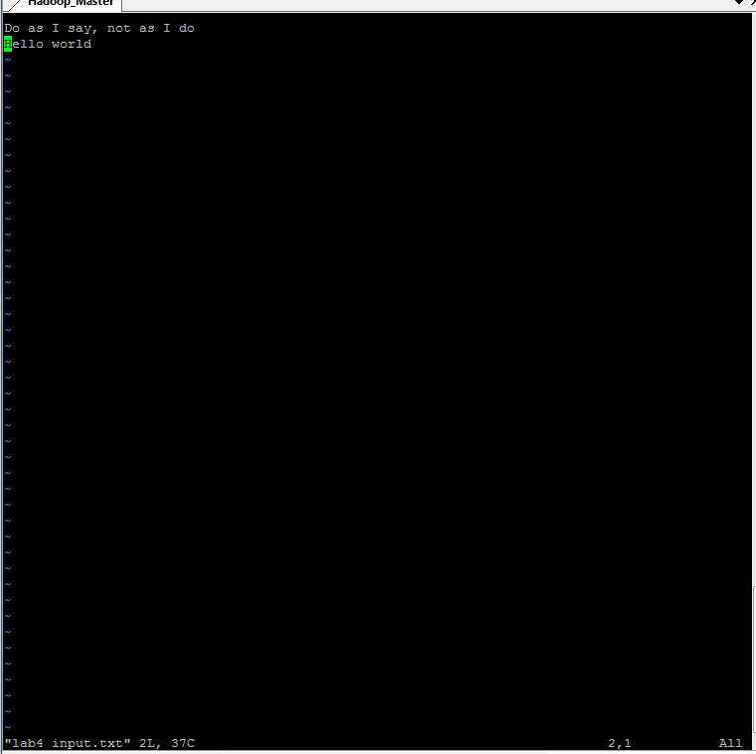

I put the input file as input for my hadoop job using ‘hadoop fs –put lab4_input.txt /home/idcuser. I ran my hadoop job using my jar: ‘hadoop jar VC_Lab4_Lanning.jar’.

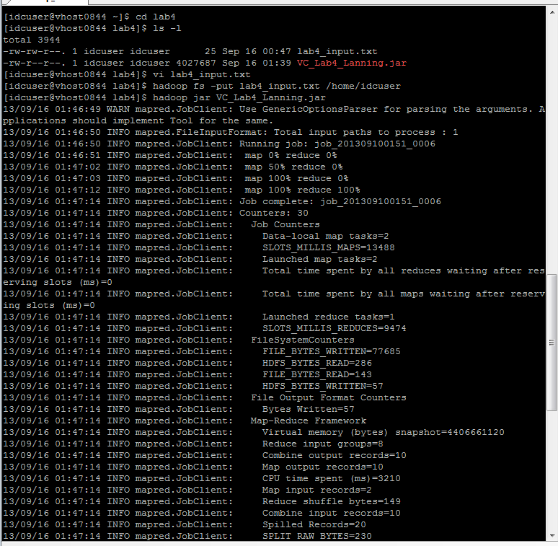

After my job was ran I viewed the contents of my output file:

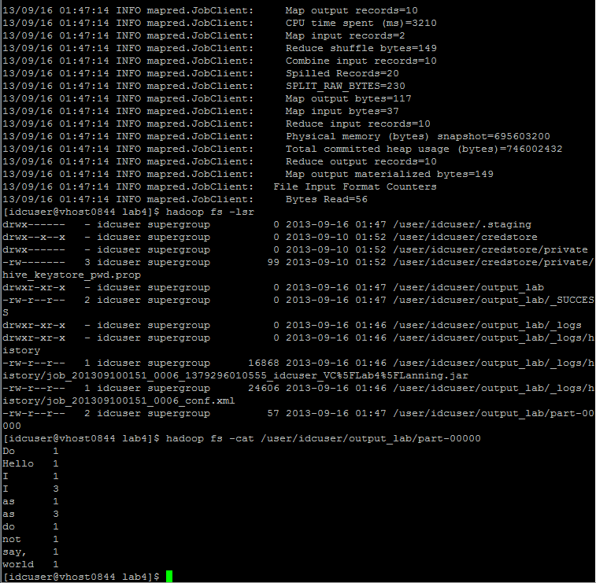

1. Implement a new MapReduce Algorithm

This new MapReduce algorithm takes the input of the first MapReduce word count algorithm and orders it by the number of word counts to word in descending order.

/**

* **@see** org.apache.hadoop.mapred.Mapper#map(java.lang.Object, java.lang.Object, org.apache.hadoop.mapred.OutputCollector, org.apache.hadoop.mapred.Reporter)

*/

@Override

**public** **void** map(LongWritable key, Text value, OutputCollector<LongWritable, Text> out, Reporter reporter) **throws** IOException

{

String line = value.toString();

StringTokenizer stringTokenizer = **new** StringTokenizer(line);

**long** num = 1000;

String word = "none";

**if**(stringTokenizer.hasMoreTokens())

{

String s1 = stringTokenizer.nextToken();

word = s1.trim();

}

**if**(stringTokenizer.hasMoreElements())

{

String s2 = stringTokenizer.nextToken();

num = Long.*parseLong*(s2.trim());

}

out.collect(**new** LongWritable(num), **new** Text(word));

}

**public** **static** **class** Reduce **extends** MapReduceBase **implements** Reducer<Text, LongWritable, Text, LongWritable>

{

/**

* **@see** org.apache.hadoop.mapred.Reducer#reduce(java.lang.Object, java.util.Iterator, org.apache.hadoop.mapred.OutputCollector, org.apache.hadoop.mapred.Reporter)

*/

**public** **void** reduce(Text key, Iterator<LongWritable> values, OutputCollector<Text, LongWritable> out, Reporter reporter) **throws** IOException

{

**while**((values.hasNext()))

{

out.collect(key, values.next());

}

}

}

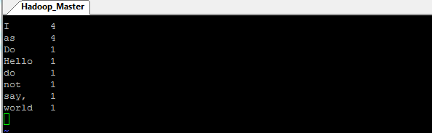

1. Implement web services to put data to hadoop, run Hadoop using algoirhtm implemented in Step 3, and retrieve Hadoop result and also implement a client using these web services.

I created a web client in JSFiddle to call into my RESTful web service that called into Hadoop. I input the name of the input file for hadoop on my node and click submit, the output is the output from my MapReduce algorithm in step 3.