It has use:
- Python (LangChain)
- Gradio
- Vector Database(chroma)
- SQLite Database
- APIs used: Gemini API and Gmail API

System Architecture
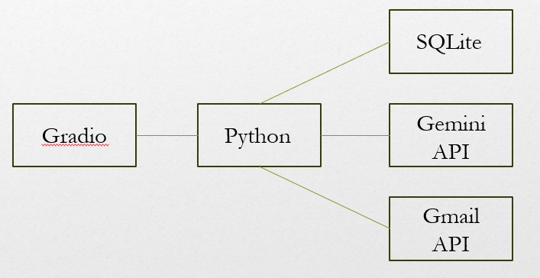

Pip Install all the following in requirements.txt:
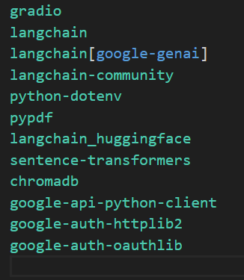
Setup you own gemini api key in .env file
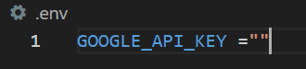

Login the huggingface account in tools.py and pdfloader.py file
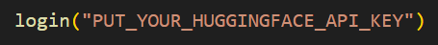

To be able to send Gmail. Setup you own Gmail Json file (https://console.cloud.google.com/) and put into the same folder with the code.
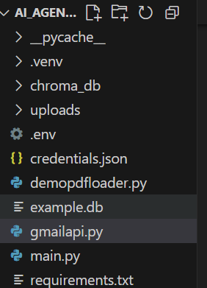

then insert the Json file name into this code in gmailapi.py file
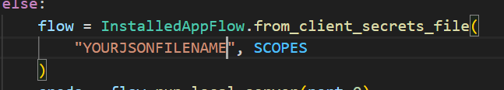

Also, the recipient of the Gmail should be updated in the update_order and cancel_order functions in the tools.py file.
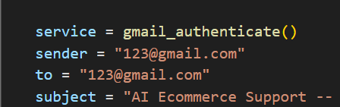
Change the 123@gmail.com (sender) to the your Gmail you and 123@gmail.com (to) Gmail that you want to send to someone

After all done, run the main.py file and click the URL in terminal
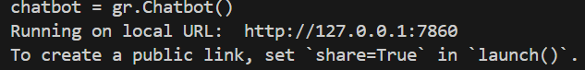

For user login
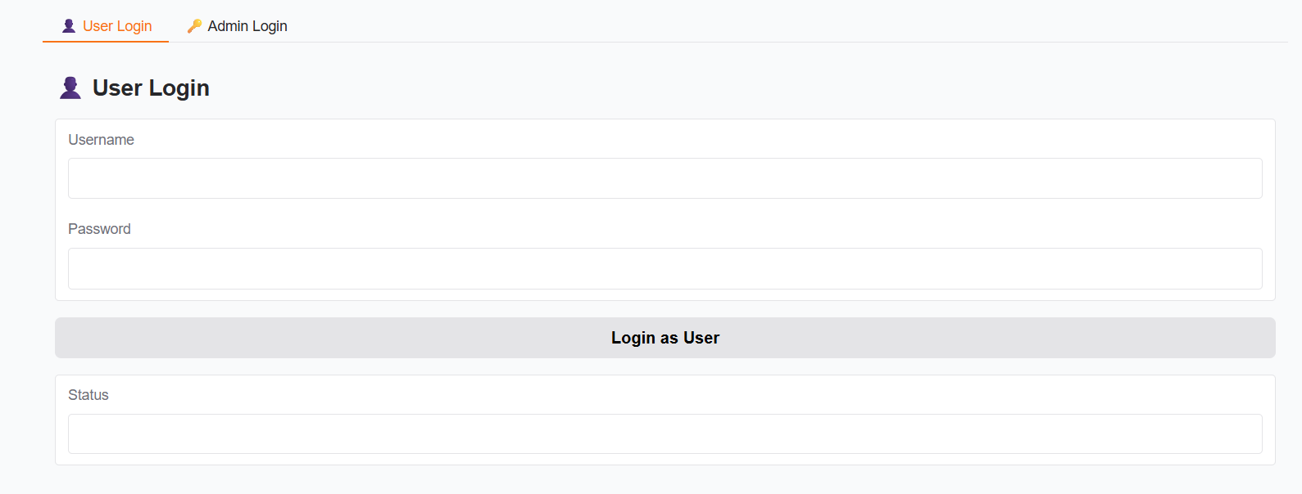
You can get the username and password from customers table
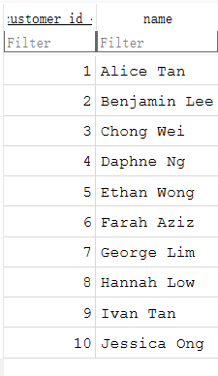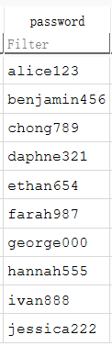
After login successfully, you can see the chatbot tab appear in above


You can ask the AI such as product information, your order information, change the order product, cancel the order.
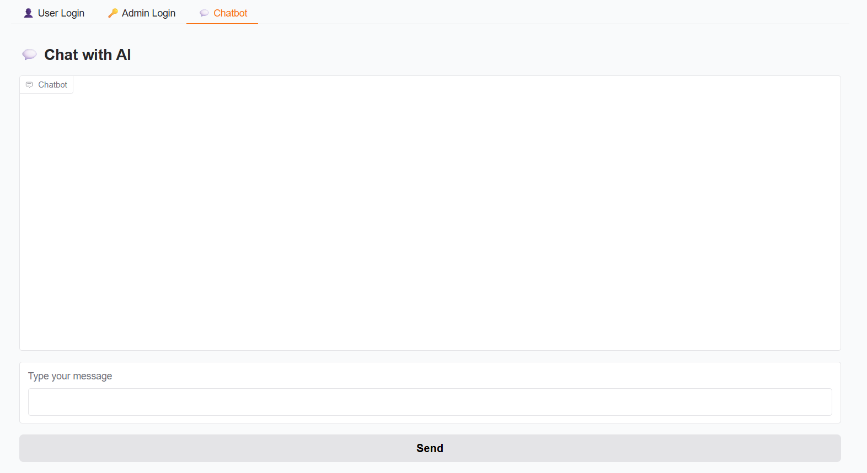

For Admin login
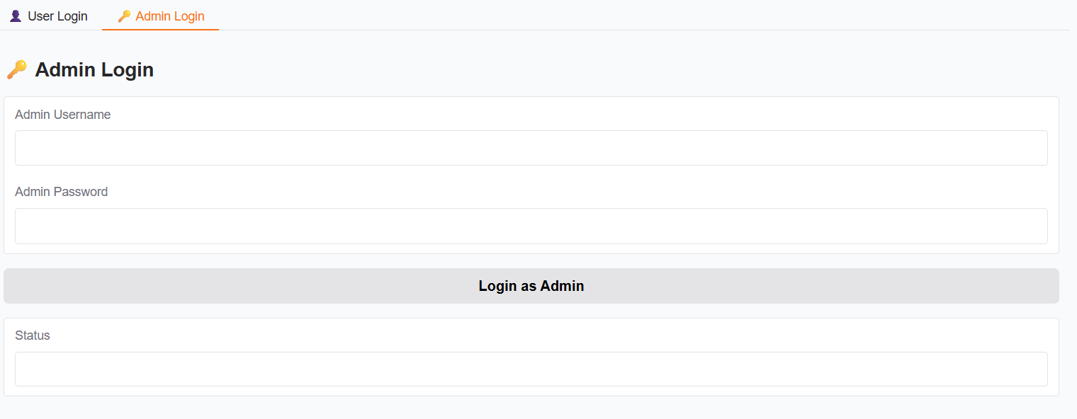
You can get the username and password from admins table
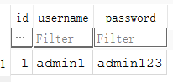

After login successfully, you can see the Admin Panel tab appear in above


As an admin, you can upload pdf file to insert the product information into database
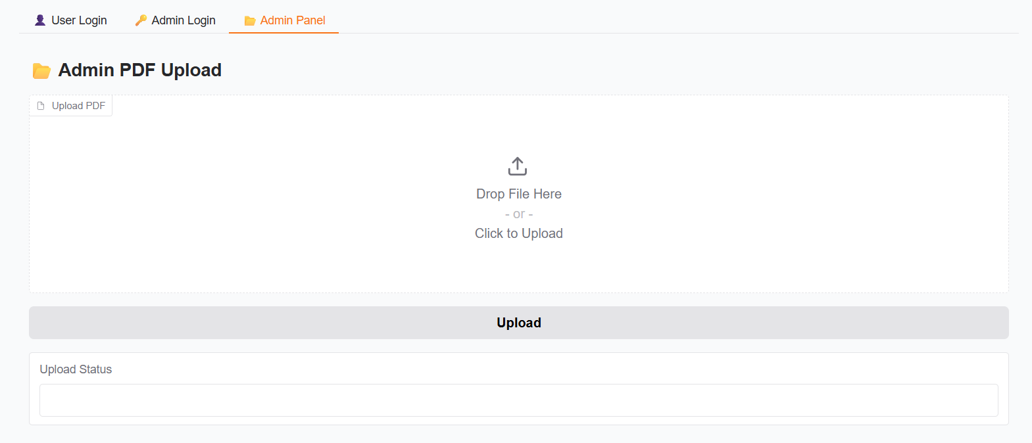

The pdf file content must include the product name, category, type, description, price, inventory_count, information, as an example show below:
