README
The SLIMS2 front-end was developed using ReactJS and back-end using Spring MVC+Data 3.2 framework.
- Checkout the source code from SVN: https://svn.hli.ubc.ca/Daley-Lab/slims/branches/slims2
- The front-end source code is under [path to slims]/src/main/app
- In NetBeans IDE, the front-end src folder will be under slims2/Other Sources/app/src
- Building the front-end module in ReactJS is easy if you use the create-react-app build tool.
- Database connection is currently set to: jdbc:db2://192.168.21.61:50001/ALLERGEN
- The front-end source code needs a lot of work. The RecursiveTable.js still needs to be refactored and properly tested again.
- Older build is currently deployed on the lab’s internal server here: http://dlappsrv01.hli.ubc.ca:8080/slims2/
Note: might need to hit refresh few times for the JVM to load the app and do GC
- Latest working .war build is saved in target
- Login user for testing purposes: Username: ddaley Login pass:ddaley

Installing and running the create-react-app build tool for front-end development:
To minimize disk space, I removed node_modules folder that comes with the create-react-app build environment. So once you checkout the project from SVN, you will need ot reinstall create-react-app. To install create-react-app, follow the instructions below:
- Go to nodejs.org. Download latest version of Node.js. Select install directory to C:/APPS. Note installation needs to run in Administrator mode.
- NPM binary should have been placed automatically in PATH. Open Windows Command Prompt.
- Type in: npm install –g create-react-app. For more information on create-react-app, checkout: http://github.com/facebookincubator/create-react-app
- First copy and save the app/src folder somewhere safe and remove the old app folder.
- cd into [path to the project]/slims2/src/main/.
- run the command: create-react-app app
- This will create a new app folder including the build tool. See figure 1
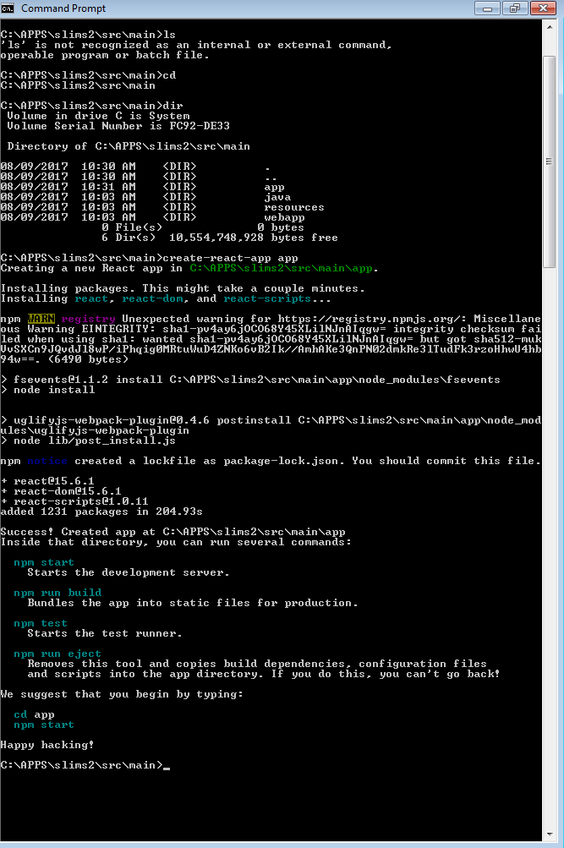
Figure 1

5. Now we have to install the required libraries:
#> npm install –s react-bootstrap bootstrap@3
#> npm install –s jquery
#> npm install –s react-bootstrap
#> npm install –s react-bootstrap-table
#> npm install –s react-dom
#> npm install –s react-loader
#> npm install –s react-router
#> npm install –s react-router-dom
#> npm install –s react-try-catch-render
6. Once all the libraries are installed, cd into [path to project]/src/main/app. Remove the existing src folder and copy back in the original. Then type: npm start
7. This will launch the app in the development server on port 3000. The development server allows hot loading so changes to the source code will be shown right away on the browser
8. Note that in [path to slims2]/src/main/app/src/App.js, the url value in MainApp component’s state has to be changed before it is deployed on http://dlappsrv01.hli.ubc.ca:8080. See Figure 2

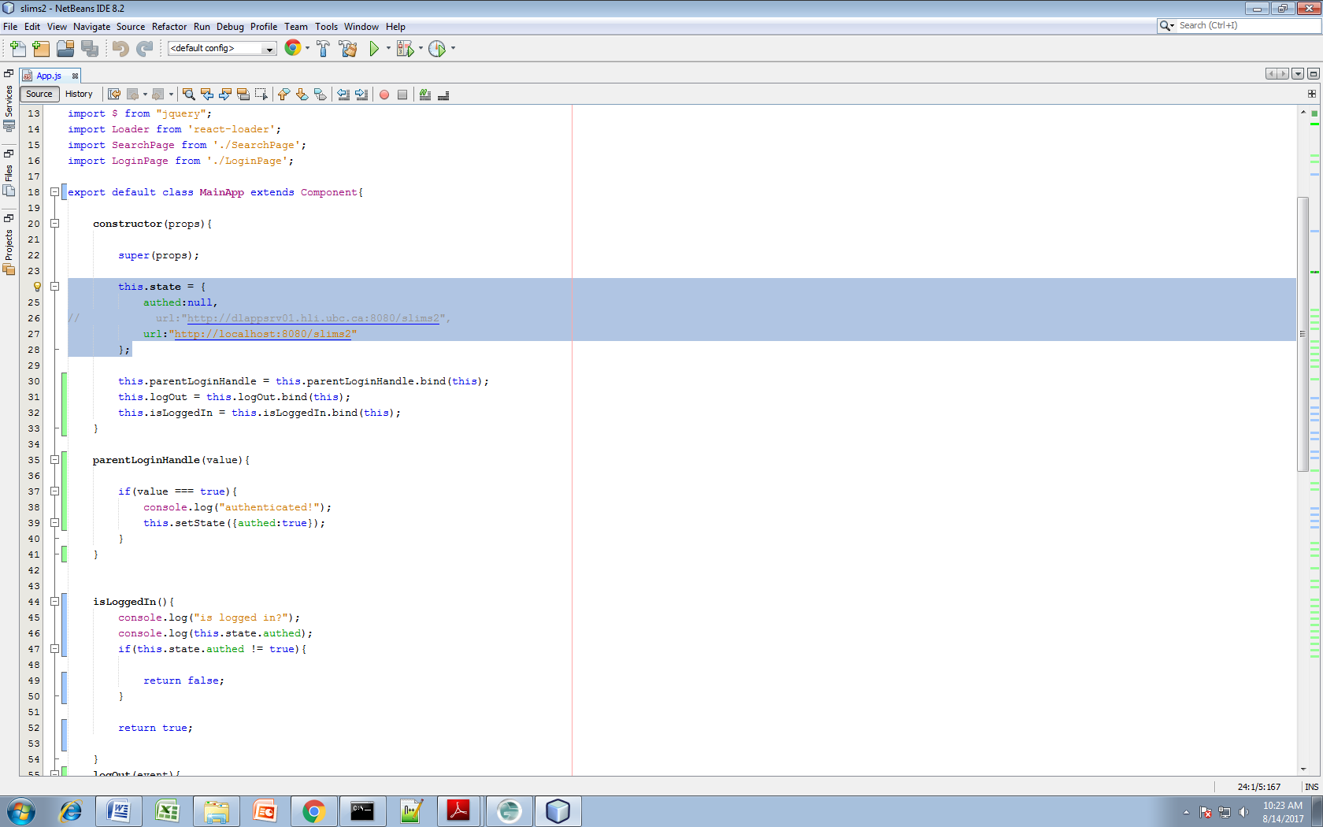
Figure 2

Compiling and Packaging the build with rest of the SLIMS2 application:
There is a maven build plugin called frontend-maven-plugin that automatically builds and packages your react app with rest of the SLIMS. But the lab’s tomcat server runs on JRE 1.6, so I can’t build the project using the plugin because the plugin needs Maven version 3.2 or greater.
So the react app has to be compiled manually but once it is compiled, the build folder is automatically copied and packaged into the SLIMS2 .war file during the maven packaging phase. So all you have to do is manually compile the front-end react app by doing the following:
- Cd into [path to slims]/src/main/app. Then type: npm run build
- This will compile and package everything into the build folder
- In pom.xml, maven-resources-plugin will copy the build folder into [path to slims]/target/slims2/resources/ folder during .war packaging phase. See Figure 3
- Everytime you recompile the SLIMS project, the react app build folder will be included with rest of the .war file
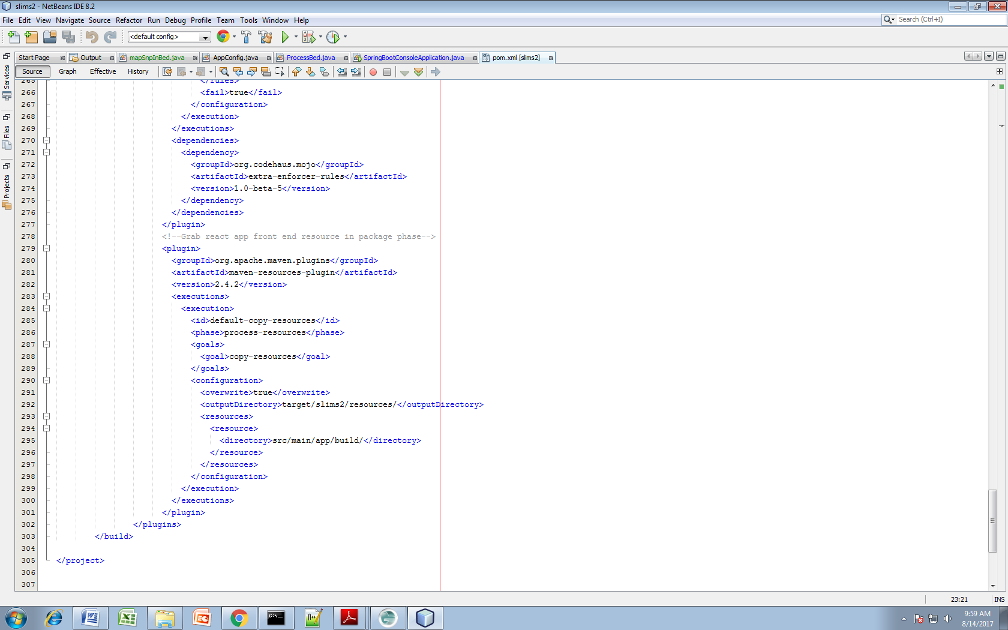
Figure 3
Compiling and running the SLIMS back-end module:
- Checkout the project from SVN
- Open the project in NetBeans IDE
- All servlet and listener declarations are in web.xml
- The mvc-dispatcher servlet.xml contains:
  - static resource url mappings for serving the ReactJS front-end content
  - Datasource, database connection pool, and repository configurations
- Application.properties folder is no longer used (was originally used on Spring Boot but couldn’t use spring boot due to compatibility issues on the lab’s tomcat server)
- The source/config folder configures the Context Class Loader’s garbage collection to prevent Heap Space Out of Memory Error when it is deployed on Tomcat
- Controller folder contains Controller classes for handling user login and the search pipeline logic
- Dao folder contains Repository configurations for Tblsubject, Tblsamples etc.
- Json folder contains JSON object templates used by jackson.databind.ObjectMapper to handle HTTP post requests/responses
- Service folder contains all the database queries
- Model folder contains Allergen database ORM (Tblsubject, Tblsamples etc.). Note that if any of the ALLERGEN database schema changes, ORM has to be done again to generate Java Objects matching the new changes. This source shows you how to use Maven to create java object mappings of your database schema: https://developer.jboss.org/thread/222171?_sscc=t

