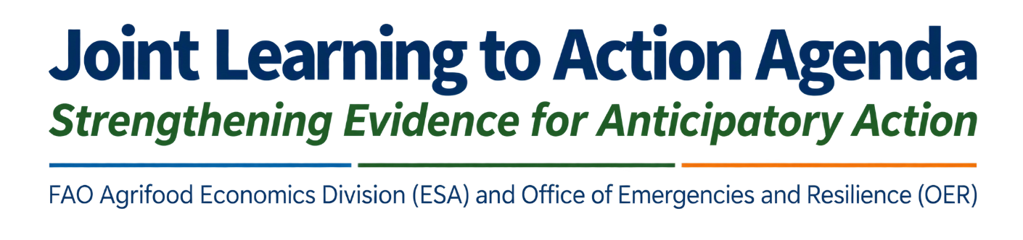

1. Our existing knowledge
The need for rigorous evidence in anticipatory action, as in any area of development and humanitarian policy, is paramount to ensure that programmes are designed effectively, resources are allocated in a way that yields the greatest impact, and decision-makers can justify and advocate sustained investment. Impact evaluations have become a cornerstone of the broader humanitarian and development landscape, where every dollar counts and donors seek to invest in approaches that generate the maximum impact per unit of spending. Because anticipatory action requires upfront resource commitment, before a crisis materializes, the need for a strong evidence base is all the more important to build and maintain donor and broader stakeholder confidence.
Anticipatory action has attracted growing attention as a means of maximizing the efficiency of humanitarian aid, and rightly so. The existing evidence demonstrates that anticipatory action can protect assets, reduce distress selling, and preserve food security when it reaches people before a shock hits. These benefits operate through two complementary pathways: mitigating the immediate impacts of a shock on lives and livelihoods and protecting the productive assets and capacities that underpin longer-term resilience. Compared with other forms of humanitarian assistance, the evidence base for anticipatory action is already substantial, yet continued learning remains essential to guide and improve programming as the approach matures. Confidence in key design and delivery modalities is still developing, and some important knowledge gaps persist around when, where, and how anticipatory action works best.
This document sets out a coordinated learning agenda to close remaining knowledge gaps by proposing a concerted effort to align the pace of evidence generation with the speed of implementation, enabling implementers, Member countries, and donors to have greater confidence in the efficacy of anticipatory action and to sustain the funding needed for it to scale.

2. Priority areas for continued learning
To guide future anticipatory action programming, there are three dimensions where structured evidence generation can add the most value:
Thematic priorities. The evidence base can be deepened across a range of themes and contexts, including payment timing and modalities, disaster types, multi-hazard settings, and household types and characteristics. The comparative effectiveness of cash versus in-kind assistance, and even more importantly of cash in combination with other in-kind interventions (cash+), offers a particularly promising area for further study. Building a fuller understanding of the design features that drive differential outcomes, of effects beyond the immediate post-shock period, and of harmonized cost-effectiveness ratios would further strengthen the confidence that underpins scaling decisions.
Geographic priorities. While the body of evidence is growing, studies remain unevenly distributed across geographies, hazard types, and livelihood settings. A coordinated approach to evidence generation offers the opportunity to systematically diversify this coverage, ensuring that future studies extend findings to underrepresented regions and crisis typologies and strengthen the generalisability of the evidence base as a whole.

3. Priority research questions
The learning agenda aims to answer the following priority questions through coordinated evidence generation:
- How effective is anticipatory action across different hazard types, livelihood contexts, geographies, and time horizons? This includes understanding the comparative performance of different delivery modalities, the variation in impact across crisis types and geographic settings, and the persistence of effects in the short versus long term.
- Long term and connecting with resilience outcomes?
- Which design features drive differential outcomes, and how do the two impact pathways, mitigation of immediate impacts and protection of longer-term resilience, operate in practice across different settings?
- What is the cost-effectiveness of anticipatory action relative to traditional emergency response?

4. Proposed actions
The following actions address these priorities, aligning the pace of evidence generation with the pace of implementation so that learning keeps step with the scaling of anticipatory action:
Generate a critical mass of coordinated evidence. Targeting at least 10 rigorous analytical studies across different geographies, themes, and time horizons by 2030, with study selection guided by the priorities identified above.
Common measurement module and coordination. Partners will develop a shared set of outcome indicators for anticipatory action evaluations, enabling cross-country-study comparison and meta-analysis, drawing on tools already developed by partner agencies and organizations.
Evidence and ongoing project dashboard and studies inventory. Building on existing platforms, notably the Anticipation Hub, partners will consolidate and extend a public-facing database of anticipatory action evaluation studies, mapping coverage by geography, hazard type, modality, and research question.
Coordinated evaluations. Rather than conducting parallel evaluations in the same contexts, partner agencies will identify opportunities for joint evaluations with shared baselines and pre-defined analyses and outcomes, coordinated through the inter-agency mechanism described in Section 5.
Stakeholder engagement Beyond practitioners and researchers, governments, donors, Member countries, and beneficiaries will be engaged to both co-produce and use the evidence, with dedicated briefings on how learning agenda outputs inform scaling and financing decisions.
Coordination mechanisms. Thinking beyond memorandum of understandsings (MoU) which are hard to execute, the agenda also proposes to use Memorandum of Cooperation or just transmission of information through informal working groups to ensure that all stakeholders involved know the evidence that is being generated by whom.

5. Enabling conditions
Delivering on this agenda requires both dedicated funding and institutional coordination.
Pre-arranged financing for evidence generation. Generating rigorous evidence on anticipatory action requires resources that are additional to, and do not compete with, humanitarian programming budgets. Pre-arranged financing mechanisms, whether through dedicated evidence windows within existing anticipatory action funding streams or through stand-alone research grants, are essential to sustain a pipeline of coordinated evaluations alongside programme delivery. Without a distinct funding track for evidence generation, evaluations will remain opportunistic rather than systematic, and the learning agenda will be unable to achieve the scale and comparability it requires.
Coordination across institutions and agencies. The current landscape of anticipatory action evidence is fragmented across agencies, with limited coordination on evaluation design, indicator selection, and data sharing. Addressing this requires bringing together a core group of partner organisations and leading researchers in the anticipatory action evaluation space to jointly produce a critical mass of coordinated evidence. The inter-agency monitoring and evaluation (M&E) practitioner group on anticipatory action, will serve as the primary mechanism for operational coordination across these efforts.
Study design transparency
Operationalizing existing evidence. The current landscape of anticipatory action evidence is fragmented across agencies, with limited coordination on evaluation design, indicator selection, and data sharing. Addressing this requires bringing together a core group of partner organisations and leading researchers in the anticipatory action evaluation space to jointly produce a critical mass of coordinated evidence. The inter-agency monitoring and evaluation (M&E) practitioner group on anticipatory action, will serve as the primary mechanism for operational coordination across these efforts.
Individual financing, pooled agenda

6. Indicative timeline

The learning agenda will be implemented in three phases, with milestones calibrated to the 2030 target for a critical mass of coordinated evidence.
Phase 1: Validation and consolidation (2026). The learning agenda will be finalised through a structured validation round with partner organisations and leading researchers in the second half of 2026. Opportunities to embed evidence generation in ongoing and upcoming anticipatory action activations will be identified as they arise, ensuring that the agenda is grounded in live programming from the outset.
Phase 2: Coordinated evidence generation (2027 to 2030). The core of the agenda will be delivered in this period. Partner agencies will launch coordinated evaluations under the common measurement module, prioritising the thematic and geographic areas identified in this document.
Phase 3: Synthesis and uptake (2030). By 2030, at least 10 rigorous analytical studies will have been completed across different geographies, themes, and time horizons. Findings will be synthesised through comparative analysis and meta-analysis enabled by the harmonised indicators, and communicated through dedicated briefings for governments, donors, and Member countries to inform scaling and financing decisions.

Annex A:

