

NE 155 FINAL REPORT

**BAGHDAD RESEARCH REACTOR NEUTRON FILTER – FAST NEUTRON FLUX INVESTIGATION**

Joseph H. Labrum

Keeton T. Ross

May 12, 2015

**I. INTRODUCTION**

Great interest has been shown over the years toward inelastic neutron scattering in regards to the unique information that it can give us about various behaviors at the atomic level. In the 1970’s a group of researchers at the IRT-5000 Baghdad Research Reactor set up an experimental thermal neutron filter that was designed to enable fast, inelastic neutron scattering experimentation. This data is of special interest to LLNL Scientist and UC Berkeley Adjunct Professor Lee Bernstein, however a lack of specification surrounding the flux at the detector in the aforementioned experiments is providing issues in attempts to extract useful data. The data was collected in Ahmed and contributing author’s paper *ATLAS of Gamma-Ray Spectra from the Inelastic Scattering of Reactor Fast Neutrons.*

The motivation of our project is to find, or at least accurately approximate, the neutron flux present at the sample location prescribed in Figure 1 on Page 2 using the MCNP6 software package. This flux will help to reveal useful nuclear data surrounding inelastic scattering off of iron, cadmium, and other metals.

Throughout this paper we will describe our progress towards our goal, including:

1. Modeling the experimental setup and a number of approximations that we were forced to make due to a lack of detailed information about the setup
2. Making the appropriate MCNP code, including the source type, Vised simulations, materials, tallies and so on
3. Interpreting our data, specifically in comparison to what we might expect to see at the location due to basic knowledge of solid angle, cross section, and reactor flux
4. Our final conclusions and further steps that we can take towards both a more accurate flux calculation as well as useful inelastic scattering data

**II. PROBLEM DESCRIPTION**

The original paper which we are referencing, *Investigation of Gamma-Ray Spectra from the Inelastic Scattering of Reactor Fast Neutrons,* written by M.R. Ahmed and his colleagues, details the efforts that the group made with their thermal neutron filter. It outlines the reactor flux after a 10cm lead plug (Figure 2), along with an experimental setup and their gamma ray spectra for inelastic scattering after their neutron filter (ATLAS 7). The setup provided is shown in Figure 1, along with the fast reactor flux data in Figure 2.

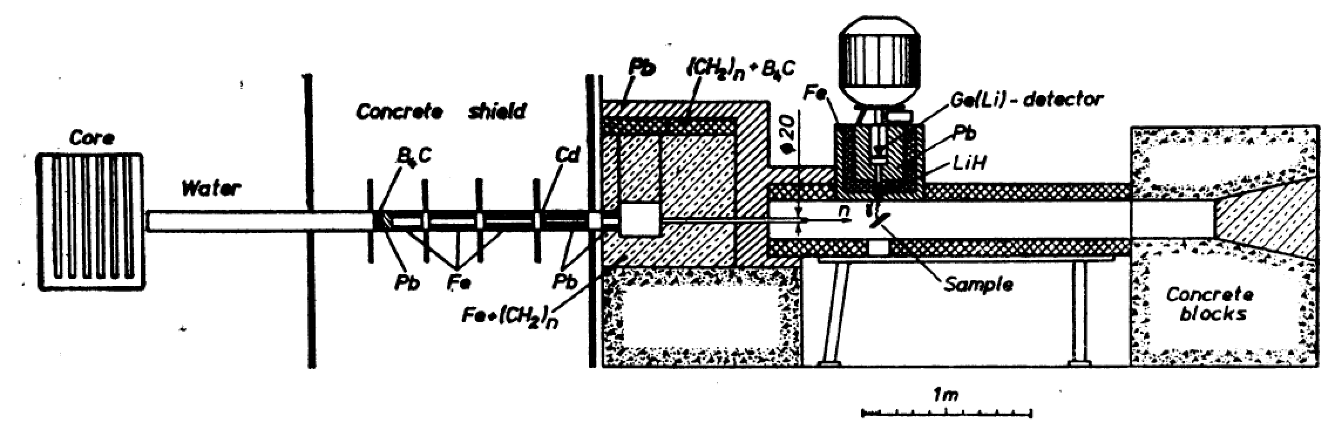

**Figure 1:** Experimental set up of neutron filter at the IRT 5000 Bagdad reactor. (ATLAS 4)

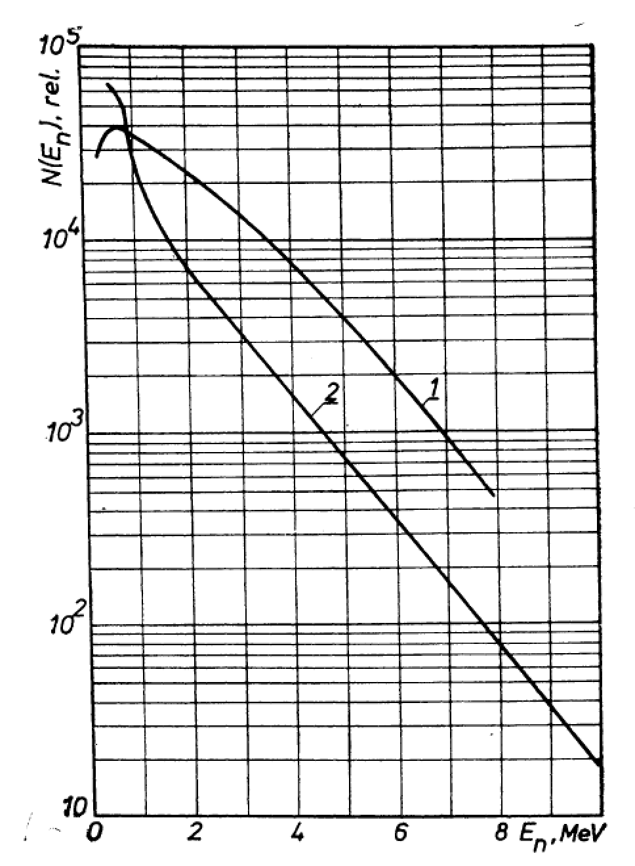

From this experimental diagram, we are aiming to construct an accurate MCNP model of the neutron filter. This model relies heavily upon a “drawn to scale” assumption; the small scale and lack of details and resolution in the sketch provide a great deal of issues in the pursuit of this goal. Once we can accurately model the geometry, and define the materials of the situation, we will be able to run a Monte Carlo simulation of the experiment. This simulation should provide flux measurement at the surface of the sample as shown in Figure 1. It is important to remember that a large number of assumptions can quickly lead to a lack of accuracy, which the software can mask by showing a high precision regardless of the accuracy. Thus we must critically analyze our results in order to avoid such a foolish error, an error that is only prevented through experimentation and prior knowledge.

**Figure 2:** Plot of the number of neutrons per energy level. (1) fission neutron spectrum (2) IRT Reactor fission spectrum. Note this spectrum was recorded after neutron flux was filtered through a 10 cm lead plug. (ATLAS 7)

**Figure 2:**

As mentioned, this flux calculation will allow researchers like Prof. Bernstein to more confidently use the data provided by Ahmed and his team. Without a great deal of confidence in the neutron flux, the common approximation of “flux goes like e-B\*(E\_n)”, where En is the energy of the neutrons, and *B* is a proportionality constant, can yield a great deal of variation on further calculations if *B* is not well known. For example, in alignment with Ahmed’s work Prof. Bernstein estimated that a *B* value ranging from 0.65-0.75 yielded variation of approximately 20% in one further scattering calculation that he conducted. Such variation is unacceptable, and thus we aim to find the “true” value for B for the prescribed situation.

**III. DESCRIPTION OF WORK**

In this section, we will describe the process of making our model and MCNP code. We will focus on the assumptions, data, and steps involved so that our project can be properly repeated for verification and future alterations.

MAKING THE GEOMETRY

To help aid our recreation of the geometry we created a 3D model of the geometry in SolidWorks. This offered two advantages, first it gave us an easy way to access the dimensions of the geometry and second it gave us a way to compare our initial vision to the end product we created with MCNP. Below is the model:

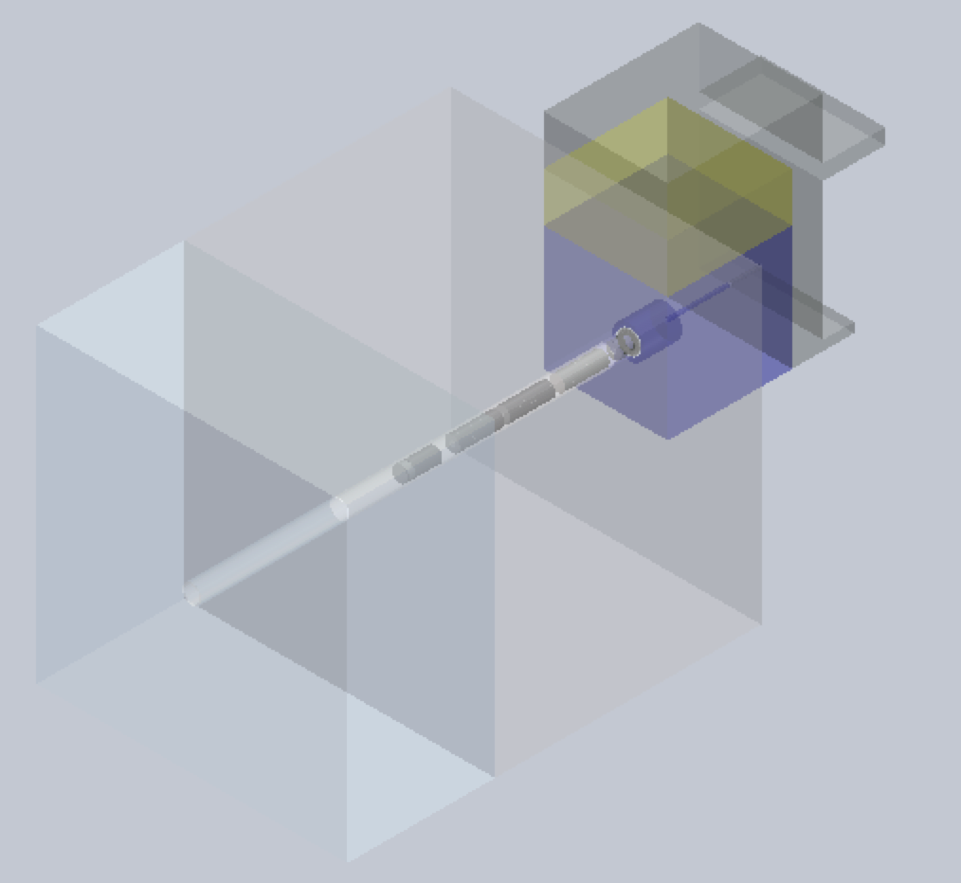

**Figure 3:** The transparent light blue above is water, the transparent light gray is concrete, and the collimator system can be seen running throughout the model. The blue, yellow, and gray at the end of the drawing are Fe + (CH2)n, (CH2)n + B4C, and natural Pb respectively. Please refer to Figure 4 for a cross-section view.

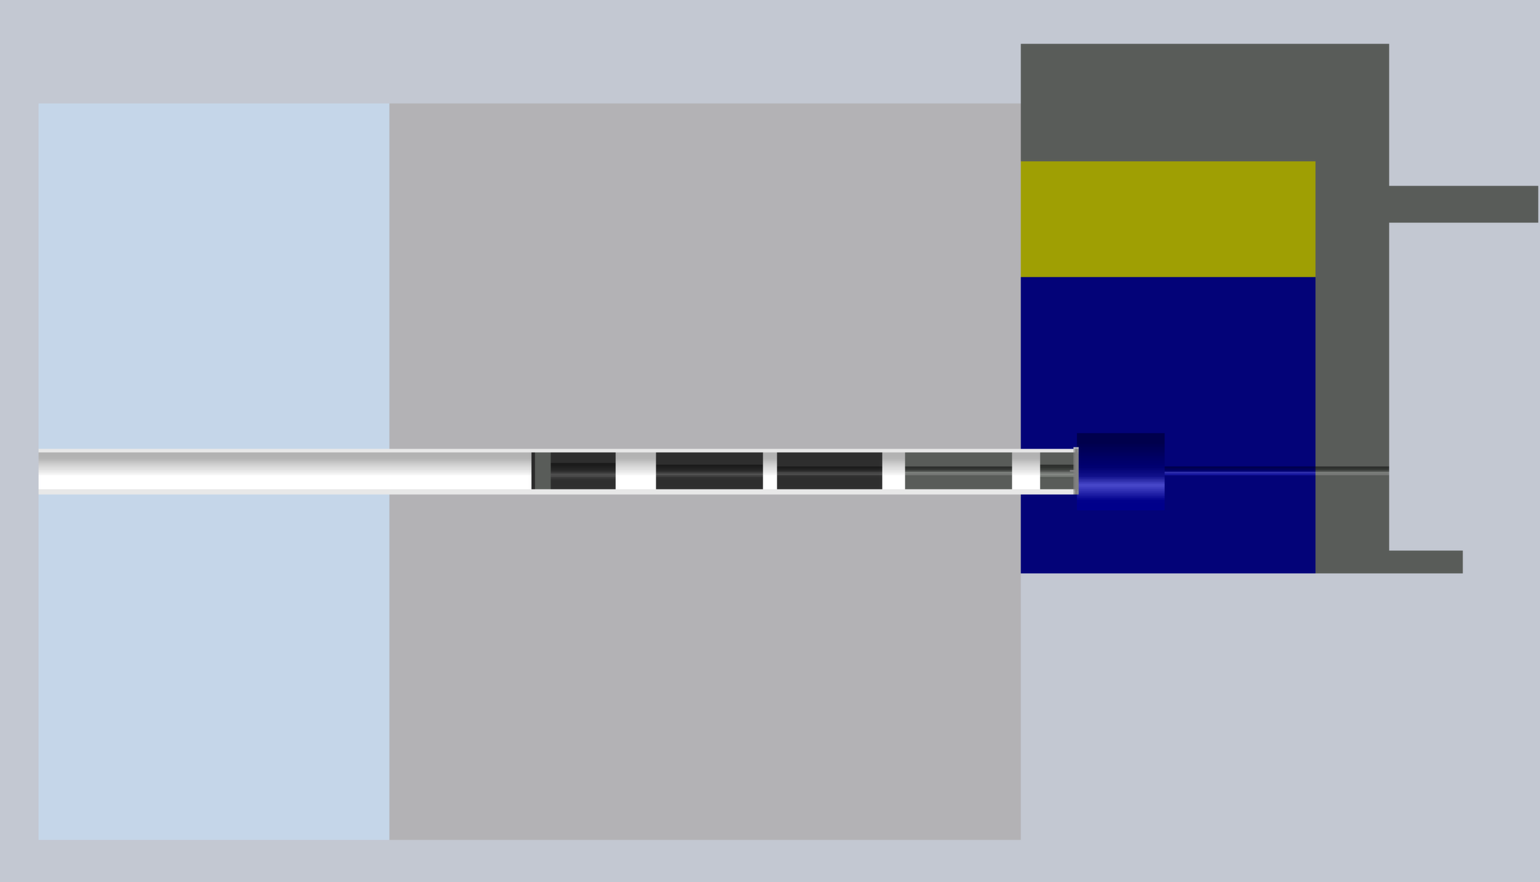

Lead

Concrete

Water

(CH2)n + B4C

Fe + (CH2)n

**Figure 4:** A cross-section view of our SolidWorks model. The collimator consists of (in order), 1cm plug of B4C, 4cm plug of Pb, a series of 3 Fe collimators, a 0.5mm Cd foil, and lastly 2 lead collimators. A series of voids is spaced throughout, and the material of the tube is unknown. The red dot indicates the location of the neutron source.

Briefly explained in the caption above the collimator is designed to minimize thermal neutrons being emitted from the reactor core and allow only fast neutrons to reach the end where they are detected by a germanium detector. Before moving onto the MCNP model, we will first explain the assumptions made in creating this SolidWorks model, as the assumptions will spill over into the MCNP design.

Ahmed’s paper*, Investigation Of Gamma-Ray Spectra From the Inelastic Scattering of Reactor Fast Neutrons* offered a very brief description of the neutron filter that we set out to recreate and it is given below:

“A neutron beam from the water-moderated reactor of the Baghdad Nuclear Research Institute was passed through a filter consisting of 1 cm of B4C, 0.5 mm of Cd, and 4 or 9 cm of Pb. A system of collimators was used to obtain a beam diameter of about 25 mm on the target.” (Investigation 1-2)

This clearly was not enough to recreate an entire elaborate experimental set up; we then had to make an assumption that the sketch (Figure 1) given to us was to scale. Using the scale indicated by the figure we created our own method to determine measurements using the pixels of the figure. The scaling tool that we used was going pixel by pixel on the image, and 1 m was equivalent to 80 pixels, thus our scaling was limited to 10/8 = 1.25 cm per pixel. This introduced an inherent error in all of our scaling measurements. We also were unable to determine what that black lines sticking up and down from the voids on the main filter tube were made of, so we did not include them. Lastly, we assumed a cylindrical geometry for the filter system, and a rectangular geometry for the surrounding materials. We made this assumption because we determined that in the building process, these shapes would have been the most common to construct.

We found that the main scaling issue that we ran into was defining the width of our voids. We took these to be our “error absorbers” of sorts, and did our best to match them, while ensuring that the length of our overall parts matched up to the overall length that we set at the beginning and measured from the scale. Because they are voids, we figured that they should not affect the overall flux greatly, so that is why we chose them to absorb the error.

The final issue when making the geometry was that we had two different images of the reactor/filter setup. One pictured in Figure 1 from *ATLAS of Gamma-Ray Spectra from the Inelastic Scattering of Reactor Fast Neutrons* and another not pictured from *Investigation Of Gamma-Ray Spectra From the Inelastic Scattering of Reactor Fast Neutrons.* Although these two images were very similar, they were not exactly the same. We thus defaulted to using the image that was smaller, but had a better-defined scale to use.

In Figure 1, because we were only worried about the flux at the sample we were able to disregard the structure after the collimation process, including the detector and concrete blocks. Our SolidWorks models reflect this design and our MCNP model will also reflect this. In the description as well there is a part where the collimator is being described in which it states “4 or 9 cm of Pb.”(Investigation 2) From the length of the design and relative to all the other structures we decided to go with the 4 cm of lead.

Again all these assumptions were made in creating the SolidWorks design of the neutron filter and will carry over to the MCNP design. Because this geometry, although assumption-full, was relatively simple we were able to create the MCNP design using planes and cylinders. This is simply done on MCNP by using the commands c/x and px when c and p are cylinders and planes respectively each of which are followed by the desired axis you wish to work with. As a brief description, MCNP works by first defining cells, and then defining surfaces which bound the cells (each cell also having various material properties which will affect the path of flight and interaction cross section for a photon or neutron). The combined cells create your geometry, which is then sealed up, by creating neutron graveyards. Graveyards kill the neutron when it leaves the geometry (Shultis 2-5).

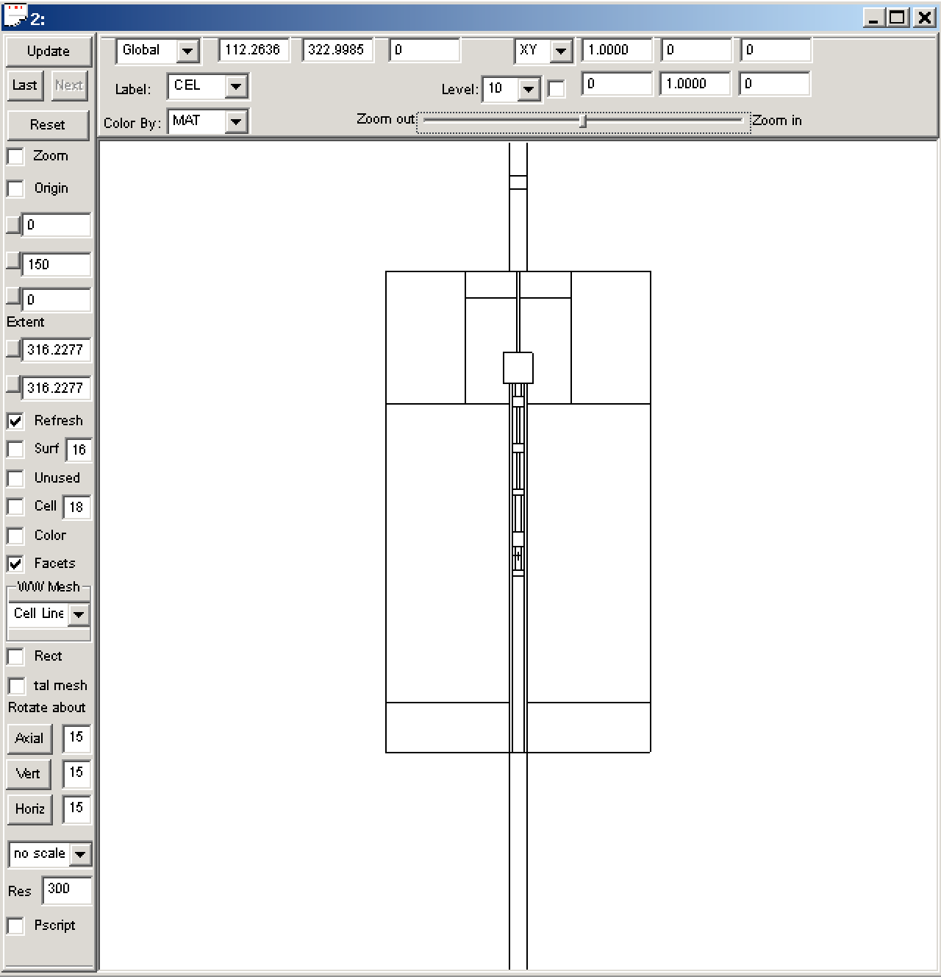 A vital tool used to visualize and help ensure our MCNP code was correct was the visual aid software Vised (Schwarz). Vised took our MCNP code and first created 2D sketches of the model. This was especially helpful because it showed if our code was creating a closed geometry. This was a large initial problem in our code because although it would run, it would quickly terminate because particles would be lost. Vised gave the ability to show surface by surface and cell by cell if the geometry was closed and defined. The 2D image is shown to the left.

**Figure 5:** Vised 2D model of our geometry. This is a cross section view showing the neutron filter and a clear view of the collimation process. The key to the Vised software is to ensure all lines become a solid black because this indicates the geometry is closed.

Furthermore Vised allowed for us to obtain a 3D view of the geometry, which compares to the SolidWorks design very well and shows our vision from start to finish. The model is below:

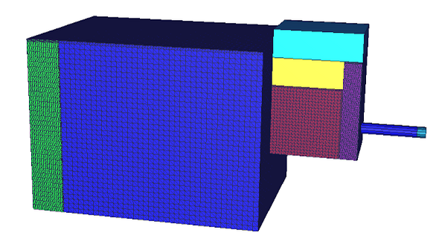

**Figure 6:** Vised 3D model. This model is very similar to the SolidWorks we made in the very beginning of our process.

Another useful feature Vised has is that you can upload a .sat CAD file. We attempted to do this by converting our SolidWorks file but were unsuccessful. This would have been a convenient check for our code because it could have outputted MCNP cell/surface cards that we could have referenced our “homemade” code with.

As a last note, one method we used to speed up our code was to treat the concrete and water as graveyards (i.e. IMP:N = 0 IMP:P = 0). We believed that this was appropriate because once a neutron entered either material the energy would quickly drop after a large number of interactions, making that neutron null. Following these neutrons would be a waste of computing time because they are not important as very low energy thermal neutrons in our final flux tally.

PRESCRIBING THE MATERIALS, SOURCE, AND TALLY CARDS

Now that we have an appropriate MCNP geometry defined, including all of the surface and cell cards needed in the first two steps of the program, it is time to define our materials, source, and tally cards.

For our materials, as shown in Figure 4 we have to define water, concrete, iron, lead, cadmium, B4C, polyethylene, and lastly air. It was crucial that we defined the isotopic make-up of each material as various isotopes can vary significantly in the cross-sections for neutron interactions. Fortunately, we were able to find a large number of our materials pre-defined in DMC’s *MCNP Tips: Materials*, however when this was not possible we would find the isotopic abundances (mole fraction), and choose a library to pull the material data from. The main assumption that was involved with the material selection came when we were describing the mixtures. No set mixture was listed, so for the (CH2)n + B4C, and Fe + (CH2)n mixtures we chose a 50/50 composition as to not bias one way or the other. This involved averaging the densities, and dividing all of the mole fractions by 2.

For our source term, we chose to go with a point source located at the origin as shown in Figure 4. We approximated our source to be a point source with a Maxwellian distribution modeling the flux that a typical reactor would have (a ≈ 0.6 MeV).

Lastly for our tally term we simply did an “F1” tally of the current that crossed the PY surface located where the sample was shown in the original sketch. We then broke that tally up into a large number of energy bins as to facilitate plotting a Flux vs. Energy spectrum at various locations in our setup later on.

HYPOTHESIS/EXPECTATIONS

As mentioned, it is crucial to think critically about what sort of results we should expect so we can evaluate the accuracy of our data. In order to do this, we will use knowledge of a typical reactor flux, solid angle effects, basic knowledge of relevant cross sections, and energy cut offs.

To begin, we are approximating our reactor flux with a Maxwellian distribution, with an *a*-value of 0.6 MeV (*a* is the scale parameter determined by the distribution function). This corresponds to a most-probable *En* value of about 0.7-0.8 MeV, which as shown in Ahmed’s *ATLAS of Gamma-Ray Spectra from the Inelastic Scattering of Reactor Fast Neutrons* is a good approximation of a reactor energy spectrum. In regards to an expected fast neutron flux at our detector, with this prescribed point source we can immediately expect that no more than 50% of the neutrons emitted will be able to hit the detector (on one side of the point vs. the other). Further, with *a* = 0.6 MeV, and a classification of a “fast” neutron being 1 MeV or above, we can integrate a PDF of the energy spectrum, or evaluate the Maxwellian CDF as found in Wolfram’s *Maxwell Distribution* and shown in (Eqn. 1)

**(Eqn. 1)**

to find that only 42.7% of these Maxwellian neutrons will be considered “fast” upon birth. We are now at 21.4% chance without even considering any materials or solid angle!

Next to contemplate the solid angle subtended by the sample; we will be looking for the solid angle of a disk at a radius of 366.25 cm, in regards to the point source located at the origin. Solid angle is found in (Eqn. 2)

**(Eqn. 2)** **(2**

And performing the integration of our disk with a radius of 1.25 cm, translating to θ and φ values ranging from ±tan-1(1.25/366.25) = ±0.003413 rad. Performing the calculation we find a solid angle of 4.66 \* 10-5 steradians. This is a measly 0.00037% of the total 4π steradians, bringing our ratio of “fast” neutrons with a head on shot to the detector to 1 in every 1.3 million! This number has been calculated without even taking into account material properties, which will add another dimension to the problem. Now is a good time to note that because we are looking for “fast” neutron flux, we can safely assume that a neutron which wanders out of the collimator system and goes through a number of collisions will no longer be “fast” by the time it would make it to our detector – thus leading us to only look at the direct solid angle which the sample subtends.

For our final expectation parameter, we know that Cadmium and Boron are both relatively good neutron absorbers. Thus we would expect through our geometry that the bottom portion of our reactor Maxwellian distribution should be diminished significantly. Naturally, the entire spectrum will be attenuated to some point, thus we would expect to see some value smaller than 7.77\*10-5 % of neutrons at our detector, but without doing exact cross section calculations and looking at resonances it might be difficult to tell!

Thus our final expectation is that some percentage less than 7.77\*10-5 % of fast neutrons ( >1 MeV) will arrive at our detector.

**IV. RESULTS**

We ran our code for a total time of 560.05 minutes, and roughly 7.27 billion neutrons. We found the neutron current crossing the very end of our geometry and only through the R = 1.25 cm collimation cylinder. Although this plane is not exactly at the sample location, because the sample is roughly 10x10 cm, the entire current will hit the sample, which we can confirm with solid angle calculations. Below we plot the PDF of the neutron spectrum at this disk, the log(Probability) vs. Energy distribution with a exponentially fitted regression line, and lastly the neutron flux at several significant points along our collimator axis. The second method was also used in Figure 2 by the Atlas team to find a *B* value so we will compare our data.

Please reference Appendix A for the Github links to our exact code and results.

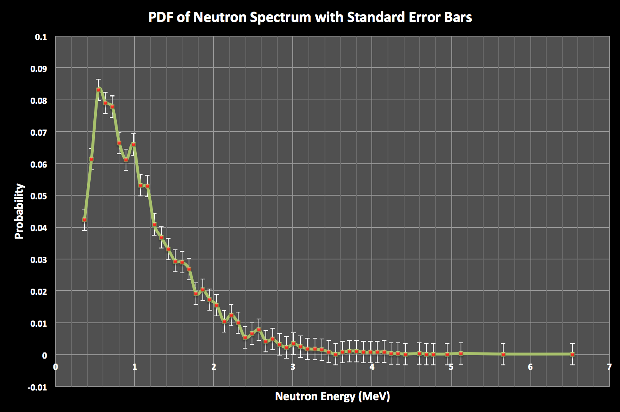

**Chart 1:** PDF of Neutron Spectrum: This plot shows us the probability of a neutron of a certain energy to be at the detection zone. Using this PDF, if we were given the true neutron output of the IRT reactor we could calculate the flux (#/cm2/s). In our code we also put a 0.3 MeV cut off to increase speed, which is reflected in the plot. Refer to Section V for a more detailed explanation.

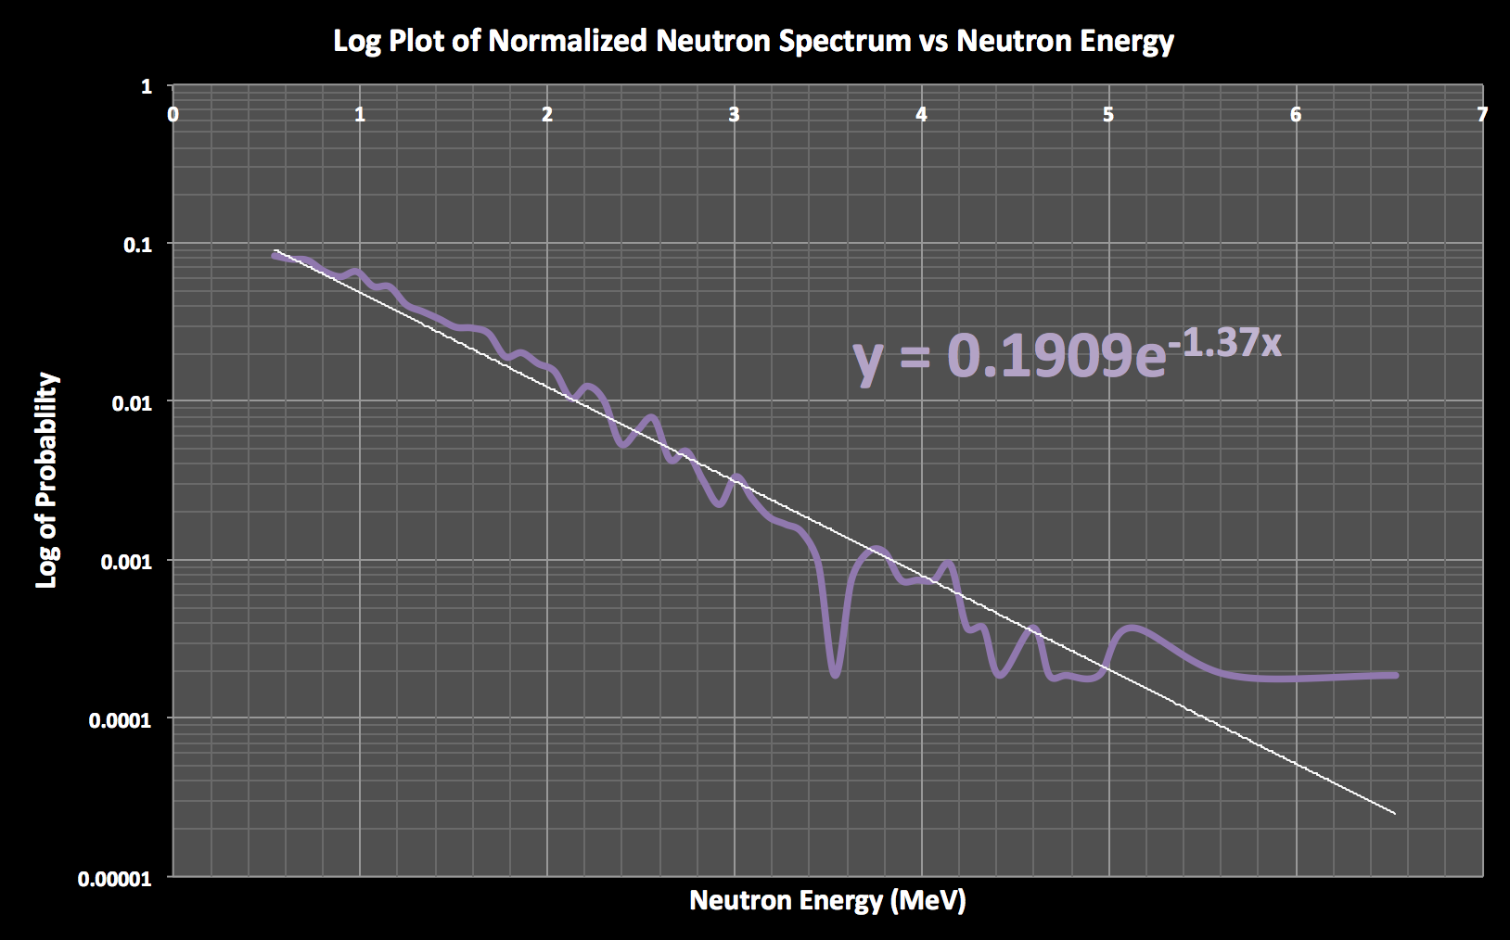

**Chart 2:** This plot gives us the same information as Chart 1, however it allows us to show the relationship between the energy of the neutrons and the probability, which was found to go with the relationship e^(-1.37\*E\_n). This fits the desired form of the equation of e-B\*(E\_n). Refer to Section V for a more detail explanation.

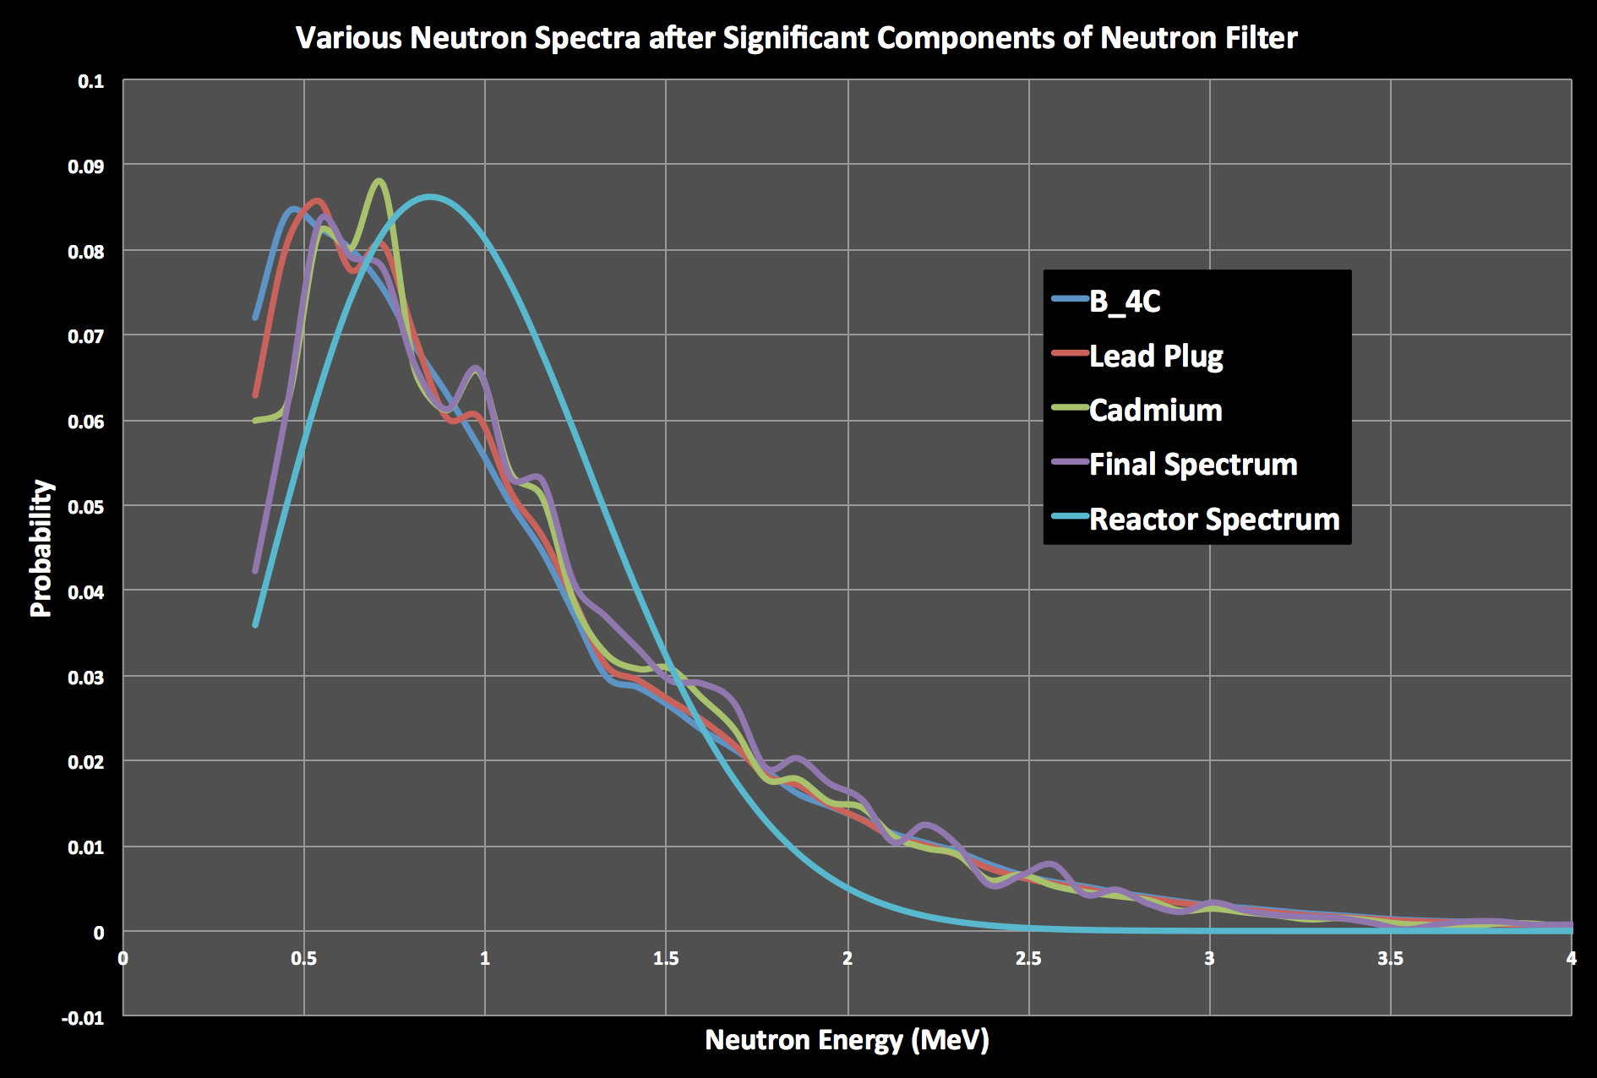

**Chart 3:** This plot shows how the types of neutrons change as they travel through the filter. It can be seen that as the neutrons pass through the filter they begin with a higher concentration of thermal neutrons but then shift to fast as they move down the collimator. Refer to Section V for a more detail explanation.

**V. CONCLUSIONS**

We have now constructed three very useful plots in evaluating and understanding the neutron filter built by Ahmed and his team. To begin, Chart 1 shows our results for the final neutron spectrum at the sample, and also shows corresponding standard error bars. This graph shows the Maxwellian shape, as expected due to our Maxwellian source, and is somewhat smooth except for a few distinct peaks on the >0.5 MeV side of the plot. The error appears to be quite small on the graph, however when looking at the SD produced by MCNP it is important to see that for energy bins greater than 2.5 MeV the SD is >.15 which is not very acceptable in a high precision study. This large SD is due to the relatively small amount of particles that we run. If you stipulate that a reactor emits 1012 n/s, then our 7.2 billion particles is only equivalent to 7 ms of reactor time! That is an incredibly small amount of time, and in order to achieve more precise results we would need to run far more particles. This increase in particles would be achieved by a number of variance reduction methods that can be employed, including Russian Roulette, source biasing, and geometry splitting as found in Shultis and Faw’s *An MCNP Primer*.

Disregarding some of our large SD’s and moving forward with an understanding that this is a preliminary run in the large scheme of things, we move to Chart 2. Chart 2 aims to mimic the graph in Figure 2 as we are only looking at En > 0.5 MeV. We show a logarithmic relationship for probability and fit this curve just as in Figure 2. We then found the *B* value that we were initially aiming to find! This *B* value is 1.37, which is significantly higher than 0.65-0.75 *B* value found from modeling the flux through a 10cm lead plug. Prof. Bernstein had used a *B* these early *B* values for his calculations and had found a variation of 20%. This would mean that a far greater Δ*B* would produce an even larger differences! We are inclined to trust our value slightly more than that listed in Ahmed’s works, due to the fact that we modeled the entire filter stochastically rather than what seems to be an approximation of an entirely different set up.

Our final plot shows the progression of neutron flux in the collimation system over space as we move from the origin toward our sample. We chose to sample the flux after the B4C plug, the lead plug, and the cadmium plug as these are all very significant filtering materials with respect to their neutron cross sections. They also have no direct material-less pass through them, which leaves no path for a neutron to move freely past. We then plotted the initial source/reactor spectrum that was used in order to gain a reference. We first notice that as we move through space towards the sample, and especially after the B4C and lead plugs, the flux shifts towards the “fast” neutron side. This is good to see as Ahmed’s group initially set out to filter out the thermal neutrons. It is also very clear that the most probable energy for all of our attenuated fluxes is shifted significantly towards the thermal side in regards to the initial reactor spectrum. This could be trouble, but if you were to analyze the CDF you would see that each of these attenuated fluxes has a larger total probably of a fast neutron. This is also seen in the PDF through the difference in areas under the respective curves beginning at 1.5 MeV.

A final interesting result to analyze is the total percentage of “fast” neutrons that made it to our final sample plane. We first hypothesized that this value should be less than 7.77\*10-5 %, but were unsure of what factor without detailed cross-section analysis. If we sum the discrete PDF beginning at 1 MeV, we find a fast neutron percentage of 3.42\*10-5%! This is within about a factor of 2, which is not too bad at all for making a very rough approximation.

We have found a number of very interesting results from this relatively short run of particles. We have found a *B* value of 1.37 which can greatly help Prof. Bernstein in his calculations, we’ve seen how various materials and plugs can affect a flux over space, and lastly we’ve gained a huge appreciation for variance reduction methods (more sophisticated than our 0.3 MeV cutoff) and how these methods drastically improve the precision and speed of a stochastic software like MCNP when you have to run on such a massive scale. In the future, we will investigate how to utilize these reduction methods in order to run a more accurate and precise simulation of this neutron filter. We will also try out different source geometries that might be a more appropriate model of the core, in order to see how our results may change. A much faster, more sophisticated computing system would be greatly beneficial as well and will be pursued in the coming months.

**VI. REFERENCES**

[1] AHMED, M. R, SHAKARCHI, Kh., AL-NAJJAR, S., & AL-AMILI, M. A, Govor, L I., Demidov, A M. (1973). Investigation of Gamma-Ray Spectra from the Inelastic Scattering of Reactor Fast Neutrons. Nuclear Instruments and Methods. Nuclear Research Institute, Bagdad. I. V. Kurchatov Institute of Atomic Energy, Moscow.

[2] AHMED, M. R, SHAKARCHI, Kh., AL-NAJJAR, S., AL-AMILI, M. A, Al Assafi, N., Rammo, N. Govor, L I., Demidov, A M. (1978) ATLAS of Gamma-Ray Spectra from the Inelastic Scattering of Reactor Fast Neutrons (Part 1). Atomizdat. Nuclear Research Institute, Bagdad. I. V. Kurchatov Institute of Atomic Energy, Moscow.

[3] DMC. (2011, August 1). MCNP Tips: Materials. Retrieved May 11, 2015, from [http://mcnptips.blogspot.com/2011/08/123.html](http://mcnptips.blogspot.com/2011/08/123.html" \t "_blank)

[4] Los Alamos National Laboratory. (2005) MCNP User Manual. RSICC Computer Code Collection. Oak Ridge Nation Laboratory. U.S. Department of Energy.

[5] Labrum, J. Ross, K. MCNP Flux Model of IRT-5000 Bagdad Research Reactor Neutron Filter-Interim Report. (2015). UC Berkeley Nuclear Engineering Department.

[6] Schwarz, A.L., Schwarz, R. A., & Carter, L. L. (2011) MCNP/MCNPX Visual Editor Computer Code Manual. Visual Editor Consultants.

[7] Shultis, J. K., & Faw, R. E., (204-2011). An MCNP Primer. Dept. of Mechanical and Nuclear Engineering Kansas State University.

[8] Wolfram. Maxwell Distribution. Mathworld. (2015). Retrieved May 12, 2015, from http://mathworld.wolfram.com/MaxwellDistribution.html

**Appendix A**

MCNP Code and Final Results: https://github.com/jlabrum/NE\_155\_Final\_Project.git