The APIs below pull data from YELP, process and display.

1. [/business/search](http://localhost:8082/swagger-ui.html#/operations/business-controller/getBusinessesUsingPOST)

Parameters:

term and location

API that pull business from YELP based on term and location

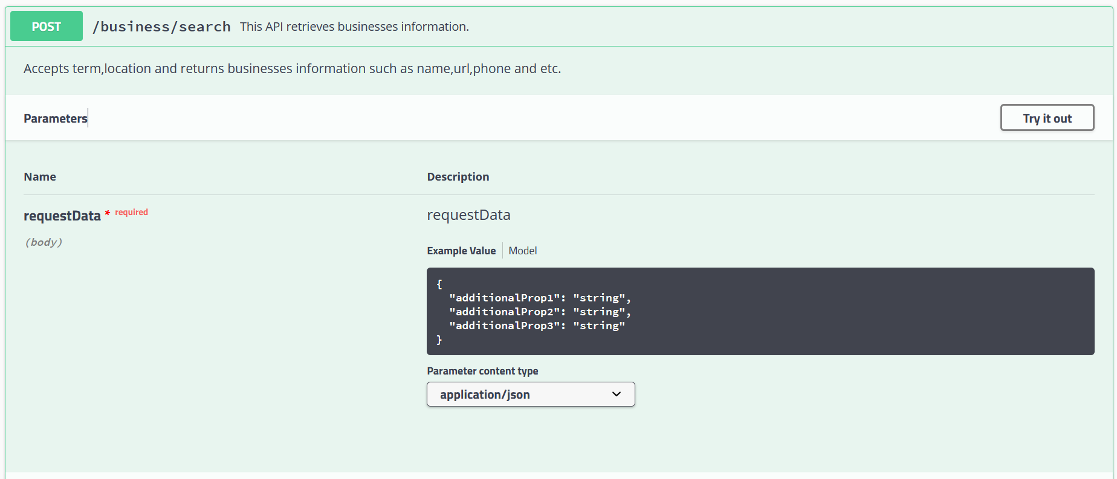

1. [/business/reviews/{id}](http://localhost:8082/swagger-ui.html#/operations/business-controller/getBusinessReviewsUsingGET)

Parameters:

Id=path

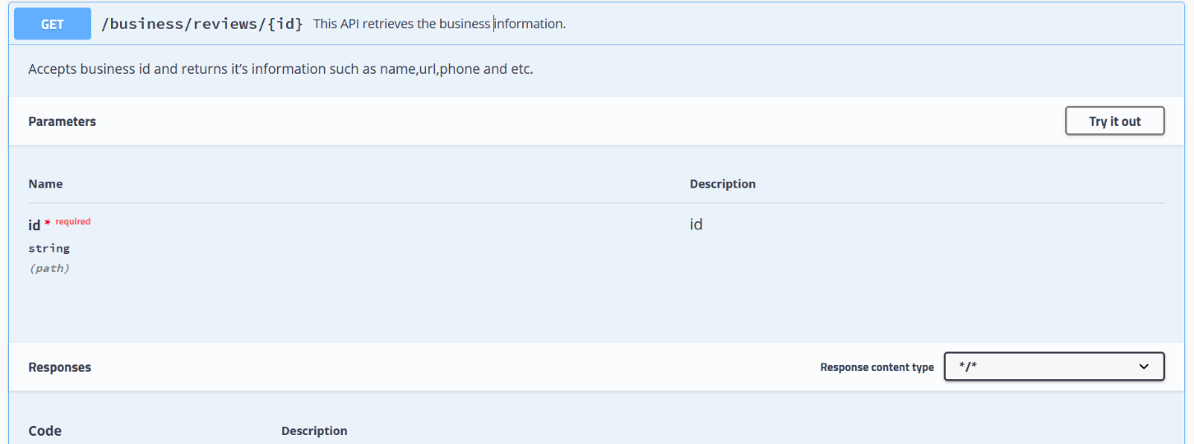API that pull the business reviews from YELP

Code Structure:

