RMarkdown

James L. Adams

## Installation

install.packages("rmarkdown")  
  
## This one's just for making plots later  
install.packages("gapminder")

# Syntax

## Headers

# Header 1

# Header 1

## Header 2

## Header 2

### Header 3

### Header 3

#### Header 4

#### Header 4

##### Header 5

##### Header 5

###### Header 6

###### Header 6

## Text Styles

block quote

> block quote

**Bold**

**Bold**

*Italic*

*Italic*

endash: --

endash: --

emdash: ---

emdash: ---

inline equation (using $LaTeX$): $A=π*r^{2}$

inline equation (using $LaTeX$): $A = \pi*r^{2}$

Subscripts Hello! and superscripts Hello! are easy.

Subscripts ~Hello!~ and superscripts ^Hello!^ are easy.

[Here's a link](https://www.google.com)

[Here's a link](https://www.google.com)

## Images

image: 

image: ![](https://s-media-cache-ak0.pinimg.com/originals/1d/96/13/1d96138537ae93c28554fa623f56a527.gif)

## Lists

* unordered list
* number 2
  + sub-item (four spaces)

* unordered list  
* number 2  
 + sub-item (four spaces)

1. ordered list
2. item 2
   * sub-item (four spaces)

1. ordered list  
2. item 2  
 + sub-item (four spaces)

## Tables

The default rendering is as you would see in the R terminal:

head(mtcars)

## mpg cyl disp hp drat wt qsec vs am gear carb  
## Mazda RX4 21.0 6 160 110 3.90 2.620 16.46 0 1 4 4  
## Mazda RX4 Wag 21.0 6 160 110 3.90 2.875 17.02 0 1 4 4  
## Datsun 710 22.8 4 108 93 3.85 2.320 18.61 1 1 4 1  
## Hornet 4 Drive 21.4 6 258 110 3.08 3.215 19.44 1 0 3 1  
## Hornet Sportabout 18.7 8 360 175 3.15 3.440 17.02 0 0 3 2  
## Valiant 18.1 6 225 105 2.76 3.460 20.22 1 0 3 1

You can use other styles, including interactive tables when knitting to HTML. Here's one using a knitr kable:

knitr::kable(head(mtcars))

|  |  |  |  |  |  |  |  |  |  |  |  |
| --- | --- | --- | --- | --- | --- | --- | --- | --- | --- | --- | --- |
|  | mpg | cyl | disp | hp | drat | wt | qsec | vs | am | gear | carb |
| Mazda RX4 | 21.0 | 6 | 160 | 110 | 3.90 | 2.620 | 16.46 | 0 | 1 | 4 | 4 |
| Mazda RX4 Wag | 21.0 | 6 | 160 | 110 | 3.90 | 2.875 | 17.02 | 0 | 1 | 4 | 4 |
| Datsun 710 | 22.8 | 4 | 108 | 93 | 3.85 | 2.320 | 18.61 | 1 | 1 | 4 | 1 |
| Hornet 4 Drive | 21.4 | 6 | 258 | 110 | 3.08 | 3.215 | 19.44 | 1 | 0 | 3 | 1 |
| Hornet Sportabout | 18.7 | 8 | 360 | 175 | 3.15 | 3.440 | 17.02 | 0 | 0 | 3 | 2 |
| Valiant | 18.1 | 6 | 225 | 105 | 2.76 | 3.460 | 20.22 | 1 | 0 | 3 | 1 |

## Code

Here's a piece of inline code to look at.

Here's a piece of `inline code` to look at.

Here is a piece of inline R code: 10

Here is a piece of inline R code: `r sum(3, 7)`

```  
Code chunks are delineated by three backticks  
```

# R Code goes here!!

# This will generate output  
summary(cars)

## speed dist   
## Min. : 4.0 Min. : 2.00   
## 1st Qu.:12.0 1st Qu.: 26.00   
## Median :15.0 Median : 36.00   
## Mean :15.4 Mean : 42.98   
## 3rd Qu.:19.0 3rd Qu.: 56.00   
## Max. :25.0 Max. :120.00

# Including "eval = FALSE" means this code will not run  
summary(cars)

## Plots

# Throw some plots in:  
library(ggplot2)  
library(gapminder)  
  
ggplot(gapminder, aes(x = gdpPercap, y = lifeExp)) +  
 geom_point(aes(color = continent))

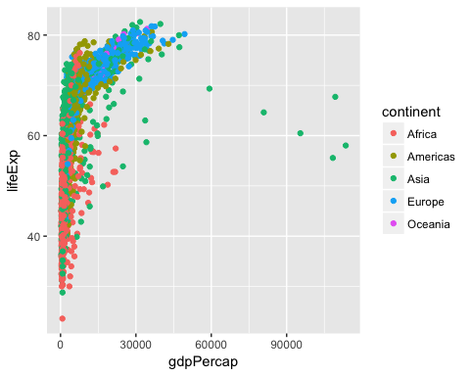

# Reproducible reports for when your data changes:  
library(MASS)  
library(ggplot2)  
set.seed(42)  
  
df <- data.frame(mvrnorm(500, mu = c(0,0), Sigma = matrix(c(1,0.56,0.56,1), ncol = 2),  
 empirical = TRUE))  
  
head(df)

## X1 X2  
## 1 -1.5229629 -0.1039770  
## 2 -0.6037383 -1.0562666  
## 3 -0.1830964 0.1967777  
## 4 -0.4197538 0.2290691  
## 5 0.4354155 0.8071503  
## 6 0.1885482 0.1035446

ggplot(df, aes(x = X1, y = X2)) +  
 geom_point() +  
 geom_smooth(method = "lm")

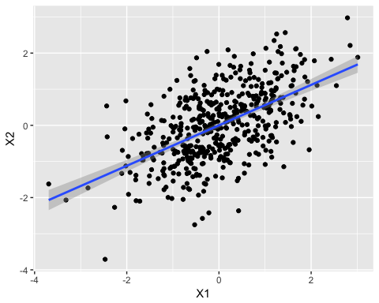

set.seed(500)  
  
df <- data.frame(mvrnorm(500, mu = c(0,0), Sigma = matrix(c(1,0.56,0.56,1), ncol = 2),  
 empirical = TRUE))  
  
head(df)

## X1 X2  
## 1 -2.2014050 -0.6368717  
## 2 -1.3510351 -1.9537550  
## 3 0.7808272 -1.2277939  
## 4 0.9720240 -0.3084019  
## 5 0.3479552 -1.1997703  
## 6 0.4815081 0.4875031

ggplot(df, aes(x = X1, y = X2)) +  
 geom_point() +  
 geom_smooth(method = "lm")

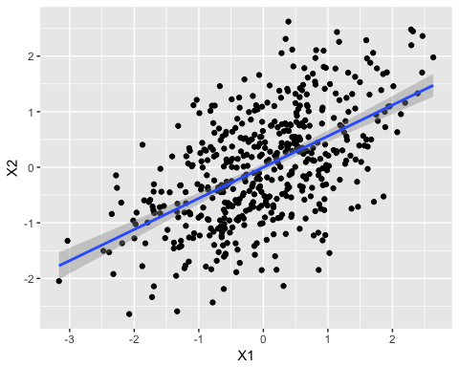

## Other Languages

Code chunks can be in other languages including:

* Python
* SQL
* Bash
* Rcpp
* Stan
* JavaScript
* CSS

### Python

x = 'hello, world!'  
print(x.split(' '))

## ['hello,', 'world!']

### Bash

pwd

## /Users/jamesadams/projects/parker/Rmd

## Footnotes

Here's a footnote,[1] and a second one. [2]

Here's a footnote,[^1] and a second one. [^longnamednote]  
  
[^1]: Here's the first footnote.  
  
[^longnamednote]: Here's the other.

1. Here's the first footnote.
2. Here's the other.