RMarkdown

James L. Adams

3/10/2017

## Installation

install.packages("rmarkdown")

## Syntax

# Header 1  
## Header 2  
### Header 3  
#### Header 4  
##### Header 5  
###### Header 6

# Header 1

## Header 2

### Header 3

#### Header 4

##### Header 5

###### Header 6

> block quote

block quote

endash: --

endash: --

emdash: ---

emdash: ---

inline equation ($LaTeX$): $A = \pi*r^{2}$

inline equation ():

image: ![](https://s-media-cache-ak0.pinimg.com/originals/1d/96/13/1d96138537ae93c28554fa623f56a527.gif)

image: 

* unordered list  
* number 2  
 + sub-item (four spaces)

* unordered list
* number 2
  + sub-item (four spaces)

1. ordered list  
2. item 2  
 + sub-item (four spaces)

1. ordered list
2. item 2
   * sub-item (four spaces)

Here's a piece of `inline code` to look at.

Here's a piece of inline code to look at.

```  
Code chunks are delineated by three backticks  
```

# R Code goes here!!

# This will generate output  
summary(cars)

## speed dist   
## Min. : 4.0 Min. : 2.00   
## 1st Qu.:12.0 1st Qu.: 26.00   
## Median :15.0 Median : 36.00   
## Mean :15.4 Mean : 42.98   
## 3rd Qu.:19.0 3rd Qu.: 56.00   
## Max. :25.0 Max. :120.00

# Including "eval = FALSE" means this code will not run  
summary(cars)

# Throw some plots in:  
library(ggplot2)  
library(gapminder)  
  
ggplot(gapminder, aes(x = gdpPercap, y = lifeExp)) +  
 geom_point(aes(color = continent))

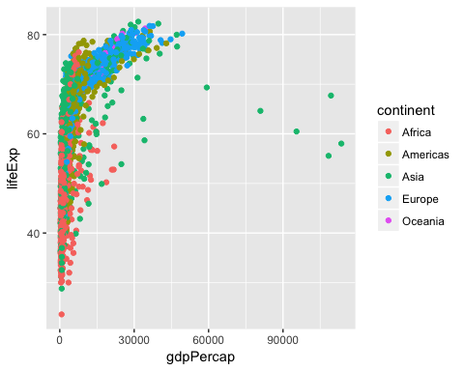

# Reproducible reports for when your data changes:  
library(MASS)  
library(ggplot2)  
set.seed(42)  
  
df <- data.frame(mvrnorm(500, mu = c(0,0), Sigma = matrix(c(1,0.56,0.56,1), ncol = 2),  
 empirical = TRUE))  
  
head(df)

## X1 X2  
## 1 -1.5229629 -0.1039770  
## 2 -0.6037383 -1.0562666  
## 3 -0.1830964 0.1967777  
## 4 -0.4197538 0.2290691  
## 5 0.4354155 0.8071503  
## 6 0.1885482 0.1035446

ggplot(df, aes(x = X1, y = X2)) +  
 geom_point() +  
 geom_smooth(method = "lm")

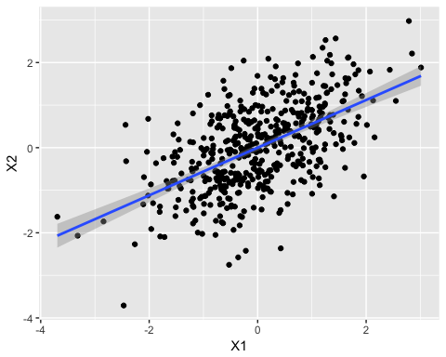

set.seed(500)  
  
df <- data.frame(mvrnorm(500, mu = c(0,0), Sigma = matrix(c(1,0.56,0.56,1), ncol = 2),  
 empirical = TRUE))  
  
head(df)

## X1 X2  
## 1 -2.2014050 -0.6368717  
## 2 -1.3510351 -1.9537550  
## 3 0.7808272 -1.2277939  
## 4 0.9720240 -0.3084019  
## 5 0.3479552 -1.1997703  
## 6 0.4815081 0.4875031

ggplot(df, aes(x = X1, y = X2)) +  
 geom_point() +  
 geom_smooth(method = "lm")

