**NCP3106: SOFTWARE DESIGN (LABORATORY)**

1st Semester, School Year 2021 - 2022

**MACHINE PROBLEM**

Machine Problem No. 1

Submitted by:

**LAGUNDA, JAMES B.**

20190157370

Submitted to:

**Engr. ERROL JOHN M. ANTONIO**

Assistant Professor, DCpE

AUGUST 21, 2021

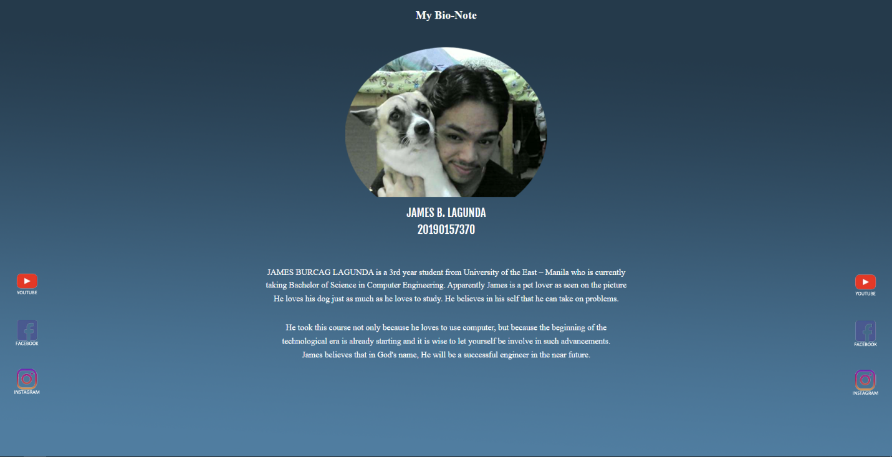

SOURCE:

