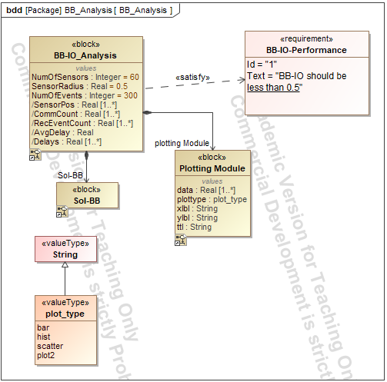
Figure 1. Block definition diagram of the BB Analysis system.
Block definition diagram showing the BB-IO Analysis, Sol-BB, and Plotting Module blocks, their properties and relationships, the performance requirement, and the available plot types.

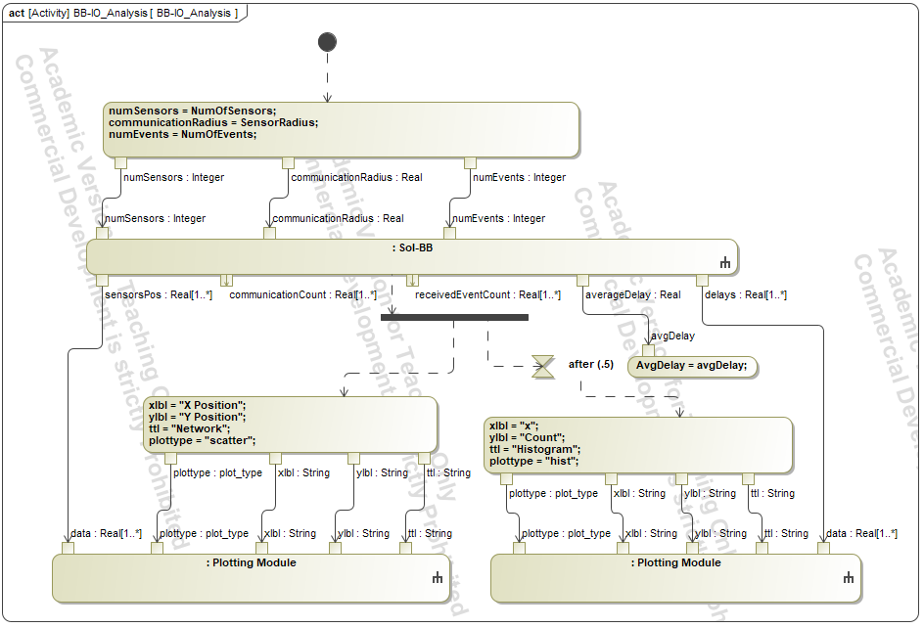
Figure 2. Activity diagram for BB-IO Analysis.
Activity model illustrating the flow of the BB-IO Analysis, including sensor configuration, execution of the Sol-BB system, calculation of performance measures, and generation of visualizations.

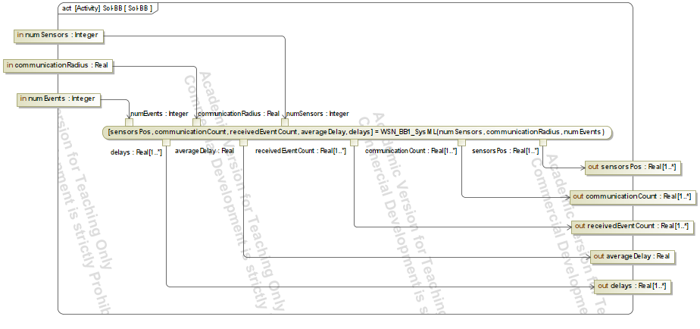
Figure 3. Activity diagram of the Sol-BB system of interest.
Activity model showing the inputs to the Sol-BB system, including the number of sensors, communication radius, and number of events, and the resulting sensor positions, communication counts, received-event counts, average delay, and delays.

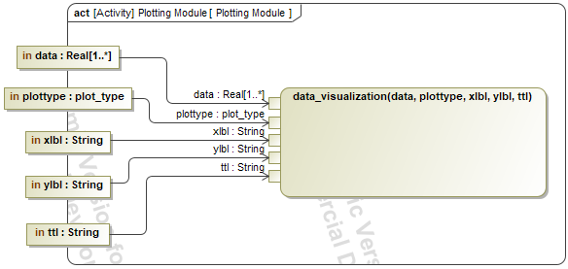
Figure 4. Activity diagram of the Plotting Module.
Activity model showing how input data and plotting parameters are passed to the visualization function to generate the specified plot.

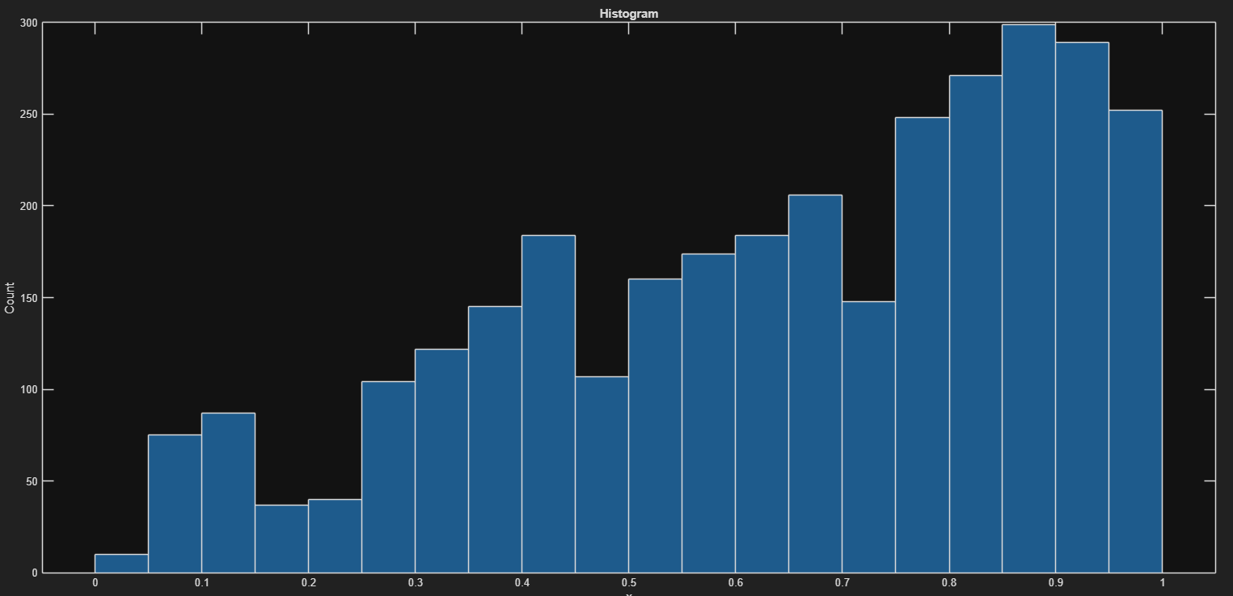
Figure 5. Histogram of simulation results.
Distribution of the analyzed simulation values, showing the frequency of observations across the range from 0 to 1.

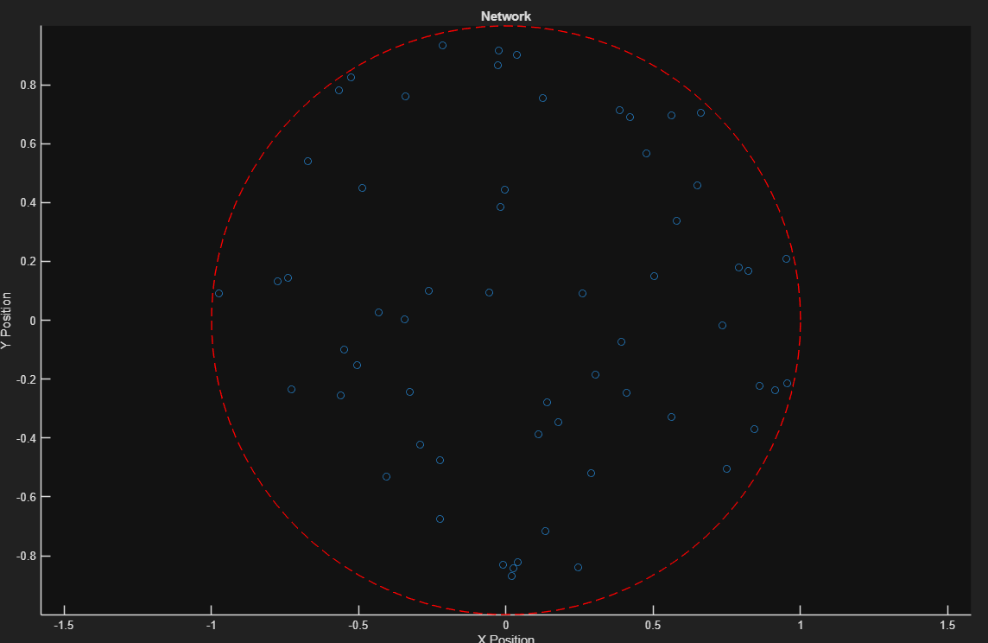
Figure 6. Network topology and sensor positions.
Spatial distribution of sensor nodes within the defined network area, with the dashed circle representing the communication boundary.

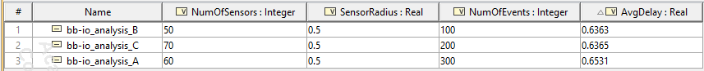
Figure 7. BB-IO Analysis instance data.
Instance data showing the configured numbers of sensors, sensor radius, number of events, and corresponding average-delay values for the analyzed BB-IO Analysis configurations.

