Provide Real-Time Weather Data At Home

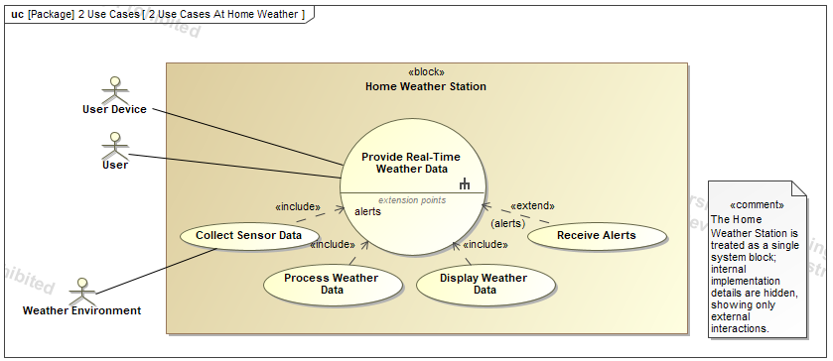
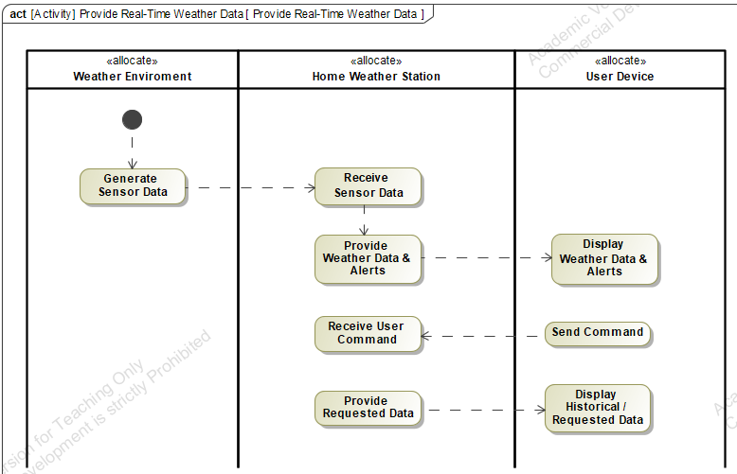

This activity diagram illustrates the functional behavior of the Provide Real-Time Weather Data use case for the Home Weather Station system. It presents a black box view by modeling interactions between external entities and the system without exposing internal structure. The diagram captures both continuous system-driven processes and user-initiated interactions.

The model is organized into three partitions: Weather Environment, Home Weather Station, and User Device. The automated flow begins with the generation of sensor data in the environment, which is transmitted to the system for processing. The Home Weather Station then produces weather data and alerts, which are sent to the User Device for display. This sequence reflects the core functional decomposition of the use case, including data collection, processing, and presentation.

A second flow represents user-initiated behavior, where a command from the User Device is received and processed by the system to provide requested or historical data. This highlights the system’s ability to support both real-time monitoring and on-demand queries.

An activity diagram is appropriate for this use case because it captures the overall workflow and data flow across system boundaries, including both continuous and event-driven behavior. The diagram refines the primary use case while maintaining a black box perspective, and it provides a foundation for further development of internal structure in subsequent white box models.

