EcoTwin
Wind-Aware Temporal Graph Convolutional Network for 24-hour PM2.5 forecasting
and a digital-twin prototype for Delhi's air-quality network

Complete implementation overview: what was built, how, and with what results

23CSE498 Project Phase II | Team 86 | Amrita School of Computing, Coimbatore, Amrita Vishwa Vidyapeetham
Guide: Dr. Divya Bharathi P, Department of CSE
State of the work: November 2026. Numbers in this document come from the saved result files of the notebooks listed in Section 7.

Reading guide
Sections 1-2 | What the project is and the end-to-end workflow
Sections 3-5 | Dataset, methodology and every formula used
Sections 6-8 | Metrics, implementation environment, core module details
Section 9 | Verification and ALL quantitative results (score tables)
Sections 10-11 | What can be demonstrated; design justifications and trade-offs
Section 12 | Work still to be implemented, and what in this document will change

Executive summary
EcoTwin forecasts PM2.5 24 hours ahead, every hour, at all 37 continuous monitoring stations in Delhi, and serves the forecasts through a digital-twin dashboard. The core model, the Wind-Aware Temporal Graph Convolutional Network (WA-TGCN), passes information between stations over a graph that is rebuilt every hour from the wind, then models each station's history with a GRU and self-attention, and decodes a 24-hour forecast conditioned on the calendar and the future wind.

Headline results (held-out test set, 8 Dec 2025 to 9 Apr 2026, 2,918 forecast windows)
Model | RMSE (µg/m³) | MAE | R² | Notes
Persistence (last value repeated) | 83.87 | 56.93 | 0.307 | baseline; best only at +1 h (33.8)
WA-TGCN v1 (5-seed ensemble) | 64.59 | 41.50 | 0.589 | first working model
WA-TGCN v2 (7-seed ensemble) | 60.92 | 39.69 | 0.634 | 26 features, forecast-graph decoder, volatility-weighted loss
WA-TGCN v3 (7 seeds, ERA5 wind + forecast wind) | 58.79 | 38.10 | 0.659 | wind from reanalysis, future wind given to the decoder
Graph-free model + real day-old forecast wind | 58.53 | 38.17 | 0.662 | the real, deployable gain comes from forecast wind
dyn_adv: wind graph + upwind (wind-aware) feature (5 seeds) | 57.71 | 37.92 | 0.672 | best Delhi model so far

What the experiments established
- Works as a forecaster. The hourly wind-driven graph beats persistence by about 27 µg/m³ (RMSE 83.87 to 60.92 for v2) and is a sound, well-behaved design. All 37 stations improved from v1 to v2 (mean change in station RMSE -3.50 µg/m³).
- Largest single gain. Forecast wind as an input is worth about 2 to 5 µg/m³ (graph-free: 63.21 with no wind, 60.59 with observed wind, 58.53 with a real day-old forecast, 58.41 with perfect future wind).
- Honest finding on the wind graph. Across the original pipeline, the ERA5 pipeline, four controls and four other cities, the wind-aware graph is within about 1 µg/m³ of a static or graph-free model. It is statistically a tie, not a clear win. The best wind-aware model (dyn_adv, 57.71) is 0.33 µg/m³ better than the best non-wind model (58.04).
- Cross-city transfer works. The Delhi-trained model, with no retraining, beats persistence in all four tested cities (Kolkata -32%, Ahmedabad -24%, Patna -18%, Mumbai -13% RMSE in zero-shot).
- Live pipeline and prototypes. A real data-in, forecast-out live system exists (OpenAQ and Open-Meteo to 37-station forecasts), and a React digital-twin front end and a Streamlit dashboard exist as prototypes.

1. Project overview

1.1 Problem and contribution
Delhi's winter PM2.5 episodes are severe and change fast. Most services report the level after it is already high. Graph-based forecasters that could warn earlier usually link stations with a fixed, distance-only graph, which cannot respond to the wind that actually carries pollution between stations. EcoTwin builds a forecaster whose graph is recomputed every hour from wind direction and speed, tests carefully what that graph contributes, adds forecast wind where it helps, and exposes the results through a digital-twin interface with alerts and what-if scenarios.

1.2 Scope decisions made during the project
- The first proposal was a fog-enabled federated-learning architecture. Because CPCB data is public, the privacy argument for federated learning no longer held, so the work now uses one centralised model for Delhi.
- The sensor-hardware prototype (edge and fog) was dropped for this semester, because a node in Coimbatore cannot feed a Delhi-trained model. Live data is obtained from public monitoring feeds instead.
- Cross-city generalisation was implemented as a second research axis (Section 9.7).

1.3 What was built (inventory)
Component | What it is | Status
Dataset | Cleaned hourly dataset, 37 stations x 19,921 hours, with DOI | Done, published
WA-TGCN v1, v2, v3 | Forecasting models with saved 5 and 7-seed ensembles | Done
Baselines and ablations | Persistence, graph-free, static graph, dynamic graph on three data settings | Done
Forecast-wind study | Observed vs real day-old forecast vs perfect future wind | Done
Follow-up experiments | Orientation test, blend and context dropout, transport features | Done
Explainability | Attention, exact Shapley over feature groups, edge sensitivity | Done
Cross-city | Four cities, zero-shot and few-shot | Done
Live ingestion | OpenAQ + Open-Meteo to live 24-hour forecasts | Built and tested end to end
Prototypes | Streamlit dashboard, React digital-twin front end, documentation portal | Built (live wiring still to do)

2. Overall workflow
The system is a pipeline from public monitoring data to a forecast and an interface. The figure shows the end-to-end architecture (solid boxes are implemented).
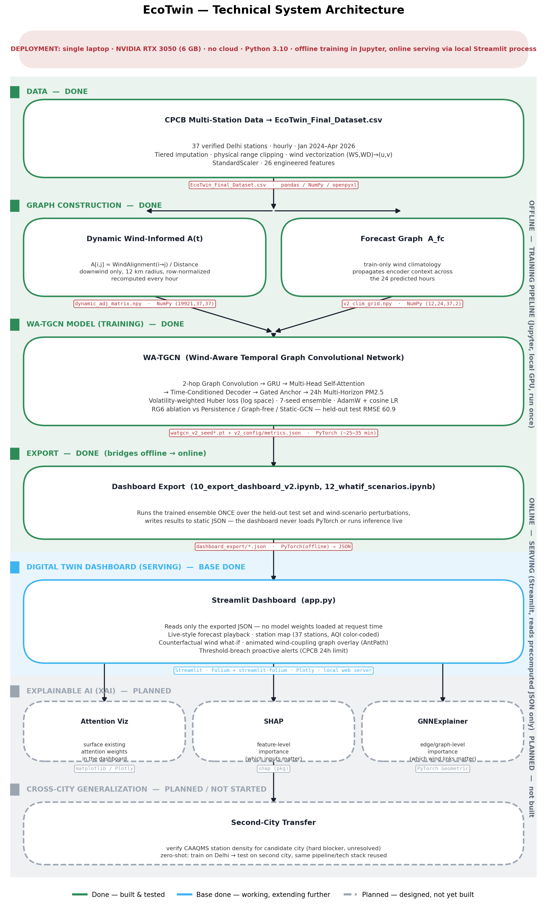
Figure 1. Technical architecture of EcoTwin.

2.1 Stages
1. Acquire and audit. 45 CPCB station files (hourly, Jan 2024 to Apr 2026) are audited for missingness; dead stations are removed, two are recovered with verified coordinates, one phantom is dropped, leaving 37.
2. Preprocess. Physical-range clipping, a four-tier imputation, conversion of wind speed and direction to u and v components, 26 features, StandardScaler, log-transformed target.
3. Build graphs. A static distance graph (12 km), an hourly wind-driven graph A(t), and a forecast graph for the future hours.
4. Model. 2-hop graph convolution, GRU, self-attention, time-conditioned decoder, gated anchor; volatility-weighted Huber loss; seed ensembles.
5. Evaluate. Persistence, graph-free, static and dynamic variants; by horizon, volatility regime and wind regime; leakage checks.
6. Explain. Attention, Shapley values over six feature groups, and edge sensitivity.
7. Transfer. Delhi-trained models applied to Kolkata, Mumbai, Ahmedabad and Patna.
8. Live ingestion. Hourly data from OpenAQ and wind from Open-Meteo go through the same preprocessing and the 7-seed ensemble to produce JSON forecasts.
9. Serve and visualise. Map, forecast panel, alerts, wind-graph overlay, what-if scenarios.
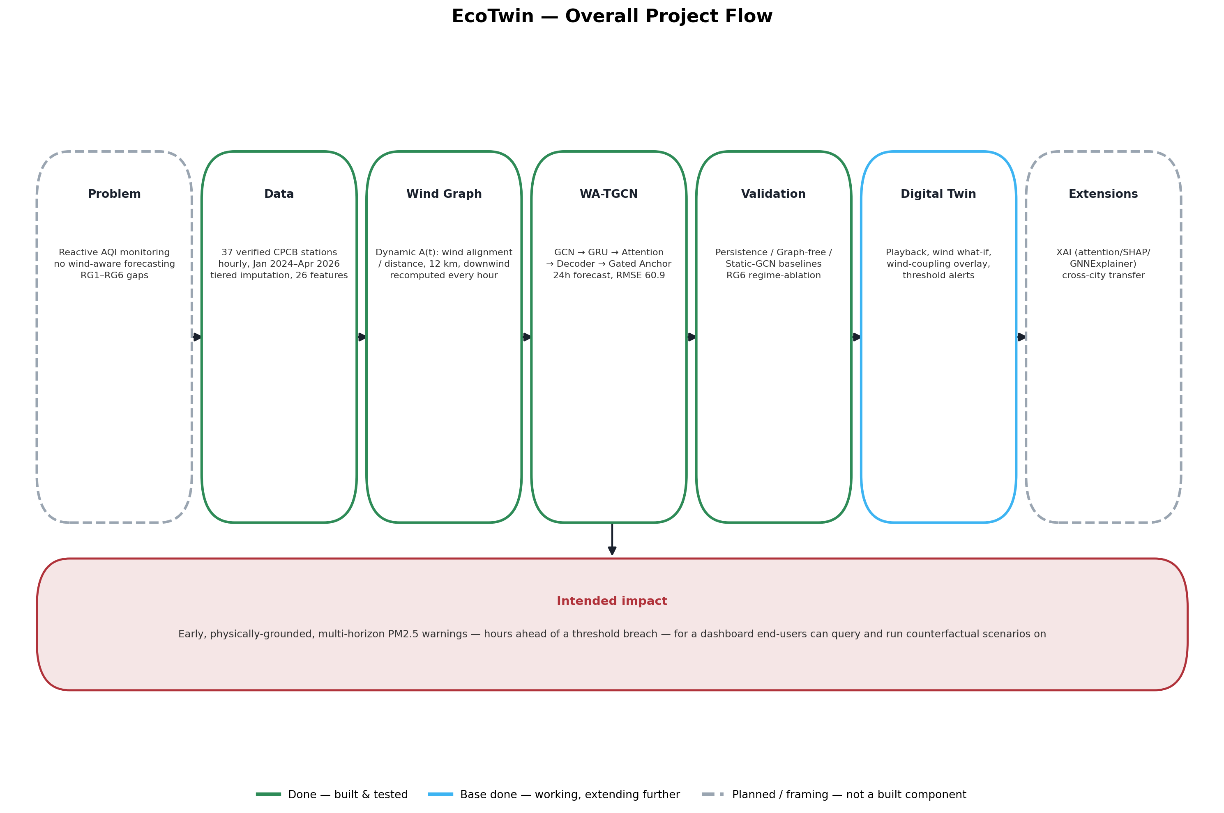
Figure 2. Overall flow diagram.

3. Dataset and input specifications

3.1 Source and coverage
Item | Specification
Source | CPCB continuous ambient air-quality monitoring stations (CAAQMS), Delhi NCT, downloaded as hourly station files
Stations | 37 (from 44 in the original list: 8 dropped as 85-96% empty or too sparse, 2 recovered with verified coordinates, 1 phantom with no data removed)
Period | 2024-01-01 00:00 to 2026-04-10 00:00 (IST), hourly
Size | 19,921 hourly rows per station, 737,077 station-hours, no gaps and no duplicates after resampling
Pollutants | PM2.5, PM10, NO2, SO2, CO, O3 (µg/m³; CO in mg/m³)
Meteorology (CPCB) | Relative humidity, ambient temperature, wind speed, wind direction
External wind (v3) | Open-Meteo / ERA5 reanalysis wind at each station (10 m), real day-old forecast wind (Previous Runs API) for the forecast-wind study
Published | Zenodo, DOI 10.5281/zenodo.23619409 (processed and derived material under CC BY 4.0; CPCB observations remain under CPCB's terms)

3.2 Data quality
Missing values were imputed (Section 3.3), so the released series are complete, but a large share of some variables are not original readings:
Variable | Mean share of original readings | Variable | Mean share of original readings
PM2.5 | 94.6% | SO2 | 75.6%
PM10 | 95.4% | Relative humidity | 75.7%
NO2 | 96.3% | Wind speed | 71.4% (0% original at 9 stations)
CO | 95.6% | Wind direction | 73.6%
O3 | 90.5% | Ambient temperature | 70.9%

- CPCB wind agrees only weakly with ERA5 reanalysis wind (correlation about 0.25 in the first audit), which motivated the v3 pipeline.
- The raw files contain exact 1000 values, a reporting ceiling. They are masked as missing before imputation, not clipped.

3.3 Preprocessing
1. Range clipping. Physical range limits are applied before imputation so that sensor spikes are not borrowed by neighbours.
2. Four-tier imputation. (1) mean of graph neighbours at the same hour, (2) city mean at that hour, (3) linear interpolation per station, (4) forward and backward fill.
3. Wind vectors. u = -WS sin(WD), v = -WS cos(WD) (the direction the air moves toward), computed before scaling; WD of 360 is first mapped to 0.
4. Scaling. StandardScaler, fit on the training period only. MinMax scaling was rejected because it squashed the wind components to a standard deviation of about 0.013.
5. Target transform. log(1 + PM2.5) then standardised. Raw PM2.5 skew is 2.56; after the log it is -0.18.

3.4 Model input and output specification
Item | Specification
Input window | 48 hours x 37 stations x 26 features
Output | 24 hours x 37 stations of PM2.5 (log-scaled, converted back to µg/m³)
Graph inputs | A(t) for each input hour (48 x 37 x 37) and a forecast graph for each of the 24 future hours (24 x 37 x 37)
Future inputs (decoder) | v2: 7 calendar features; v3: 7 calendar features plus forecast wind u, v and speed (10 channels)
Anchor | Last observed PM2.5 (log-scaled), added back with a learned per-horizon weight
Split | Chronological 70 / 15 / 15, no shuffling: train hours 0-13,943, validation to 16,931, test after
Windows | Train 13,873, validation 2,917, test 2,918 (a window needs 48 + 24 hours)
Test period | 2025-12-08 to 2026-04-09 (deep winter, harder than the validation period)

The 26 features
Group | Features
Pollutants and weather (8) | pm2.5, pm10, no2, so2, co, o3, rh, at
Wind (3) | u_wind, v_wind, wspd (speed)
PM2.5 history (6) | 6 h and 24 h rolling mean and standard deviation, 3 h change (pm_roll6_mean/std, pm_roll24_mean/std, pm_delta3)
City context (3) | city_mean_pm, city_max_pm, pm_minus_city (station minus city mean)
Calendar (7) | sin and cos of hour, day of week and month; weekend flag

4. Methodology: methodological breakdown

4.1 Graph construction
- Static graph. Stations are nodes. The static graph links stations within 12 km (254 station pairs, 508 directed entries).
- Dynamic wind graph A(t). For every hour t, an edge from station i to station j exists if j is within 12 km and the wind at i blows toward j. Weights grow with the aligned wind component and shrink with distance, and each row is normalised. On average about 260 directed edges are active per hour, against 508 in the static graph.
- Forecast graph for the decoder. v2 builds a second wind graph from a wind climatology (mean u, v by month, hour and station) computed on the training period only, so no test information is used. v3 uses the actual (ERA5) future wind, which is an oracle setting; the real-forecast version uses day-old forecast wind.

4.2 Model: WA-TGCN, stage by stage
Stage | Operation | Shape after the stage
1. Input projection | Linear (26 to 32) + ReLU | (B, 48, 37, 32)
2. Graph encoder | 2 hops of A(t)-weighted aggregation, each Linear + LayerNorm + ReLU + residual; self-loops added inside the model | (B, 48, 37, 32)
3. Temporal GRU | One-layer GRU (hidden 32) over the 48 hours of each station, dropout 0.2 | (B x 37, 48, 32)
4. Self-attention | 4-head self-attention over the 48 steps, residual + LayerNorm, last step kept | (B, 37, 32)
5. Forecast-graph propagation | Context spread across stations with the forecast graph for each of the 24 future hours | (B, 24, 37, 32)
6. Time-conditioned decoder | Concatenate [context, propagated context, future-feature embedding] (96 values), MLP 96-32-1 | (B, 24, 37)
7. Gated anchor | Add the last observed PM2.5 multiplied by a learned per-horizon gate (initialised from 1.0 at +1 h down to 0.3 at +24 h) | (B, 24, 37)

The model has 18,201 parameters (v2) and 18,297 (v3 variants, which have the 10-channel future embedding); the variant with the two upwind features has 18,361. Capacity was never the bottleneck: a 64-unit, 2-layer version gave identical accuracy with 5.6 times more parameters.

4.3 Training
- Weighted Huber loss in log space. Windows are weighted by how much the target changes over the 24 hours, so fast weather-driven episodes get more weight (weights 0.5 to 4, normalised to mean 1; 0.56x to 1.87x in practice).
- AdamW (learning rate 1e-3, weight decay 1e-4), batch 16, cosine schedule with 5% warmup, gradient clipping 1.0, up to 60 epochs, early stopping with patience 12 on validation loss. The best epoch is typically 4 to 7.
- Seed ensembles: 7 seeds (42, 7, 123, 2024, 999, 2025, 77) for final models; the first 5 for ablations. Ensemble predictions are averaged in log space and converted back.
- About 4 to 6 minutes per model on a laptop RTX 3050 (a 7-seed ensemble takes 25 to 35 minutes).

4.4 Experimental design principles
- Each comparison changes one thing: same features, loss, seeds and splits. Choices are made on the validation set and the test set is scored once.
- Scalers, climatology and the target transform are fit on training data only; splits are made before windowing. Persistence on the same pipeline (81.5 in the first check) confirms there is no leakage.
- Single-model results vary by 1 to 2 µg/m³ across seeds, so ensemble differences below about 1 µg/m³ are treated as inside the noise.

4.5 Experiment ladder (what was tested, in order)
Step | Question | Notebook
Architecture ablation A-E | Which design choices matter? (hidden size, pooling, delta prediction, future-time conditioning, log + Huber + anchor) | 06
v1 to v2 | Do engineered features, a forecast-graph decoder, 2-hop GCN and a volatility-weighted loss help? | 07, 09
Graph ablation | Does the wind graph beat static and no graph? | 11, 15
Wind-source study | Does reanalysis wind and future wind help? Is wind-only-through-graph useful? | 13-17
Real forecast wind | What is a real day-old forecast worth, with and without the graph? | 18-20
Orientation test | Does transposing the graph (receiver gathers from upwind) help? | 21
Explainability | What does the model use? | 22
Cross-city | Does it transfer to other cities? | 23-26
Make the wind graph win | Blend, context dropout, transport-aligned features | 27, 28
Regional upwind stations | Do stations 25-250 km upwind add a wind-dependent signal? | 32-35

5. Mathematical and algorithmic formulations

5.1 Notation
N = 37 stations, T_in = 48 input hours, H = 24 forecast hours, F = 26 features. X_t ∈ R^(N×F) holds the (scaled) features at hour t. (u_i(t), v_i(t)) is the wind at station i, meaning the direction the air moves toward. d_ij is the great-circle distance in km and (e_ij, n_ij) is the unit vector from i to j.

5.2 Wind graph
u = -WS · sin(WD), v = -WS · cos(WD) (wind-from convention converted to air-motion components)
a_ij(t) = u_i(t) · e_ij + v_i(t) · n_ij (wind speed component from station i toward j)
A_ij(t) = a_ij(t) / (d_ij + ε) if d_ij ≤ 12 km and a_ij(t) > 0, else 0 (row i keeps only downwind neighbours)
Ā_i·(t) = A_i·(t) / Σ_j A_ij(t) (row normalisation)
Ã(t) = D⁻¹ (Ā(t) + I) (self-loops added inside the model, then renormalised)
A_static,ij = 1[ d_ij ≤ 12 km ] (static control graph)

5.3 Graph convolution, recurrence and attention
h_i^(l+1)(t) = ReLU( LayerNorm( W^(l) · Σ_j Ã_ij(t) h_j^(l)(t) ) ) + h_i^(l)(t), l = 0, 1 (2-hop residual graph convolution)
g_i(1..48) = GRU( h_i^(2)(1..48) ) (one layer, hidden size 32, per station)
Attn(Q, K, V) = softmax( Q Kᵀ / √d_k ) V, 4 heads; c_i = LayerNorm( Attn(g_i) + g_i )[last step] (temporal self-attention)

5.4 Decoder and anchor
c'_i(τ) = Σ_j Ã^fc_ij(τ) c_j, τ = 1..24 (context propagated with the forecast graph)
r_i(τ) = MLP( [ c_i , c'_i(τ) , φ( z(τ) ) ] ) (z(τ) = calendar (v2) or calendar + forecast wind (v3) at the target hour)
ŷ_i(τ) = r_i(τ) + γ_τ · y_i(0), γ_1..24 learned, initialised 1.0 → 0.3 (gated anchor: last observed value y_i(0))
y = ( log(1 + PM2.5) - μ ) / σ, PM2.5 = exp( σ ŷ + μ ) - 1 (target transform and its inverse)

5.5 Loss
L = Σ_b w_b · (1 / (H·N)) · Σ_(τ,i) Huber_δ( ŷ_bi(τ) - y_bi(τ) ), δ = 1 (weighted Huber in log space)
w_b = clip( 1 + α · s_b / median(s), 0.5, 4 ), s_b = mean over i of ( max - min of PM2.5 over the 24 target hours ), α = 1 (volatility weight, normalised to mean 1)
ŷ_ens = (1 / S) · Σ_s ŷ^(s) (in log space, S = 5 or 7) (seed ensemble)

5.6 Baselines
ŷ_i(t + τ) = PM2.5_i(t) (persistence)
A = I (no graph), A = A_static (static graph) (ablation graphs; everything else identical)

5.7 Transport-aligned features (Round 2)
adv_i(t) = Σ_j w_ji · PM_j( t - τ_ji ) / Σ_j w_ji, τ_ji = round( d_ji / (max(a_ji, 0.5) · 3.6) ) capped at 6 h (wind-aware: upwind neighbours at their travel-time lag)
nb_i(t) = mean over j in N(i) of PM_j(t) (static control: same-hour mean of all neighbours within 12 km)

5.8 Explainability
φ_g = Σ_(S ⊆ G∖g) [ |S|! (n - |S| - 1)! / n! ] · [ v(S ∪ {g}) - v(S) ], n = 6 feature groups (exact Shapley value (64 coalitions); absent group = training mean)
E_ij = mean | ∂ŷ / ∂A_ij · A_ij | (edge sensitivity, averaged over windows, lags and seeds)

5.9 Cross-city transfer
Zero-shot: the saved Delhi checkpoints, the Delhi scalers and the Delhi feature definitions are applied unchanged to another city's stations, graph (built with the same 12 km rule) and ERA5 wind. Few-shot: each checkpoint is fine-tuned for up to 15 epochs (learning rate 3e-4, patience 4) on the city's own September to November 2025 data, and scored on the same test period.

6. Evaluation metrics and protocol
RMSE = √( (1/M) Σ (ŷ - y)² ), MAE = (1/M) Σ |ŷ - y|, R² = 1 - Σ (ŷ - y)² / Σ (y - ȳ)² (computed in µg/m³ on the original scale)
Metric or slice | Definition and use
RMSE (headline) | Penalises large misses; dominated by episodes, so it is the right metric for early warning
MAE, R² | Typical error and explained variance, reported alongside RMSE
By horizon | RMSE at each of +1 h to +24 h; shows the error growth and where persistence wins (+1 h)
By volatility regime | Test windows split into thirds by the 24-hour swing of the target: Stable, Moderate, Volatile (the volatile third gives about 76% of the total error)
By wind regime | Windows split into calm, breezy, windy by mean wind speed (input-window CPCB wind in the v2 pipeline; forecast-period wind in v3)
Seed noise rule | Single models differ by 1-2 µg/m³; five-seed ensembles are 1-2.5 better than single models; gaps under about 1 µg/m³ are not conclusive
Cross-city scoring | On hours with a real PM2.5 reading only (imputed hours excluded); persistence is the bar to beat
Explainability | Test RMSE of the full model against the model with a feature group set to the training mean; share of the error reduction per group

7. Implementation details and environment

7.1 Environment
Item | Specification
Machine | Windows 11 laptop, NVIDIA GeForce RTX 3050 Laptop GPU (6 GB), CUDA build of PyTorch
Language and core packages | Python 3.14.2, PyTorch 2.11.0 (CUDA 12.8 build), NumPy 2.4.3, pandas 3.1.0, scikit-learn 1.9.1
Visualisation and apps | Matplotlib 3.10.8, Plotly 6.9.0, Folium 0.20.0, Streamlit 1.61.1; React 18 + TypeScript + Vite front end (ECharts, MapLibre)
Data access | openpyxl 3.1.5, requests 2.32.5; OpenAQ v3 API and public S3 archive, Open-Meteo archive, forecast and Previous Runs APIs
Workflow | JupyterLab 4.5.1; numbered notebooks with a 'how to check' comment on each cell; Git and GitHub for the code
Latency | A 24-hour forecast for all 37 stations costs about 0.31 ms per window for the dynamic model (0.26 ms graph-free); cost grows about linearly with the number of stations (0.08 ms at 10 stations)

7.2 Notebook index
Nb | Purpose | Nb | Purpose
01 | Preprocessing and 37-station cleanup | 21 | Graph-orientation test
03 | Static and dynamic wind graphs | 22 | Explainability (attention, Shapley, edges)
04 | Feature engineering and windows | 23 | Cross-city station audit (OpenAQ)
05-06 | First training, architecture ablation A-E | 24 | Build Kolkata, Mumbai, Ahmedabad, Patna data
07 | WA-TGCN v1 | 25 | Train and save Delhi static and graph-free variants
08, 10 | Dashboard exports (v1, v2) | 26 | Cross-city zero-shot and few-shot evaluation
09 | WA-TGCN v2 | 27 | Round 1: blend and context dropout
11 | Baselines and ablation (v2 pipeline) | 28 | Round 2: transport-aligned features
12 | What-if scenarios (v2) | 29 | Live ingestion
13 | Fetch ERA5 wind | 31 | What-if response check (v3)
14-15 | WA-TGCN v3 and ablation (ERA5 pipeline) | 32-35 | Regional upwind-station analysis
17 | Matched controls | (30, 36) | Built, not yet run in full (Section 12)
18-20 | Real forecast wind and graph integration

7.3 Reproducibility
- Seeds, splits and scaler fitting are fixed in the notebooks; v3 results were re-derived exactly from saved checkpoints (59.08 for five seeds, 58.79 for seven).
- Checkpoints are saved per seed (watgcn_v2_*, watgcn_v3_*, watgcn_v3static_*, watgcn_v3none_*, watgcn_v5*), with configuration and scaler files.
- The notebooks use absolute Windows paths and the repository has no requirements file yet (Section 12).

8. Core module implementation details

8.1 Preprocessing module (notebooks 01, 04)
Reads the 45 raw station files, audits per-station missingness, applies the station cleanup, clips physical ranges, runs the four-tier imputation, converts wind to u and v, resamples to the hourly grid, and writes the 37-station dataset. Feature engineering then adds rolling statistics, city context and calendar features, fits the scalers on the training period, and builds the sliding windows.

8.2 Graph builder (notebook 03 and the model notebooks)
Computes the haversine distance matrix and the unit-direction matrices once, then for any wind field returns the row-normalised A(t). The same function builds the stored hourly graph (19,921 x 37 x 37), the climatology forecast graph, and the live graphs. A recipe check confirmed that the recomputed graph equals the stored one to within 1e-8.

8.3 WA-TGCN model class (notebooks 09, 14)
- A single PyTorch module with a graph mode switch (dynamic, static or none), so every ablation uses identical code and parameter counts.
- The model never depends on the number of stations: no layer has a station-sized dimension, so the saved weights run on any city's graph without change (checked on the saved weights).
- The windowed dataset slices shared full-length arrays by window start, which avoids copying and keeps memory low.

8.4 Training and evaluation harness
A common loop (weighted Huber, AdamW, cosine schedule, early stopping on validation, best-state restore) trains each seed; predictions are ensembled in log space, converted to µg/m³, and scored by horizon and regime. Later notebooks reuse the same loop and only change the model variant or the features, which is what makes the comparisons controlled.

8.5 Explainability module (notebook 22)
- Attention: a forward hook on the attention layer captures the last position's weights over the 48 input hours; averaged over heads, stations, windows and seeds.
- Shapley: all 64 coalitions of six feature groups are run through the 7-seed ensemble on 400 evenly spaced test windows, with absent groups set to the training mean.
- Edge sensitivity: gradient of the forecast with respect to the adjacency, multiplied by the adjacency, averaged (GRU backward is run with cuDNN disabled).

8.6 Cross-city pipeline (notebooks 23-26)
Notebook 23 audits OpenAQ for 12 candidate cities and counts stations with at least 70% hourly PM2.5 coverage. Notebook 24 builds each city's dataset in the Delhi format (PM2.5 and gases from the OpenAQ archive, humidity and temperature from the stations or ERA5, ERA5 wind, the same imputation and features). Notebook 25 trains and saves the static and graph-free Delhi variants, which were not saved earlier. Notebook 26 evaluates zero-shot and few-shot.

8.7 Live ingestion module (notebook 29)
Step | Implementation
Stations | 35 of the 37 Delhi stations are matched to OpenAQ monitors by coordinates (within 1 km); the other two are imputed from neighbours
Data | Per station and parameter the freshest OpenAQ sensor is chosen; hourly values are fetched (first run about 5 minutes, then only the last hours; OpenAQ allows 60 requests per minute)
Wind | One Open-Meteo forecast API request for all stations gives the recent wind and the next 3 days
Features and graph | The same cleaning, imputation, 26 features, A(t) from the live wind, and a forecast graph from the forecast wind
Models | The 7 saved v3 models on CPU; mean and the 10th and 90th percentile across seeds for each station and hour
Outputs | live_frame.json, live_playback.json, live_meta.json (data age, stations reporting, warnings), live_whatif.json
Safeguards | A replay mode flagged as replay if the internet is down; a warning when fewer than half of the stations report or the data is older than 6 hours

8.8 Dashboard and front end
- Streamlit dashboard (app.py): station map coloured by CPCB category, click-to-inspect forecast chart (actual vs predicted), alert panel, playback over 970 test windows, wind-coupling overlay with animated flow lines, three precomputed what-if scenarios.
- React front end (frontend/, built by teammates): digital-twin map with wind particles and A(t) overlay, forecast panel, what-if studio, health advisor, credibility page and a guided walkthrough, loading its data from JSON files.

9. Preliminary verification and quantitative results

9.1 Verification checks
Check | Result
Leakage | Scalers, climatology and splits fit on training data only; persistence on the same pipeline scores 81.5, a sane value
Self-loop bug | Without self-loops some stations scored R² = 0.0000; fixed by adding A + I inside the model
Phantom station | A station with coordinates but no data file had explained constant outputs; removed (44 to 37 stations)
Reproduction | v3 re-derived from saved checkpoints: 59.08 (5 seeds) and 58.79 (7 seeds), exactly as trained
Graph recipe | Recomputed A(t) from ERA5 wind equals the stored matrix (difference 0.0 in the what-if notebook, 1e-8 in the first check)
Orientation | The graph orientation was checked and the original (receiver gathers from downwind neighbours) is better; Section 9.5
Live vs stored | Live pipeline features are on the training scale (NO2 50.8 vs 43.2, SO2 17.2 vs 14.7, CO 1.93 vs 1.23, temperature 26.5 vs 25.9)

9.2 Score table across model versions (test set)
Model | RMSE | MAE | R² | Seeds / setting
Persistence | 83.87 | 56.93 | 0.307 | last observed value
WA-TGCN v1 | 64.59 | 41.50 | 0.589 | 5 seeds, 14 features, 1-hop
WA-TGCN v2 | 60.92 | 39.69 | 0.634 | 7 seeds, 26 features, CPCB wind (validation RMSE 55.14)
WA-TGCN v3 | 58.79 | 38.10 | 0.659 | 7 seeds, ERA5 wind + forecast-wind decoder (validation 55.51)
dyn_adv (best Delhi model) | 57.71 | 37.92 | 0.672 | 5 seeds, wind graph + upwind feature, v3 pipeline

The validation RMSE of the v2 ensemble (55.14) is lower than the test RMSE (60.92) because the validation months are easier than deep winter. The test figure is the one to quote.

9.3 Error by horizon, regime and station
Table. Test RMSE (µg/m³) by forecast horizon. Persistence is best only at +1 h; the learned models are better from about +2 h. The first row of the model block is the graph-free ablation model of the v2 pipeline.
Horizon | +1 h | +3 h | +6 h | +12 h | +18 h | +24 h
Persistence | 33.82 | 61.23 | 82.94 | 93.22 | 92.56 | 76.72
v1 (no-graph, v2 pipeline) | 41.59 | 49.81 | 57.89 | 64.50 | 67.31 | 67.73
v2 (7 seeds) | 41.41 | 48.86 | 56.70 | 62.99 | 65.97 | 66.49
v3 (7 seeds) | 41.19 | 48.86 | 56.05 | 60.67 | 62.90 | 63.06

Table. Test RMSE by volatility regime. The volatile third of windows produces about 76% of the total error.
Regime | Persistence | No-graph (v2 pipe) | Static (v2 pipe) | Dynamic (v2 pipe) | v2 (7 seeds) | v3 (7 seeds)
Stable (third of windows) | 37.02 | 29.55 | 29.56 | 30.24 | 29.89 | 27.81
Moderate | 62.91 | 43.64 | 43.81 | 43.24 | 42.95 | 41.00
Volatile | 124.57 | 93.13 | 92.18 | 90.54 | 90.87 | 88.22

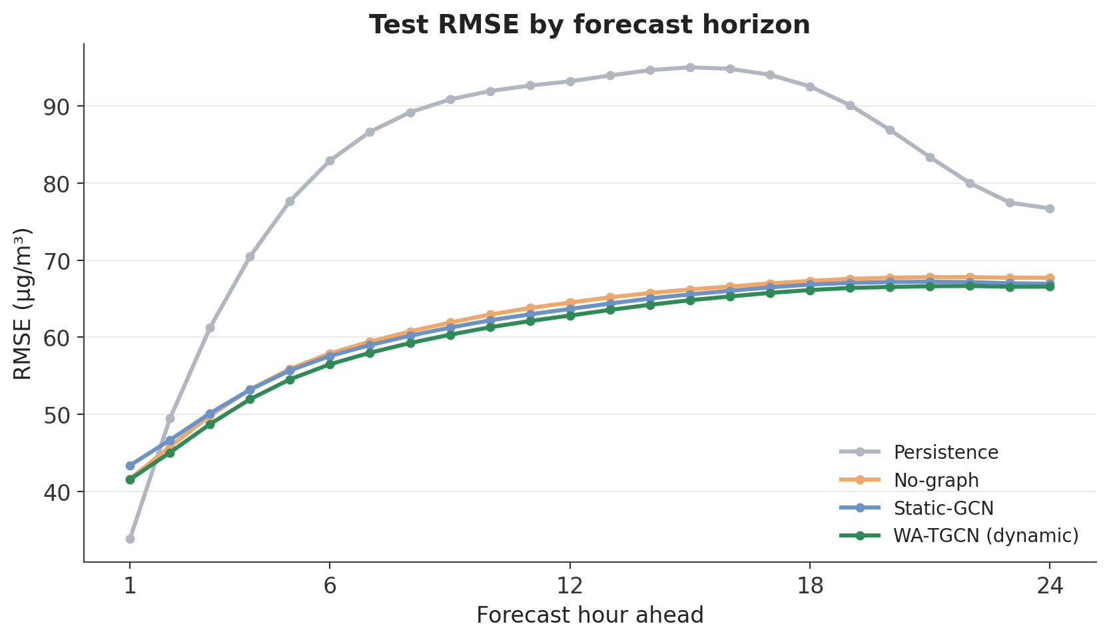
Figure 3. Test RMSE by forecast horizon.
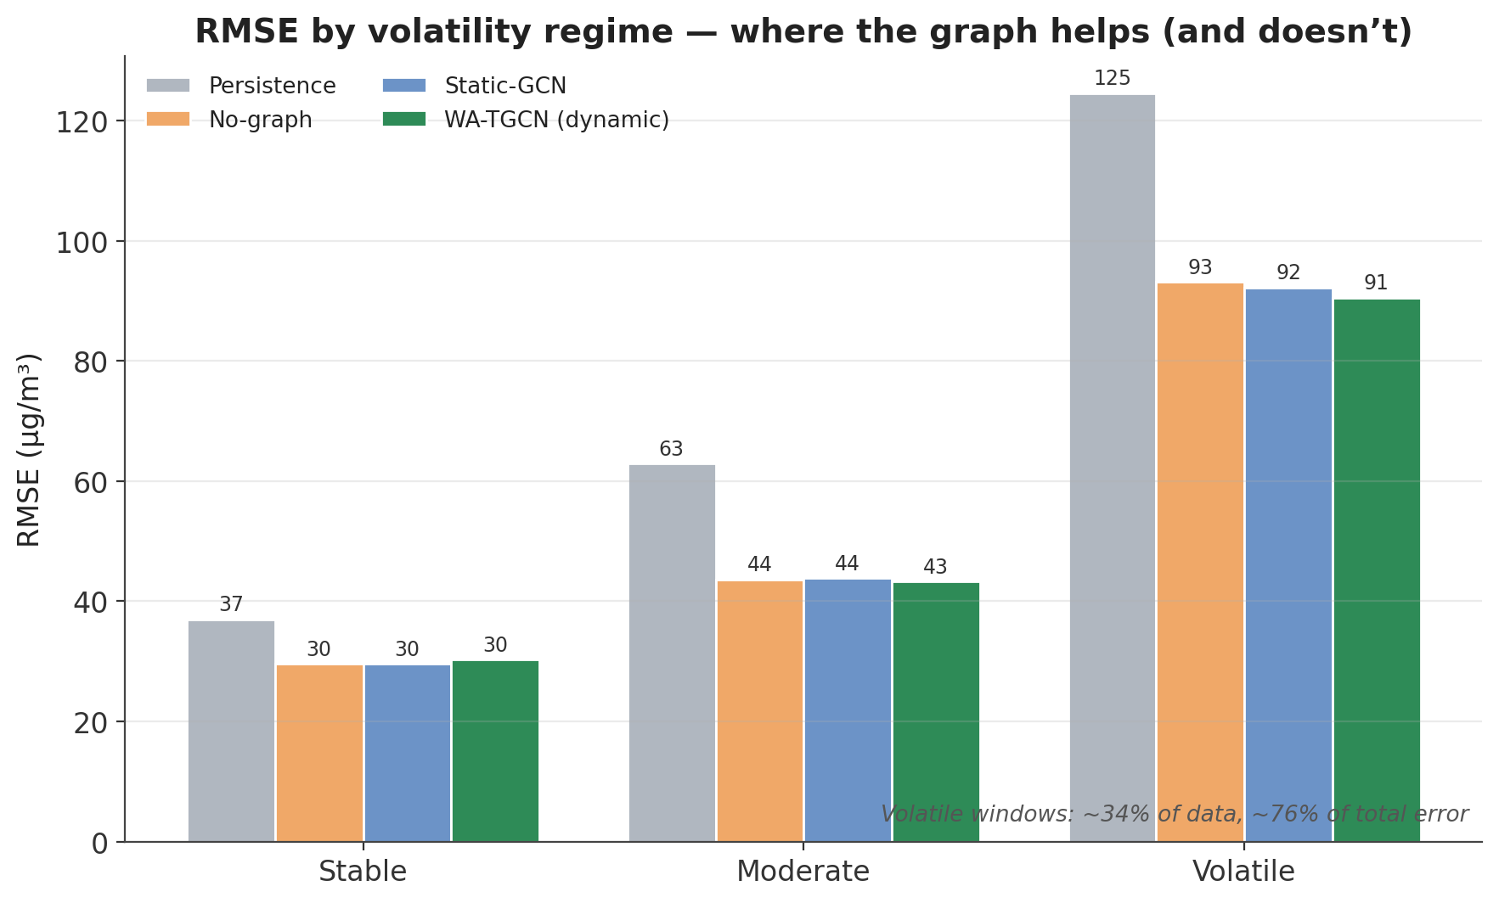
Figure 4. Test RMSE by volatility regime.
Per station (v1 to v2): all 37 stations improved, by 0.30 to 6.35 µg/m³ (mean 3.50). Station RMSE under v2 ranges from 39.2 to 84.2 (mean 59.7), with the largest gains at the hardest hotspots (Mundka -6.4, Karni Singh -5.7, Bawana -5.4, DTU -5.3). Station R² under v2 has a median of 0.62.

9.4 Graph ablation: does the wind graph help?
Table. Test RMSE (µg/m³). The sign of the dynamic-versus-static difference changes between settings and is within seed noise.
Setting (5-seed ensembles) | No graph | Static graph | Dynamic wind graph
Original pipeline (CPCB wind features) | 62.18 | 61.73 | 60.88
ERA5 pipeline (reanalysis wind + future wind) | 58.41 | 58.16 | 59.08
Wind only through the graph (no wind inputs) | 63.21 | 62.72 | 62.80
Real day-old forecast wind + forecast graph | 58.53 | 58.62 | 59.51

Table. By input-window wind regime, the dynamic graph helps most in calm conditions (+2.1 over static) and not in windy ones. In the ERA5 pipeline the calm-hour effect is reversed (dynamic 80.5 against static 78.4), so it is not stable.
Regime (v2 pipeline) | No graph | Static | Dynamic
Calm | 79.83 | 79.87 | 77.78
Breezy | 59.03 | 58.07 | 57.96
Windy | 42.44 | 41.75 | 42.04

9.5 Forecast wind and the orientation test
Table. What wind information is worth. A real forecast recovers almost all of the oracle gain and removes the long-horizon plateau.
Graph-free model, future wind shown to the decoder | RMSE | MAE | R² | +24 h RMSE
No wind anywhere | 63.21 | 40.31 | 0.606 | n/a
Observed wind only | 60.59 | 39.62 | 0.638 | 66.1
Real day-old forecast (deployable) | 58.53 | 38.17 | 0.662 | 62.5
Perfect future wind (oracle) | 58.41 | 37.79 | 0.664 | 62.6

Orientation test (v2 pipeline, 5 seeds): the graph as built scores 60.88; transposing it so that each station gathers from its upwind sources scores 62.29 (1.41 worse). The original orientation is kept.

9.6 Attempts to make the wind graph win by a margin
Experiment (Delhi, 5 seeds) | Test RMSE | Finding
Round 1 baselines: none / static / dynamic | 58.40 / 58.23 / 59.08 | reference
Learnable blend of wind and static graph | 59.00 | no better than dynamic; not better than static
Context dropout (hide city aggregates): dynamic / static / none | 58.81 / 58.17 / 58.24 | hiding the aggregates does not make the graph matter
Round 2: graph-free + upwind feature (none_adv) | 57.91 | helps a little
Round 2: graph-free + same-hour neighbour mean (none_nb) | 58.04 | static control for the feature
Round 2: wind graph + upwind feature (dyn_adv) | 57.71 | best model; +0.33 over the best non-wind model
Round 2: static graph + neighbour mean (stat_nb) | 58.79 | static control for dyn_adv; dyn_adv is 1.08 better

Chosen on validation, the best wind-aware model beats the best non-wind model by 0.33 µg/m³, below the 1 µg/m³ level that would separate it from seed noise. Finer wind products were also checked: ERA5-Land returns no wind in Open-Meteo, and ECMWF IFS, GFS, ICON, GEM and JMA agree with CPCB's measured wind no better than ERA5 for direction (correlation 0.15 to 0.37) and none gives neighbouring stations noticeably different wind. Wind direction quality limits what the graph can learn.

9.7 Cross-city results (zero-shot and few-shot, test period 8 Dec 2025 to 9 Apr 2026)
Table. RMSE (µg/m³) on hours with a real PM2.5 reading. The Delhi-trained model beats persistence in every city without retraining (12-32% better zero-shot, 20-33% few-shot).
City (stations) | Persistence | Zero-shot: none / static / dynamic | Few-shot: none / static / dynamic
Kolkata (10) | 44.60 | 30.46 / 31.22 / 31.35 | 29.97 / 30.92 / 29.95
Mumbai (21) | 33.13 | 29.00 / 28.90 / 29.02 | 26.09 / 26.20 / 26.36
Ahmedabad (9) | 35.67 | 27.04 / 29.16 / 27.47 | 26.26 / 26.30 / 26.03
Patna (6) | 39.25 | 32.83 / 32.37 / 32.38 | 29.82 / 30.14 / 30.36

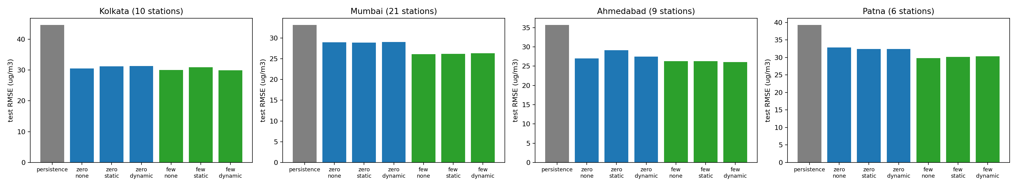
Figure 5. Cross-city RMSE for persistence, zero-shot and few-shot variants.
- Kolkata is closest to Delhi in winter pollution and gives the strongest transfer; Mumbai, with lower PM2.5 levels, gains less (zero-shot bias of about +7 µg/m³ that few-shot removes).
- The dynamic graph is as good as the static graph or better in most cities (largest effect in Ahmedabad: dynamic 27.47 against static 29.16), and no clearly different from no graph. The fixed distance graph can hurt when moved to a new city.
- Station selection: 12 candidate cities were audited; cities needed at least 6 stations with at least 70% hourly PM2.5 coverage. Kolkata, Mumbai, Ahmedabad and Patna were built after filtering out stations with under 80% real PM2.5.

9.8 Explainability results (7-seed v2 ensemble, 400 test windows)
Table. RMSE is 61.18 with all groups and 94.65 with none (the last observed value still enters through the anchor). Other pollutants add noise on average.
Feature group | Share of the error reduction (exact Shapley)
PM2.5 history (levels, rolling statistics, change) | 35.2%
Weather (temperature, humidity) | 34.6%
City context (city mean, max, station minus city) | 18.3%
Calendar (input hours) | 13.3%
Wind (u, v, speed) | 7.0%
Other pollutants (PM10, NO2, SO2, CO, O3) | -8.3%

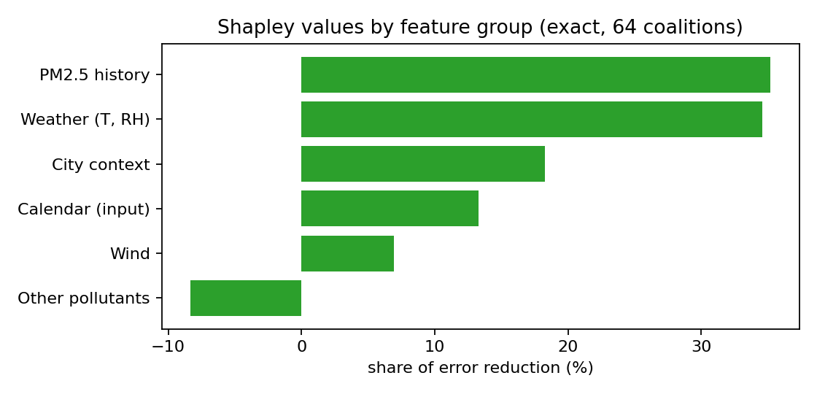
Figure 6. Shapley values by feature group.
- Attention is almost flat over the 48 hours (0.020 to 0.023 per hour; an even split is 0.0208), with only a slight rise toward the latest hours. Blanking the last 6 hours costs +10.9 RMSE, about the same as blanking the 24 oldest hours (+10.8), so per hour the recent hours matter about four times more than attention suggests. Attention alone understates recency.
- Edge sensitivity: the 15 most influential edges hold 15.8% of all edge sensitivity and cluster in north-west Delhi (Bawana, Narela, Alipur, Mundka, Burari, NSIT Dwarka, Najafgarh) and a few in the east (Anand Vihar, Vivek Vihar). This is a sensitivity map, not proof of transport.
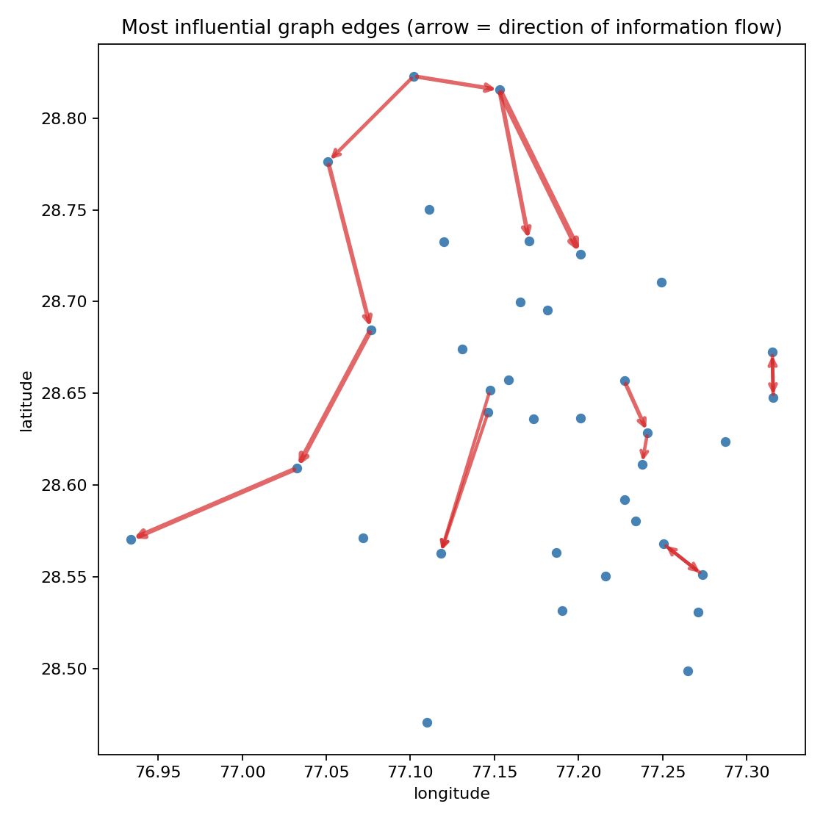
Figure 7. Most influential graph edges (arrows show the direction of information flow).

9.9 Response to wind scenarios (v3, 300 test windows)
Table. Doubling the wind lowers PM2.5 on average, through the forecast-wind path. Direction scenarios barely move the forecast.
Scenario (applied to) | Mean change in the 24 h forecast (µg/m³) | Windows where PM2.5 rises
Wind speed doubled (input and forecast wind) | -8.0 (calm +0.6, breezy -9.2, windy -15.2) | 22%
Wind speed doubled (forecast wind only) | -19.1 | 0%
Wind speed doubled (input wind only) | +13.6 | 96%
Wind from the north-west (both) | -0.9 | 46%
Wind reversed (both) | -5.3 | 41%

9.10 Live ingestion: a worked example (12 Nov 2026, 21:00 IST)
The live pipeline fetched 249 sensor series, found 34 of 37 stations reporting in the latest hour (data age 3.1 hours), and forecast a mean of 307 µg/m³ now with a mean 24-hour peak of 320 and a maximum of 460 at North Campus; all 37 stations were forecast to exceed 60 µg/m³ during a severe pollution episode.

9.11 Regional upwind stations (analysis)
Eight CPCB stations upwind of Delhi in Haryana and Punjab (24 to 250 km) were loaded for 2024 to 2026. Haryana's stations have no PM2.5 from about February to September 2025, so regional data covers 63% of training and 100% of test hours. A regional reading above Delhi's predicts a small later rise in Delhi (partial correlation +0.06 to +0.13 aligned), but it does not depend on whether the wind blows toward Delhi (aligned minus opposed -0.02 to +0.05, intervals include zero), and after controlling for the time of day a plain linear model gains only about 0.7 to 1.5 percentage points of R². Regional stations are therefore at best a modest context feature and give no wind-dependent signal.

10. Experimental visualisations and prototypes we can demonstrate

10.1 Prototypes
Prototype | What it shows | Data it uses
Streamlit dashboard (app.py) | Station map by CPCB category, forecast vs actual chart, alerts, playback of 970 test windows, animated wind-coupling flow, wind what-if scenarios | v2 export (replay of held-out windows)
React digital-twin front end | Map with wind particles and the A(t) graph, forecast fan chart, what-if studio, health advisor, credibility page, 5-step guided walkthrough | JSON files (replay); live wiring pending
Live ingestion notebook | Real-time data in, 24-hour forecasts and wind what-ifs out for 37 stations | OpenAQ + Open-Meteo, live
Documentation portal | Project website: objectives, methodology, results, repository and documentation | Static site, deployed from GitHub

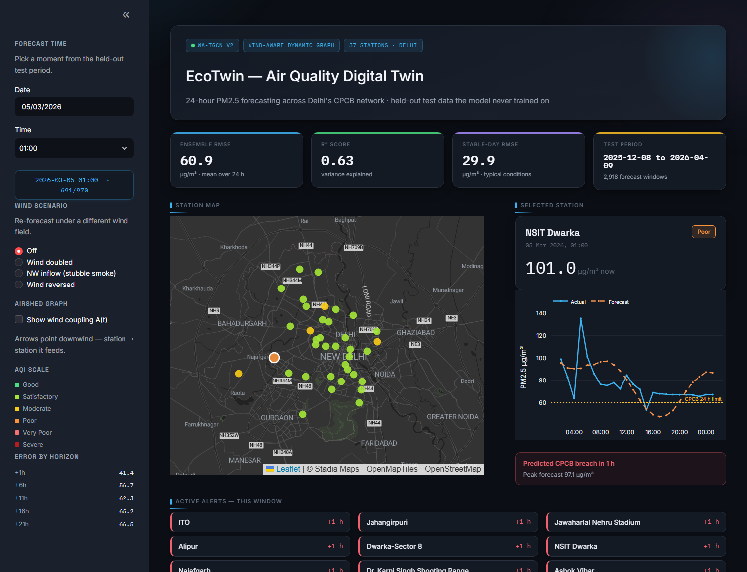
Figure 8. Digital-twin dashboard: station map with 24-hour forecast panel.
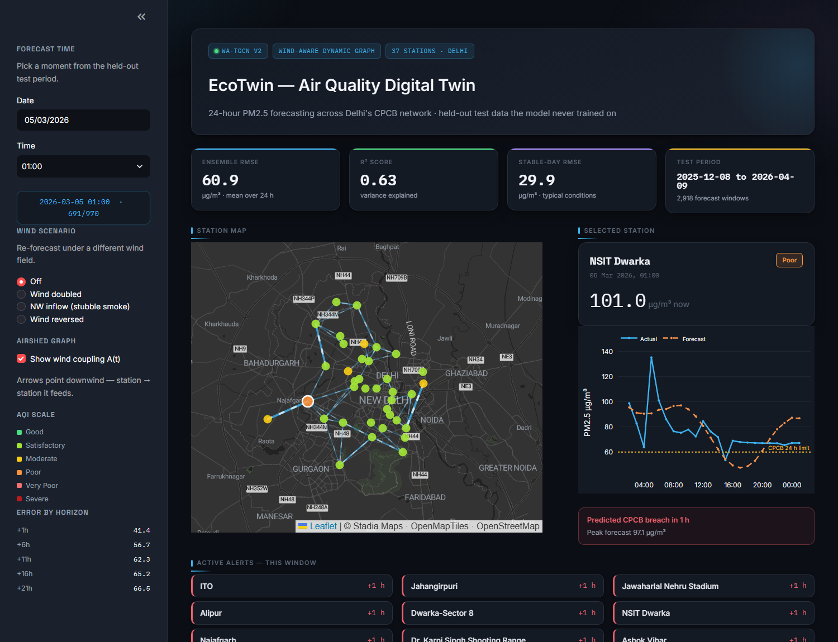
Figure 9. Wind-coupling overlay: edges follow the current wind.

10.2 Result visualisations (all in ecotwin_outputs/plots)
Figure file | Shows
ARCH1b_technical_architecture, ARCH1_full_project_architecture, ARCH3_overall_flow | Technical architecture, full-project architecture and overall flow
B1_wind_graph_snapshot, B2_calm_vs_windy, B3_wind_vectors_vs_graph | The hourly wind graph in calm and windy hours; wind vectors against graph edges
C1_loss_curve_v2_corrected | Training and validation loss of the v2 models (best epoch 4 to 7)
C2_baseline_comparison, D3_rmse_by_horizon, D6_regime_comparison | Baselines, error by horizon, error by regime
D2_best_worst_window_corrected | Best and worst forecast windows against the actual series
xai_attention, xai_shapley, xai_edges | Attention profile, Shapley values by feature group, influential edges
crosscity_rmse | Cross-city RMSE by method

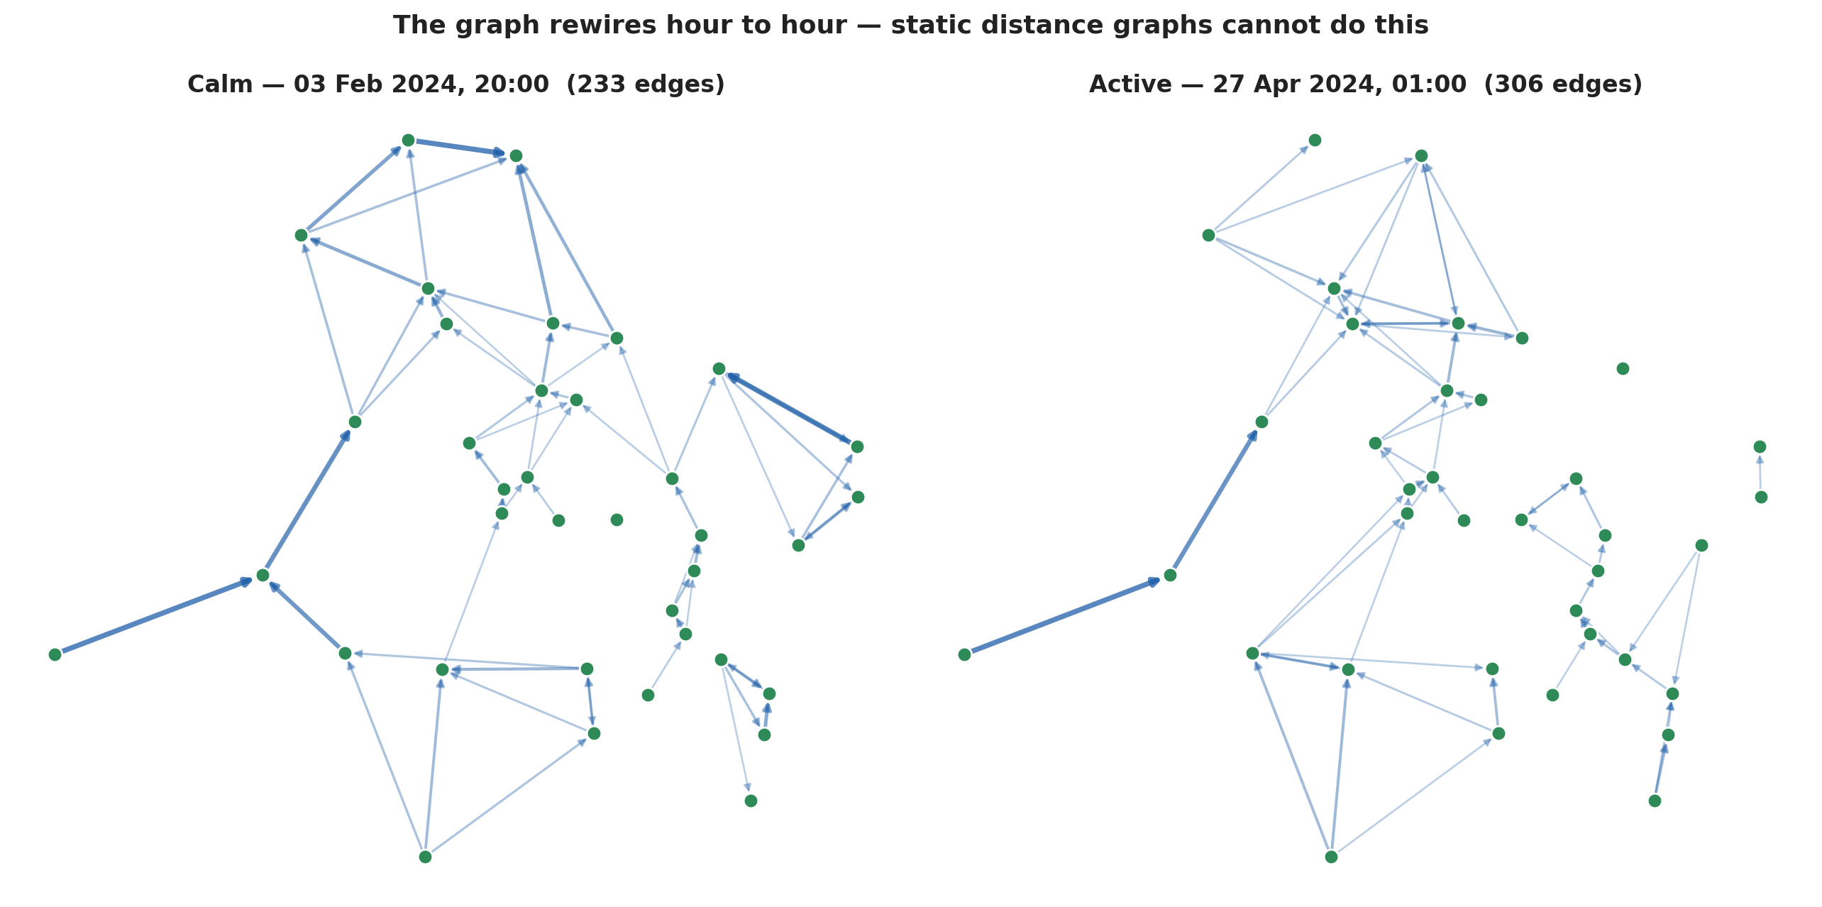
Figure 10. The wind graph in a calm hour and an active-wind hour.
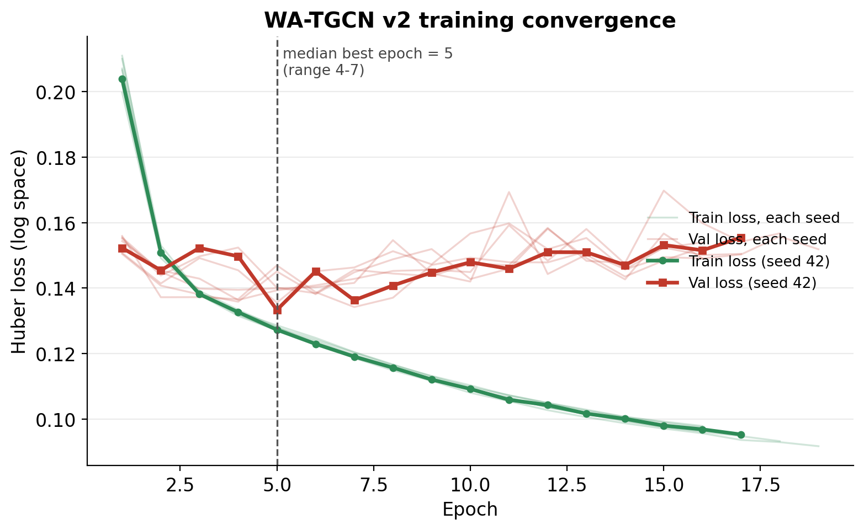
Figure 11. Training and validation loss of the v2 ensemble.

11. Technical justifications and design trade-offs
Decision | Why | Evidence and trade-off
StandardScaler, not MinMax | A few extreme spikes stretched the MinMax range; 68.7% of PM2.5 values fell below 0.1 and wind components had std 0.013 | All features now have std about 1.0 and the wind is informative; scalers are fit on training data only
Log target + Huber loss | PM2.5 is heavily right-skewed (skew 2.56) | Spikes no longer dominate the loss; trade-off: scored in µg/m³ the short horizons are worse than persistence at +1 h (41 vs 34)
Wind as u and v vectors | Direction is circular; vectors keep it continuous and physical | Direction and speed are available to both the graph and the features
Self-loops inside the model | A(t) has no self edges (a station cannot be downwind of itself); stations with no active edge lost their own signal | Fixed R² = 0.0000 failures
Hourly dynamic graph | Transport follows the wind, which changes hourly | Gain is small and within noise (Section 9.4); it costs only 0.05 ms extra per window
12 km threshold | About 1.7 hours of travel at 2 m/s; keeps the graph sparse and local | Wider radii (30-35 km, advection weighting) gave no gain; a longer reach beyond the city needs data we only partly have
Small model (hidden 32, 1 GRU layer) | Capacity was not the limit | A 64-unit, 2-layer model matched it with 5.6 times the parameters; fast enough for live use (0.31 ms per window)
Future-time conditioning and gated anchor | A smooth average shape with no daily cycle appeared without them; the anchor keeps short horizons strong | Gate runs from 1.0 at +1 h to 0.3 at +24 h
Forecast-graph decoder | v1 only saw historical wind | Extends the wind-aware idea to the decoder; v3 gives real future wind
Volatility-weighted loss | Most error comes from fast episodes (76% from the volatile third) | Targets the hard windows; small cost in the stable regime (29.9 vs 28.1)
Seed ensembles | Single models vary by 1-2 µg/m³ | 5 to 7 seeds improve results by 1-2.5 µg/m³ and quantify the spread
Chronological split and test once | A time series must not leak the future; the test winter is harder than validation | We quote the test RMSE (60.92), not the easier validation figure (55.14)
Forecast wind, not just a graph | The deployable gain is what wind says about the future | Real day-old forecast gives 58.53 against 63.21 without wind
Public live data instead of own sensors | A single sensor in another city cannot feed a Delhi graph model | 35 of 37 stations match public monitors, with a 2-4 hour reporting lag

11.1 Insights
- The strongest lever for accuracy is information about the future atmosphere (forecast wind), not the choice of graph. Graph structure is a secondary effect that sits at the level of seed noise.
- The model is genuinely good on typical days and degrades in rapid weather-driven episodes, so reporting by horizon and regime is more truthful than one headline number.
- Station-level wind from CPCB is unreliable (nine stations have no original wind speed), and every reanalysis or forecast product agrees poorly with it in direction. Wind direction quality caps what a wind-aware graph can learn.
- Weather variables (temperature, humidity) carry as much explained error as the PM2.5 history, probably as proxies for the atmospheric regime; wind carries only 7%.
- A model trained on Delhi transfers because the temporal and spatial structure is learned from wind-driven features that are not specific to Delhi's geometry.

11.2 Limitations
- Wind-aware graph advantage is not established; the best margin is 0.33 µg/m³.
- Imputed values are not flagged in the released dataset; about a quarter of humidity, temperature, wind and SO2 values are imputed.
- The v3 results use ERA5 reanalysis wind as future wind (an oracle) except where a real day-old forecast is used (Section 9.5).
- A single test winter (Dec 2025 to Apr 2026); no other seasons or years have been evaluated.
- No automated unit-test suite; validation is by held-out evaluation, controls and manual checks of the dashboards.

12. Remaining work, and what in this document will change
Everything described above is implemented and verified. The items below are what is left. They are small compared with what is done.

12.1 Remaining implementation
# | Item | Effort | Status
1 | Loss fix: add a µg/m³ term to the training loss, test on the best wind-aware model and the best non-wind model (notebook 36) | About 50 min of GPU, plus 15 min for the cross-city re-check | Built and smoke-tested; full run pending
2 | Real explainability and 7-seed uncertainty export for the front end (notebook 30) | About 10 min of GPU | Built and tested on 40 windows; full run pending
3 | Final model decision and a saved config and metrics file for dyn_adv | About 1 hour | Not started
4 | Live system additions: wind edges for the map, final what-if scenarios (speed on forecast wind), unattended scheduling | 1 to 2 hours | Not started
5 | Front-end wiring in single steps: real bands, real explainability, live data hook with a Live/Replay badge, final what-if | About 1 working day | Not started
6 | Housekeeping: commit and push notebooks 17 onward, requirements file, ignore rules for the large caches | About 1 hour | Not started
7 | Optional: what-if lab (temperature, humidity, hotspot intervention, sensor outage); boundary-layer height as a feature (ERA5 has none for Jan-Jun 2024) | 2 to 4 hours each | Optional

Estimate. Total for the required items (1 to 6): roughly two working days, most of it the front-end wiring. Hardware is not planned this semester.

12.2 Will the information in this document change after these are implemented?
Area in this document | Will it change? | How
Dataset, preprocessing, graph, model architecture, formulas, metrics (Sections 3-6) | No | These stay as they are, except one extra loss term in Section 5.5 if the loss fix is adopted
Core score tables for v1, v2, v3 and the ablations (9.2 to 9.5) | No | Already final; results are saved
Best Delhi model and its score (57.71) | Possibly | If the loss fix lowers RMSE, the best model and its score, the by-horizon profile (+1 h especially) and the cross-city table (9.6, 9.7) would be updated
Wind-graph conclusion (9.4, 9.6) | Unlikely | The loss fix affects all variants; it is not expected to create a margin, but the gap would be re-measured
Explainability results (9.8) | No | The global results are final; the export adds per-window values for the interface
What-if description (9.9) | Yes | The interface will use speed scenarios on the forecast wind; direction scenarios will be dropped or marked experimental
Live system description (8.7, 9.10) | Minor | Adds map wind edges and scheduled running; the pipeline itself does not change
Prototypes (Section 10) | Yes | The front end will show live data and real explainability and bands instead of placeholder numbers
Limitations (11.2) | Minor | The line about the interface's placeholder values will be removed once wired

Appendix A: master score sheet
Experiment | Variant | Test RMSE | Notes
Baseline | Persistence | 83.87 | MAE 56.93, R² 0.307
Models | WA-TGCN v1 (5 seeds) | 64.59 | MAE 41.50, R² 0.589
 | WA-TGCN v2 (7 seeds) | 60.92 | MAE 39.69, R² 0.634
 | WA-TGCN v3 (7 seeds) | 58.79 | MAE 38.10, R² 0.659
Ablation, v2 pipeline (5 seeds) | No graph / static / dynamic | 62.18 / 61.73 / 60.88 | R² 0.619 / 0.624 / 0.635
Ablation, ERA5 pipeline (5 seeds) | No graph / static / dynamic | 58.41 / 58.16 / 59.08 | R² 0.66 / 0.67 / 0.66
Wind only through the graph | No graph / static / dynamic | 63.21 / 62.72 / 62.80 | 7-seed v3b: 62.21
Forecast wind (graph-free) | none / observed / real forecast / oracle | 63.21 / 60.59 / 58.53 / 58.41 | R² 0.606 / 0.638 / 0.662 / 0.664
Real forecast + graph | none / static / dynamic | 58.53 / 58.62 / 59.51
Orientation | as built / transposed | 60.88 / 62.29 | 5 seeds, v2 pipeline
Round 1 | blend / dyn_cd / static_cd / none_cd | 59.00 / 58.81 / 58.17 / 58.24
Round 2 | none_adv / none_nb / dyn_adv / stat_nb | 57.91 / 58.04 / 57.71 / 58.79 | dyn_adv best
Cross-city zero-shot (best of none/static/dynamic) | Kolkata / Mumbai / Ahmedabad / Patna | 30.46 / 28.90 / 27.04 / 32.37 | persistence 44.60 / 33.13 / 35.67 / 39.25
Cross-city few-shot (best) | Kolkata / Mumbai / Ahmedabad / Patna | 29.95 / 26.09 / 26.03 / 29.82

Appendix B: how this work was produced
The code, notebooks and part of the documentation were developed with the help of an AI assistant (Anthropic's Claude, used through Claude Code). The team directed the work, ran the experiments and reviewed the results; the experiments, results and conclusions are the team's to verify and defend. The repository README carries the same statement.

