University of Waterloo

Faculty of Engineering

SYDE 542: Assignment 2

###### 

Prepared by:

Sayantan Chatterjee – 20304742

Abderaouf Delileche - 20402482

Jonathan Lam – 20381242

# Wireframing Phase

In this section, wireframes for an IT ticketing system were built based on the requirements gathered in requirements gathering report. The IT ticketing system will be primarily used by three types of users: clients, IT technicians and IT managers. It was determined that the most critical scope of the project and the tasks that it needed to support include the ability for users to create tickets and look at its progres, as well as having access to an FAQ page. IT technicians are to be able to edit the FAQ page, look at their tickets and provide feedback to clients. IT managers will be able to look at unassigned tickets and open tickets as well as all tickets. They will also have the ability to create reports by using the reporting tool. A list of requirements is shown in Appendix B.

Before creating the wireframes, the layout of the application must follow company regulations. Pages will show the company name and logo on the top left corner. Main users are also english speakers and therefore everything that has to stand out will be on the left. It is assumed that the users are already signed in when they sign in onto their computer accounts.

The client welcome page is the “Create a Ticket” page. This is shown in Figure 1 below.

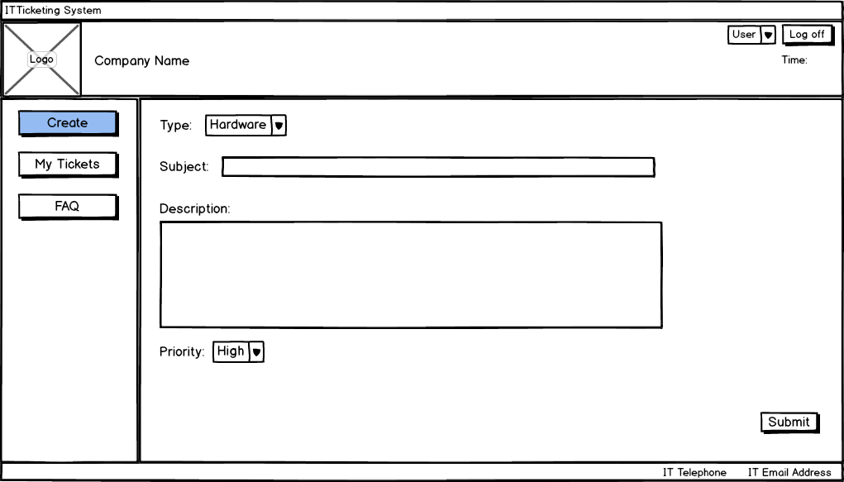

# Figure 1: Client “Create a Ticket” page

As can be seen from Figure 1, the main navigation menu is set to the left, with contact information on the footer of the page. This page allows users to specify the type of issue they have, the subject, a small description of the problem and its priority. The user can then press submit to send the ticket to IT.

Figure 2 below shows the “My Tickets” page for the clients. This is used by them to access their open or closed tickets by using the filters. It shows various details that are important such as the ID, assignee and comments made.

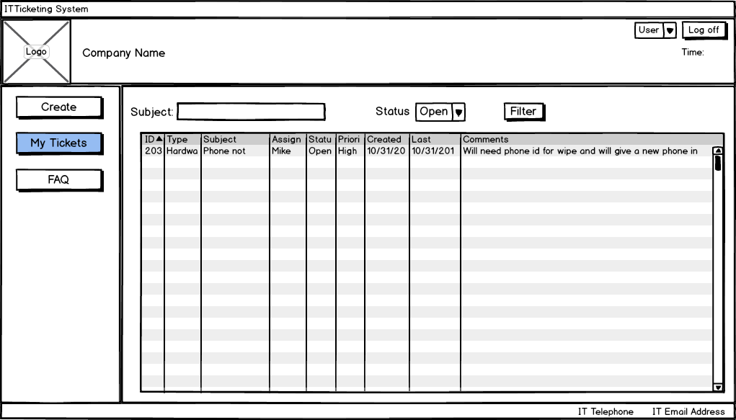

Figure 2: Client “My Tickets” page

# Each row in the table is an active link where when clicked the user will be able to see more details. This is shown in Figure 3 below. The page loads in the middle section of the page and provides the details needed by the users as well as a communication mean as gathered from the requirements by participating in the chat on the page.

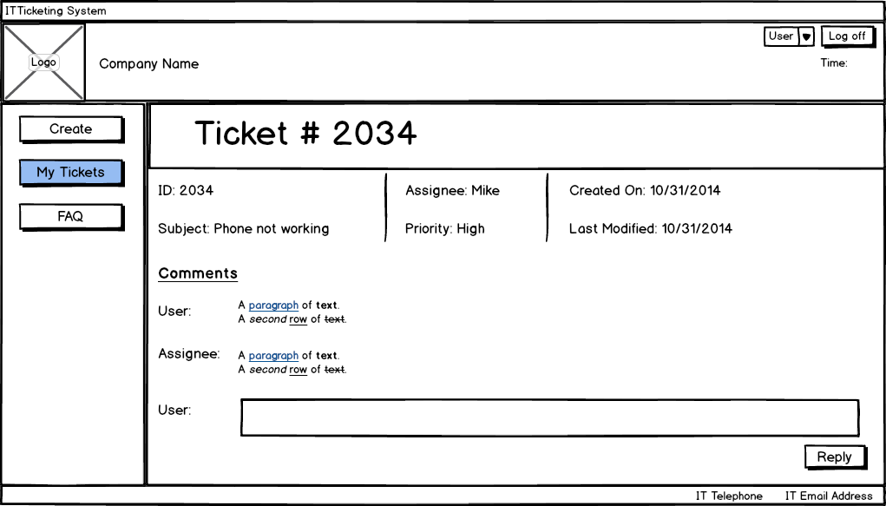

# Figure 3: Client “Click on Tickets” page

An FAQ page was also created for users. This is shown in Appendix A.

The second users are the IT technicians. The technicians are usually only concerned about their own tickets. Their homepage will reflect this. This is shown in figure 4 below.

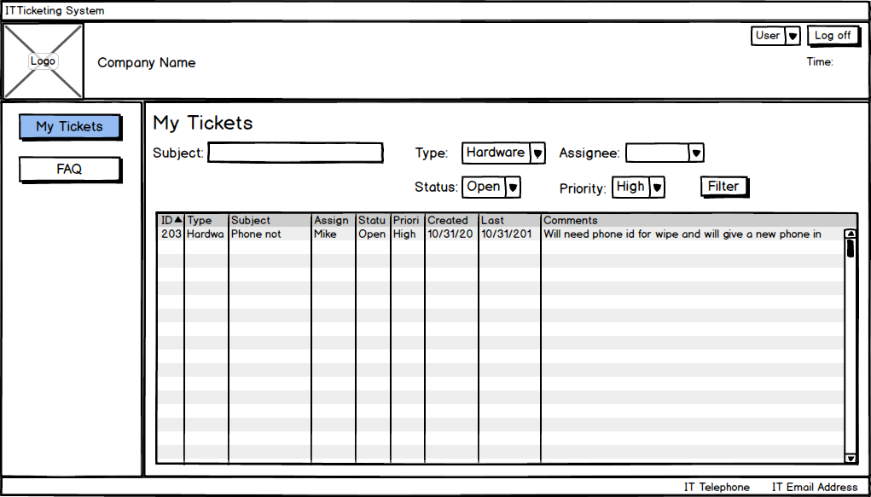

# Figure 4: IT technicians “My Tickets” page

IT technicians are able to view their tickets and apply various filters. To open their tickets, they will click on the ticket, similar to how a client will open their ticket. Figure 5 below shows the next screen for the technicians.

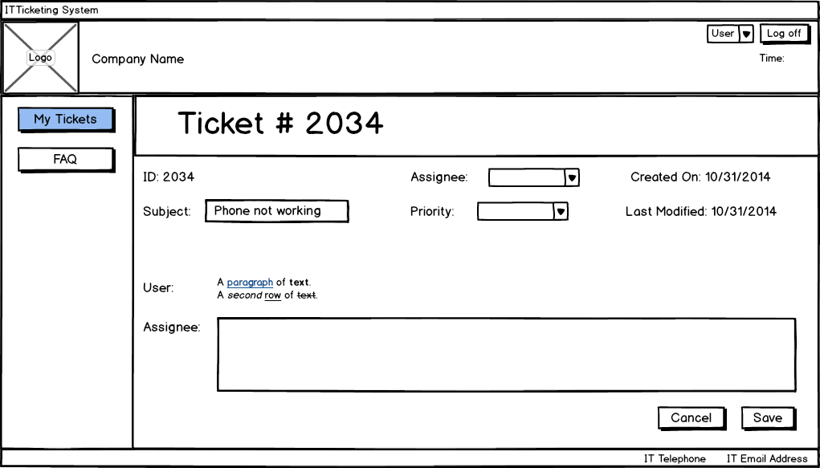

Figure 5: IT technicians “My Tickets” page

Technicians have the ability to change the subject line, assignee and priority of the ticket as necessary and can provide feedback in the comments section. This is the main way to communicate with the client. The FAQ section allows the technicians to update the FAQ pages for the clients. This wireframe is shown in Appendix A.

Finally IT managers have two main tabs. One tab is for their tickets where they are able to sort through unassigned tickets and look at all tickets. This wireframe is shown in Appendix A. The wireframe below is that of IT managers reporting tool.

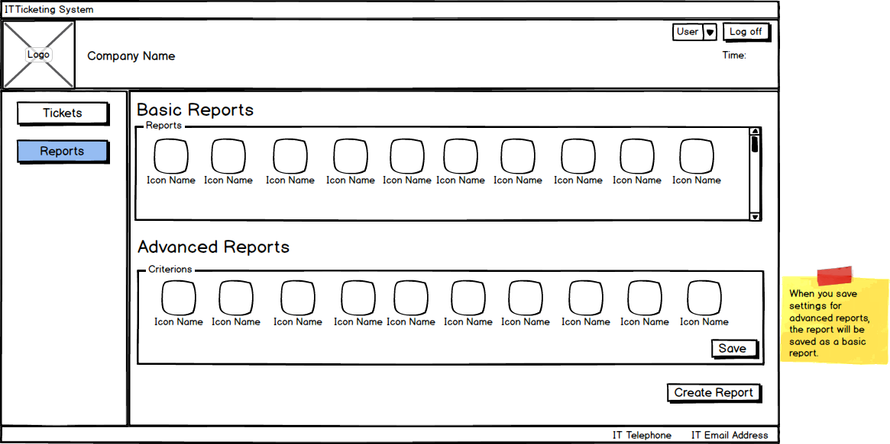

# Figure 6: IT Managers “Reports” page

# One of the requirements is the ability for IT managers to create performance based reports. The wireframe above showcases two categories of reports; A basic report where criterions and layout are already pre selected for the managers. The manager chooses one of them and creates the report by clicking on the appropriate button. The advanced reports section allows managers to create reports with different criterions that are not on the basic report window. They will then have the option to save it and the new report will appear as a basic report where they can then choose it and create it.

A settings window can be accessed by clicking on the user dropdown on the header. The user settings are different for each of the types of users and are shown in Appendix A. Notably the manager is allowed to choose the time interval for archiving tickets as mentioned in the requirements.

# Wireframe Informal Review

In this section, the requirement gathering techniques that were reflected include task analysis, use case analysis, and user personas. For the purpose of conducting our wireframe informal review the group included three different types of users. There were novice users who were unfamiliar with IT ticketing systems, experienced users who are more computer literate and have experienced different interfaces, and finally we had stakeholders who would potentially use the system. For the informal review, there were less users utilized than for the Wireframe Tests conducted later, however, users were selected to reflect the personas outlined during the requirements gathering process. The novice user role was fulfilled by individuals who are are not well versed with software interfaces and IT in general. This role was fulfilled by an older relative of a group member. The expert user role with no stake in the software were classmates with a lot of Information Technology experience, users who were also avid gamers with a high level of experience in navigating different interfaces. Preference was given to students who had worked as an IT-cop earlier. In terms of stakeholder informal reviews, for the Wireframe Tests conducted later in the process the group was able to use actual IT technicians. For the informal review only an IT manager was used who was familiar with the group from a previous co-op term.

These testers were selected to represent previously created user personas such as Sally, an avid gamer and familiar with many different types of software interfaces experience. It covered the role of the busy IT manager that was Rod, who wants to keep track of employees and values efficiency and statistical analysis above all else. Finally, the older relative represents the client persona previously created who is a novice level computer user.

The process of recruiting people included shortlisting as a group acquaintances that can fit best the personas derived. Once the list had multiple potential testers per persona, testers were recruited based on their interest level in an IT ticketing system and assuring them that it would be a short cognitive walkthrough. A cognitive walkthrough method of testing was selected for the informal review as wireframes are created fairly early in the design process and it is useful when the group already has tasks set up.

The focus was to cover as much as possible from Requirements List created during Requirements Gathering while keeping it short to get approval for testing users. The basic template of the survey is included in the final Appendix. Questions included direct probes into the requirements list, as well as more general questions which looked at qualitative feedback if the user could navigate easily through the interface. Some of the direct questions from the appendix include “How easy was it to find IT contact info on our interface?” and “How easy is the Reporting and Archiving functionality of Tickets in the software?”. These were meant to gauge if the user can easily find the IT contact info which was a key requirement of the interface as determined earlier. The second question was to target the requirement which focused on auditing and archiving, which was an important usability concern of the IT manager persona. An open box for additional concerns were also listed to allow users to comment freely after the cognitive walkthrough.

The objective was to get any interface recommendations and any clear problems discovered through the informal review. The focus was strictly on the wireframe and how to streamline the process better for the users or even if a functionality was somehow missed completely. The goal was left somewhat open ended since it is an early test in the design process and any feedback was important. The group was limited in the wireframe review process due to lack of exposure to IT technicians yet and the number of users were not large enough for a good sample size. These made the results somewhat less dependable but if concerns were voiced by all users, and by an experienced IT manager, these were deemed necessary revisions. Some smaller changes such as a missing ‘close’ button or typos were documented but are not outlined in this report. The key results from this test are listed below and their relevant priorities.

1. There was no search functionality in the software causing a lot of difficulties for users. They were unable to easily look up previous tickets, or look through technicians currently working on the ticket. All users disliked manually looking through FAQ to look for previous tickets as well. Therefore a search functionality was considered for the wireframe and this was made a high priority. This was especially concerning to the novice level user.
2. Users were unable to go back from an open ticket to go to previous tickets. They were essentially stuck after opening a ticket without closing the program or going back through multiple screens. Users wanted some way to easily go back to all tickets screen. This could be fixed through opening a completely new screen or a popup. This concern was raised by the classmate who is an expert user which made this a high priority. A javascript popup was utilized to circumvent this issue.

The manager voiced concerns which were key for him and different from all other users. The major issue for him was reporting, since he found the original wireframe to be cluttered and not easy to understood. The interface did not allow him to quickly select the report type that he wanted and further confused him since an icon based representation made him think a customized report could only select one parameter (pictured in Appendix A). Therefore a change was made to follow the wireframe in Figure 8 to show that multiple selections can be made and due to the gravity of this concern, the entire wireframe was considered to be in need of a revamp. He also wanted search functionality to include other sorts of filter such as priority and type of ticket instead of just the status of it. He also would like to comment on all tickets and this wireframe was also altered.

# Wireframe Revision

Based on the test results and reasoning above, a few revisions were made to the wireframes. A major change to the layout was the addition of a search bar in the header for faster access to tickets and questions in FAQ. One of the main changes that were made was how ticket information is viewed from both the client and IT side. Instead of new page loading, a JavaScript pop up window will now be used. This is shown in Figure 7 below. It allows for smoother transition between the table and the information. Note that there should be a red “close” box at the top right corner of the pop up.

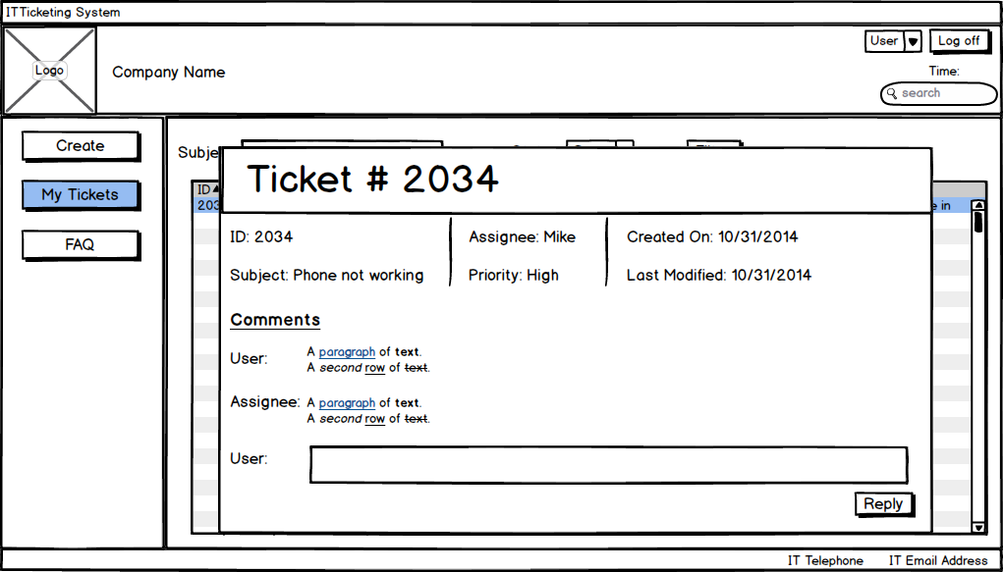

Figure 7: Clients new “Click on Ticket” page

The reporting tool for managers was majorly modified. This is shown in Figure 8 below.

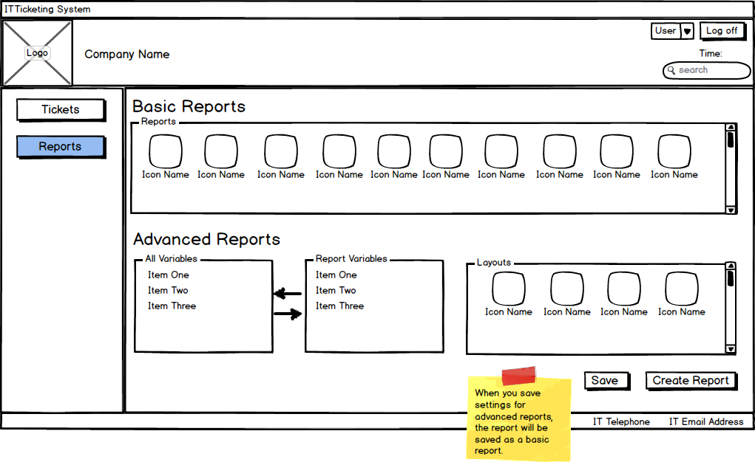

# Figure 8: IT Management new “Reports” page

# Managers are able to create a basic report by choosing an icon from the reports section. The major change comes to the Advanced Reports section. Managers are now able to choose certain variables to put in the report and will be shown in the Report Variables data group. They will also be able to choose a layout to their report, a new feature added. They can then save and create the report.

In figure 23 in Appendix A, managers will be able to add comments to tickets that are not assigned to them. Additional filters were also introduced for IT technicians and is shown in Figure 24 in Appendix A. The rest of the revised wireframes are shown in Appendix A.

# Wireframe Test

In this section, five scenarios were created in order to test the layout and navigation of the new system design. Each scenario was created to test not only basic functionality for the IT ticketing system, relative to the two types of users recorded in the previous report: clients and IT service desk technicians. Another scenario was also created for a specific task that an IT manager needs to do. Scenarios were made in light of the requirements gathered in the previous report. Effort was made to reach out to users that the personas recorded before were based on, similar users were also surveyed in order to have a representative number of users to base solid user testing on. Each user was tested individually.

Prior to this wireframe test, questions about a user’s age, computer aptitude, and familiarity with the current IT ticketing system were asked. These questions can be found in the Appendix. Once these questions were done, the objectives of the scenarios relative to the user group were described. Then, the methods in each scenario was carried out. At the end of each scenario, an open-ended question was asked regarding the entire scenario process. Following this, the next scenario started from that point; there was no resetting back to an initial page. Responses were documented electronically via tablet in point form during the test in order to focus primarily on observation. In addition, since Balsamiq was used as a prototyping tool, users were asked to describe their thinking process in addition to what they were clicking on the tool.

To represent the clients, 3 friends of the members of this group were chosen. They are all around 22, male, and are familiar with using computers on a regular basis to do daily tasks such as email and word processing. Two of these friends have worked with a IT ticketing system before, this was important because it is clear that an IT ticketing system is already implemented in the company, and only a new interface (and possible features as well) is being created. However, these friends were introduced to the old system of this company as part of the testing. In addition, a client from the company was also interviewed in order to get someone that used the current system to evaluate the interface as well. Test Scenarios 1 and 2 were conducted on the clients.

To represent the IT service desk technicians, 3 technicians from the company were provided. They were also all male, have been working at the company for about a year, and are very familiar with computers. They all have a good understanding of what an IT ticketing system should be able to do and how to use it. An IT manager from the company was also encouraged by the company to test the designed interface. He had been an IT manager at a previous company and thus he had a lot of experience in this particular system. Test Scenarios 3 and 4 were conducted on the service desk technicians, while Test Scenario 5 was conducted on the IT manager.

|  |  |
| --- | --- |
| **Test Scenario 1** | |
| **Objective** | Evaluate intuitiveness of ticket creation process. This objective ties most similarly to requirement #7, as it focused on ensuring efficiency through personalization. |
| **Method** | Task: Create an IT ticket with an appropriate subject line, Type: authorization, appropriate data to the situation, Priority: medium or higher. After ticket creation, check that your ticket exists.  Script: While working, you realize that in order to continue your work, you need permission to access a database from another server. Create a ticket that encompasses this information. How was this creation process? Are you sure that it was created? How can you make sure?  Props: Types available, priorities available  Record: Time to complete task, ease scale (1-7), open-ended remarks  Target: 2:30 minutes to complete IT ticket creation, ease of 5 or higher  Justification: Creating a simple scenario that required a typical authorization change for the IT department would be a standard that can be used for benchmarking intuitiveness of the creation process. Target benchmarks were based on expectations of a user to create a ticket, as well as standards that the team has self-imposed to ensure a quality design. An open-ended question regarding the process invites opportunity for users to provide their own unique perspective to the problem. Challenge the user to find where they can see the details of the tickets they have made. |
| **Results** | 4/4 users were able to finish the task in 2:30 minutes or less  Average task completion time: 1:40  4/4 users rated the ease of this task 5 or higher  Average ease of task rating: 6.0  Open-ended responses: it was good x2, that was it? x2  4/4 users were able to find the My Tickets section, although one user took longer than the rest and required a hint. |
| **Discussion** | From the results, it seems like the design is intuitive and easy to use even when the users have seen it for the first time. The actual results have exceeded the benchmarks set, as it was unexpected that the users would find the task to be this easy. Nevertheless, the resultant positive feedback does let the team know that the process for making a ticket will not be a challenging task. This ensures that one of the most basic tasks of a IT ticketing system can be easily done by any user.  It was interesting to note that two of the four testers were surprised at the shortness of this scenario. As such, this scenario should have probably been increased in complexity in order to test more attributes.  One user also took longer on finding the My Tickets section and required a hint to reach there. Thus, a design change might be needed in order to redirect the user to the My Tickets section after creating a ticket. With this, a user can confirm if their ticket was created properly with correct fields. |

|  |  |
| --- | --- |
| **Test Scenario 2** | |
| **Objective** | Evaluate the ease of the FAQ navigation. Relates to requirement #3, which indicates that there needed to be a visible FAQ section on the client interface. |
| **Method** | Task: Navigate to the FAQ page. Look for the answer to that particular question.  Script: On completing the previous scenario, you realize that someone might have had a similar problem. Find the answer to your problem in the FAQ section. How easy was it to find the answer to your question? Is this how you would organize the FAQ?  Props: FAQ page with 10 possible question and solutions.  Record: Time to complete task, ease scale (1-7), open-ended remarks  Target: 25 seconds to complete task, ease of 6 or higher  Justification: Looking for solutions on a FAQ page should be a client’s first response to a problem. The time that it takes to search through a FAQ should be much quicker than creating a ticket; this is to encourage clients to search the FAQ and independently solve their problem. Target benchmarks were based on a small percentage of the target in Test Scenario 1. An open-ended question regarding the process invites opportunity for users to provide their own unique perspective to the problem. |
| **Results** | 4/4 users were able to navigate and find the related question, and expand the question to find the solution in under 25 seconds.  Average task completion time: 0:23  4/4 users rated the ease of this task 6 or higher  Average ease of task rating: 6.75  Open-ended responses: yes (that’s the way they are normally/seems normal) x4 |
| **Discussion** | From the results, it seems like the design is intuitive and easy to use even when the users have seen it for the first time. The average task completion time was close to the target, so it seems like the benchmarks were well set. The positive feedback lets the team know that the FAQ searching process is an even easier task than creating a ticket, which would hopefully encourage users to go to the FAQ first. This way, clients can solve simple problems by themselves without having to tax the IT service desk.  Through the open-ended responses, the FAQ design is a normal design relative to other FAQs that the users have seen. This was expected by the team as deviation from the norm may lead to confusion, something that is not wanted on a FAQ.  The limits of this test scenario is that it is simplistic in nature. However, this was the intention of this scenario, so no further changes would be made. |

|  |  |
| --- | --- |
| **Test Scenario 3** | |
| **Objective** | Evaluate the ease and functionality of finding a ticket. Relates to requirement #2 and #4, which indicates that there needed to be a quick way of finding the next highest priority non-assigned ticket. |
| **Method** | Task: Open a non-assigned ticket and assign it to yourself. Verify that the ticket has been assigned to you. Sort tickets by most recent, and assign the most recent ticket to another technician.  Script: Assign the next ticket of the highest priority to yourself, and after assigning, verify that the ticket is in your assigned tickets. Assign the most recent ticket to another technician. How hard was this process of assigning tickets? How do you normally search for tickets?  Props: List of 8 non-assigned tickets (with varying dates), list of 3 technicians  Record: Time to complete task, ease scale (1-7), open-ended remarks  Target: 40 seconds to complete task, ease of 4 or higher  Justification: Apart from doing their work for clients, a large part of a service desk technician’s job is to triage through new incoming tickets, and ensure that tickets are taken care of, relative to their priority. Target benchmarks were based on the expectation that a technician knows the process of assigning tickets, and that it would be relatively quick to learn how to assign and sort tickets, even with a new interface. An open-ended question regarding the process invites opportunity for users to provide their own unique perspective to how they sort tickets to see if the required functionality is there. |
| **Results** | 2/3 users were able to assign the ticket to themselves, sort the list of tickets, and assign the most recent ticket to another technician within 40 seconds.  Average task completion time: 0:46  3/3 users rated the ease of this task 4 or higher  Average ease of task rating: 5.0  Open-ended responses: sort by most recent x1, sort by highest priority x2 |
| **Discussion** | From the results, it seems like the design is intuitive and easy to use even when the users have seen it for the first time. This is important specifically for this task because it is a common daily task for every service desk technician. The average task completion time was close to the target, so it seems like the benchmarks were well set. However, the average completion time was in fact higher than the benchmark, which indicates that there was some learning curve for people. The positive feedback for ease lets the team know that even though the completion time was over average, the task seemed overall simple. This indicates that the task, after completing for the first time, it would be easily reproducible for subsequent occasions..  Through the open-ended responses, the sorts on the table provided the needed sorts for common searches for service desk technicians, while the other filter by subject functionality provides only more precise searches, perhaps when searching for a specific ticket.  With more time, a more complex test requiring multiple search criteria would demonstrate the greater functionality of this interface. However, it was important to the team to instill confidence in the technicians to use this interface for its basic functionality first. |

|  |  |
| --- | --- |
| **Test Scenario 4** | |
| **Objective** | Evaluate the ease of finishing a ticket. Relates to requirement #4, which looks at communication between client and technician. |
| **Method** | Task: Check My tickets to figure out which one was most recently updated. Mark the ticket as closed.  Script: One of your tickets had recent activity on your ticket where the client has solved the problem through the FAQ and indicated this in a comment. Close the ticket. Is there any other information that you need to have after closing a ticket?  Props: 5 tickets assigned to the current technician. One with the client’s comment so that that ticket has the most recent activity.  Record: Time to complete task, open-ended remarks  Target: 20 seconds to complete task, ease of 6 or higher  Justification: Closing tickets is another daily task of a service desk technician, and often clients can rescind their request. Target benchmarks were based on the expectation that after the previous scenario (Scenario 3), technicians are more comfortable with the current interface and its design. An open-ended question regarding the process invites opportunity for users to provide their own unique perspective on what the interface needs to do after finishing a ticket. |
| **Results** | 3/3 users were able to close the ticket within 20 seconds.  Average task completion time: 0:13  3/3 users rated the ease of this task 6 or higher  Average ease of task rating: 7.0  Open-ended responses: did the email send out x3, is there a faster way of closing tickets x3 |
| **Discussion** | From the results, it seems like closing a ticket is quite intuitive. The average completion time was much faster than the benchmark, so the target time was probably a little too slow. The ease rating was perfect as well, so judging by the results, the task was probably much too simple to be considered as a full out scenario. More complexity should have been implemented in this scenario to demonstrate functionality such as the comments.  Through the open-ended responses, a few more functionalities were discovered. First, there needed to be a notification on the ticket that indicated if an email had been sent out for closing the ticket. In addition, the only way to close the ticket is to open the ticket window, mark as close, and then save, but it seemed like the technicians wanted more of a one-click solution without going through the ticket window. These functionalities seemed very important to the technicians as all three voiced these opinions. Putting the email functionality in the settings page, and letting both the clients and service desk technicians know, would probably be the simplest way of fixing this. |

|  |  |
| --- | --- |
| **Test Scenario 5** | |
| **Objective** | Evaluate the ease and functionality of creating reports on the ticketing system. Relates to requirement #6, which looks at IT managers creating performance reports based on a number of key performance indicators. |
| **Method** | Task: Enter the reports section. Create a new advanced report of tickets per day over technicians. Save the report and generate.  Script: Generate a report of tickets per day over technicians. It may not be a default report, so you should save it in case you want to generate it again. How intuitive was this report creation process?  Props: 4 default reports. Metrics available as part of advanced report settings.  Record: Time to complete task, ease scale (1-7)  Target: 1 minute to complete task, ease of 5 or higher  Justification: IT managers often need to report to upper management about the performance of their team through various reports. Some reports are common week-to-week reports, while others may be less used (quarterly, yearly). Target benchmarks were based on an expectation that the manager may be interested in the different indicators available and be less interested in the testing. |
| **Results** | 0/1 user was able to complete the task in 1 minute or less.  Average task completion time: 1:20  1/1 users rated the ease of this task 5 or higher  Average ease of task rating: 5.0 |
| **Discussion** | From the results, the manager was not able to meet the target benchmark for the time. This was primarily because the manager asked a lot of questions about how to do different things on the Reports page, such as what indicators would be available, and got distracted by the newer functionality. Nevertheless, what was learned is that a tutorial should most likely be done on the page, whether if the interface notices it is a first time user on the page, or if it is done offline such as a training session. The interface most likely does not need to be changed, as the ease of the task met the benchmark. |

# Appendix A

**Original Wireframes**

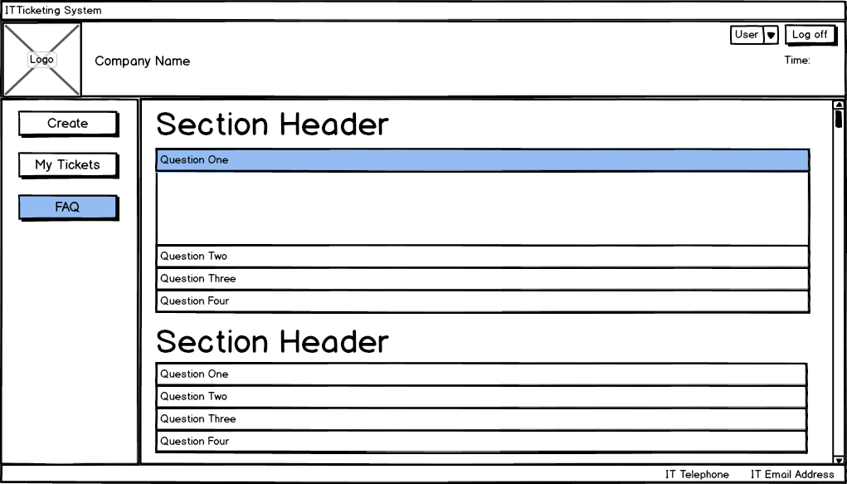

Figure 9: Client “FAQ” page

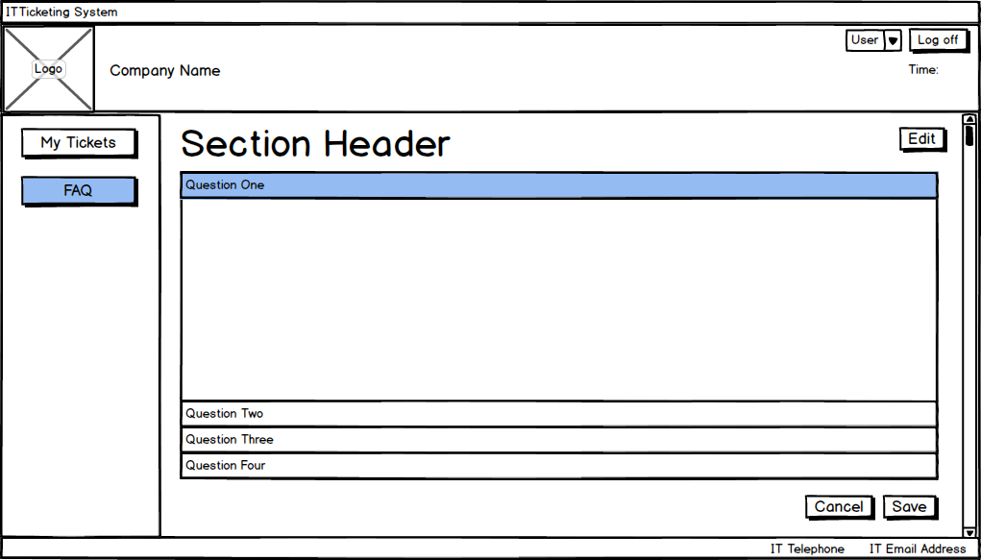

Figure 10: IT Technician “FAQ” page

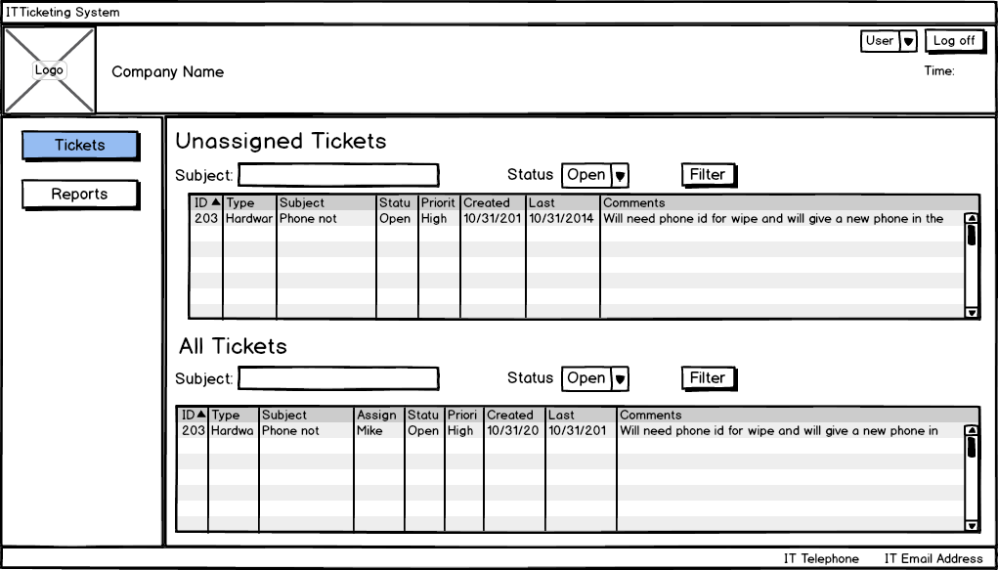

Figure 11: IT Manager “Tickets” page

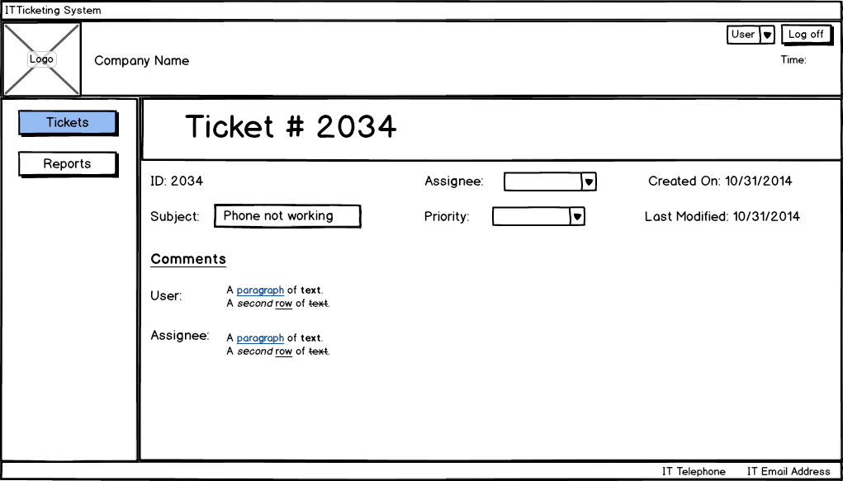

Figure 12: IT Manager “Click on Tickets” page

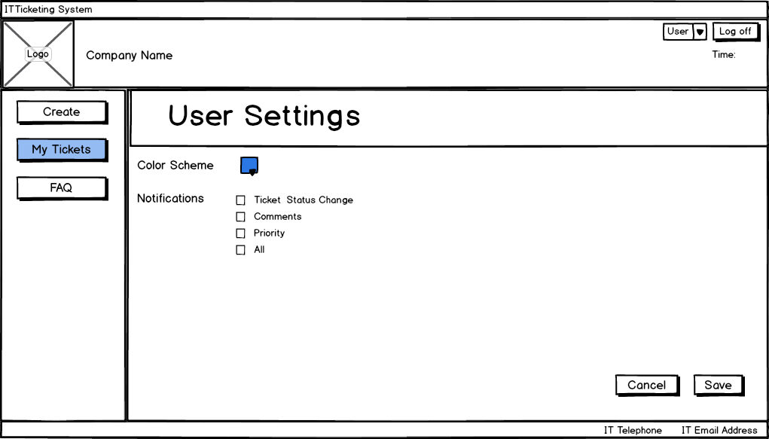

Figure 13: Clients “Settings” page

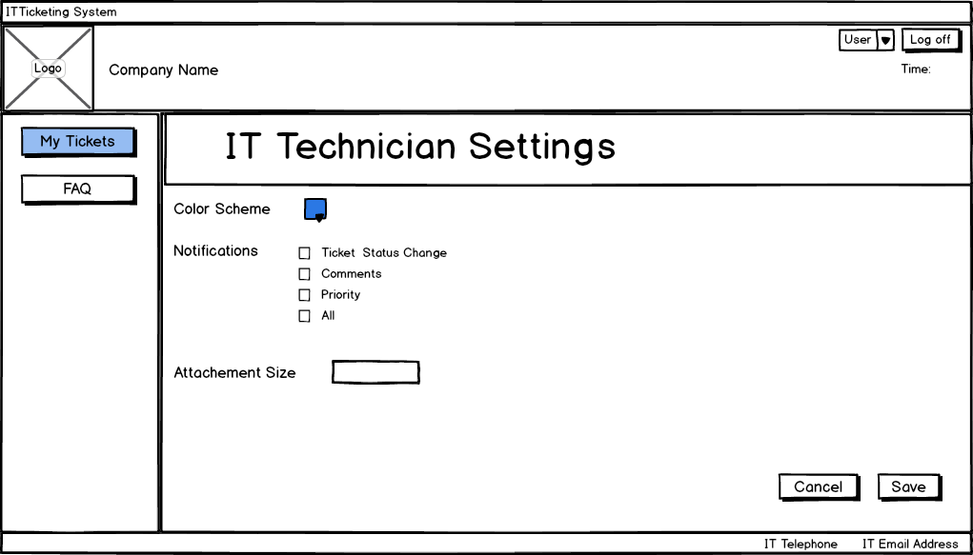

Figure 14: IT Technician “Settings” page

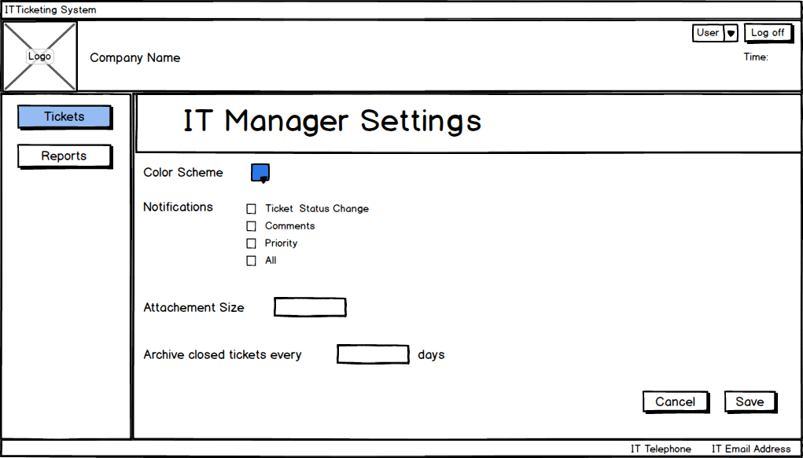

Figure 15: IT Manager “Settings” page

**Revised Wireframes**

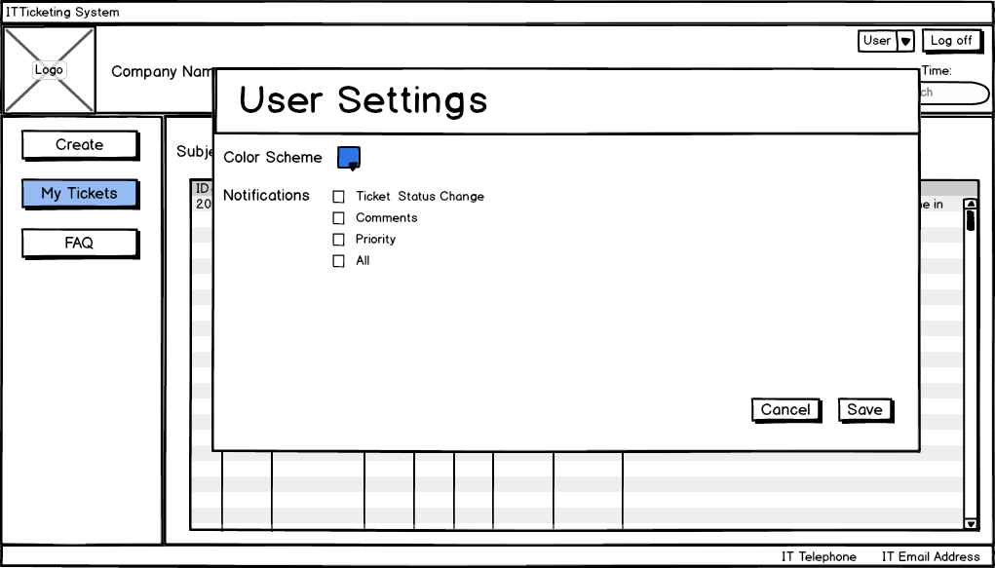

Figure 16: Clients new “Settings” page

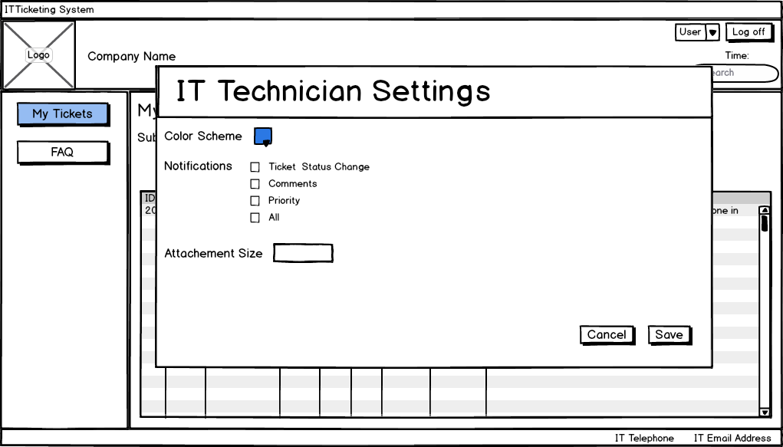

Figure 17: IT Technician new “Settings” page

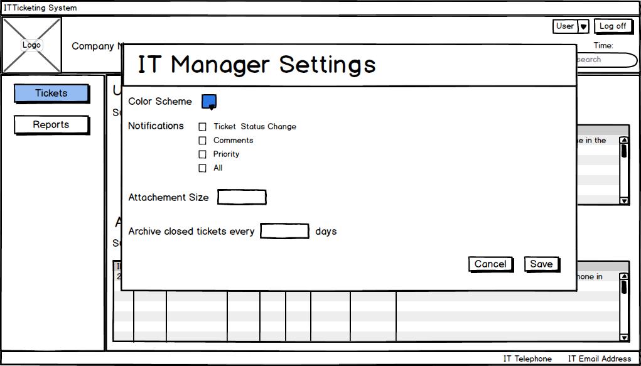

Figure 18: IT Managers new “Settings” page

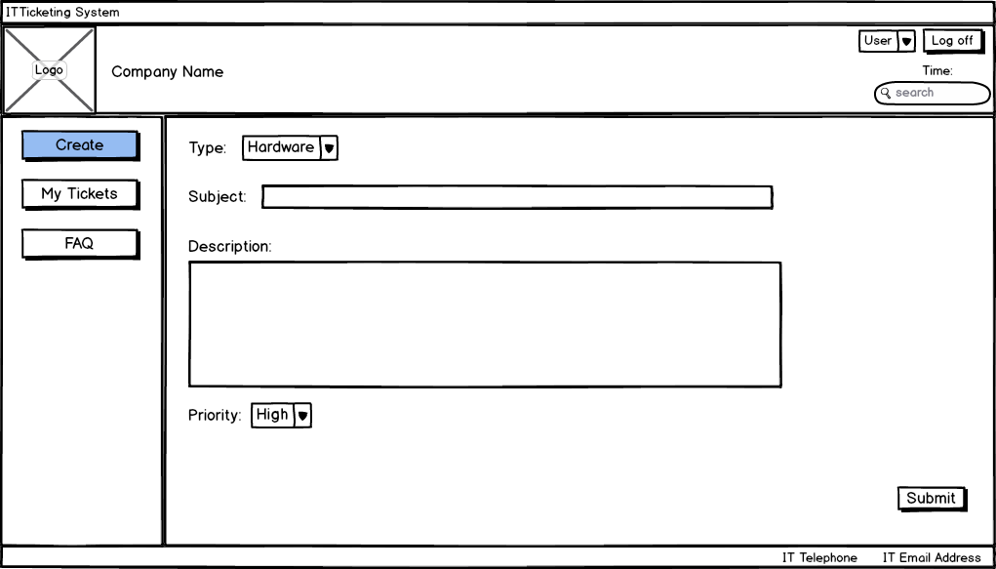

Figure 19: Clients new “Create a Ticket” page

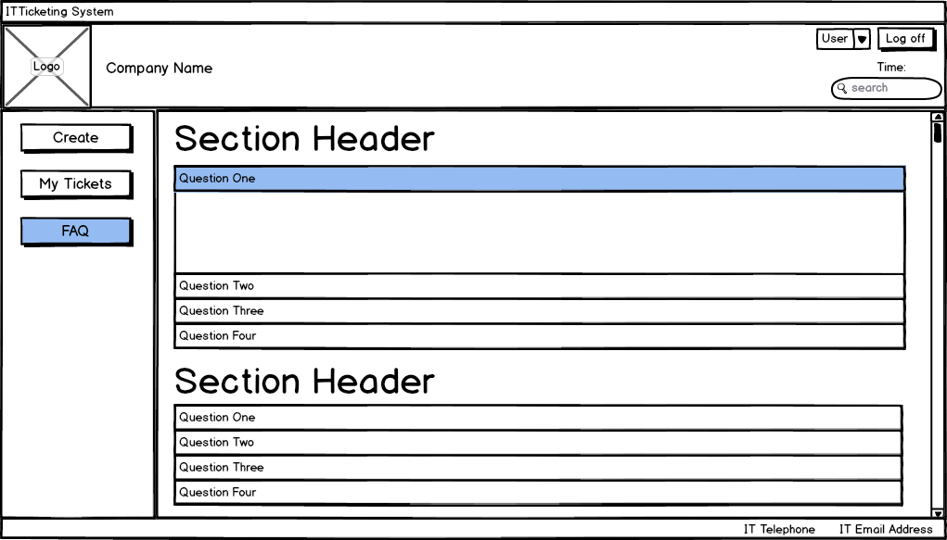

Figure 20: Clients new “FAQ” page

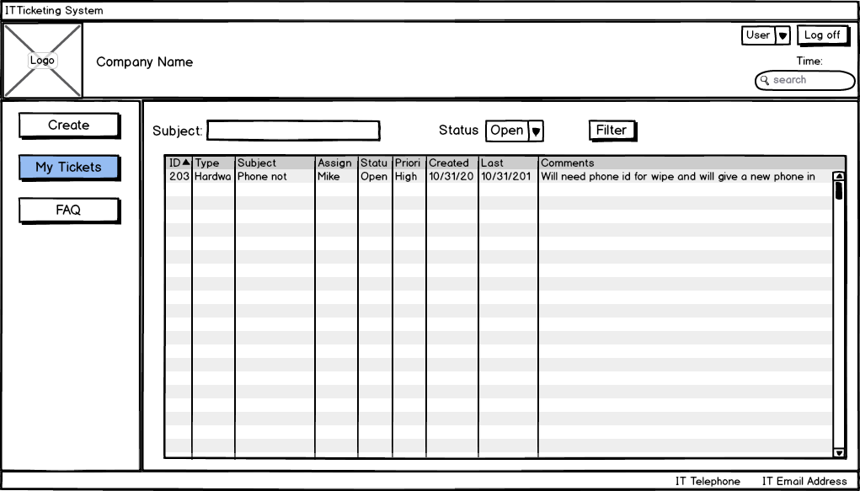

Figure 21: Clients new “My Tickets” page

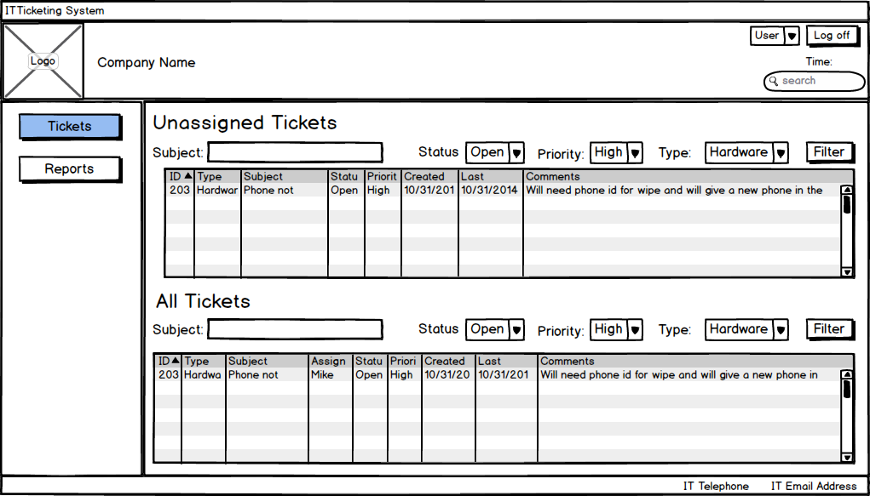

Figure 22: IT Managers new “My Tickets” page

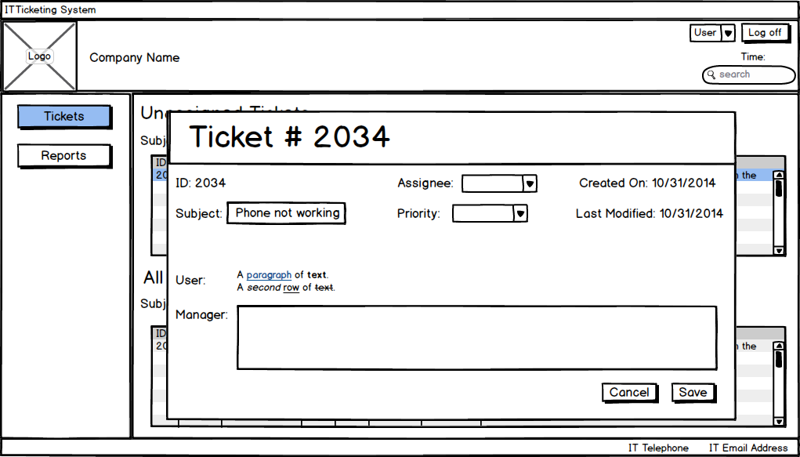

Figure 23: IT Managers new “Click on Tickets” page

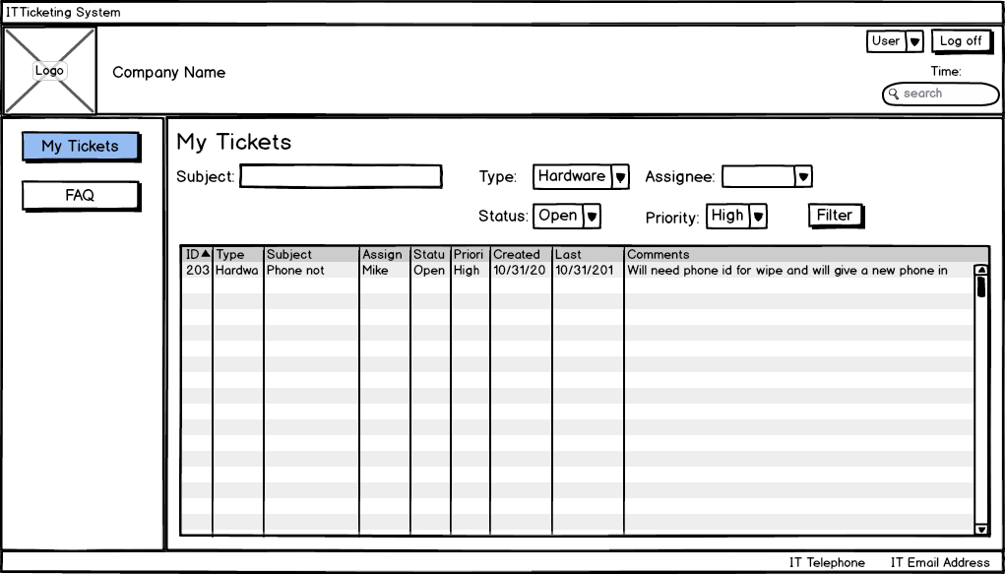

Figure 24: IT Technician new “My Tickets” page

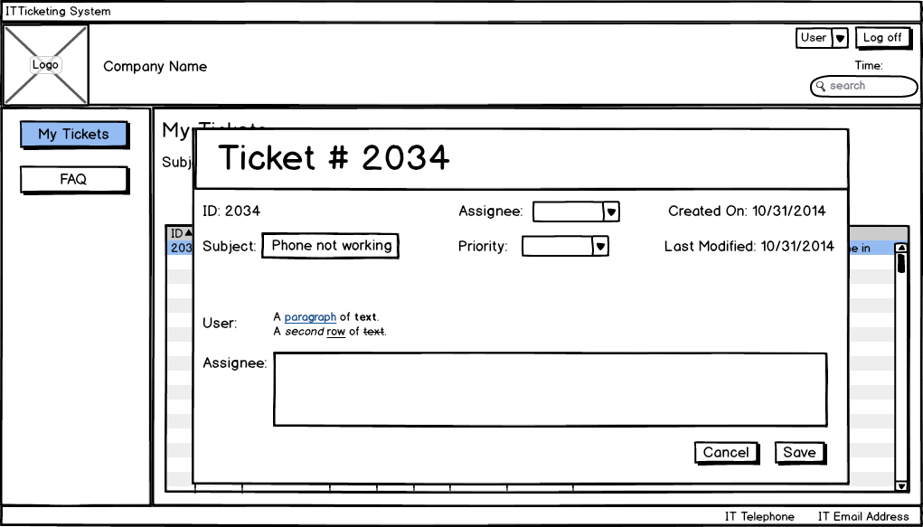

Figure 25: IT Technician new “Click on Tickets” page

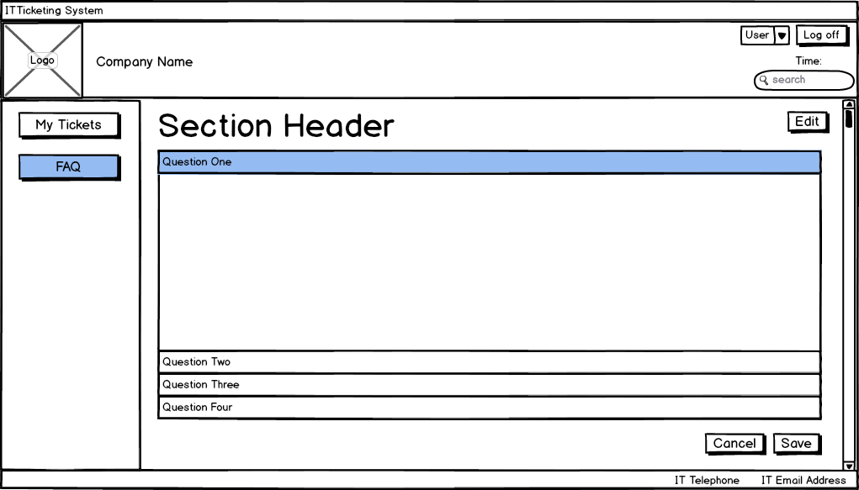

Figure 26: IT Technician new “FAQ” page

# Appendix B

## Requirements List

|  |  |  |
| --- | --- | --- |
| **Index** | **Requirement** | **Technique** |
| 1 | IT Contact Information visible on client interface | Task Analysis/Use Case Analysis |
| 2 | List of non-assigned incidents for IT, sorted from highest priority | Task Analysis |
| 3 | FAQ for clients visible on client interface | Use Case Analysis |
| 4 | Ticket updates given to users without resorting to email or phone | Use Case Analysis/Personas |
| 5 | Archive of all tickets created (daily, month etc…) for auditing purposes on IT service desk interface | Use Case Analysis/Personas |
| 6 | Ability for managers to create performance reports on number of solved tickets per day, etc on IT service desk interface | Use Case Analysis/ Personas |
| 7 | Customized home screen for user levels to ensure efficiency | Personas |
| 8 | Ability to restrict access to edit sensitive tickets / Permission control | Personas |

**Wireframe Test raw data**

Clients:

|  |  |  |  |  |
| --- | --- | --- | --- | --- |
|  | Client 1 | Client 2 | Client 3 | Client 4 |
| **Name** | Rob | Brandon | Kyle | Ben |
| **Age** | 22 | 22 | 23 | 23 |
| **Computer familiarity** | Good | Good | Good | Good |
| **IT ticketing familiarity** | Yes | Yes | No | Yes |
| **Scenario 1 Time** | 1:54 | 1:32 | 2:00 | 1:14 |
| **Scenario 1 Ease** | 6 | 6 | 5 | 7 |
| **Scenario 1 Remarks** | it was good | that was it? | it was good | that was it? |
| **Scenario 2 Time** | 0:23 | 0:23 | 0:25 | 0:21 |
| **Scenario 2 Ease** | 7 | 7 | 6 | 7 |
| **Scenario 2 Remarks** | seems normal | seems normal | seems normal | seems normal |

Service Desk Technicians and IT Manager:

|  |  |  |  |  |
| --- | --- | --- | --- | --- |
|  | Technician 1 | Technician 2 | Technician 3 | Manager 1 |
| **Name** | Mo | James | Tarjinder | Bruce |
| **Age** | 27 | 22 | 23 | 40+ |
| **Computer familiarity** | Good | Good | Good | Good |
| **IT ticketing familiarity** | Yes | Yes | Yes | Yes |
| **Scenario 1 Time** | 0:42 | 0:45 | 0:51 | 1:20 |
| **Scenario 1 Ease** | 4 | 5 | 6 | 5 |
| **Scenario 1 Remarks** | sort by most recent | sort by most recent | sort by priority |  |
| **Scenario 2 Time** | 0:23 | 0:23 | 0:25 |  |
| **Scenario 2 Ease** | 7 | 7 | 7 |  |
| **Scenario 2 Remarks** | emails, faster ticket closing | emails, faster ticket closing | emails, faster ticket closing |  |

