Tanya Jagdish
Project 1 Feedback
Component | Points available | Points achieved
Project Description | 3 | 3
Overview: What is the source of the data, when the data was collected, what data within the website was collected, and decisions about how to restrict the data collection process.
Scraping Algorithm
- Quality of code  (no errors, proper use of web scraping tools) | 2 | 2
- Automate data collection via loops | 3 | 3
- Extract data from multiple items (for example, in a marketplace it would be different products) | 2 | 2
- Algorithms includes navigation  (there is an instance on clicking of a button or link, going to another page, and extracting information) | 2 | 2
- Covert raw data to a workable dataset  (dataset is included with submission). | 3 | 3
Results
- Quality Checks  (Count number of observations, check that data is non-empty) | 2 | 2
- Present a table counting the number of observations and missing values. Present mean and variance for any numeric variables. | 2 | 2
Discussion
Clarity and conciseness | 1 | 0.5
Total |  | 19.5

Things that you did very well:
Excellent job! I think this was a very impressive project incorporating player rosters from multiple websites.
- I thought that the overview and methodological description was particularly well done.
- I see a lot of hard work in adapting to different issues that emergeed in web scraping data across websites.
Keep it up!
Major Feedback:
- Breakdown code into separate files: I see that your code is generating several intermediate “helper” functions starting with “def ….” that play different roles throughout the web scraping and visualization process. This makes the code unnecessarily long. This can be bad in the long run because it makes your code harder to manage, update, and debug. I think that it would be helpful to start breaking down the file into separate parts, to make sure it remains tractable and easy to debug.
  - Create a folder called “scripts” and create separate “.py” where you copy-paste the “functions” code in Block 3, 3.5, etc. Give each file an interpretable name.
  - In the main Jupyter notebook setup import the Python “.py” scripts using the “exec()” code introduced in Lectures 6c and 8b.
- Store long output as a log file: In Block 8, there’s a lot of intermediate diagnostic output being printed. This contributes to the length of the file and makes it harder to read. Perhaps suppress the printing for the final version, or even better, create additional code to store it in a separate log file.
- It wasn’t clear to me how the “missing percentage” by school and season was being calculated. Is this with respect to some particular variable or some other overall metric?
- I wonder if there’s more you can do to diagnose missing data. For example, I did a frequency table in Excel by school season, and see that some schools have some missing years, e.g. Alabama has data on 2010 and 2012, but not 2011, and 2013. Is this expected, or an error in the web scraping process. Perhaps you can do a similar analysis in Python, and adjust your code, if necessary?
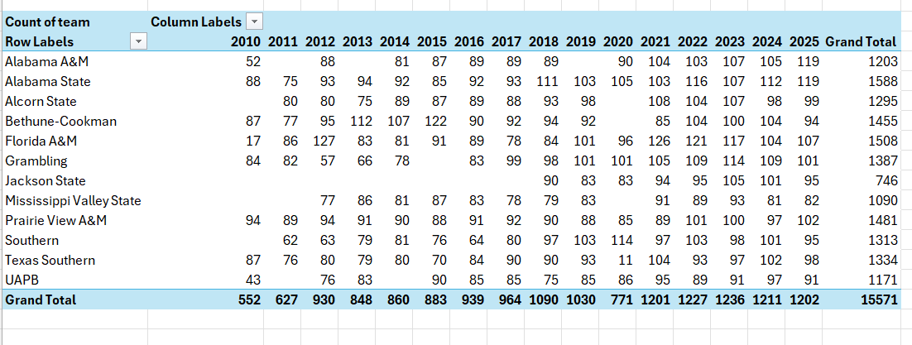
Please let me know if you have any questions or concerns.
Minor Feedback:
- I see that you broke things down into intermediate blocks 3.5, 4.5, etc. I see that this is common when you write AI-assisted code because that’s how AI tools tells you where to insert new content. However, you should also polish your code after you’re done to have clean numbering and/or more organic subsection divisions.
- The dashboard has a figure with no data. This could be dropped from the analysis.
- I noticed that you imported packages at certain intermediate points in the file. It’s better to import all the packages at the very beginning.

