Joshua Landron

CSS 422

6Apr2019

Hello output results:

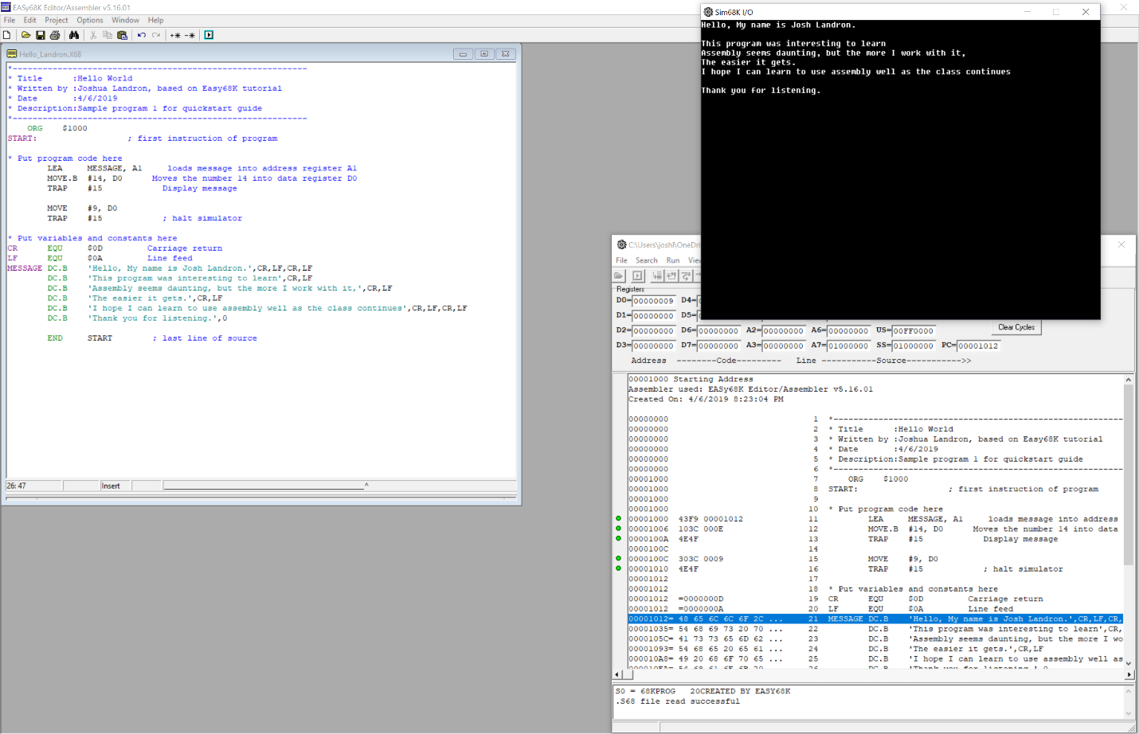

This program showed some basic syntax of Assembly. As far as I can tell, the key is remembering some basic codes, and being able to search for the correct code to get a job done. This file will serve as a base for the next program.

Input branch result:

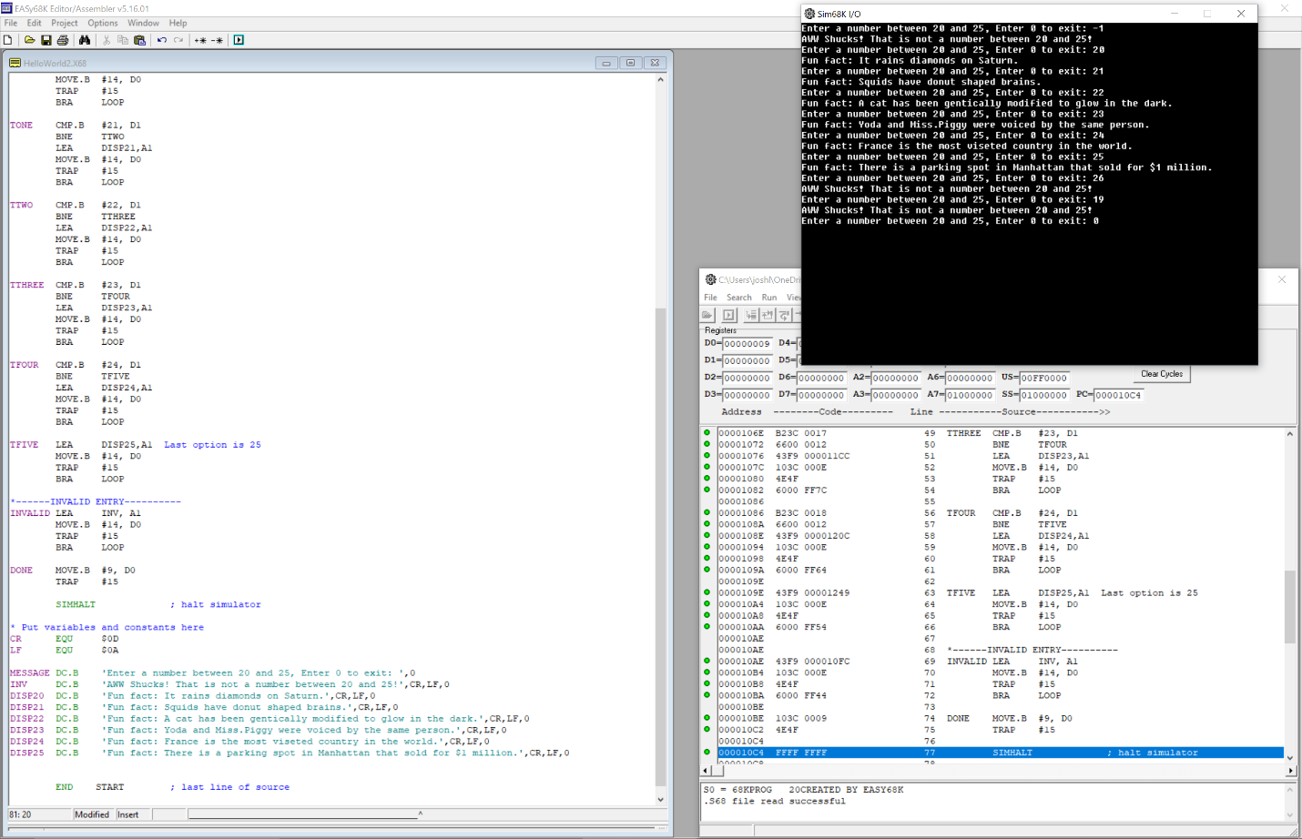

This program was a bit more complicated. This seems like the basic buildings of a switch statement, with output defined in DC.B messages only. The “while” loop structure built in this program is not as difficult to build as I imagined it would be.

Conclusion:  
This lab taught me the basic layout of a simple program in assembly, as well as the use of the X86 emulator.