CS 148 Database Design for the Web

Jacob Laramee

Assignment 7.1

Sontone of Burlington

Version <1.0>

|  |  |  |  |
| --- | --- | --- | --- |
| Time Log | | | |
| Date | Time Spent (in hours) | Description | Author |
|  |  | Your estimated time to complete assignment ____30___ hours | Jacob Laramee |
| 11/4/13 | .5 | ER-Diagram | Jacob Laramee |
| 11/4/13 | .5 | Schema | Jacob Laramee |
| 11/4/13 | .5 | Data Dictionary | Jacob Laramee |
| 11/4/13 | .5 | Story Board | Jacob Laramee |
| 11/5/13 | .5 | Version one of Specification Document | Jacob Laramee |
|  |  |  |  |
|  |  |  |  |
|  |  |  |  |
|  |  |  |  |
|  |  |  |  |
|  |  |  |  |
|  |  |  |  |
|  |  |  |  |
|  |  |  |  |
|  |  |  |  |
|  |  |  |  |
|  |  |  |  |
|  |  |  |  |
|  |  |  |  |
|  |  |  |  |
|  |  |  |  |
|  |  |  |  |
|  |  |  |  |
|  |  |  |  |
|  |  |  |  |
|  |  |  |  |
|  |  |  |  |
|  |  |  |  |

Table Of Contents

Software Requirements Specifications 4

Introduction 4

Purpose 4

Definitions, acronyms, and abbreviations 4

Overview 4

Overall Description 5

Data Dictionary 5

E-R Diagram 5

Schema 5

Story Board 5

Specific requirements 5

# Software Requirements Specifications

## Introduction

### Purpose

The purpose of this document is to describe the requirement specification for the web site “Sonotone of Burlington”

The intended audience for this document is companies or people whom are interested in hearing aids. The goal being that you can give this document to someone and they can make the site without having to ask any questions.

### Definitions, acronyms, and abbreviations

HTML – Hypertext markup language – used to define your conent.

PHP – Personal Home Page – language that helps to customize html.

CSS – Cascading Style Sheets – used to define the look of a web site.

W3 Validation – refers to both Html and CSS validation tool

ER-Diagram – Graphical Representation of database.

Data Dictionary – Shows structure of database tables.

Schema- SQL statements created from ER-diagram.

Story Board – Graphical representation of web site.

### Overview

**Overall Description**

The website Sonotone of Burlington is going to be a website designed to give companies and people information about audiology. It will give basic information on hearing aids, procedures, the staff, and more. It will also have a form that people will be able to fill out in order to get into contact with Sonotone of Burlington. There will be location information and other means of contacting them.

### Data Dictionary

tblContactInfo

| **Field** | **Type** | **Null** | **Key** | **Default** | **Extra** |
| --- | --- | --- | --- | --- | --- |
| pkEmail | varchar(25) | NO | PRI | *NULL* |  |
| fldFirstName | varchar(20) | YES |  | *NULL* |  |
| fldLastName | varchar(20) | YES |  | *NULL* |  |
| fldTelephone | int(11) | YES |  | *NULL* |  |

tblAddress

| **Field** | **Type** | **Null** | **Key** | **Default** | **Extra** |
| --- | --- | --- | --- | --- | --- |
| pkAddressID | int(11) | NO | PRI | *NULL* | auto_increment |
| fldAddress | varchar(50) | YES |  | *NULL* |  |
| fldCity | varchar(20) | YES |  | *NULL* |  |
| fldState | varchar(20) | YES |  | *NULL* |  |
| fldZip | int(11) | YES |  | *NULL* |  |

tblMessage

| **Field** | **Type** | **Null** | **Key** | **Default** | **Extra** |
| --- | --- | --- | --- | --- | --- |
| pkMessageID | int(11) | NO | PRI | *NULL* | auto_increment |
| fkEmail | varchar(25) | NO |  | *NULL* |  |
| fldMessage | text | YES |  | *NULL* |  |

tblContactInfoMessage

| **Field** | **Type** | **Null** | **Key** | **Default** | **Extra** |
| --- | --- | --- | --- | --- | --- |
| fkAddressID | int(11) | NO | PRI | *NULL* |  |
| fkEmail | varchar(25) | NO | PRI | *NULL* |  |

### E-R Diagram

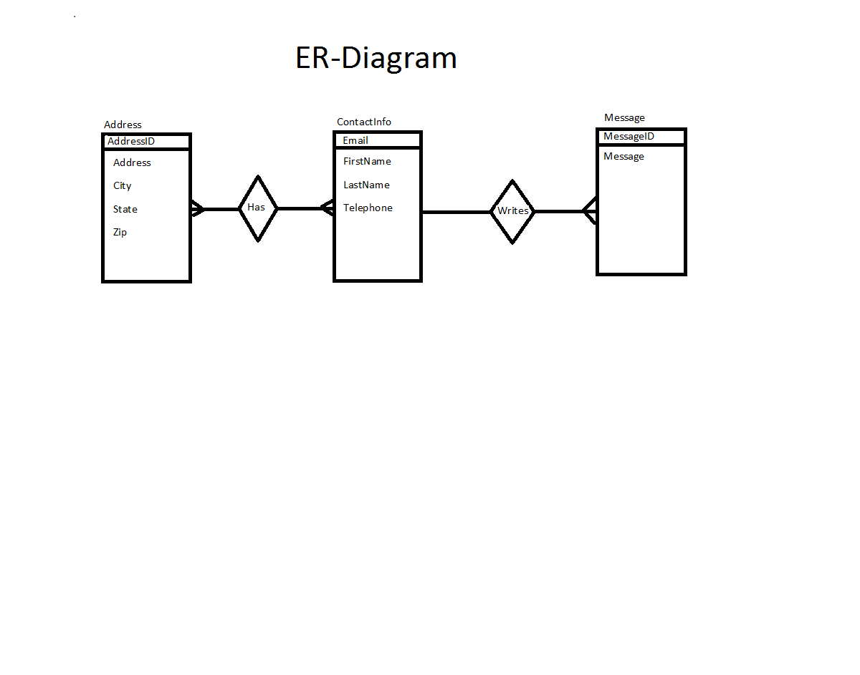

### Schema

CREATE TABLE tblContactInfo(

pkEmail VARCHAR(25) PRIMARY KEY,

fldFirstName VARCHAR(20),

fldLastName VARCHAR(20),

fldTelephone INT

);

CREATE TABLE tblMessage(

pkMessageID INT PRIMARY KEY AUTO_INCREMENT,

fkEmail VARCHAR(25) NOT NULL REFERENCES tblContactInfo(pkEmail),

fldMessage TEXT

);

CREATE TABLE tblAddress(

pkAddressID INT PRIMARY KEY AUTO_INCREMENT,

fldAddress VARCHAR(50),

fldCity VARCHAR(20),

fldState VARCHAR(20),

fldZip INT

);

CREATE TABLE tblContactInfoAddress(

fkAddressID INT NOT NULL REFERENCES tblAddress(pkAddressID),

fkEmail VARCHAR(25) NOT NULL REFERENCES tblContactInfo(pkEmail),

PRIMARY KEY(fkAddressID, fkEmail)

);

### Story Board

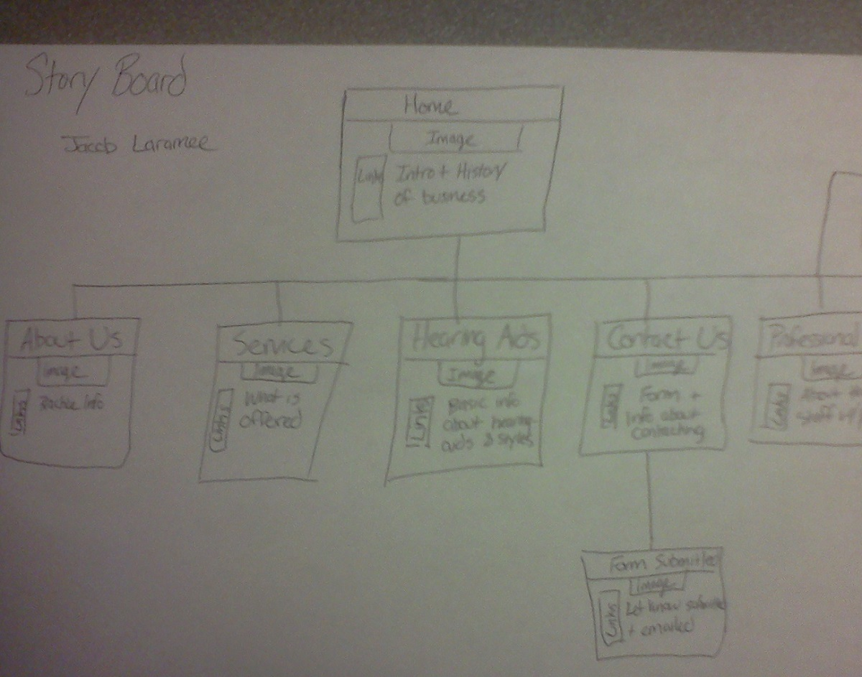

## Specific requirements

1. *Location* –files will be located in the public_html/cs148/assignment7.1 folder
2. *Html Validation* – All pages will pass W3C Html validation for html 5.
3. *CSS Validation* – All pages will pass W3C 3.0 CSS validation.
4. *Meta Information* – All pages will contain a proper title tag, Meta tags (author, character set and description).
5. *CSS* – all pages will have a linked style sheet.
6. *Navigation* – All pages will contain navigation to all other pages on the site using an ordered list. Be sure to enclose the navigation in the correct element.
7. *Content* –
8. *Browser compatibility* - This site will be checked on Firefox, Safari, Chrome and Internet Explorer.
9. *File Names* – the main home page will be called home.php with the rest of the file names up to you (be sure to use .php, .css for the respective files).
10. Develop complete GUI using php allowing customers, clients, and management to access database information.
11. A form that will insert data into at least 2 tables that passes validation and displays error messages.
12. Mail forms information to someone.
13. GUI should allow administrator to add, update, and delete records.
14. Use git and github to version project.