Leadership Theories Notes:

**LT1: Leadership, What is it?**

It is the first concepts and elements we cover about leadership in general, its not a theory so to say.

Leadership is a process it involves: influencing others, it happens within a context of a group, it involves goals attainment, these goals are shared by leaders and their followers.

**Trait vs. Process**

A trait is a single feature that a person has. A process is more a period of time where an individual learns to use the tools to lead.

**Leadership can be: Assigned versus Emergent.**

Assigned leadership is like company positions where you are a leader. Its more a title than anything else. Emergent leadership is where the followers will naturally respond to this individual.

**Leadership versus Power**

Power does not come automatically.

**LT2: Leadership Trait Approach:**

*You’re a leader if: you are born with the right set of traits.*

You are a leader if you have specific traits, and if you don’t have them, you’re not a leader.

Intelligence, sociability, self-confidence, integrity, determination. This theory was thought to be true, but scientists later found this to be untrue. The Greatman Theory, which is part of this theory, says that some men in history are just born leaders.

**LT3: Leadership Skills Approach:**

*You’re a leader if: you have specific skills.*

3 specific types of skills:

**Technical Skills**: Prof. in new technologies, ability to troubleshoot problems, certification, problem solving, technical writing.

**Conceptual Skills**: involve the ability to see the organizations as a whole. –Managers with conceptual skills are better able to understand various functions of the organizations complement one another, the relationship of the organization to it’s environment and how changes in one part of the organization affect the rest of the organization.

**Interpersonal Skills:** The previous skills are nice, but comparatively this one is essential. The ability to understand someone and how well you are going to manage working with others.

These skills play different parts at different position levels: (see chart below)

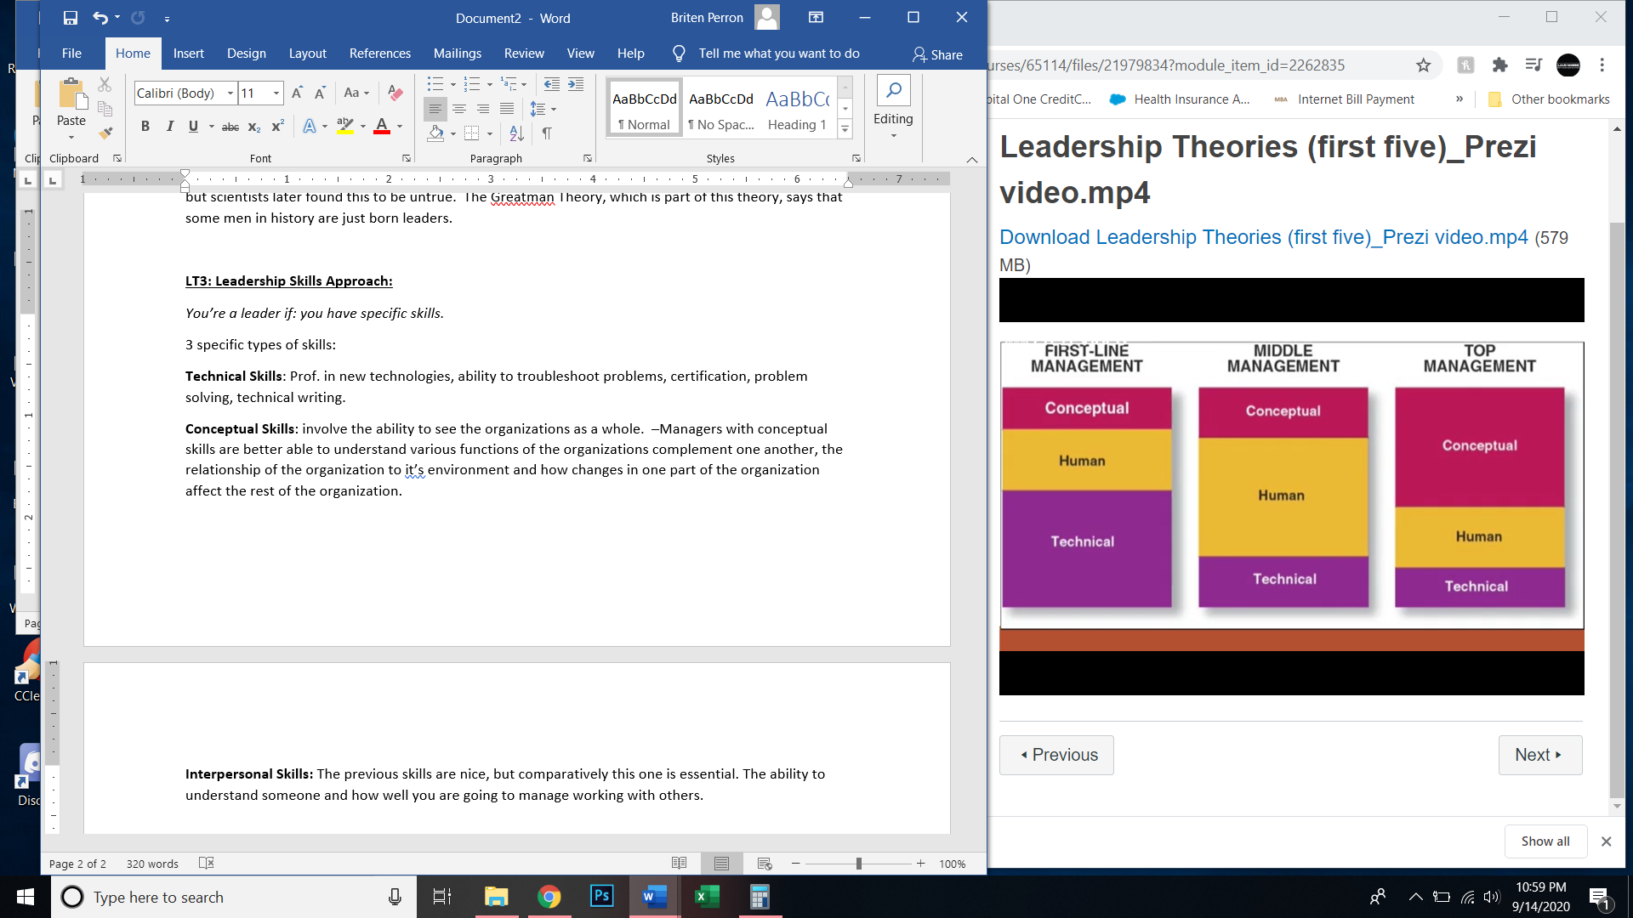

**LT4: Leader Style Approach:**

*You’re a leader if: you have the right style.*

Its about how you present yourself and interact with people.

There are 5 styles and they all balance between Concern for People and Concern for Production.

Then there are 3 other styles Lewin’s Leadership styles:

Democratic Style: everybody and come to a solution through the process of including everyone.

And others.

**LT5: Situational Approach to Leadership:**

Trait, skills, and styles behaviors) are descriptive. Situational approach is prescriptive.

Make sure to learn about each of the four in the chart below.

