LT1

Power is defined as the potential or capacity to influence others to bring about desired outcomes.

Personal Power – the capacity to influence that comes from being viewed as knowledgeable and likable by followers. It derives from the interpersonal relationships that leaders develop with followers.

Related to power is a specific kind of power called coercion. Coercive leaders use force to cause change. These leaders influence others through the use of penalties, rewards, threats, punishment, and negative reward schedules.

Leadership and Management

They both involve influencing people, however leadership and management are different on more dimensions than they are similar.

Zaleznik believes that managers and leaders are very distinct, and being one precludes being the other.

Leaders are emotionally involved, seek to shape ideas instead of reacting to others ideas, leaders work to expand the number of alternatives to problems, leaders change people attitudes while managers only change their behavior.

Kotter argues that organizations are overmanaged and underled. You must have strong leadership and strong management.

Rowe contends that leaders and managers are different and suggests that one aspect of the difference may be philosophical. Managers believe that decisions they make are determined for them by the organizations they work for, which is determined by the industry or environment they are in. Being too strong in management or leadership and weak in the other has its own slew of issues.

“managers are people who do things right and leaders are people who do the right thing.” You need both.

LT2

Leadership Trait theory (The “Great Person” theory) inherent characteristics and qualities of leaders considered to be great. Traits are attributes that include aspects such as values, needs, motives, and personality.

1. Intelligence, 2. Alertness, 3. Insight, 4. Responsibility, 5. Initiative, 6. Persistence, 7. Self-confidence, 8. Sociability.

Stogdill’s 10 traits: drive for responsibility and task completion, 2. Vigor and persistence in pursuit of goals, 3. Venturesomeness and originality in problem solving, 4. Drive to exercise initiative in social situations, 5. Self-confidence and sense of personal identity, 6. Willingness to accept consequences of decisions and actions, 7. Readiness to absorb personal stress, 8. Willingness to tolerate frustration and delay, 9. Ability to influence other people’s behavior, and 10. The capacity to structure social interaction systems to the goal to be achieved.

Mann had his own traits: intelligence, masculinity, adjustment, dominance, extroversion, conservatism.

Kirkpatrick and Locke: 1. Drive, 2. Desire to lead, 3. Honesty and integrity, 4. Self-confidence, 5 cognitive ability and 6. Knowledge of the business.

These writers argued for a nurture and nature perspective in that they believed that people can learn these traits, be born with them, or both.

Summarizing all the above reach 5 common ones: intelligence, self-confidence, determination, integrity and sociability.

To furher narrow done the most defining traits you could say the best leaders have just 2 strong traits:

A sense of humility and a steely resolve to get the job done.

**The Five-Factor Personality Model:**

5 factors that determine a person’s personality.

Neuroticism, extraversion, openness or intellect, agreeableness, and conscientiousness or dependability.

The trait approach to leadership is not relational. It concentrates on leaders with no focus on followers or situations. In other words, selecting the right people will improve organizational performance.

LT3:

**The Skills Approach**

Leader-centered perspective like traits approach. This one, however, focuses on a person’s skills and abilities that can be learned and developed.

**Katz’s Three-Skills Approach**

Technical Skills – prof. based on specific knowledge, in a particular area of work.

Interpersonal Skills – prof. in working with people based on a person’s knowledge about people and how they behave. These skills allow them to influence others.

Conceptual Skills – Allow you to think trhough and work with ideas.

**Leadership Skills Model**

Implies many people have leadership potential, if they can learn from their experiences.

Five elements: individual attributes, competencies, leadership outcomes, career experiences, and environmental influences.

Competencies are the most important element. Competencies lead to leadership outcomes but themselves are affected by a leader’s individual attributes.

There are different Competencies:

Leader Competencies:

Problem-Solving Skills: These are creative abilities that leaders bring to unique, vague, “hard to get a handle on” organization problems. Defining problems and ways to solve them.

Social Judgment Skills – skills that enable leaders to comprehend people and the social systems within which they work, play, and have a social life. Four Elements: perspective taking, social perceptiveness, behavioral flexibility, and social performance.

Knowledge – the gathering of information and the development of mental structures to organize that information in a meaningful way.

And now, to really piss in my tea, Mumford and his colleagues identifies four attributes that affect the three (above) leader competencies:

General Cognitive Ability: Perceptual processing, information processing, general reasoning skills, creative divergent thinking capacities, and memory skills.

Crystallized Cognitive ability: intelligence that develops because of experience

Motivation: Motivation affects leadership competencies in several ways. They must want to lead and being willing to exert influence.

Personality: things like being tolerant, ambiguity, openness and curiosity. Confidence and adaptability.

Individual attributes lead to leader competencies, which lead to leadership outcomes.

**Without the development of leader competencies, individual attributes may have little effect on leadership outcomes. Leadership competencies element is the “kingpin” component of the leadership skills model.**

There are TWO leadership outcomes: Effective problem solving, and performance.

All these competencies are developed with carrer experiences and environmental influences.

--Career experiences work indirectly to affect leadership outcomes, while environmental influences work indirectly and directly to influence leadership outcomes.

This model suggests that leadership effectiveness as measured by outcomes is a direct result of leader competencies and the indirect result of individual attributes working through leader competencies.

LT4: **Leader Style Approach**

The leadership style approach is different from the trait approach and the skills approach. The trait approach emphasized the personality characteristics of leaders. The skills approach focused on the leader’s competencies.

The leadership style approach accentuates leader behaviors—in other words what leaders do and how they act, particularly toward subordinates, in a multitude of situations to change subordinates performance and influence.

These behaviors can be distilled into two broad types:

Initiating structure (task behavior) – makes it easier for group members to accomplish goals and objectives

Consideration (relationship behavior) == make it easier for group members to feel at ease with the context in which they are operating.

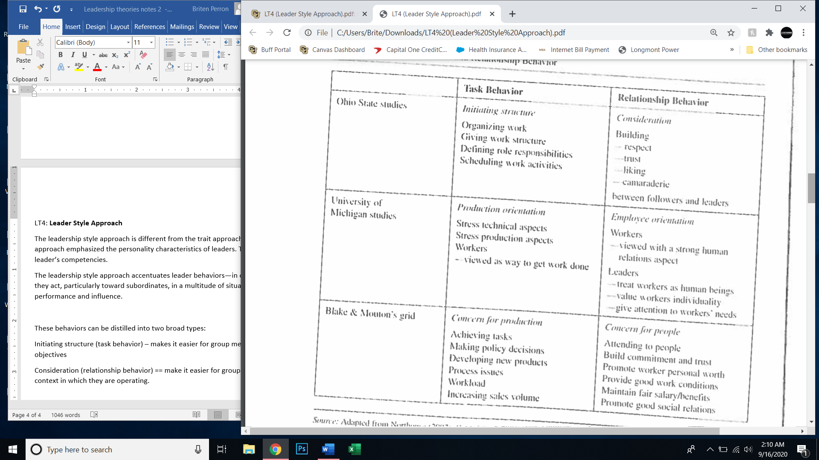

**The Blake and Mouton Grid** describes two leader orientations: concern for production and concern for people. These resemble task behavior and relationship behavior.

Using the grid researches developed **5 leadership styles:**

Authority-Compliance style – results driven, with little or no concern for people.Limited communication and used only to give order, controlling, hard-driving, overpowering and demanding.

Country Club Style – high concern for people and low concern for results or production.

Impoverished Management – Little or no concern for people or for production. They do enough to “not get fired”

Middle-of-the-Road Style – moderate concern for people and production. Compromisers who do not push production hard or push to meet the needs of their followers to the maximum limit

Team Management Style – emphasize getting results and interpersonal relationship. Promote teamwork and high level of participation in work-related decisions by employees. “stimulates participation, acts determined, gets issues into the open, makes priorities clear, follows through, behaves open-mindedly, and enjoys working. Switch between authority-compliance style and country club style depending on the situation.

Opportunism Style – opportunistically uses any combination of the five styles to advance his or her career.

Blake and Mouton argue that leaders usually have a style that is most dominant and one that is their “backup”.