**Josiah Kephart  
ADS1 Final Project**

**Household PM2.5 concentrations in rural and urban households in Peru**

**Introduction**

Peru, along with other low and middle-income countries (LMICs) is experience a transition in the burden of disease from infectious diseases to non-communicable diseases 1. Non-communicable disease are the cause of 66% of total deaths in Peru 1, and cardiovascular disease and diabetes are the largest source of years lost due to premature mortality 2. Air pollution, both ambient and indoor, is a known risk factor for chronic disease of the lungs and heart 34. In Peru, air pollution is known to vary by geography due to differences in both urbanicity and household behaviors 5. Characterizing the airborne exposures faced by Peruvians in both urban and rural areas is critical to understanding the contribution of air pollution to rising non-communicable disease and to inform interventions that reduce exposures.

Particulate matter are small, airborne particles that are a major contributor to air pollution 6. The size of particulate matter particles is inversely associated with the health risk, as small particles are able to lodge deeper into the lungs and cause greater damage 7. Particulate matter with diameter smaller than 2.5 micrometers are known as PM2.5 or fine particles, and can travel deep into the lungs, causing a range of heart and lung disease 8.

PM2.5 can come from both natural and human-induced sources and is a frequent target of environmental regulations 6. Natural sources of PM2.5 include dust, sea-spray and ash. The most common source of human-induced PM2.5 is the combustion of fossil fuels for electricity, industrial processes, or transport 9. The Environmental Protection Agency (EPA) has set a PM2.5 regulatory standard of 12 ug/m3 per annual mean with the goal of protecting public health 10.

Ambient, or outdoor PM2.5 is frequently modeled through remote sensing via satellite images and/or samples taken by air quality monitors at strategic locations that are extrapolated to unmeasured locations 11. However, less is known about indoor concentrations of PM2.5 due to the strong effect of household activities and kitchen construction that can produce wide variability of concentrations between nearby households 12. For example, one household may cook with wood while another cooks with gas. The household concentrations and subsequent personal exposures to PM2.5 could vary in orders of magnitude between otherwise identical houses because of the different sources of cooking fuel 13. The difficulty and lack of measurement of indoor concentrations is important, since many people spend the majority of their time indoors. Understanding household concentrations of PM2.5 is critical to assess total air pollution exposure and to accurately quantify the connections between PM2.5 exposure and chronic disease.

This analysis seeks to compare kitchen PM2.5 concentrations among urban and rural households in Peru.

**Methods**

*Data Collection*

To accomplish this aim, a study of household air pollution and clinical outcomes, known as CRONICAS, was conducted in Lima and Puno, Peru from 2010-2015 14. PM2.5 was measured for 48 hours at one-minute intervals in households in Lima (urban) and in Puno (rural). The devices were placed inside the main kitchen area of all household at approximately 1.5 meters height from the floor.

The study used DataRAM pDR-1000 (PDR) monitors (Thermo Fisher Scientific, Waltham, Massachusetts, USA) to measure PM2.5 levels in real-time. PDR monitors are battery-powered devices about the size of a VHS tape which use light-scattering to estimate concentrations of PM2.5 at one-minute temporal resolution. As air enters the top of the PDR, a laser is directed through the air towards a light-sensing receptacle. As the laser encounters PM2.5, the beam reflects off the particles and scatters throughout the air chamber. The amount of light measured by the receptacle is inversely related to the concentration of PM2.5 in the chamber. The data is logged within the device and downloaded upon completion of the 48-hour sample.

*Exploratory Analysis*

Various plots and graphs were used to perform exploratory data analysis on the raw data. PM levels were transformed to a log base 10 scale to assist in visualization and comparison between geographic groups.

*Reproducibility*

To provide reproducibility, all analyses were recorded in a R markdown file named “analysis.Rmd”. The raw data has been provided in a folder named “Data”.

**Results**

PM2.5 samples were taken in 336 urban households and 357 rural households. At one-minute intervals, there were 503,742 PM2.5 estimates logged among urban households and 523,512 among rural households. An average of 25.0 and 24.4 hours of logging was recorded for each sample among urban and rural households respectively, a significant departure from the stated goal of 48-hour samples, but still providing concentration data for all hours of the day.

Due to the large amount of observations at one-minute intervals, all data were summarized into hourly median estimates by household. These hourly household estimates were then summarized across households by mean, median, 95th interval concentrations as well as hourly standard deviation. The mean hourly concentration was 0.664 mg/m3 in rural samples and 0.016 mg/m3 in urban samples. The median hourly concentration was 0.003 mg/m3 among rural samples and 0.005 among urban samples. The 95th percentile hourly estimate in rural samples was 2.066 mg/m3, while among urban samples was 0.048 mg/m3. The variability among rural samples was also higher, as the hourly standard deviation among rural samples was 5.693 mg/m3 and 0.048 mg/m3 among urban samples.

Concentrations in both urban and rural households were consistently above the EPA standard, and rural concentrations were often two orders of magnitude higher than the standard (Figures 1 & 2). Among urban households, the mean hourly median PM2.5 concentration was above the EPA standard (0.012 mg/m3) for 17 hrs of the day, with a range of (0.005, 0.047 mg/m3). In rural households, the mean hourly median concentration was above the EPA standard 20 hours of the day, with a range of (0.004, 3.326 mg/m3). The highest concentrations among both groups were between 6:00am and 8:00am with smaller peaks midday and between 6:00pm and 7:00pm in the evening.

Hourly median concentrations among both groups were log-transformed (base 10) to facilitate comparison between the vastly different ranges of concentrations found in urban and rural groups. Box plots were produced to visualize the log hourly median concentrations by hour of the day, as well as the variability between households (Figures 3 & 4).

Heat maps were created to visualize changing concentrations throughout the day at the household level (Figures 5 & 6).

**Discussion**

Rural households showed consistently higher concentrations of PM2.5 than urban households. Within this study, rural households had mean PM2.5 concentrations over the EPA standard for 20 hours out of the day. These mean concentrations were two orders of magnitude greater than the EPA standard set to protect public health.

Urban households consistently showed lower and less varying concentrations. In contrast, many rural households showed steep spikes in the morning and evenings, reaching levels orders of magnitude higher than most urban households.

The timing of the concentration spikes in rural households closely aligns with common meal preparation times. It is likely that the increase in PM2.5 concentrations seen in rural households is closely related to cooking practices, specifically fuel sources and type of stove. Stoves which use wood, dung, and other solid fuels (collectively known as biomass fuel) are known to cause high spikes in PM2.5 concentrations. Due to the correlation between time of the day and concentrations among rural households, it is plausible that the primary cause of variation between urban and rural household PM2.5 concentrations is a greater prevalence of biomass-fueled stoves in rural areas. Additional research is needed to identify the cooking fuel of households in both urban and rural areas to isolate the effect of biomass combustion for cooking from other ambient and household sources of PM2.5.

As visible in the heat maps, while some households show variability throughout the day, other households have relatively constant concentrations at all hours, suggesting other sources of PM2.5 unrelated to cooking. Within these households there is variation in the relatively constant PM2.5 concentration level which they experience. This variation of constant PM2.5 is likely due to variation in ambient PM2.5 associated with location of the household. Houses that are close to electricity plants, factories, or major roadways would expect to see higher, relatively constant concentration levelsthan houses which are not close to point sources of PM2.5.

Regardless of the source, this data suggests that individuals in rural households in Peru experience high levels of exposure to PM2.5 within their homes, in relation to those in urban households in Peru.

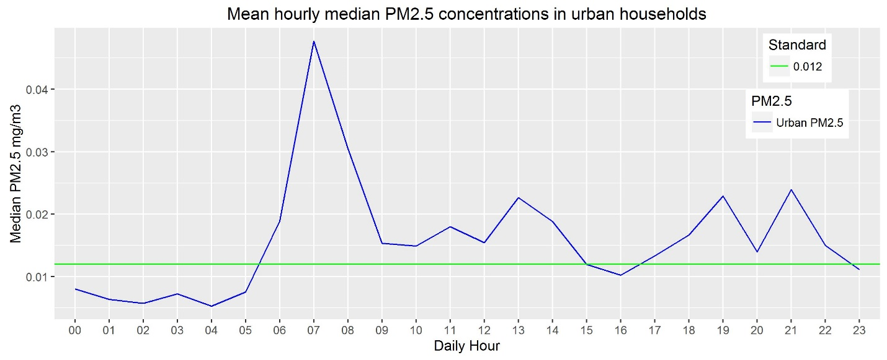

Figure 1. **Urban households in Peru experience indoor PM2.5 concentrations above EPA standards.** Mean hourly PM2.5 concentrations by hour of day among Peruvian kitchens in urban areas.

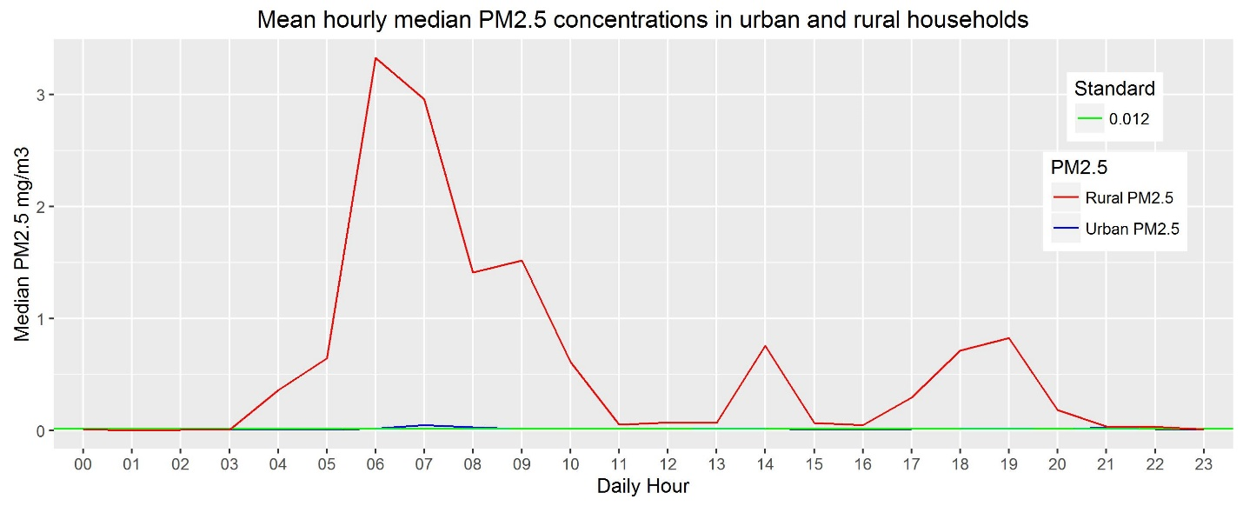Figure 2. **Rural households in Peru experience indoor PM2.5 concentrations orders of magnitude higher than urban households and the EPA standard.** Mean hourly PM2.5 concentrations by hour of day among Peruvian kitchens in rural and urban areas. Concentration spikes are centered around dawn and dusk, common times for meal preparation.

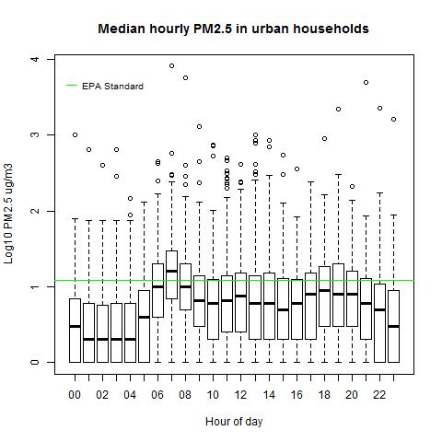

Figure 3. **In urban households, log-transformed median PM2.5 concentrations have similar variability throughout the day.** Log (base 10) transformed median hourly PM2.5 concentrations in kitchens among urban households in Peru. Throughout the day, approximately 75% of households have concentrations below the EPA standard. Concentrations are generally lower at night.

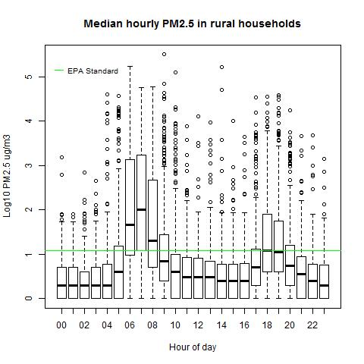

Figure 4. **Among rural households, variability of PM2.5 concentrations is highly associated with time of day.** Log (base 10) transformed PM2.5 concentrations in kitchen of rural households in Peru. Spikes in concentrations are closely aligned with common hours for meal preparation, suggesting an association with cooking practices.

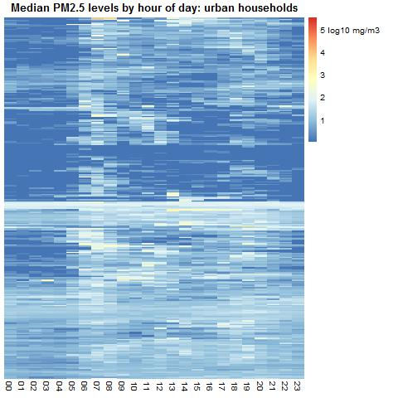

Figure 5. **PM2.5 in urban households has variability across households, but little variability across time.** Heat map of individual household log-transformed (base 10) PM2.5 concentrations throughout the day among urban households in Peru. Horizontal rows are individual households. Columns are hours of the day. There are slight increases in concentrations within many households in the morning and evening, but many households show constant levels throughout the day.

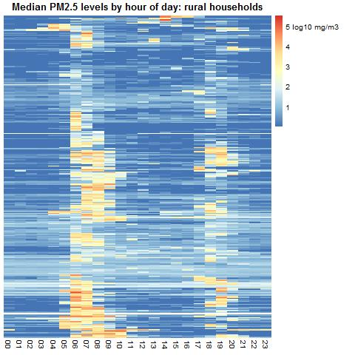

Figure 6. **PM2.5 concentrations in rural households have large spikes around common cooking times for most households.** Heat map of individual household log-transformed (base 10) PM2.5 concentrations throughout the day among rural households in Peru. Horizontal rows are individual households. Columns are hours of the day. Concentration spikes are closely aligned with common hours for food preparation, suggesting an association between concentrations and cooking practices.

1. WHO. Peru: WHO Statistical Profile. *WHO* (2016). Available at: http://www.who.int/gho/countries/per.pdf?ua=1. (Accessed: 22nd October 2016)

2. WHO. Peru: Non-communicable diseases. *WHO* 2014 (2014). Available at: http://www.who.int/nmh/countries/per_en.pdf?ua=1. (Accessed: 22nd October 2016)

3. Abbey, D. E., Ostro, B. E., Petersen, F. & Burchette, R. J. Chronic respiratory symptoms associated with estimated long-term ambient concentrations of fine particulates less than 2.5 microns in aerodynamic diameter (PM2.5) and other air pollutants. *J. Expo. Anal. Environ. Epidemiol.* **5,** 137–59 (1994).

4. Dockery, D. W. Epidemiologic evidence of cardiovascular effects of particulate air pollution. *Environ. Health Perspect.* 483–6 (2001).

5. Helen, G. St. *et al.* Exposure of Pregnant Women to Cookstove-Related Household Air Pollution in Urban and Periurban Trujillo, Peru. *Arch. Environ. Occup. Health* **70,** 10–18 (2015).

6. US EPA. Particulate Matter. (2016). Available at: https://www.epa.gov/pm-pollution/particulate-matter-pm-basics#PM. (Accessed: 24th October 2016)

7. US EPA. Health and Environmental Effects of Particulate Matter (PM). *US Environmental Protection Agency* 1 (2003). Available at: https://www.epa.gov/pm-pollution/health-and-environmental-effects-particulate-matter-pm. (Accessed: 24th October 2016)

8. Boldo, E. *et al.* Apheis: Health Impact Assessment of Long-term Exposure to PM2.5 in 23 European Cities. *Eur. J. Epidemiol.* **21,** 449–458 (2006).

9. Mei Zheng, *,§,†, Glen R. Cass, §,⊥, James J. Schauer, † and & Edgerton‡, E. S. Source Apportionment of PM2.5 in the Southeastern United States Using Solvent-Extractable Organic Compounds as Tracers. (2002). doi:10.1021/ES011275X

10. US EPA. NAAQS Table. (2016). Available at: https://www.epa.gov/criteria-air-pollutants/naaqs-table. (Accessed: 22nd October 2016)

11. Jerrett, M. *et al.* Comparing the Health Effects of Ambient Particulate Matter Estimated Using Ground-Based versus Remote Sensing Exposure Estimates. *Environ. Health Perspect.* (2016). doi:10.1289/EHP575

12. Hartinger, S. M. *et al.* Chimney stoves modestly improved Indoor Air Quality measurements compared with traditional open fire stoves: results from a small-scale intervention study in rural Peru. *Indoor Air* **23,** 342–352 (2013).

13. Zhang, J. J. & Smith, K. R. Household air pollution from coal and biomass fuels in China: measurements, health impacts, and interventions. *Environ. Health Perspect.* **115,** 848–55 (2007).

14. Miranda, J. J. *et al.* Addressing geographical variation in the progression of non-communicable diseases in Peru: the CRONICAS cohort study protocol. *BMJ Open* **2,** e000610 (2012).