**Tiwi-SL Sample Code: First SPI Command Sent**

SPI protocol is shown:

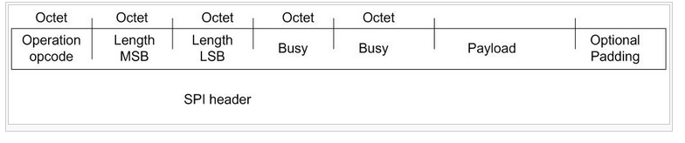

The padding is one byte and is only added when , without it, the number of bytes in the entire message would be odd.

The two length bytes are a 16-bit value sent MSB (so not reversed), and indicate the number of bytes after the SPI header (so payload plus padding bit (if present)).

The operation code is either read or write.

#define SPI_READ 3

#define SPI_WRITE 1

In the case of the first write, it is SPI_WRITE.

The Payload is an HCI message, the first byte of which is the “type”:

#define HCI_TYPE_CMND 0x1

#define HCI_TYPE_DATA 0x2

#define HCI_TYPE_PATCH 0x3

#define HCI_TYPE_EVNT 0x4

In the case of the first write, it’s HCI_TYPE_CMND, which must be followed by a two-byte command. The command in this case is HCI_CMND_SIMPLE_LINK_START, which is defined as:

#define HCI_CMND_SIMPLE_LINK_START 0x4000

16-bit commands and parameters are sent as LSB, so this command is sent as 0x00,0x40

The next byte is the length of the parameters. For this first call, it’s just one byte, so 0x01.

For this first message, we must tell the CC3000 whether to get the patches from the EEPROM (DEFAULT), to request the patches from the host MCU (FORCE_HOST), or not to use any patches (FORCE_NONE):

#define SL_PATCHES_REQUEST_DEFAULT (0)

#define SL_PATCHES_REQUEST_FORCE_HOST (1)

#define SL_PATCHES_REQUEST_FORCE_NONE (2)

Here now are the messages for Smart Config, starting from power up:

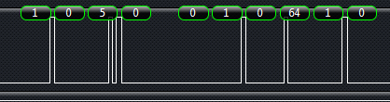

1 (SPI_WRITE)

0,5 (the length of the message after the 5-byte SPI header, sent as two bytes, most significant byte first)

0,0 (two busy bytes)

1 (HCI_TYPE_CMND)

0,64 (which is CMND_SIMPLE_LINK_START, 0x4000, send as least significant byte first)

1 parameter length (WLAN_SL_INIT_START_PARAMS_LEN)

1 (SL_PATCHES_REQUEST_DEFAULT)

First receive:

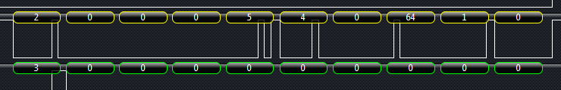

3 (SPI_READ)

0 means nothing on a read

0 means nothing on a read

0 means nothing on a read

0 means nothing on a read

0 means nothing on a read

4 HCI_TYPE_EVENT

0,64 (which is CMND_SIMPLE_LINK_START, 0x4000, send as least significant byte first)

1 length past HCI header, which is 4 bytes

0 not sure if this has any meaning, maybe a SUCCESS status

Second send: 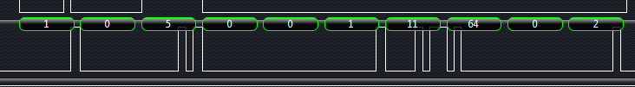

1 (SPI_WRITE)

0,5 (the length sent as two bytes, most significant byte first)

0,0 (two busy bytes)

1 (HCI_TYPE_CMND)

11,64 (which is HCI_CMND_READ_BUFFER_SIZE, 0x400B, send as least significant byte first)

2 just a padding byte to make it an even number of bytes sent

Second receive:



4 HCI_TYPE_EVENT

11,64 (which is HCI_CMND_READ_BUFFER_SIZE, 0x400B, send as least significant byte first)

4.0 length past HCI header, which is 4 bytes (LSB, so flip)

6 number of free buffers

220,5 buffer length as LSB so 1500

0 padding byte

Third send:

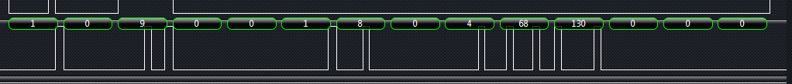

1 (HCI_TYPE_CMND)

8,0 HCI_CMND_EVENT_MASK (0x0008)

4 WLAN_SET_MASK_PARAMS_LEN

68,130,0,0 = HCI_EVNT_WLAN_KEEPALIVE, HCI_EVNT_WLAN_UNSOL_INIT,

HCI_EVNT_WLAN_ASYNC_PING_REPORT (or-ed together as 4 byte value)

Third Receive:



4 HCI_TYPE_EVENT

8,0 HCI_CMND_EVENT_MASK (0x0008)

5,0 length (0X0005)

0,0,0,0 = 32 bit param (sample code seems to ignore these bytes)

Fourth send:

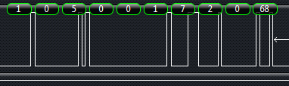

1 (HCI_TYPE_CMND)

7,2 HCI_CMND_READ_SP_VERSION (0x0207)

5 PARAMS_LEN

68 = padding

Third Receive:

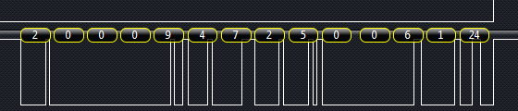

4 HCI_TYPE_EVENT

7,2 HCI_EVNT_READ_SP_VERSION (0x0207)

5 length

0,0,6,1,24 = 1 and 24 are the major and minor versions

According to <http://processors.wiki.ti.com/index.php/CC3000_Release_Notes>, 1.24 is the service pack version, which corresponds to 1.11.1 Release Package version.

Fifth Send:

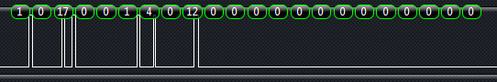

1 (HCI_TYPE_CMND)

4,0 = 0x0004, HCI_CMND_WLAN_IOCTL_SET_CONNECTION_POLICY

12 = length

0,0,0,0 = should_connect_to_open_ap

0,0,0,0 = ulShouldUseFastConnect

0,0,0,0 = ulUseProfiles

Fifth receive:



4 HCI_TYPE_EVENT

4,0 = 0x0004, HCI_CMND_WLAN_IOCTL_SET_CONNECTION_POLICY

5 length

0,0,0,0 = 32 bit param (sample code ignores)

Sixth send:

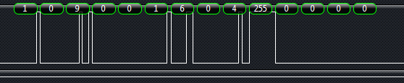

1 (HCI_TYPE_CMND)

6,0 = HCI_CMND_WLAN_IOCTL_DEL_PROFILE (0x0006)

4 = length of params

255,0,0,0 = 0x000000ff (4 byte value) for “index”

0 = padding byte

Sixth receive:

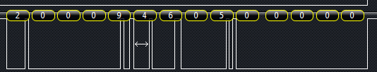

4 HCI_TYPE_EVENT

6,0 = 0x0006, HCI_CMND_WLAN_IOCTL_DEL_PROFILE (0x0006)

5 length

0,0,0,0 = 32 bit param (sample code ignores these bytes)

Seventh send:

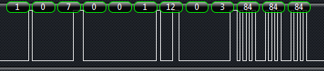

1 (HCI_TYPE_CMND)

12,0 = HCI_CMND_WLAN_IOCTL_SIMPLE_CONFIG_SET_PREFIX (0x000C)

3 = length of params

84,84,84 = [‘T’,’T’,’T’]0

Sevent receive:

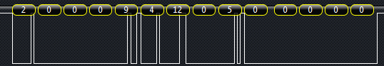

4 HCI_TYPE_EVENT

12,0 = HCI_CMND_WLAN_IOCTL_SIMPLE_CONFIG_SET_PREFIX (0x000C)

5 length

0,0,0,0,0 = sample code ignores these bytes

Eighth send:

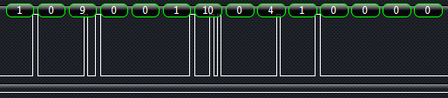

1 (HCI_TYPE_CMND)

10,0 = HCI_CMND_WLAN_IOCTL_SIMPLE_CONFIG_START (0X000a)

4 = length of params

1,0,0,0 = 4 byte value for algoEncryptedFlag (tells whether info. is encrypted), as LSB, so 0x0001

0 padding byte

Eight receive:

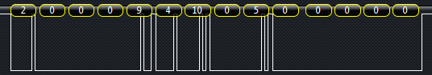

4 HCI_TYPE_EVENT

10,0 = HCI_CMND_WLAN_IOCTL_SIMPLE_CONFIG_START (0X000a)

5 length

0,0,0,0,0 = sample code ignores these bytes

Received:

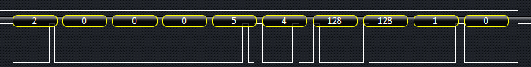

4 HCI_TYPE_EVENT

128,128 = HCI_EVNT_WLAN_ASYNC_SIMPLE_CONFIG_DONE (0x8080)

1 length

0 = sample code ignores these bytes

Sent:

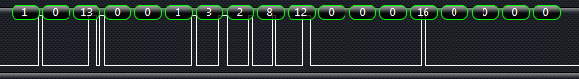

1 (HCI_TYPE_CMND)

3,2 = HCI_CMND_NVMEM_CREATE_ENTRY (0X0203)

8 = length of params

12,0,0,0 = FieldID (0x000c)

16,0,0,0 = new length (0x0010)

0 padding byte

Received:



4 HCI_TYPE_EVENT

3,2 = HCI_CMND_NVMEM_CREATE_ENTRY (0X0203)

1 length

0 = sample code ignores these bytes

Sent:

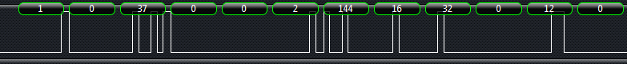

2 = HCI_TYPE_DATA

144 = HCI_CMND_NVMEM_WRITE (0x90)

16 = NVMEM_WRITE_PARAMS_LEN (key length here)

32,0 = length of all data after HCI header (so 0x0020 or 32)

12,0,0,0 = FILE ID (0x000c)

12,0,0,0 = (not sure, since it’s hardcoded and uncommented)

16,0,0,0 = length of data (length of encryption key)

0,0,0,0 = “Offset”, which is zero

115,109,97,114,116,99,111,110,102,105,103,65,69,83,49,54 = “smartconfigAES16”

Receive:

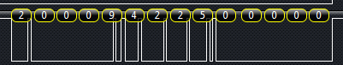

4 = HCI_TYPE_EVE NT

0202 = HCI_EVNT_NVMEM_WRITE (0x0202)

5 = length

0,0,0,0,0 ignored

Received:

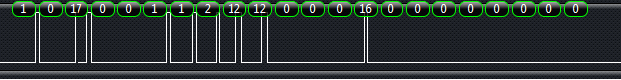

1 = HCI_TYPE_CMND

1,2 = HCI_CMND_NVMEM_READ (0x0201)

12 = length

12,0,0,0 = File ID (NVMEM_AES128_KEY_FILEID)

16,0,0,0 = Length

0,0,0,0 = Offset

0 = padding

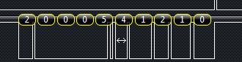

4 = HCI_TYPE_EVE NT

1,2 = HCI_CMND_NVMEM_READ (0x0201)

1 = length

0 = status

Received:

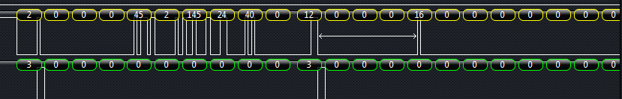

2 = HCI_TYPE_DATA

145 = HCI_DATA_NVMEM

24 = HCI Packet argsize

40,0 = HCI Packet Length as LSB, so 40

12,0,0,0 = FILE ID as LSB, so 12 (NVMEM_AES128_KEY_FILEID)

16,0,0,0 = length

0,0,0,0 = offset

16 more zeros = not sure

115,109,97,114,116,99,111,110,102,105,103,65,69,83,49,54 = “smartconfigAES16”

Next Write:



1 = 1 (HCI_TYPE_CMND)

1,2 = 0x0201 = HCI_CMND_NVMEM_READ

12 = length

13,0,0,0 = File ID (NVMEM_SHARED_MEM_FILEID)

67,0,0,0 = SMART_CONFIG_PROFILE_SIZE (67)

0,0,0,0 = offset

0 = padding byte

Next Received:

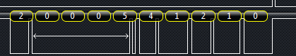

4 = HCI_TYPE_EVE NT

1,2 = 0x0201 = HCI_CMND_NVMEM_READ

1 = length

0 = status

Next Received:

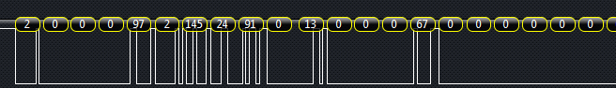

2 = HCI_TYPE_DATA

145 = HCI_DATA_NVMEM

24 = HCI Packet argsize

91,0 = HCI Packet Length as LSB, so 91

13,0,0,0 = File ID (NVMEM_SHARED_MEM_FILEID)

67,0,0,0 = length

0,0,0,0 = offset

16 more zeros = not sure

110,101,114,100,107,105,116, = “nerdkit”

32,3,180,4,251,250,33,211,214,76,222,209,45,201,249,142,104,75,199,190,12,65,58,138,253,235,25,171,42,209,76,10,241,146,209,76,10,241,146,255…(20 255’s)

Next Send:



1 = 1 (HCI_TYPE_CMND)

5,0 = 0x0005 = HCI_CMND_WLAN_IOCTL_ADD_PROFILE

61 = length

… (includes SSID and password)

Response:

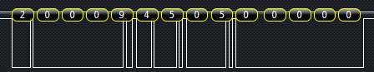

4 = HCI_TYPE_EVE NT

5,0 = 0x0005 = HCI_EVNT_WLAN_IOCTL_ADD_PROFILE

5 = length

0,0,0,0,0 ?

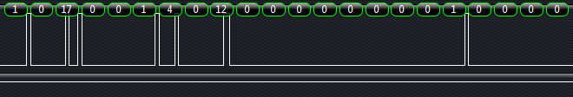

1 = 1 (HCI_TYPE_CMND)

4,0 = 0x0004 = HCI_CMND_WLAN_IOCTL_SET_CONNECTION_POLICY

12 = length