## Growing neighbors

## Group Cyan:

1. Phuc Cai
2. Apoorv Joshi
3. Sparsh Rawlani
4. Jonathan Laughlin

## Project description:

* Our group will redesign the website of growing neighbor to (try to) fix all the problem and improve the user interface of the website.
* The target is to make the website more appealing and easier for people who haven’t heard of Growing Neighbor before.
* The new website should be somewhat similar to the old website in term of navigating so that people are

## Project marketing plan

* The target market of the website will be the people who are living in Spokane, since most of the farm are in Spokane. The website should be appealing to young people who spend a lot of time on the internet. At the same time, the websites still have to be readable, easy to navigate so that people who doesn’t know about technologies can still use it.
* The website we make should be appealing to young people and still easy for others to navigate and find information. We also help the client to improve the way they promote themselves on social media to attract more young people who use social media daily (Ex: include photo in each post on Facebook, create events on Facebook to let followers know)
* The website should be introduced on all of the current social media accounts of Growing Neighbor, which will let people who are following Growing Neighbor to know about the new site. The admin of these social media accounts can also ask follower to share the new website to let their friends know about the organization and the website.
* SEO: Our group will use tool/plugin to help improve the load time, improve the keyword. This will improve the ranking of the website on Google, let people find the page easier.
* If the client feels comfortable, we can help them using advertisement service online (Ex: google ad) to help them reach out to more people.

## Project requirement list:

Must Haves:

* Links need to open in a new window
* Menu top of the screen
* Reorder the items on the menu bar
* Seamless design
* Easy to use
* Signup button takes you to sign up to volunteer.

Wish list:

* FAQ’S page
* News page
* Icons for each of the items on the about page
* Make text easier to read
* Slide show on home screen
* Follow up on the map
* Image that scrolls behind the words
* Promote farmer markets
* Login button in the menu bar
* Optimization

## Project test plan:

* Every page that we make should be test on both computers and smartphones to verify that everyone can access it easily.
* Make sure that all the contents are readable (color and font size).
* Let other users who are not in our group to try the site, ask them to perform specific task (Ex: find information about the organization, find contact information, register,...) to make sure that the site is easy to navigate.
* Test the site in different type of connection (slow, fast,…) using Chrome Dev Tool.
* We will use it.

## Software Design Documentation:

* Our group focus in making the interface of the website. We use Wordpress server, hosted online on the site <https://www.cloudaccess.net/>. We choose not to host our own wordpress server locally because we won’t be able to access the local server off campus or when we turn of the computer with the local server.
* Besides using Wordpress template to help us design, we also use many plugin on wordpress (Elementor,WPForm lite,…). We also make our own custom CSS file and and edit the PHP file to make the site look like what we want.
  + We used Elementor as the main editor for our page, since the plugin support create many part of the page, and we can hide some element on mobile version for a friendlier version.
  + Custom CSS is another plugin that help us to have full control over the layout of the webpage through CSS.
  + Code snippet lets us add our own code to modify parts of the webpage such as the font.
  + We also used editor to edit the PHP of the theme, which helps us remove part that we don’t want on our website.

## Project design:

1. Prototype website:
2. Story board:
   * When user first get to the web site, they will be greeted with the name and information about the organization:

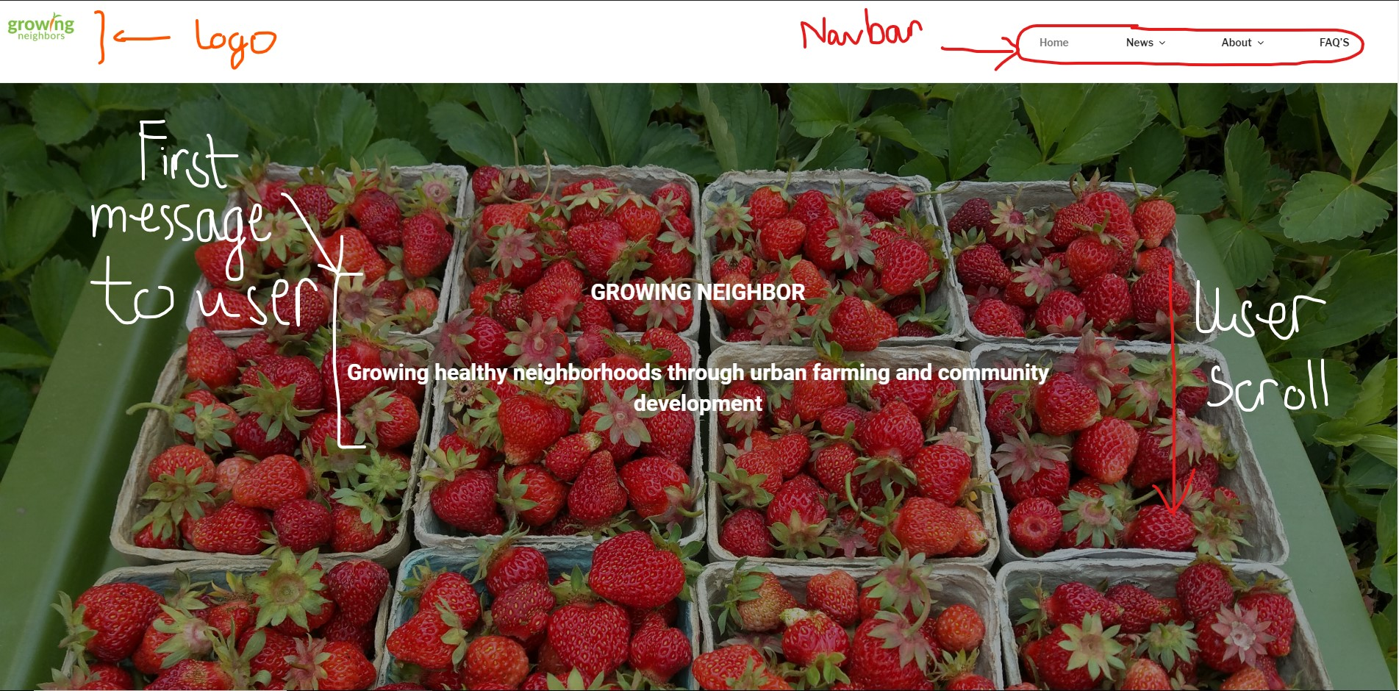

* As the user scroll down, they will see separate section with the title and the information with link to relevant site:

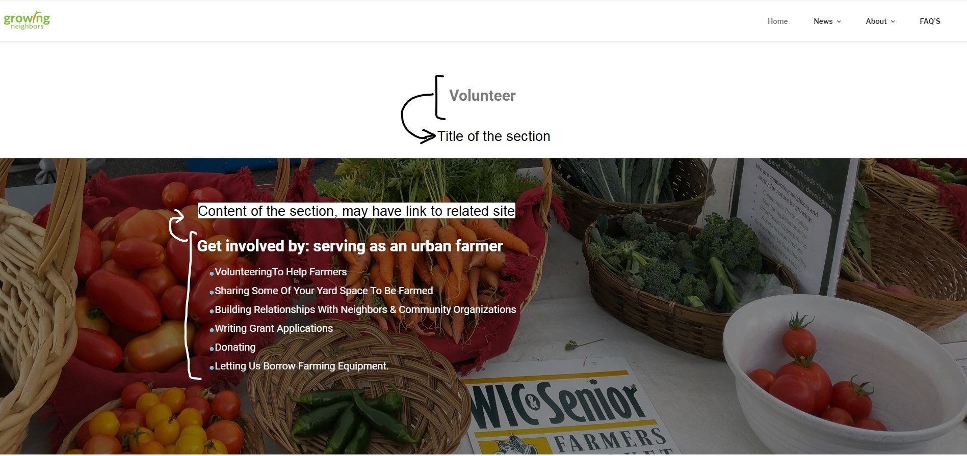

* As user scroll down to the end, they will find contact information, the menu , donate button and way to send message and subscribe:

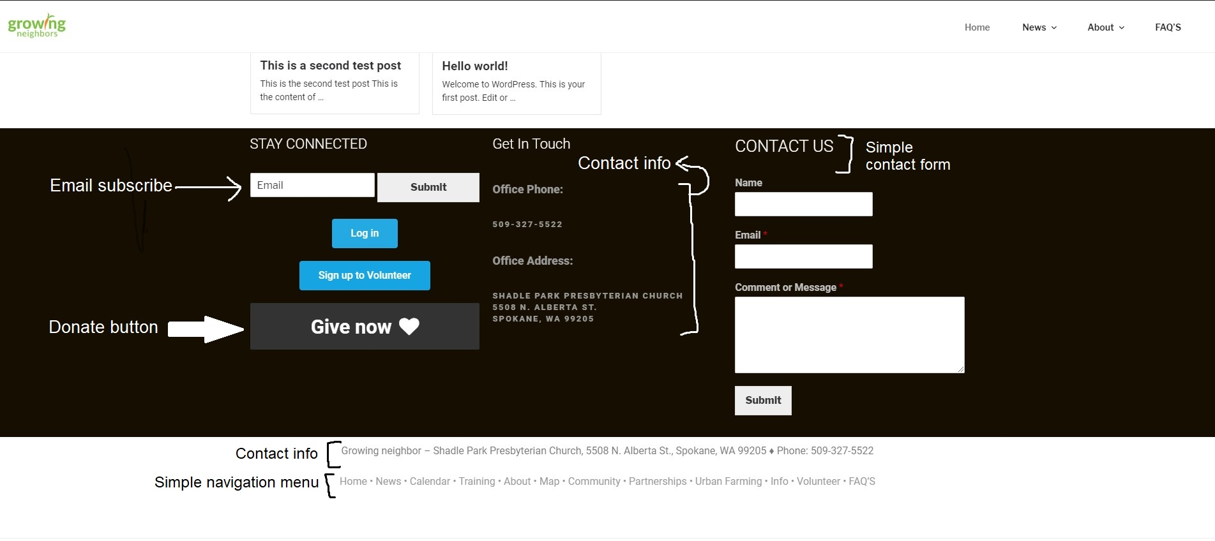

* We also added news and frequently asked questions page:

