Project Plan IS 608
Project: Effect of mid-term elections on the stock market.
Summary:
I would like my project to be based on the effect of mid-term elections on the stock market. In the year following the mid-term elections, the stock market has historically surged (recorded a positive gain) higher (on an average, more than 15 % according to some estimates). This is true for elections up to 2010. This surge has been generally attributed to clearing of the uncertainty related to how the elections might turn out (who will win, what policies will be adopted etc.). The gains have been registered starting from October of the election year to the October of the following year. Our analytics will reflect this fact. There has been a lot of speculation for as to why these gains are registered, but this is just a correlation and is not causal. That means it does not guarantee gains for future mid-terms elections.
For the analytics, the stock market data will be cleaned of any outliers, if they are present. I will be creating visualizations showing the correlation of the mid-term election and the stock market. I will also be showing the trend of the bump in the stock market over a few decades in the past.
Some Articles supporting this claim:
http://www.kiplinger.com/article/investing/T041-C007-S001-how-elections-affect-the-stock-market.html
http://online.barrons.com/articles/the-midterm-elections-impact-on-markets-1412094638
http://www.cnbc.com/id/102152641 (Look at the video and graphs in it)
Data Sources:
Data sources for stock data:
Source: Yahoo finance.
URL: http://finance.yahoo.com/q/hp?s=IBM&a=00&b=2&c=1962&d=03&e=9&f=2015&g=d
(Above is an example of historical price data for IBM from Jan 1962 to Apr 2015)
Source: Quandl
URL: https://www.quandl.com/c/stocks
I will prefer to use Yahoo.

Data source for the mid-term election dates:
http://en.wikipedia.org/wiki/List_of_elections_in_the_United_States
The stock market data will be dynamically sourced from Yahoo.com at run time, so we will not need a local copy. The dates for the mid-term elections will be encoded manually into a csv file or hardcoded into the code.

Analytics:
Please refer to the appropriate sections of the code in the server.R file for description of the analytics.
We will be using the ‘Close’ price for our calculations, though other prices should also work.
We will be taking the data for Years ranging from 1953 to 2011. This is because we have data for election years from 1954 to 2010. So we can see one year before and one after. We want to bin data from October of each year to the October of the following year. For e.g., we will bin data from October 1953 to October 1954 and name the bin 1953. So on the graph the bin marked 1953 actually contains data from October 1953 to October 1954. This is because the bump in the market has been historically seen between the October of the election year and the October of the following year and our analytics should reflect.

Visualizations:
The visualizations will be focused on showing the correlation between the post-election period (25 weeks or so) and the stock market. I will be showing these for at least 5 elections in the past. I will also show the general trend of the post-election rise in the stock markets for a few decades separately.

Following is a google charts visualization for the returns of S&P 500.

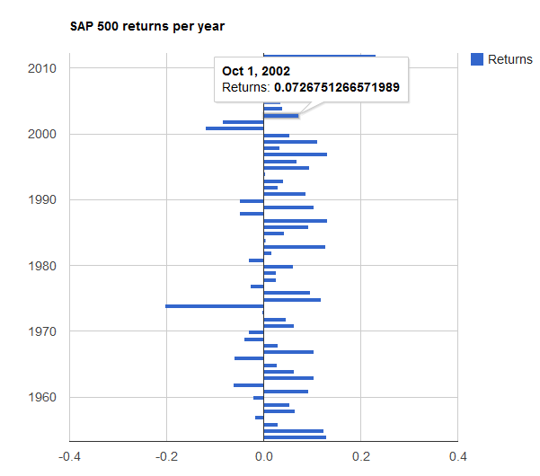

Following is a Shiny/ggplot presentation of the returns of the S&P 500.
The election years are shown in RED and the non-election years are shown in Blue.
All the election years have positive returns.
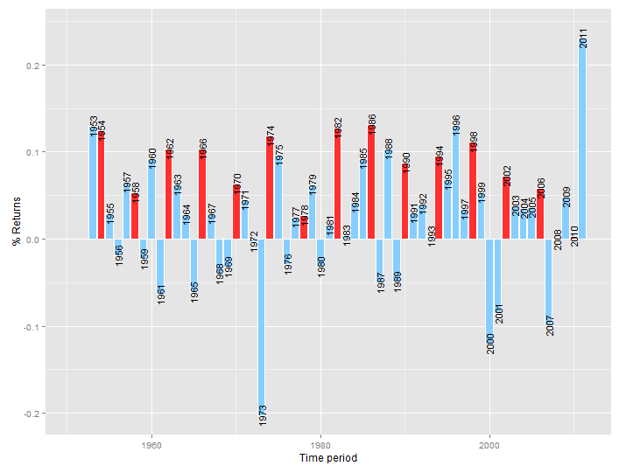elc

Technologies to be used for the Project:
I would like to use R for the functional coding along with ggplot2 and the lattice package. I will probably be using other graphical packages as needed.
I would like to use shiny to expose my project as a web application.

Relevancy:
Anything that affects the stock market is of importance to a lot of different parties. For e.g., corporations and individuals can time their investments so that gains can be locked in, or risk can be minimized.
Implementation and Installation details:
The project will be uploaded as a zip file named BIM_Project_608.zip (BIM are my initials). You can unzip the file in ‘C:/Temp’ folder. This will create a folder names ‘BIM_Project_608’ in the ‘C:/Temp’ folder. Navigate to the ‘C:/Temp/ BIM_Project_608’ folder and run the runApp.R file. This should start the shiny app and display the results.
The ‘C:/Temp/ BIM_Project_608’ folder contains a ‘data’ folder and a ‘www’ folder. The ‘data’ folder contains the data files for SAP returns and the election years. These data files are optional because the data will be read dynamically from yahoo finance. This is explained in the comments inside the code. You can either use a local copy of the data or load it dynamically by commenting out the appropriate lines in the code.
When the shiny server is run, it will also drop a ‘returns.csv’ file in the ‘www’ folder. This file will then be picked up by the google charts html page and displayed as google chart. The html is served by the shiny server through the www folder. So you will need to keep the Shiny server running to see the google chart.
To display the google charts page please use the following URL.
http://127.0.0.1:7777/google_charts.html

Please change the port in the URL if you run the shiny server on a different port. If shiny is started through the runApp.R file (as described above), it will start it on port 7777.

I have also created an R markdown file to display the raw data and to show that the returns of SAP 500 follow a normal distribution. I have created a graph using the Lattice package to do so. You may need to install additional packages for this to work. The name of the R markdown file is ‘BIM_Density_Plot.rmd’. This file has to be run through the R studio separately.

