j-lawyer.org
Table of Contents
Authors / Contributors 1
Change log 1
Launching the application 3
Launching the j-lawyer.org Server 3
Launching the j-lawyer.org Client 3
User Interface 4
Navigation and Main Elements 4
“My Desktop” 4
Case Management 6
Case Numbering 6
Document Preview 6
Case History 7
History across Cases 7
Contacts / Adresses 8
Document Management 9
PDF Conversion 9
Reminders and Respites 10
Email Integration 11
Add-Ons: Drebis 12
Add-Ons: Sipgate 13
Supported Country Codes 13
Systems Administration 14
Resolving port conflicts 14
Monitoring 14

Authors / Contributors
Jens Kutschke – j-lawyer.org, info@j-lawyer.org

Change log
Version | Date | Editor | Notes
0.1 | Jun 24 2016 | Jens Kutschke | Initial version, contents taken from current online documentation.
0.2 | Jun 29 2016 | Jens Kutschke | J-lawyer.org 1.8
0.3 | Aug 1 2016 | Jens Kutschke | Launching the application
0.4 | Sep 21 2016 | Jens Kutschke | Custom case numbering
0.5 | Oct 21 2016 | Jens Kutschke | Port configurations

Launching the application

Launching the j-lawyer.org Server
Versions | Platforms
1.0+ | All

Launching the j-lawyer.org Client
Versions | Platforms
1.0 .. 1.7.1 | All
1.8+ | All, new JNDI port

After launching the j-lawyer.org Client, users are required to authenticate with valid credentials. When logging in for the first time, there are two default users available:
- User name “user”, password “u” - user with basic privileges
- User name “admin”, password “a” - user with full administrative privileges
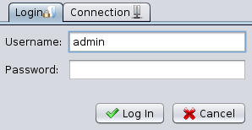Figure 1: Login dialog, User credentials
Before logging in and during your first connection attempt, please provide connection parameters in the “Connection” tab. Specify the name or the IP of the j-lawyer.org Server (or “localhost” when using j-lawyer.org Server and Client on the same device).
Up to version 1.7.1. use the following ports:
- JNDI-Port: 1099
- HTTP-Port: 8080
Starting with version 1.8:
- JNDI-Port: 8080
- HTTP-Port: 8080
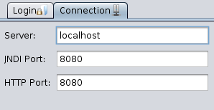Figure 2: Login dialog, Connection parameters

User Interface

Navigation and Main Elements
Versions | Platforms
1.0+ | all

Tbd

“My Desktop”
Versions | Platforms
1.0+ | all
1.8+ | All, completely redesigned

The “My Desktop” view provides the most important information at a glace and allows navigating to the relevant objects:
- current date
- unread mail
- tip of the day
- currently logged in user
- Which cases were last changed? By whom?
- Which follow-ups / respites are due or overdue? Who is responsible?
- etc.

“Last Changed” displays information on the case and the lawyer in charge for this case.
“Due” displays follow-up reminders and respites that are due or overdue, sorted by their due date in descending order. The user in charge of the follow-up is displayed. Here are the meanings of font decorations and icons in detail:
- black font due today
- red font overdue
- follow-up, currently logged on user is in charge
- respite!
- follow-up, other user is in charge
Hovering over a case, follow-up or respite displays more information in the tooltip. Double clicking navigates to the case. Follow-ups and respites can be marked “done” by clicking the checkbox and will be removed from the ToDos on “My Desktop” upon next refresh.

Case Management

Case Numbering
Versionen | Plattformen
1.8+ | all

As of version 1.8, users can define a custom case numbering schema using menu “Settings” - “Cases” - “Case Numbering”.

The following definition values can be used:

C – random character
R – random digit
N – global index number
n – local index number within other criteria

For individual numbering requirements you can freely define a custom schema like this:

- nnnnn/YY – 5-digit local index (within one year), fixed character /, 2-digit year
- YY-CCCCC – 2-digit year, fixed character -, 5 random characters
- NNNNN/YYYYMMDD – 5-digit global index, fixed character /, 4-digit year, 2-digit month, 2-digit day

Month and day can be specified as either M or MM / D or DD. The two characters option will make sure that leading zeroes are added when required.

In any case, j-lawyer.org will force uniqueness of all case numbers.

Document Preview
Versions | Platforms
1.8+ | all

While working in a case, a single click on a document will open a preview. The following file formats are supported:
- Direct preview (content and layout): GIF, JPG, PDF, PNG, TIF
- Textual representation (content / text extract of the document): all documents with textual information
- No preview: all other binary formats
Double clicking the document will open it in an editor.

Case History
Versions | Plattforms
1.0+ | all

<todo>

History across Cases
Versions | Plattforms
1.8+ | all

In addition to the history visualized for a specific case, there is
- a history across cases, for all changes performed by the current user (“History” - “My Timeline” in navigation tree)
- a history across cases, for all changes performed by any user (“History” - “Full History” in navigation tree)
This way, it is easy to find own changes as well as cases that have been edited by co-workers.
In the upper part of the dialog there is a timeline that spans the entire history available in the system. By moving the blue (from...) and red (to...) sliders, history search is restricted to a desired timeframe. Also, there is a dropdown that allows to restrict the number of retrieved history entries. By default, a maximum number of 500 entries is displayed.
The results are visualized grouped by day and show changed cases and which user made which specific change. Clicking the case number or name navigates to the case directly.

Contacts / Adresses

Versions | Platforms
1.7.1+ | all

Document Management

PDF Conversion
Versionen | Plattformen
1.8+ | alle

j-lawyer.org is able to convert most document formats to PDF, automatically and in the background. This is required specifically for
- Sending documents via email
- Sending documents throught Drebis interface
- Sending documents as fax via Sipgate
Conversion is performed in the background, using a library called “unoconv”.
At the time of publishing j-lawyer.org 1.8, there is a restriction for users on Mac OS X: unoconv is currently not working on Mac OS X in combination with LibreOffice 5.

Reminders and Respites

Versions | Platforms
1.7.1+ | all

Email Integration

Versions | Platforms
1.7.1+ | all

Add-Ons: Drebis

Versions | Platforms
1.7.1+ | all

Add-Ons: Sipgate

Supported Country Codes
Versions | Plattforms
1.8+ | all

As of version 1.8, j-lawyer.org supports the following country codes:
- +1 USA
- +31 Netherlands
- +34 Spain
- +39 Italy
- +41 Switzerland
- +43 Austria
- +44 UK
- +49 Germany
- +53 Cuba
- +54 Argentina
- +598 Uruguay
- +7 Russia
Connections in these countries can receive faxes, messages and calls from within j-lawyer.org.
When creating / editing a contact in j-lawyer.org, it is recommended to save the full number including country code. When missing, j-lawyer.org will assume it is a German number.

Systems Administration

Resolving port conflicts
Versionen | Plattformen
1.8+ | all

The j-lawyer.org Server is listening for inbound connections on different ports, e.g. on port 8080 and others. A complete list of these ports can be found in file \wildfly-9.0.2.Final\standalone\configuration\standalone-full.xml in the installation directory of the j-lawyer.org server:
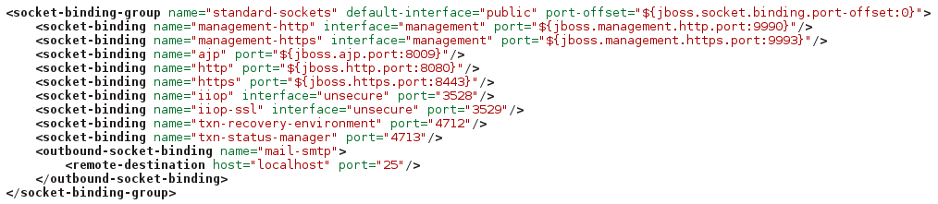Figure 3: Port configuration
In case of ports conflicting with other applications, the relevant port can be changed directly, or one can specify a numeric offset that is applied to all ports used by j-lawyer.org. Specifying an offset of “100” adds 100 to all configured ports.
The offset is configured in the line as shown:
<socket-binding-group name="standard-sockets" default-interface="public" port-offset="${jboss.socket.binding.port-offset:0}">
change to
<socket-binding-group name="standard-sockets" default-interface="public" port-offset="${jboss.socket.binding.port-offset:100}">
This change requires a restart of the j-lawyer.org server.

Monitoring
Versions | Plattforms
1.7.1+ | alle

You can configure an automated monitoring of the j-lawyer.org Server, including hard disk space, CPU load, system memory and memory of the Java Virtual Machine. To configure this feature, you can set thresholds and an optional email notification under “Settings” - “Server Monitoring”.
As of version 1.8, the memory monitoring will look at both physical memory as well as swap space. Thresholds need to be set accordingly, e.g.
Server has 4GB RAM and 2GB swap space. If you want the monitoring to notify as soon as swap is in use, set the limit to 66% (total of 2GB+4GB memory and swap, warnings desired at 4GB, that means 4/6 = 66%).

List of Illustrations
Figure 1: Login dialog, User credentials 2
Figure 2: Login dialog, Connection parameters 3
Figure 3: Port configuration 13

