JJ DESSERTS
Different Not Less ♡
Admin Panel Guide
How to upload and manage your website content
Version 1.0

1. Welcome
Hello José! This guide walks you through how to manage the content of jjdesserts.com without needing any technical knowledge. You will be able to:
- Add new desserts with their photos, prices, and descriptions
- Edit prices or info whenever you want
- Change the main video or images of the site
- See incoming orders (once payments are activated)
- Everything in Spanish AND English on the same screen

Important: the changes you make are automatically published to the website in less than a minute. Whatever you write here will be seen by your customers.

2. How to log into the panel
- Open your browser (Chrome, Safari, whichever you usually use).
- Type this address and press Enter:
https://jjdesserts.com/studio
- Log in with the same Sanity account you created when we set up the site.
- The first time it will ask for permission — accept.

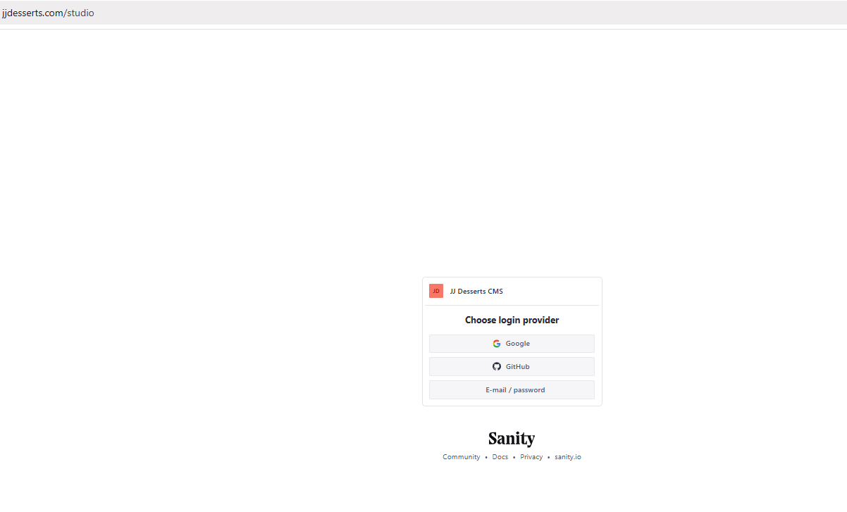
Sanity Studio login screen
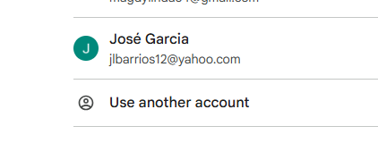

Tip: save this address in your bookmarks. You will use it every day.

3. Panel tour
When you enter the panel you will see 4 sections in the left menu:
- Postre / Dessert — Here you add, edit, or remove the desserts on the menu.
- Categoría / Category — The groups where you classify your desserts (Cheesecakes, Cupcakes, etc.).
- Configuración del Sitio / Site Settings — General info: banner video, contact, social media, etc.
- Pedido / Order — Incoming orders show up here when a customer buys.

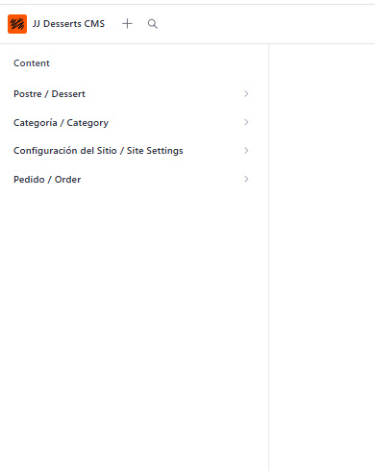
Panel overview with the 4 menu sections

Recommended first-time order: create categories first, then set up the site, then add desserts.

4. Create a Category
Categories are the groups to organize your desserts. For example: Cheesecakes, Cupcakes, Cakes, Cookies.

Steps:
- In the left menu, click on Categoría / Category.
- Click the + (plus) button at the top right to create a new one.
- Fill in the fields:
  - Nombre (Español): the category name in Spanish. E.g., "Cheesecakes"
  - Name (English): the same name in English. E.g., "Cheesecakes"
  - URL Slug: auto-generated, leave as-is
  - Orden / Sort order: number 1-100 to control display order (lower = first)
- Click Publish (bottom right button) to save.

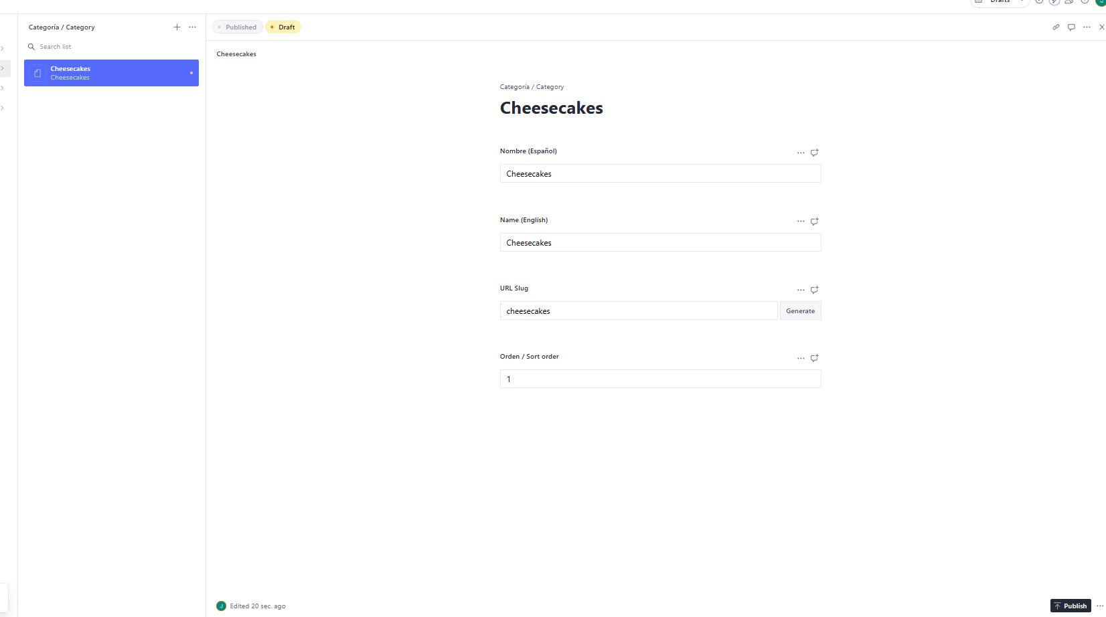
Category creation form with bilingual fields

Tip: if unsure which categories to make, start with 2 or 3 broad ones (e.g., "Sweet desserts" and "Savory desserts"). You can add more later.

5. Add a Dessert
This is the section you will use the most. Each dessert has its name, photo, price, and description.

Steps:
- Click on Postre / Dessert in the left menu.
- Click + at the top right to create a new one.
- Fill in the fields one by one (all explained below):

Dessert fields
Nombre (Español): the name as your customers know it in Spanish. E.g., "Cheesecake de Fresa"
Name (English): same name in English. E.g., "Strawberry Cheesecake"
URL Slug: auto-generated when you type the name. Do not change unless you know what you are doing.
Categoría / Category: select from the dropdown which category it belongs to. If it does not appear, create it first (see section 4).
Descripción (Español): text shown on the product page. 1-3 sentences describing the dessert, main ingredients, what makes it special.
Description (English): the same description translated to English.
Precio (USD): the price in dollars. Example: 12.50 (no $ sign, just the number with decimal point).
Foto principal / Main photo: the photo that shows in the catalog. Drag from your computer or click "Upload".
Galería / Gallery: additional photos that show on the product page. You can upload several.
Disponible / Available: leave it on (blue/green) if available for sale. Turn off if temporarily sold out.
Destacado en home / Featured: turn on if you want it to appear on the home page in the "Featured" section. Recommendation: max 3-6 featured at a time.
Orden / Sort order: number 1-100. Lower numbers appear first on the menu.

- When done, click Publish (bottom right) so it appears on the site.

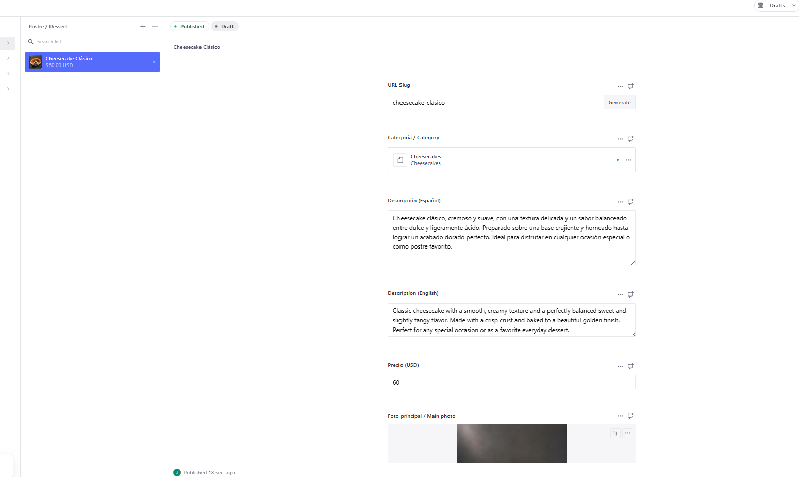 Full dessert creation form with all fields

Important about photos: use good quality images, minimum 1000 pixels wide. The main photo should be well lit. See the "Photo tips" section later for details.

6. Site Settings
Here are the general settings shown across the site: the main banner video, hero texts, contact info, social media, etc.

Important:
This section exists only once. The first time you create the document, then you only edit it.

Steps:
- Click on Configuración del Sitio / Site Settings in the left menu.
- If first time, click + to create the document.
- Fill in the fields:

Key fields:
Banner video: the MP4 video shown in the hero. Ideally under 5MB. If too large, compress first (Raúl can help).
Poster image: backup photo shown while the video loads, and as fallback on slow phones.
Hero title (Spanish/English): the big title on the home page. E.g., "Sabor que enamora" / "A taste that enchants"
Hero subtitle: smaller line below the big title.
Main button text: what the orange hero button says. E.g., "Ver Menú" / "View Menu"
Contact email: where messages from the contact form arrive.
Phone / WhatsApp: your number, shown in the footer.
Instagram URL: full link to your Instagram.
Business address: where you are located, shown in the footer.
Sales tax rate: already set to 0.07 (7% Florida + Miami-Dade). Do not change unless state rules change.
Top bar announcement: the orange text in the bar at the top of the site. E.g., "SABOR QUE ENAMORA" / "A TASTE THAT ENCHANTS"

- Click Publish to save.

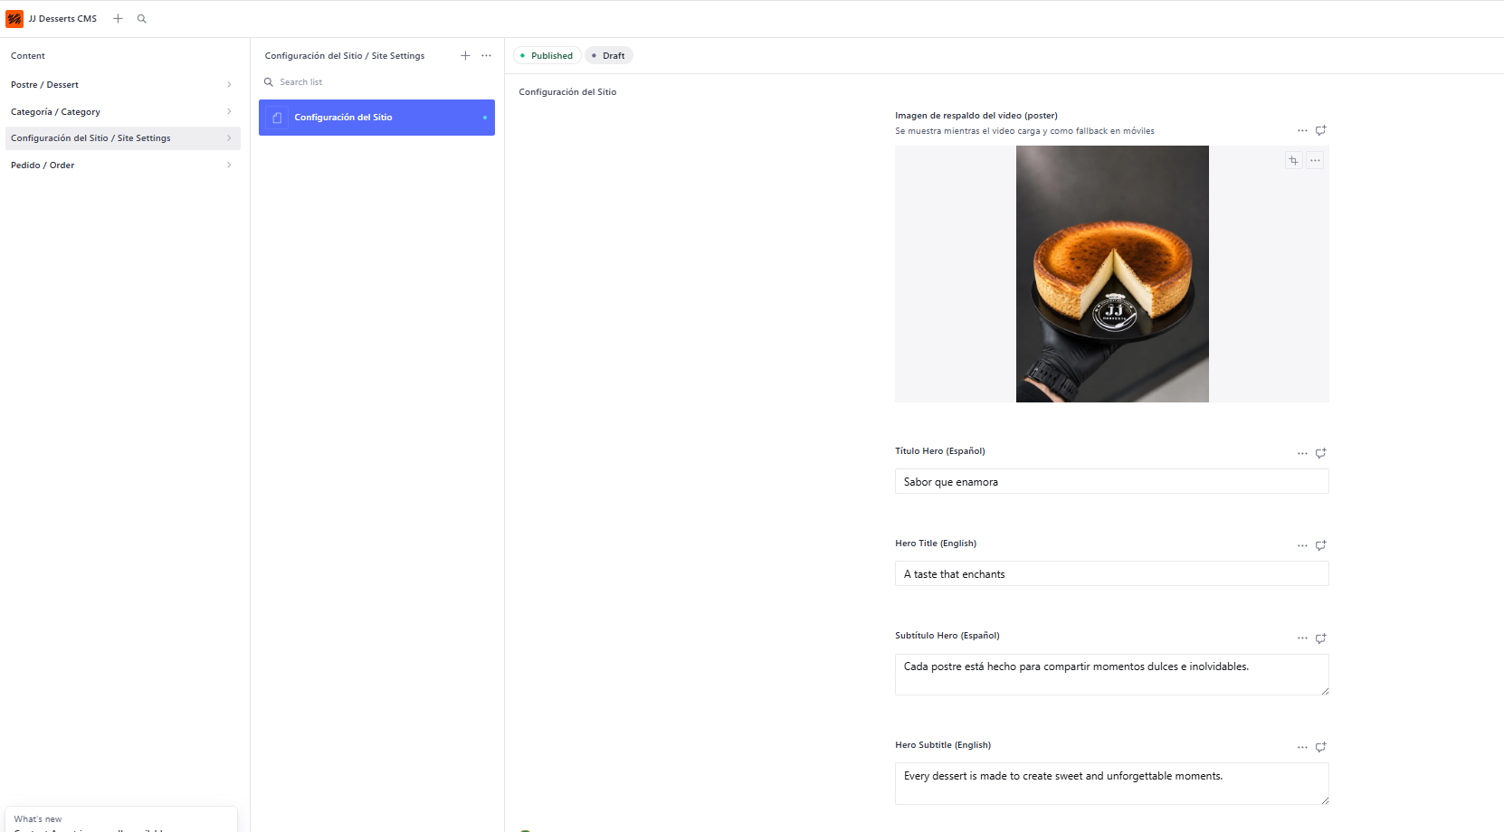 Site Settings screen with all fields

7. Publish vs Draft
When you fill out a dessert or any content, there are two options:
- Draft: content is saved but NOT visible on the public site. It is a work in progress. Sanity auto-saves every few seconds so you do not lose your work.
- Published: content is live and customers see it on jjdesserts.com.

To go from draft to published:
- Finish filling in the fields
- Click the Publish button at the bottom right (turns from gray to green)
- It appears on the site in 30-60 seconds

To make changes after publishing:
- Open the document already published
- Modify what you want to change
- Click Publish again so the changes go live

Relax: if you mess up something published, you can edit it as many times as you want. No limit. Sanity keeps the full history.

8. Orders
When we integrate online payments (Stripe), all customer orders will automatically appear in this section.
Each order shows:
- Customer name, email, and phone
- Desserts ordered, with quantity and price
- Subtotal, tax, total
- Delivery type (pickup or delivery)
- Delivery address if applicable
- Customer special notes
- Order status (pending, paid, preparing, ready, delivered, cancelled)

Your job:
- Check new orders daily
- Change status to "Preparing" when you start working on it
- Change to "Ready" when finished
- Change to "Delivered" when the customer picks up or receives it

[ SCREENSHOT ]
Orders list with statuses

This section only fills up once we activate online payments. If you need it soon, let Raúl know.

9. Photo tips
Photos sell the product. Practical tips so your desserts look irresistible:

Minimum quality:
- Resolution: minimum 1000 pixels wide. Modern phones easily exceed this.
- Format: JPG or PNG. Sanity accepts both.
- Recommended max weight: 2MB per photo.

How to take good photos:
- Use natural light near a window, best in morning or afternoon (soft light)
- Avoid direct phone flash — creates ugly shadows
- Clean background: wood table, white plate, neutral cloth
- Main photo: full dessert, centered, 45-degree view
- Gallery: add photos from different angles, close-ups of details, top view

What does NOT work:
- Blurry or out-of-focus photos
- Backgrounds with trash or clutter
- Yellowish kitchen lightbulb lighting
- Very tall vertical photos (better square or slightly rectangular)

10. Troubleshooting

"I can't log into the panel"
- Verify you typed the address correctly: https://jjdesserts.com/studio
- Make sure you use the same Sanity account you started with
- If you forgot your password, click "Forgot password" on the login screen

"I uploaded a dessert but it doesn't show on the site"
- Did you click Publish (not just Save Draft)? The button should turn green.
- Wait 1-2 minutes — the site takes time to update
- Refresh the page with Ctrl+F5 (Windows) or Cmd+Shift+R (Mac)
- Does the dessert have "Disponible / Available" enabled?
- Did you assign a category? Without category it won't appear

"I made a mistake, how do I undo?"
- If you have not clicked Publish yet: just edit and save again
- If already published: open the document, fix the mistake, click Publish
- To restore an earlier version: in the open document, look for the "History" icon at the top right — full history is there

"My photo looks cropped or wrong"
- In Sanity you can drag the "hotspot" dot (circle on the image) to decide which part stays visible when cropped
- Upload a more square photo — very rectangular images get cropped in the catalog

"I want to delete a dessert"
- Open the dessert you want to delete
- At the top right, click the 3 dots (•••)
- Click "Delete"
- Confirm. Watch out! Once deleted, it must be re-created to recover.
- Safer alternative: instead of deleting, turn off "Disponible / Available" — disappears from site but stays saved.

If nothing works:
Take a screenshot of the issue and send it to Raúl. He will help you resolve it.

11. Closing
Congratulations! With this guide you can manage jjdesserts.com content on your own with no technical help.
Remember:
- Changes publish in less than 1 minute after clicking Publish
- Everything bilingual ES + EN for each dessert
- Quality photos = more sales
- If stuck, screenshot to Raúl and he will help

Enjoy sweetening lives. ♡

