Swinburne Open Science Task Force Survey (2019)

Jennifer L Beaudry, Tom Johnstone, Jordy Kaufman & Lisa Given

24 June 2020

# Overview

We conducted a survey in September 2019 to examine people’s current use of open science practices, to examine their perceptions of these practices, and to examine their perceived barriers to adopting these practices. Across the university, 239 started the survey, although not all respondents completed all questions; thus, we report the sample size for each question. This document presents an overview of their responses.

## Demographics: Academic Levels

In terms of respondents’ demographic information, we did not collect information about gender or age to provide more anonymity to our respondents. We did, however, ask about their Academic Level/Type and their Discpline (based on 2-digit and 4-digit Field of Research [FOR] codes). Of the 142 respondents who provided details about their Academic Level, 32% were PhD students, 16% were Professors, and 12% were Senior Lecturers. The breakdown of the rest of the academic levels for the rest of the respondents are in the table below.

Academic Levels of Respondents (n = 142)

|  |  |  |
| --- | --- | --- |
| Academic Levels | Frequency | Percentage |
| Professor | 23 | 16 |
| Associate Professor | 10 | 7 |
| Senior Lecturer | 17 | 12 |
| Senior Research Fellow | 1 | 1 |
| Lecturer | 14 | 10 |
| Research Fellow | 9 | 6 |
| Postdoc | 11 | 8 |
| PhD Student | 45 | 32 |
| Masters Student | 7 | 5 |
| Research Assistant | 2 | 1 |
| Other | 3 | 2 |

## Demographics: Disciplines

In terms of Field of Research Codes, 138 respondents classified themselves as belonging to one of the two-digit FOR codes from 01 to 20, one person indicated “Other”, and 100 respondents did not specify their FOR code. We did not have any responses from researchers in Earth Sciences (04), Agricultural and Veterinary Sciences (07), History and Archeology (21), and Philosophy and Religious Studies (22).

%%% I RECKON I’LL MOVE THIS TO AN APPENDIX %%%

Reported Two-Digit Field of Research Codes for Respondents (n = 239)

|  |  |  |  |
| --- | --- | --- | --- |
| FOR Code | Field of Research Division | Frequency | Percentage |
| 1 | Mathematical Sciences | 2 | 1 |
| 2 | Physical Sciences | 14 | 6 |
| 3 | Chemical Sciences | 4 | 2 |
| 5 | Environmental Sciences | 2 | 1 |
| 6 | Biological Sciences | 5 | 2 |
| 8 | Information and Computing Sciences | 4 | 2 |
| 9 | Engineering | 17 | 7 |
| 10 | Technology | 3 | 1 |
| 11 | Medical and Health Sciences | 13 | 5 |
| 12 | Built Environment and Design | 6 | 3 |
| 13 | Education | 2 | 1 |
| 14 | Economics | 2 | 1 |
| 15 | Commerce, Management, Tourism and Services | 7 | 3 |
| 16 | Studies in Human Society | 4 | 2 |
| 17 | Psychology and Cognitive Sciences | 45 | 19 |
| 18 | Law and Legal Studies | 2 | 1 |
| 19 | Studies in Creative Arts and Writing | 2 | 1 |
| 20 | Language, Communication and Culture | 4 | 2 |
| 99 | Other | 1 | 0 |
| NA | Not Specified | 100 | 42 |

For ease of interpretation and to reduce the identifiability of the respondents, for the FOR divisions with a small number of respondents (less than 10), we combined similar divisions into disciplinary groups. Specifically, the new discipline grouping of Arts, Social Sciences, and Humanities (ASSH) included Education (FOR = 13, n = 2); Studies in Human Society (FOR = 16, n = 4); Studies in Creative Arts and Writing (FOR = 19, n = 2); and Language, Communication and Culture (FOR = 20, n = 4). The new discipline grouping of Business & Law included Economics (FOR = 14, n = 2); Commerce, Management, Tourism and Services (FOR = 15, n = 7), and Law and Legal Studies (FOR = 18, n = 2). The new discipline grouping of Technology & Computer Sciences included Information and Computing Sciences (FOR = 8, n = 4), and Technology (FOR = 10, n = 3). We allocated Built Environment and Design (FOR = 12, n = 6) to the “Other” category.

We retained the FOR divisions of Engineering (FOR = 9, n = 17); Medical and Health Sciences (FOR = 11, n = 13); Physical Sciences (FOR = 2, n = 14); and Psychology and Cognitive Sciences (FOR = 17, n = 45) as their own discipline groupings. The breakdown for the number of respondents according to discpline groupings is displayed in the next table.

I AM SURE YOU WILL ALL AGREE THAT WE DON’T NEED THESE TWO PARAGRAPHS IN THE MAIN TEXT, BUT LEAVING IT FOR NOW TO MAKE SURE WE UNDERSTAND HOW EVERYTHING WAS GROUPED TOGETHER. :)

Discipline Groupings of Respondents (n = 239)

|  |  |  |
| --- | --- | --- |
| Disciplines | Frequency | Percentage |
| Math, Chem, Enviro, & Bio Sciences | 13 | 5 |
| Physical Sciences | 14 | 6 |
| Tech & Comp Sciences | 7 | 3 |
| Engineering | 17 | 7 |
| Medical & Health Sciences | 13 | 5 |
| ASSH | 12 | 5 |
| Business & Law | 11 | 5 |
| Psyc & Cog Sciences | 45 | 19 |
| Other | 7 | 3 |
| Not Specified | 100 | 42 |

## Estimates of Reproducibility by Perceived Crisis

Participants were asked if they believed their field is experiencing a “reproducibility crisis”. Of the 138 respondents who answered this question, 17% indicated that they didn’t know if there was a crisis, 16% indicated there was no crisis, 33% indicated that there was a slight crisis, and 35% that there was a significant reproducibility crisis in their field.

Participants were also asked to estimate the percentage of research publications their field that are reproducible. In the figure below, we plotted participants’ reproducibility estimates according to their responses to the perceived crisis in their field. The black bar is the mean estimate of reproducibility perceived crisis.

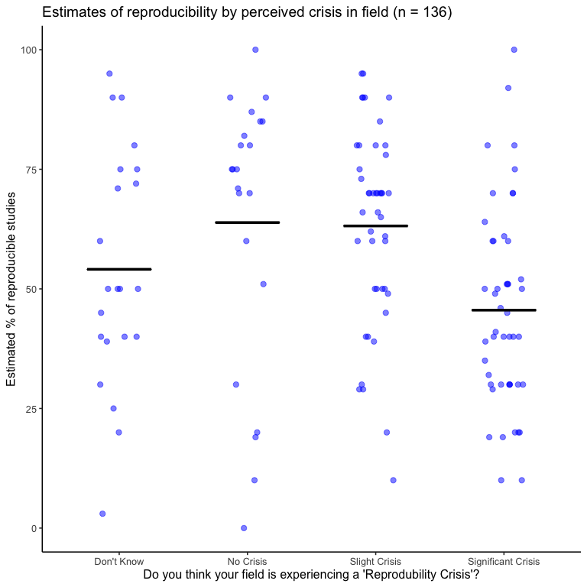

## Experience with Open Science Practices

### Overall Experience with Open Science Practices

Before we asked participants about their experience with open science practices, we explained that the practices enveloped by the umbrella term of “open science” were study preregistration, open materials and/or code, open data, pre-publication archiving, and open access publishing.

The figure below shows participants’ experience with open science practices in general. Of the 207 participants who answered this question, 51 (25%) reported that they were unaware of open science practices; 75 (36%) reported that they were aware of open science practices, but had not used them; 69 (33%) reported that they had some experience with open science practices; and only 12 (6%) reported that they had extensive experience with open science practices.

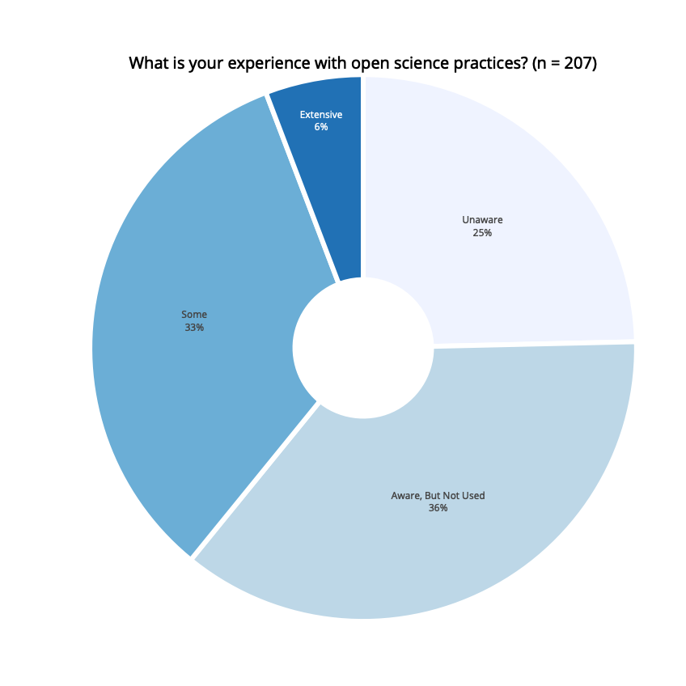

Overall Experience with Open Science Practices (n = 207)

|  |  |  |
| --- | --- | --- |
| Reported Experience | Frequency | Percentage |
| Unaware | 51 | 25 |
| Aware, But Not Used | 75 | 36 |
| Some | 69 | 33 |
| Extensive | 12 | 6 |

### Experience with different types of open science practices

Next, we break down the results according to their experience with specific types of open science practices.

#### Study Preregistration

We defined study preregistration for our participants as: “Documenting and submitting to a journal or public repository one’s research questions, methodological design, and anlysis plan prior to analysing the data. This time-stamped document is made openly available by the time the research is published so that any deviation from the original research plan is visible to the scientific community.”

##### Perceived Importance of Preregistration

We first asked participants how important preregistration of studies is for their field. Of the 195 participants who answered this question, a small percentage (4%) indicated that researchers in their discipline do not conduct research studies. As such, we excluded them from this analysis. Of the remaining 188 respondents, 37 (20%) indicated that preregistration was extremely important for their field; 69 (37%) indicated that it was somewhat important; 37 (20)% indicated that preregistration was somewhat unimportant; and 45 (24%) indicated that it was not at all important for their field.

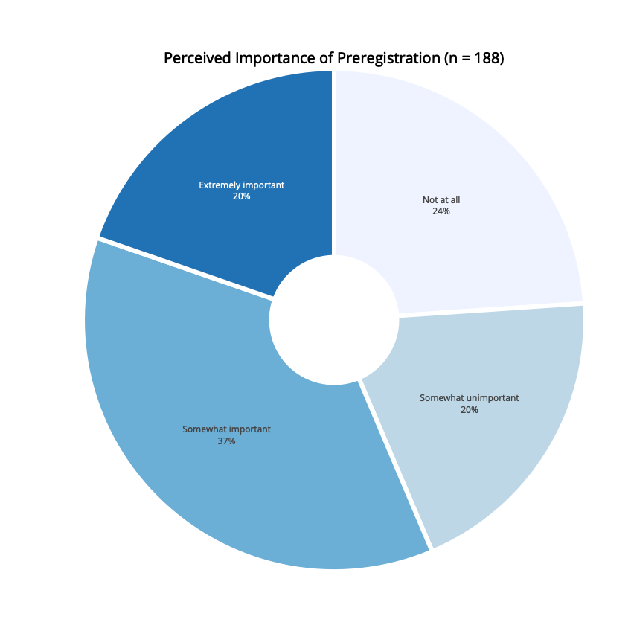

Perceived Importance of Preregistration (n = 188)

|  |  |  |
| --- | --- | --- |
| Perceived Importance | Frequency | Percentage |
| Not at all | 45 | 24 |
| Somewhat unimportant | 37 | 20 |
| Somewhat important | 69 | 37 |
| Extremely important | 37 | 20 |

##### Experience with Study Preregistration

We then asked respondents about their own experience with study preregistration. Of the 185 participants who answered this question, 74 (40%) were unaware of study preregistration; 72 (39%) were aware of study preregistration, but had not used it; 31 (17%) had some experience with it, but did not regularly preregister their studies; and 8 (4%) regularly preregister their studies.

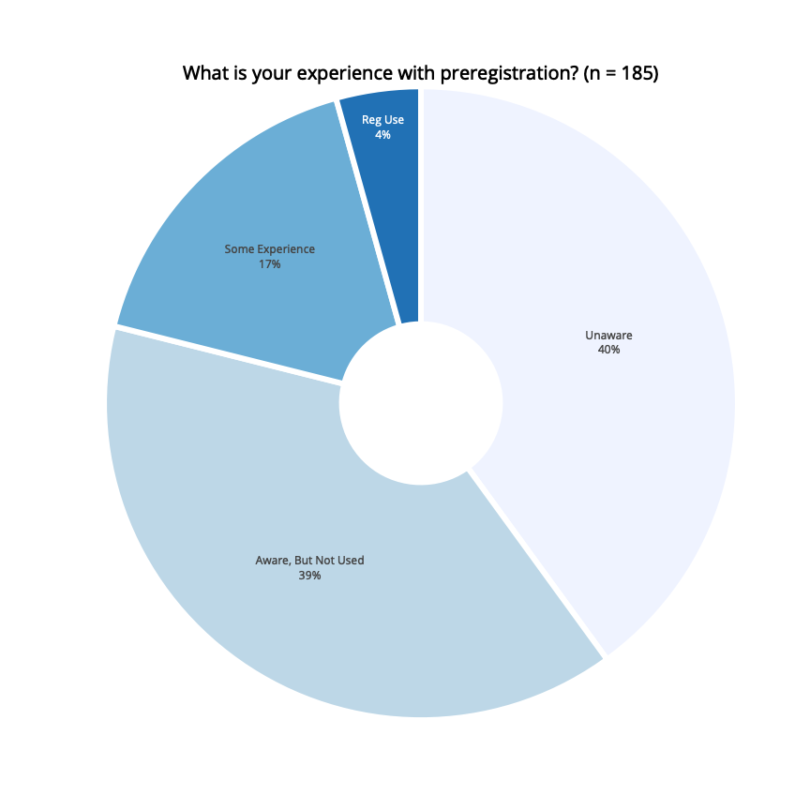

Experience with Study Preregistration (n = 185)

|  |  |  |
| --- | --- | --- |
| Reported Experience | Frequency | Percentage |
| Unaware | 74 | 40 |
| Aware, But Not Used | 72 | 39 |
| Some Experience | 31 | 17 |
| Regular Use | 8 | 4 |

##### Concerns about Preregistration

We also asked respondents if they have any concerns about preregistering their studies. After asking respondents to share their concerns in a free text format, we then provided a list of possible concerns that researchers could have about preregistering their studies.

Respondents were able to select as many concerns as they liked. Of the 162 respondents who answered this question, 25 (15%) reported that they do not share any of the listed concerns. The following figure presents, of those who answered this question, the percentage who selected each of the concerns.

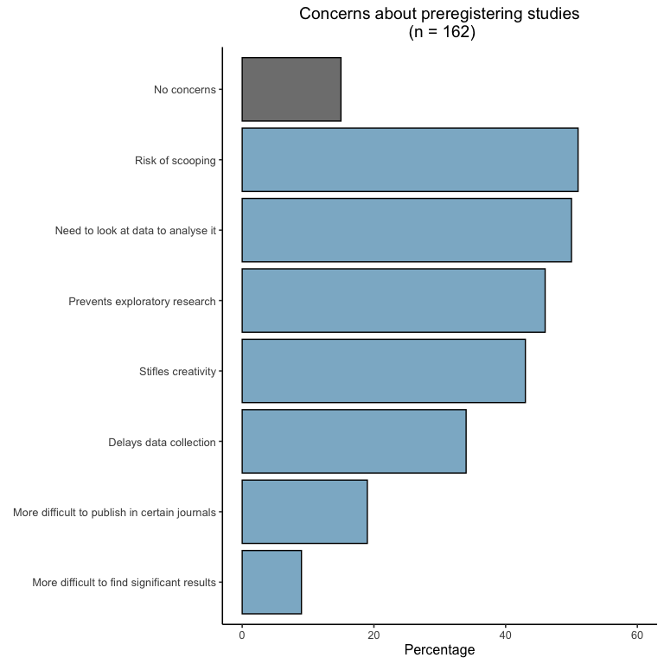

#### Open Materials and/or Code

The next section of the survey related to the use of open materials and/or code. For our purposes, we explained that open materials and/or code referred to researcher- created resources used while collecting or analyzing data (e.g., survey questions, video stimuli, vignettes, algorithms, coding schemes, analytic code, etc.) that are made openly available to the research community.

##### Perceived Importance of Open Materials and/or Code

We first asked participants how important they thought it was for their field to make materials and/or code openly available. Of the 174 participants who answered this question, a small percentage (3%) indicated that researchers in their discipline do not use materials and/or code. As such, we excluded them from this analysis. Of the remaining 169 respondents, 36% indicated that open materials and/or code were extremely important for their field; 46% indicated that they were somewhat important; 11% indicated that they were somewhat unimportant; and 8% indicated that open materials and/or code were not at all important for their field.

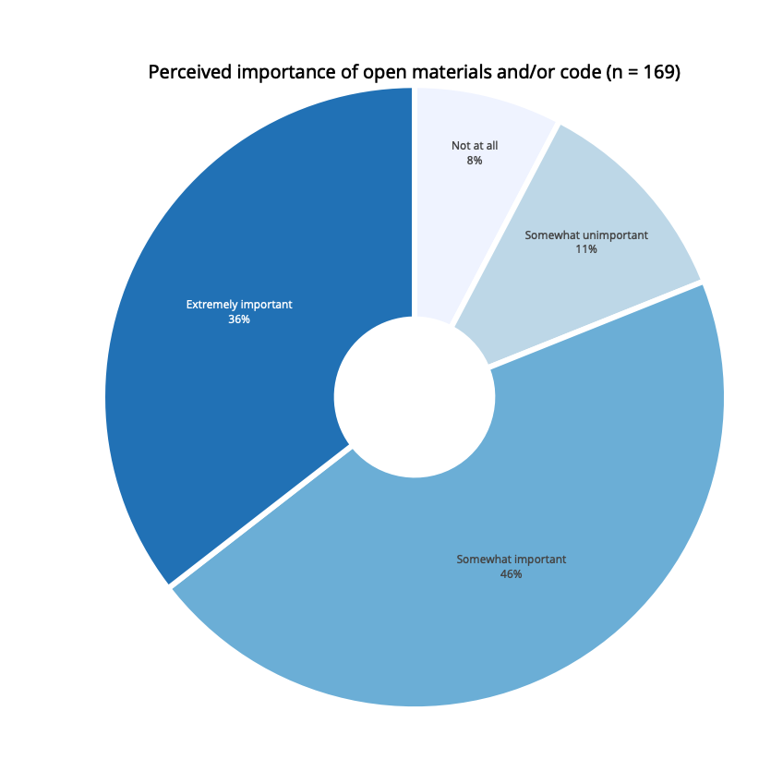

Perceived Importance of Open Materials and/or Code (n = 169)

|  |  |  |
| --- | --- | --- |
| Perceived Importance | Frequency | Percentage |
| Not at all | 13 | 8 |
| Somewhat unimportant | 19 | 11 |
| Somewhat important | 77 | 46 |
| Extremely important | 60 | 36 |

##### Experience with Open Materials and/or Code

The following section shows how many people have experience with open code and/or materials. Of the 167 participants who answered this question, 71 (43%) reported that, until now, they hadn’t heard of open materials and/or code; 37 (22%) were aware of open materials and/or code, but had not used it in their own research; 32 (19%) had some experience with open materials and/or code, but do not use them regularly; and 27 (16%) regularly use open materials and/or code.

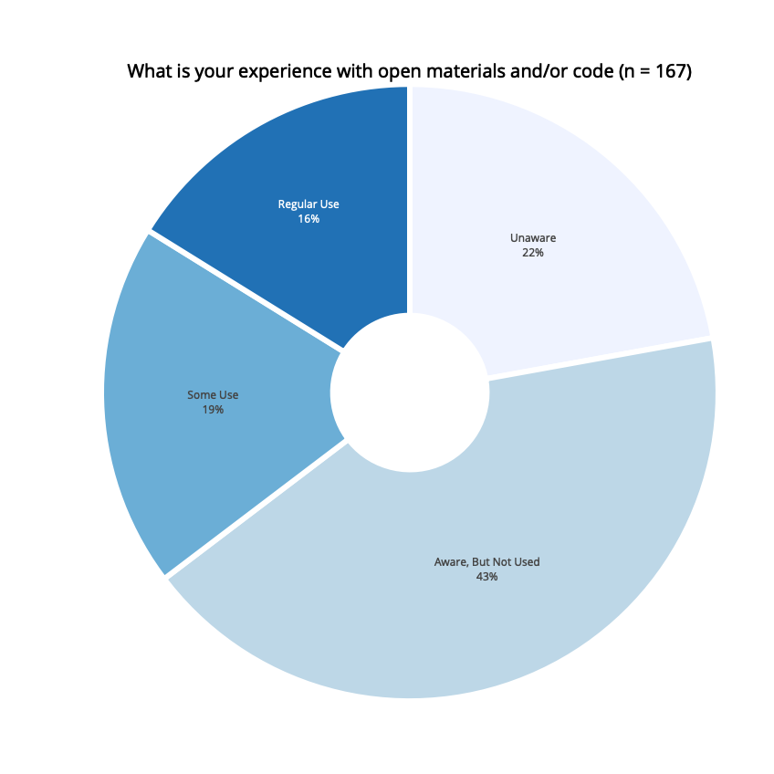

Experience with Open Materials and/or Code (n = 167)

|  |  |  |
| --- | --- | --- |
| Reported Experience | Frequency | Percentage |
| Unaware | 37 | 22 |
| Aware, But Not Used | 71 | 43 |
| Some Use | 32 | 19 |
| Regular Use | 27 | 16 |

##### Concerns about Open Materials and/or Code

We also asked respondents if they have any concerns about making their research materials and/or code open. After asking respondents to share their concerns in a free text format, we provided a list of possible concerns that researchers could have about sharing their materials and/or code. Respondents were able to select as many concerns as they liked. A total of 157 respondents answered this question. Of those who respondended to this question, 35 (22%) reported that they do not share any of the listed concerns. The following figure presents, of those who answered this question, the percentage who selected each of the concerns.

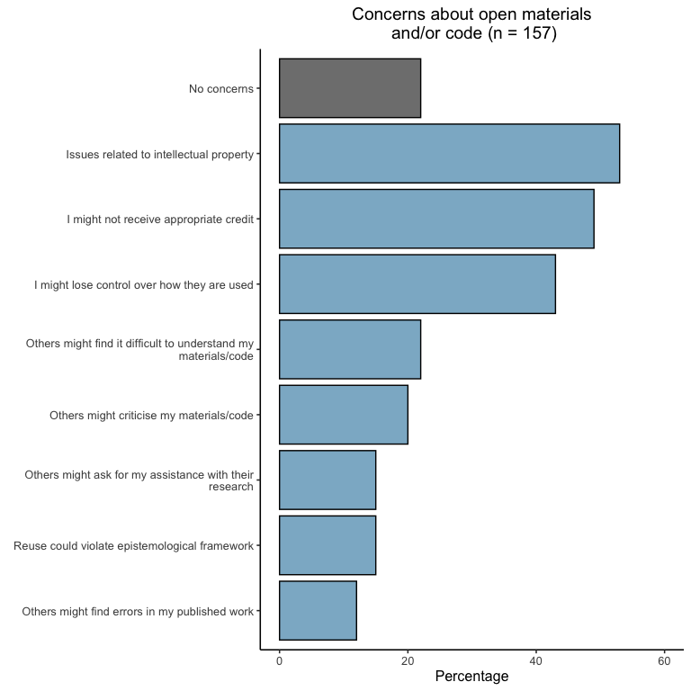

#### Open Data

THIS TEXT NEEDS TO BE UPDATED WITH OPEN DATA, BUT FIGURES ARE GOOD

The next section of the survey related to the use of open data. For our purposes, we explained that open data referred to researcher…

##### Perceived Importance of Open Data

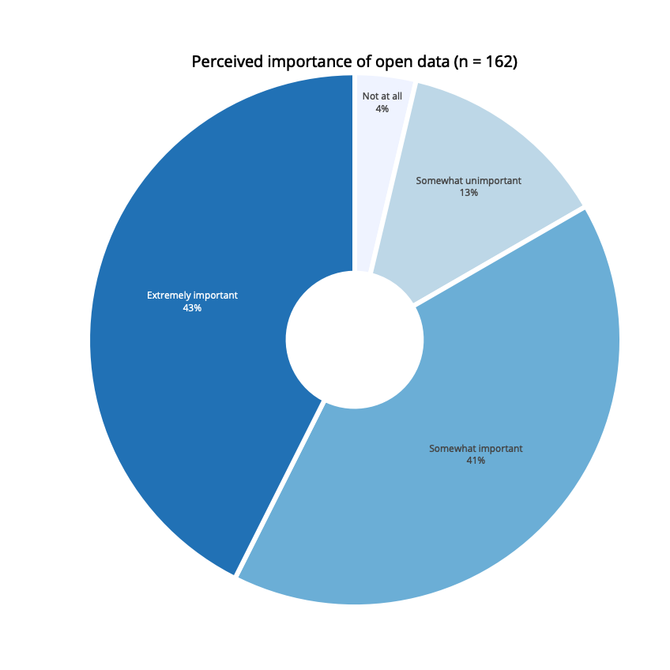

Perceived Importance of Open Data (n = 162)

|  |  |  |
| --- | --- | --- |
| Perceived Importance | Frequency | Percentage |
| Not at all | 6 | 4 |
| Somewhat unimportant | 21 | 13 |
| Somewhat important | 66 | 41 |
| Extremely important | 69 | 43 |

##### Experience with Open Data

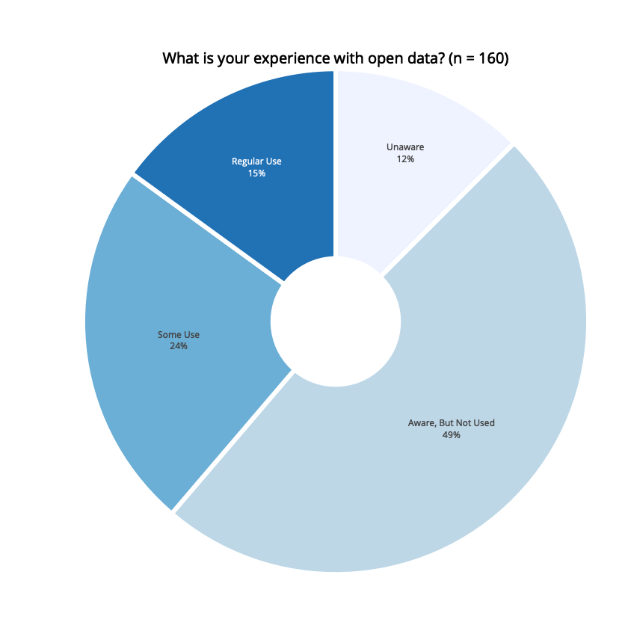

Experience with Open Data (n = 160)

|  |  |  |
| --- | --- | --- |
| Reported Experience | Frequency | Percentage |
| Unaware | 20 | 12 |
| Aware, But Not Used | 78 | 49 |
| Some Use | 38 | 24 |
| Regular Use | 24 | 15 |

##### Concerns about Open Materials and/or Code