# MACM 316 – Computing Assignment 1: Floating Point Arithmetic

## James Young, ID: 301243937

**Figure 1.**

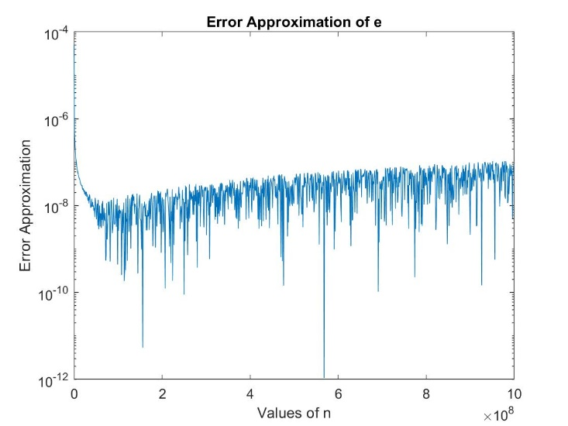We see from Figure 1 that for a large number n in equal increments, the approximation error ranges from values of 10^-6 to 10^-12. Since we are rounding each last digit either up or down, we expect to see the same up or down behaviour as seen in Figure 1. In addition, we see that the approximation error is seen to have erratic behaviour once past a certain large number n, and this is also because of floating point numbers and the resulting arithmetic. And since the upper bound for most error is machine epsilon, 10^-16, this holds true for all large number n. In terms of robustness, the effect on the resulting approximation is still precise up to 12 digits even on a big number, so thus the robustness for approximation holds rather well.

**Figure 2.**

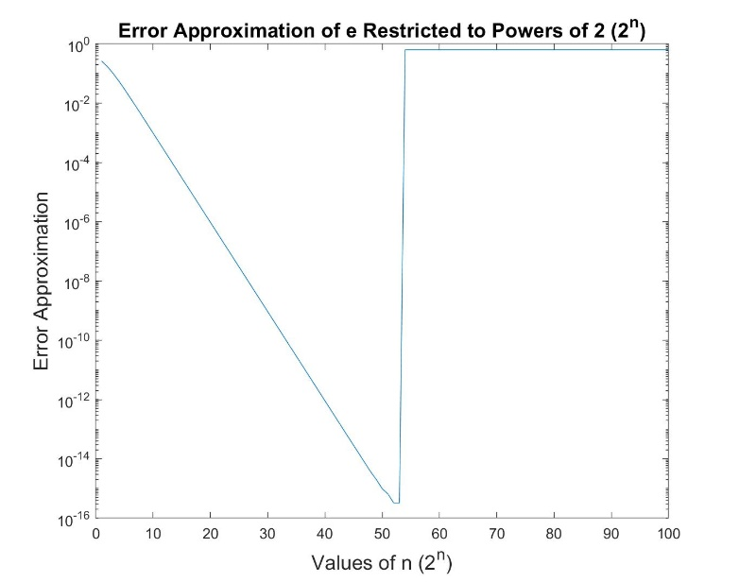Looking at Figure 2, we see the error approximation decrease up to 10^-16, which is the machine epsilon. For numbers n that are restricted to a power of 2 up to a maximum of 10^30, we see at a point where 2^n = 10^16, this is where the error approximation is machine epsilon. Once past it, the 16-digit precision and values past machine epsilon will have more than 16-digits. This makes sense as in Figure 2 because once 2^n passes that point, the error approximation becomes 1 since remaining digits are cutoff. We have more than 16 digits which are not precise. This means that it is not robust.

Now if we were to replace e with e^c with some positive number c, then the error approximation becomes smaller and smaller, as c increases. In addition, the approximation error would have the similar behaviour as Figure 1 shows, but with less erratic behaviour. In fact, error approximation becomes more and more robust.